Introduction to various programming paradigms,

- object-oriented programming,
- functional programming
- dataflow programming

- Compare different programming paradigms
- Select an appropriate programming paradigm for a given programming problem.
- Write programs using a variety of different programming paradigms.
- Explain how various programming paradigms have evolved over time.

Imperative & Procedural Programming - Big problems into smaller programs
Problem decomposition
Functions / Methods

Object-Oriented Programming - Representation identities of an entity
Encapsulation
Data and methods Objects, classes, instances

Dataflow programming
Tables, spreadsheets, tensors, Dataflow graphs
Sessions

Functional programming
Lists, pairs
Map, reduce
Recursion

What is a programming paradigm?
Programming paradigm is the style or way of thinking about and approaching problems

Why are there different paradigms?

How does it relate the notions of State & Abstraction?
abstraction is:
- the process of removing physical, spatial, or temporal details[2] or attributes in the study of objects or systems in order to focus attention on details of higher importance,[3] it is also very similar in nature to
the process of generalization;
- the creation of abstract concept-objects which are created by mirroring common features or attributes from various non-abstract objects or systems of study[3] — the result of the process of abstraction.

MIPS is very low level, one step above binary
C is higher level, though most would consider C to be a low level language

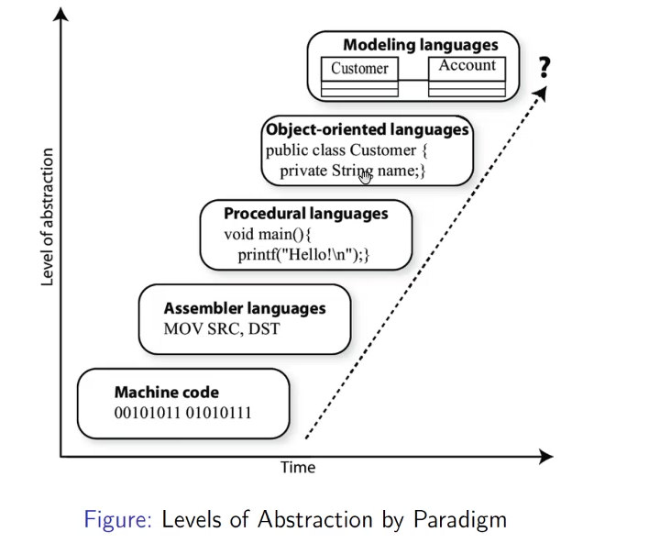

All Programming languages and paradigms are attempts to abstract low-level details

- 1 Values converted to binary
- 2 Calculations broken apart into assembly instructions e.g operations such as shifting a binary register left, or adding the binary complement of the contents of one register to another
- 3 Assigning the resulting value to the variable “a” (have to look up the variable location in physical memory)
- no abstraction the programmer would need to specify all the register/binary-level steps every time
- Abstraction also hides difference for example if the manner of performing low-level operations differs on one machine / instruction set the abstraction hides this

What is Imperative programming?
Programming with an explicit sequence of commands that update state
Difficult to understand

- Imperative Programs often compile to binary executables that run more efficiently since all CPU instructions are themselves imperative statements
- Imperative approaches and “lower level” languages are often used where efficiency and code-footprint are important such as in embedded systems.

To avoid repetition and to provide structure early programmers realized they should group instructions together into re-usable elements called procedures which can then be called when needed during program execution

C Language Example (Procedural)
Execution begins at main() the programs entry point
Proceeds linearly
Loop repeats until condition is false
printf() is a function taking args, defined as part of standard C
Program terminates returning exit code 0

How a Procedural program is structured

- DRY (Don’t repeat Yourself)
  - Group similar logic in a single method
  - Do not duplicate them all over your code
  - maintenance nightmare
- SRP (Single Responsibility Principle)
  - Your method should do one “thing”
  - Be responsible for one aspect of the program
- Smaller is better
  - Readable
  - Maintainable
- When a method is long...
  - Likely complex too!
  - break it down into smaller functions
- Good method names act as “self documenting”
  - Every language has ways of explicitly documenting when needed

