**Proposal:** Agile Delivery Services

**Prototype:** Food and Drug Warnings Search Website *(Title still in review)*

**Synopsis:** The main function of the website is to provide the user with current recalls or health hazards based on search criteria entered. The website makes use of the FDA provided data about drug and food recall and statistics. The user can enter keywords such as drug names, product names, and/or food items and return results based on health hazard classification, state, product, etc. Search results will be categorized by Recall, Allergen, etc. The user will be provided a short synopsis and be able to click on the link to read the complete entry. User entered keywords should be highlighted in returned text. In addition, easy to read graphs and/or a map on the relative data will be displayed. The user should be able to easily clear the results to start a new search or apply additional filters to the current results.

The website should utilize “human-centered” (or all-inclusive) and usability principles such as the following:

1. **Equitable use:** doesn’t disadvantage or stigmatize, easily communicates information regardless of users sensory abilities
2. **Flexibility in use:** wide range of skill levels for user, how fast a user who has never seen the user interface before can accomplish basic tasks and how fast an experienced user can accomplish tasks
3. **Simple intuitive design:** effortless understanding of architecture and navigation of site
4. **Memorability:** after visiting the site, if a user can remember enough to use it effectively in future visits
5. **Tolerance for error:** how often users make errors while using the system, how serious the errors are, and how users recover from the errors
6. **Subjective satisfaction:** does the user like using the system

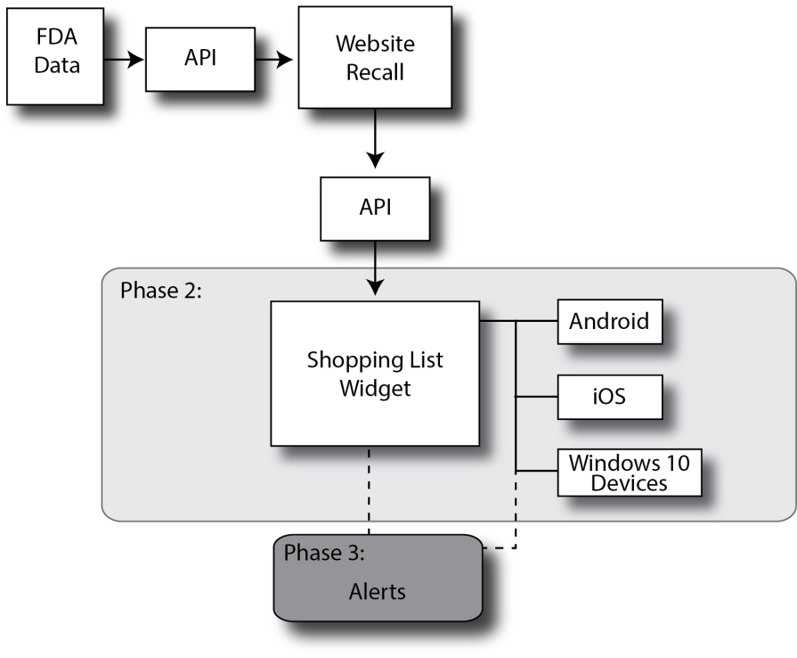**PHASE 2:** The “Food and Drug Warnings Search” website shall provide the user the ability to download a **Shopping List** app in an Android, iOS, or Windows 10 Devices format. The Shopping List app provides the user the ability to enter a shopping list of food and drug items. The shopping list will be cross referenced with the FDA provided data set. Items on the shopping list that have a recall, health hazard or other notification shall be identified to the user. Phase 2 is not expected to be completed for the prototype but will be included in the design documentation.

**PHASE 3:** The user shall receive Alerts if any item in the shopping list has a recall, health hazard or other notification without having to be in the Shopping List app at the time. Phase 3 is not expected to be completed for the prototype but will be included in the design documentation.