# Human-Centered Design Techniques

1. **Identified the people that would use the website and what they would use it for.** We targeted primarily a 30+ demographic, parents and elderly that are concerned with their health and the health of the family. The Shopping List “item check” idea was conceived to attract the parent that would be the primary shopper and purchase items for the family and elderly that might have a larger concern with medication and medical devices.
2. **Identified the goals of the website.** The goal was to bring the FDA supplied recall and adverse event data to the user instead of the user having to search for the information they were interested in. Allowing the users to enter items quickly and know immediately if the products they use have any recalls or events associated with them. The users’ general location would also be collected so the information would be specific to their area of the country.
3. **Design solutions to meet the website goals and appeal to the website demographic.** 
   1. Incorporate non-technical people on the design team to represent the user demographic.
   2. Visually stimulating design to engage and excite the user (Figure 1).
   3. Collect state information from the IP address to focus the results of area of country the user resides, but also allow user to select another state or nationwide (Figure 1).

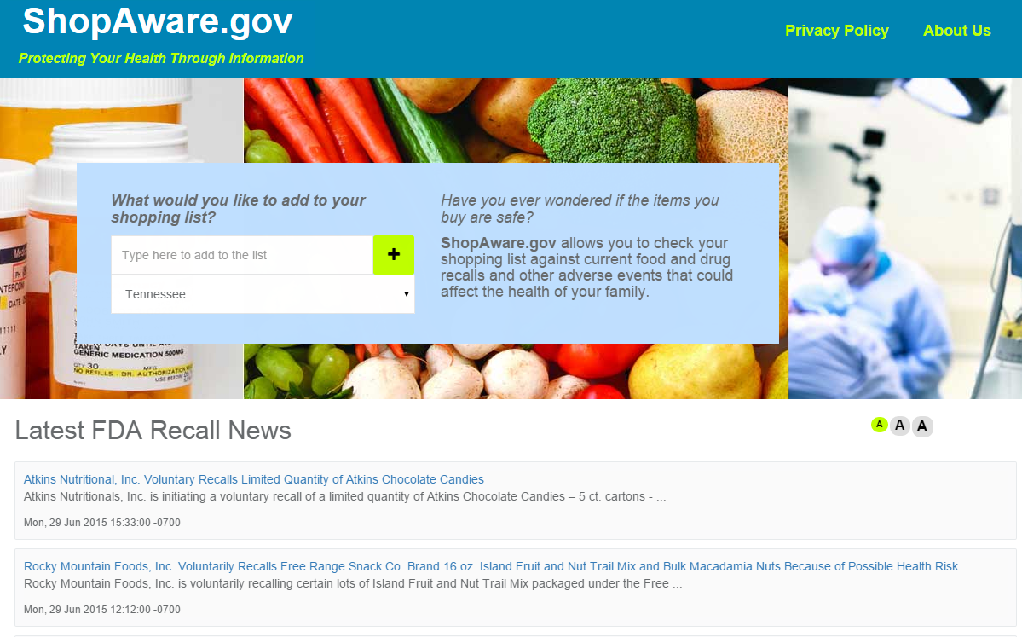

Figure - Initial Home Page Design with Imagery and Information to Support Mission of Website

* 1. Simple direct interface with one initial step (enter product of interest, click Add) that does not require any previous knowledge of site or extensive computer skills (Figure 2).
  2. The addition “hover over” tool tips to provide direction for users with basic computer skills that might need additional assistance (Figure 2).

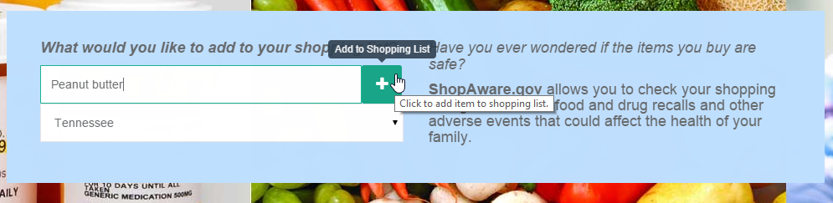

Figure - Simple Interface to Quickly Engage User

* 1. Provide a **Shopping List Legend** to explain the icon meaning to the user (Figure 3).
  2. Color-coding icons to assist in quick identification, but providing character identifiers and “hover over” tool tips to assist users with color sensory issues (Figure 3).

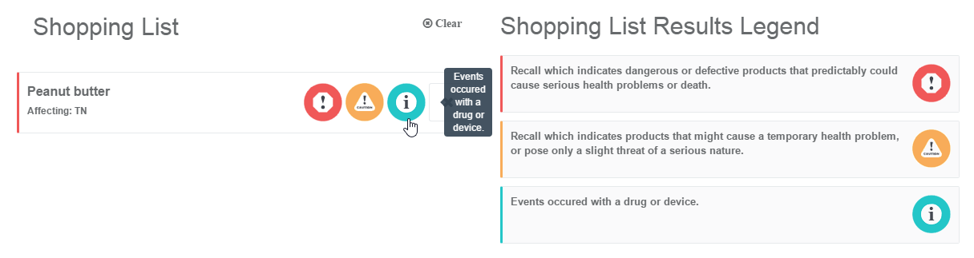

Figure - Hover Over Tool Tips and Legend

* 1. Ability for user to easily remove items from list in case item was entered in error (Figure 4).

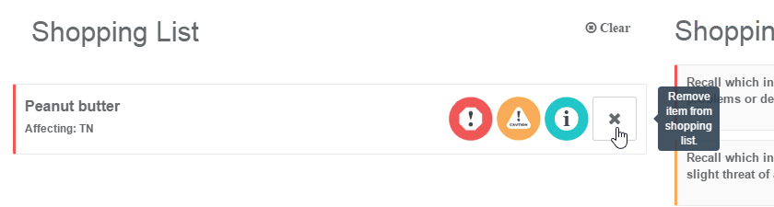

Figure - Remove Item from List

* 1. Ability for the user to engage with the website design by adjusting font size to their preference or physical needs (Figure 5).

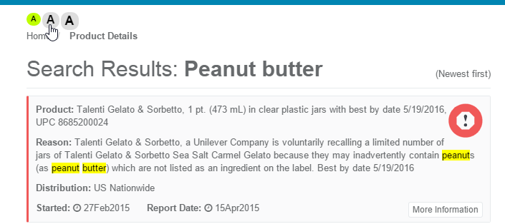

Figure - Adjust Font Size of Text

* 1. Ability for the user to comment of the value of the information presented on a web page (Figure 6).



Figure - Comment of Usefulness of Information

* 1. Create a one-click event to take the user to the information they would like to pursue, i.e. click on item in shopping list to view product details (Figure 7).

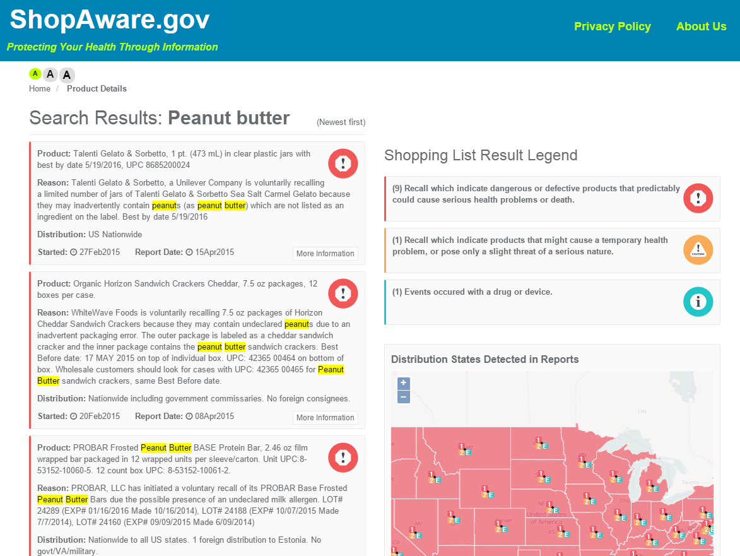

Figure - Product Details

* 1. Breadcrumb menu navigation so the user can track where they are and how to return to the start (Figure 8).

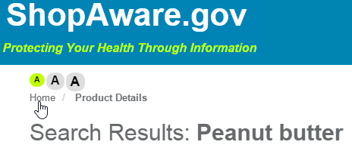

Figure - Breadcrumb Navigation Menu

1. **Evaluate the design through communication with intended users.** Conducted two focus group studies, one in the early phase of the design process and the other later in the design/development process. Each group evaluated ease of use, appeal, accessibility, organization of information, the terminology and reliability of website. Modifications were made to design to address any major concerns or issues.