RFID BASED CAR PARKING SYSTEM

*MOGULLA ARAVIND REDDY, PUJARI YASWANTH KALYAN, GUJJULA YASHWANTH REDDY*

*PRAJJWAL DUTTA, GADAM SETTY VAISHNAVI REKHA*

Abstract— Present industry is increasingly shifting towards the field of automation. This Project proposes an idea on the development of the car parking system with its improved successful parking. It is an innovative payment system that provides the ultimate solution for drivers, municipalities and private parking lot owners. Simple and cost effective to implement, this project acts as a standalone system or alongside traditional parking payment systems to eliminate fraud and reduce cash handling.

Keywords— Include at least 5 keywords or phrases

1. Introduction

Due to the surge in urbanization, the usage of the automobiles has increased which in turn, has led to traffic and parking difficulties. The most widespread solution to this problem is to increase manpower to handle such traffic. Even if it is increased, the probability of traffic less parking is not completely controlled. As per a recent survey more than 30% of traffic congestion are due to the search for vacant parking space. Hence there comes the need for the usage of automated car parking systems. There are many methods used in the automated parking like ZigBee, wireless sensor network, microcontroller. All these methods have some merits and demerits. Various technologies have been introduced with the aim of facilitating the user in daily life. This may indirectly improve productivity and efficiency in solving several matters. Radio Frequency Identification (RFID) is a wireless communication technology that is able to uniquely identify tagged objects or people.

RFID systems have been widely used in many applications, such as inventory control, product tracking through manufacturing and assembly, parking lot access and control, container or pallet tracking, Identification (ID) badges and access control, equipment or personnel tracking in hospitals and others .

RFID uses the electromagnetic fields to transfer data, for the purposes of automatically identifying and tracking tags attached to objects. RFID technology is applied in the Intelligent Transportation Systems (ITS) to monitor the traffic flow and control system for parking.

**LITERATURE SURVEY**

Based on the research, the car parking has been classified into four types. They are:

1.Wired parking

2.Wireless parking

3.Counter based parking

4.Image based parking

**Wired Parking:**

Wired parking is using detection sensors such as ultrasonic sensors which are installed at parking lot. These sensors are wired to a central control unit that store and manage the occupancy information.

**Wireless Parking:**

With the advancement in wireless technologies, wireless based methods have been employed in parking guidance systems. These systems are deployed and there are operated by the android phone. They make use of the slot allocation algorithm and Parking Management System.

**Counter based Parking:**

They use sensors to count the number of vehicles entering and exit a car park area. This can be gate arm counters and induction loop detectors located at the entrances and exits. They can give information on the total number of vacant lots in a closed car park area, but does not help much in guiding the driver to the exact location of the vacant lots.

**Image based Parking:**

Image based Parking sometimes called as video sensor techniques are used to capture the images at the parking lot and provide the information based on the image. There are arguments concerning the viability of using this technique. RELATED WORKS This section gives review about RFID history, standard, architecture, technical specification and related work on car parking system. A. RFID History RFID technology is an emerging trend in many industries worldwide over these decades. Table 1 shows the history of RFID technology over decades.

**RFID Standards**

As RFID evolves, standards are showing an interest between cost and security. There are various tag types are commercially available, including passive, semi passive, active, semi active, Lower Frequency (LF), High Frequency (HF), Ultra High Frequency (UHF), microwave, onboard sensors, ruggedized housings and implantable.

**RFID System Infrastructure**

RFID system infrastructure consists of three typical components, which are RFID tags, RFID readers, and a database that stores RFID data transferring between reader and tags as shown in Figure 1) RFID Tags RFID tags contain two major parts which are integrated circuit and antenna. The integrated circuit is a microprocessor chip whereas the antenna is responsible for defining the reading range of the tag RFID tag is activated to be read and written by the emission of radio signals from antenna.

Active RFID Tags: Active RFID tags have its own power source and transmitter that enable the tag to broadcast its signal. Active tags are capable to read longer ranges (100 meters or more) and have greater memory capacities (128kb). To achieve a huge read range and larger memory, it generates a greater power supply. Active tags usually are powered by a long-life battery.

Passive RFID Tags: Passive RFID tags did not have internal power source. Passive tags consist of microchip and antenna. Both microchip and antenna commonly referred as RFID inlay. Passive tags need to wait for interrogating signal from RFID reader. Thus, the antenna draws energy from the electromagnetic waves. Once the microchip powered, it transmits a signal.

Table below shows the comparison between active RFID and passive RFID tags based on its power, required signal strength, communication range, range data storage, cost and applications.

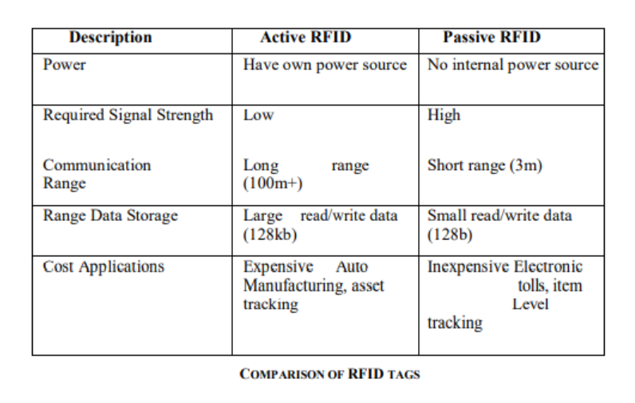

**1.RFID Reader**

The RFID reader is an electronic device which includes two basic parts: an antenna and a transceiver. The antenna is designed to allow the open communication between the tags, whilst the transceiver is responsible for acquiring the RFID data. Moreover, the RFID reader has a function of reading data from RFID tag and writing data to the RFID tag.

**2.RFID Database**

RFID databases associate tag-identifying data with arbitrary records. These records may Description Active RFID Passive RFID Power Have own power source No internal power source Required Signal Strength Low High Communication Range Long range (100m+) Short range (3m) Range Data Storage Large read/write data (128kb) Small read/write data (128b) Cost Applications Expensive Auto Manufacturing, asset tracking Inexpensive Electronic tolls, item Level tracking contain product information, tracking logs, sales data, or expiration dates. Independent databases may be built throughout a supply chain by unrelated users, or may be integrated in a centralized or federated database system.

**RFID Frequency Bands**

RFID tags fall into three regions in respect to frequency: Lower Frequency (LF), High Frequency (HF) and Ultra High Frequency (UHF).

**COMPARISON  BETWEEN  EXISTING  SYSTEM  WITH PROPOSED  SYSTEM**

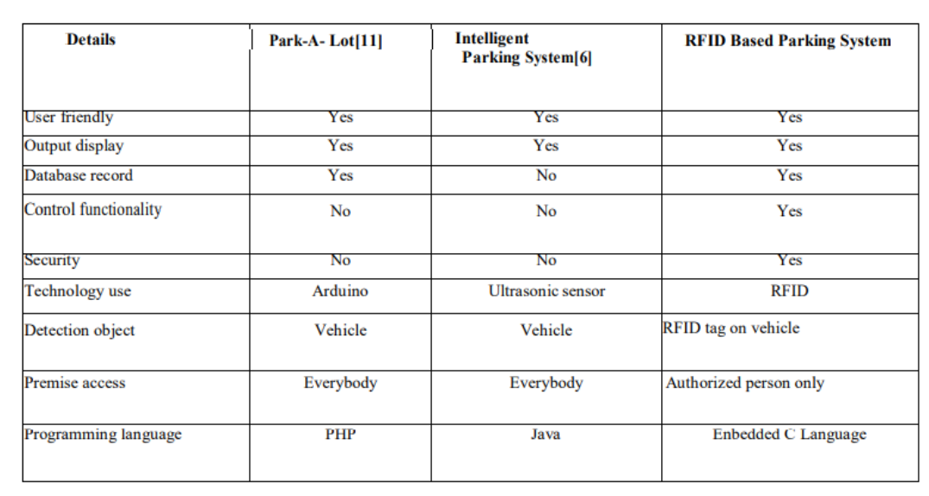

**COMPONENTS REQUIRED**

* Proteus Circuit simulation software
* Keil software

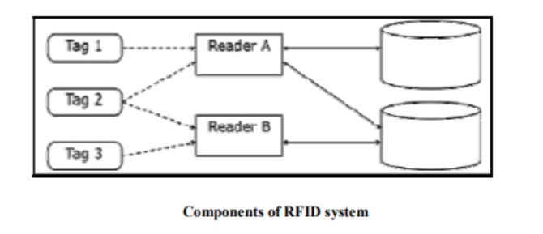

**METHODOLOGY**

The circuit shows that the RFID reader scan the RFID tag ID and the information is sent to the microcontroller. After the ID is read, Microcontroller checks whether the tag ID matches or not. If the ID is matched, LCD displays the string “Association Member” on the LCD display and the motor movement indicates the opening and closing of doors.

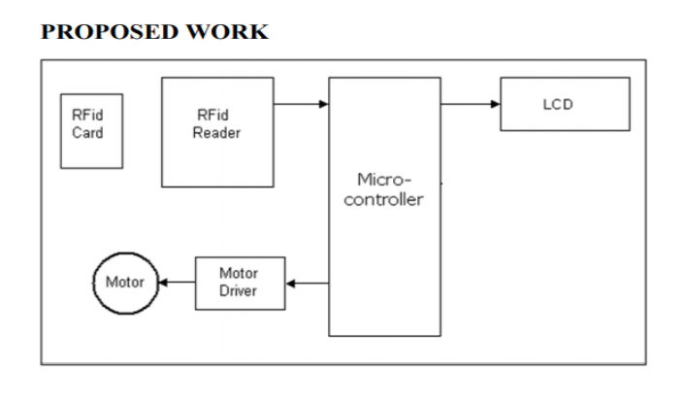

The motors are operated based on the H bridge circuit. They maintain a constant voltage across the circuit and prevent the circuit from damage. The clockwise rotation indicates the opening of the door whereas the anticlockwise rotation indicates the closing of the door.

**FLOW CHART**

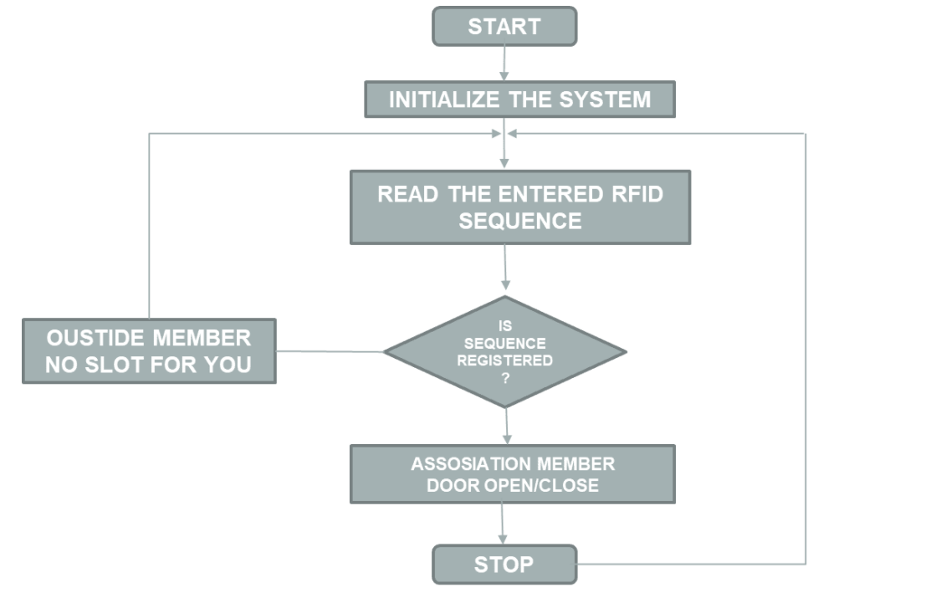

**CIRCUIT IN PROTEUS SOFTWARE**

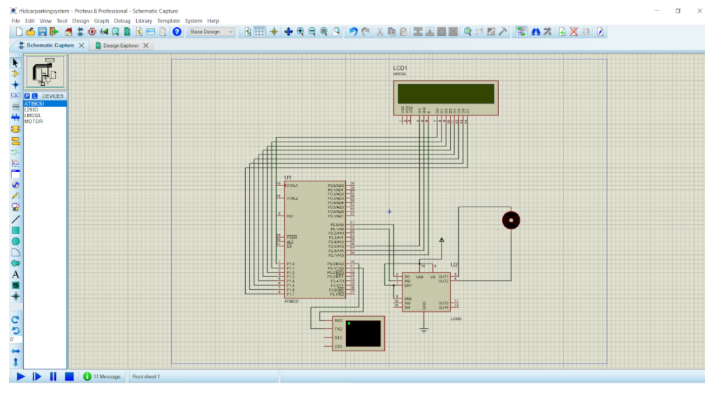

Above figure shows the working of the proposed automatic car parking system simulated using Proteus software.

When the hex file is loaded onto THE MICROCONTROLLER, the simulation begins. The display of the “**RFID BASED CAR PARKING SYSTEM**” appears. And then the LCD displays “**SWIPE YOUR CARD**” now user have to enter his 12-digit unique RFID tag input. If the entered 12-digit unique ID matches with the pre-programmed data in the microcontroller LCD displays “**ASSOCIATION MEMBER – NAME-SLOT**” and then door opening and closing messages appear on LCD and simultaneously we can see the motor rotating clock wise and anticlockwise respectively for opening and closing of doors.

**Detailed explanation of code is described below:**

This application covers, there is a gate control based on RFID tag input.

Once you are applying RFID tag input to the system, which manages the internal process and which verifies whether the person is existing person or outside person, based on that the door will open or close.

This is the header file name for 51(five-one) families

 #include<reg51.h>

 Sbit doorp= P2^0;

Sbit doorp=P2^1;

 These two are motor connections Which is going to rotate the motor clock wise and as well as anticlockwise directions for and close.

RS is the register select pin used to write display data to the LCD (characters), this Pin has to be high when writing the data to the LCD. During the initialization sequence and other commands this pin should low .

Enable pin is for starting or enable the module.

RW pin , reset if to 0,if we are going to write some data on LCD and set it to 1 if we are reading from LCD module . Generally, this is set to 0 because we do not have4 need to read data from LCD

Enable/disable the external memory interface

Sbit rs=P2^5; register select control pin

Sbit rw=P2^6; read write pin

Sbit en =P2^7; enable pin

These three are LCD control line connections.

**Void lcddat (unsigned char):** We are using the function ‘lcddat’ which is the function to pan character by character to led screen which allows 1-byte value because it is a character argument.

**Void lcdcmd (unsigned char):** The command is also 1byte size used to pan command to LCD .

**Void lcddis (unsigned char)**: This is the display with string pointer So, we are using this string pointers function whatever text you are expecting on screen, lt can pass through this function to lcd display.

**Void lcd_int ()**: Lcd initialization is the fn used to send all commands which requires for initialization.

**Void serial_int ():** Serval initialization is the fn used to write the serial communication b/w RFID reader and microcontroller .

**Void check ()**: Check is the fn for comparison Whenever you are calling this fn after reading operation we are going to call this check fn which compare whether the person is existing or outside person.

**Void delay ():**

**Void mdelay ():**

These two are delay fn’s used for LCD and as well as motor operation

Now

**Unsigned char rfid [12], v1;**

These are the two declaration with character data type rfid with 12-byte size and v1 the one temporary variable for loop repetition from here main program starts

Void main ()

{

 Doorp=Doorn=0;

So, initial assignment of two motor input lines which are two zeroes, So there is no response from motor.

**Serial_init ()**

Serial initialization fn contains the steps

Scon =0x50; //which initialization serial communication with a receive    enable mode

TMOD=0x20; //we need to select timer 1m mode 2 by using TMOD respect

TH1=-3; //baud rate =9600

TR1= 1; you need to start a timer.

These are the serial communication steps we need.

**lcd_init();**

 lcd_init is the lcd initialization functionwhich contains all the comands related to lcd.

Void lcd_init()

{

lcdcmd(0x38);initialize crystals with 5x7 matrix

lcdcmd(0x01);clear screen

lcdcmd(0x10);shift cursor position to right

lcdcmd(0x0c);display on cursor off

 lcdcmd(0x80);start display from first line first position

}

These are the initialization commands need to send from microcontroller to the lcd and whenever calling the lcdcmd(0x38).

For this lcd command which is already defined as a function so this argument we are passing to lcdcmd function.

**Description of lcdcmd function**

Void lcdcmd(unsigned char val)

{

 p1=val;

 rs=0;

 rw=0;

 en=1;

 delay();

 en=0;

 }

The command value which is equated with the ‘val’variable are assigned to p1.thus p1which is connected with all the data liner d0 to d7of lcd.while sending command one need to make sure this ‘rs’ logic as zero and ‘rw’ logic is also zero and need to enable pin high to low=1 .

Again delay function will be called.

**Description of delay function**

Void delay();

{

  Unsigned int v5;

 for (v5=0;v5<6000;v5++);

}

This is the delay function with just 6000 with for loop we need to declare one integer datatype variable v5 and executing this variable v5 variable upto 6000 and come back to enable zero .so this is the command function description enable pin high to low.

So,without making this enable pin high to low it wont allow next character or next command.

First we are sending 0x38 command and then whenever calling this lcd command function this argument will come here and executed through this lines.

After lcd initialization we are calling this lcd display which is already declared as string pointer.

Void lcddis(unsigned char *);(‘*’ which makes pointer concept)

So, this lcd display is the function string pointer to this lcd display on a argument.

 Lcd dis(“RFID BASED CAR”);

Once this lcd function is called this compitation lcd display will come.

In the description of the lcd display function whatever the stringpointer which is assigned in the main is equated with ‘s’ here.

Void lcd dis(unsigned char*s)

{

Unsigned char w;

For(w=0;s[w]!=’\0’;w++)

{

Lcd dat(s[w]);  }  }

This is equated with ‘s’.

Now,within this function we are taking one temporary variable ‘w’ and needed to pass this string .entire string which is not possible at a time we need to pass character by character so, we are taking forloop for w=0 and then s[w] means the string which always terminates with null character to this comand until unless which is not equal to null character we need to repeat this for loop this for loop continous upto null character and keep on increment this’w’ variable.

Each element of this string we are passing to the lcddat function

**Description for lcddat function is below**

In this function whatever the argument we are passing from this display function which comes here ‘val’ which is equated with p1.but

remember whenever we are passing text to lcd we need to change the control line logic ‘rs’logic as ‘1’ and ‘rw’ logic as ‘0’ and we need to make enable pin high to low once for every character change.

 Void.lcddat(unsigned char val)

 {

  p1=val;

 rs =1;

 rw=0;

en=1;

 delay();

en=0;  }

So,with the help of this we are going to execute the code .we are sending data or text to lcd screen So anyway text which will come in the first line “RFID based VAR parking” and again we are using one more function which is

Lcdcmd(0x0);

which means persion is sending cursor to 2nd line.So this forcing cursor to 2nd line and then display the function.

Lcddis(“PARKING SYSTEM”);

After that we are going to clear this text because we are entering into the application, this is the initial text am expecting on screen and motors are OFF state and serial communication which is initialized already and after lcd initialization we are sending this text to screen with the first line “RFID based CAR PARKING” And the 2nd line “PARKING SYSTEM”

And again we are sending the 0x01-command to clear the data /text lcdcmd(0x01).

Now the application you are entering into while loop

While(1)

{

 Lcdcmd(0x01);

 Lcddis(“swipe your card”);

 For(v1=0,v1<12;v++)

{

While(RI==0);

Rfid[v1] = SBUF;

RI=0;

SBUF =rfid[v1];

Now the person has to swipe the card. Once he/her swipes the card,the card reader which is going to read 12 digits from your unique rfid card. These are the steps to read the 12 digit of the rfid tag.

So for v1=0;v1<12;v++

So we are waiting here RI becomes 1 which means data is received from RFID card data to microcontroller whenever RI becomes 1 now data is ready in SBUF.so these SBUF character I am going to save in RFID of v

RFID[v1]=SBUF

Because we need to read 12 digits of RFID tag.So we are repeating the process 12 times .so because of the 12 times reading process where this details which are saved in RFID[12] which already defined as an empty array above.

**OUTPUT**

When we run the circuit in proteus software initially, we will get a message like this: “**RFID BASED CAR PARKING SYSTEM**” and a virtual terminal will pop-up to enter 12-digit unique RFID input.

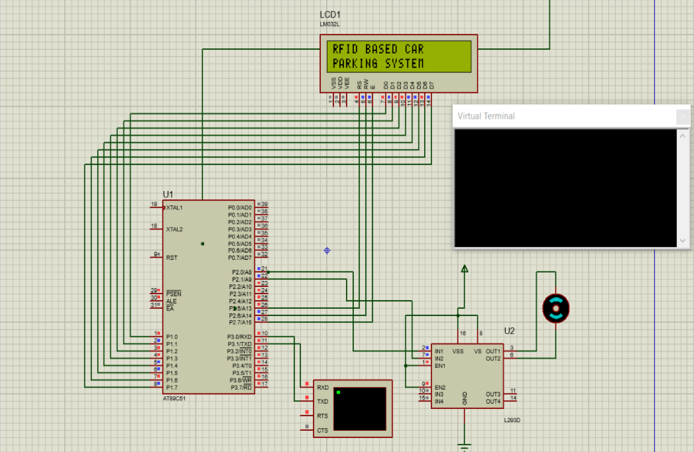

Then the LCD shows a display of “**SWIPE YOUR CARD**” Now the user has to enter his 12-digit unique RFID input sequence in order to park his car in his allotted slot.

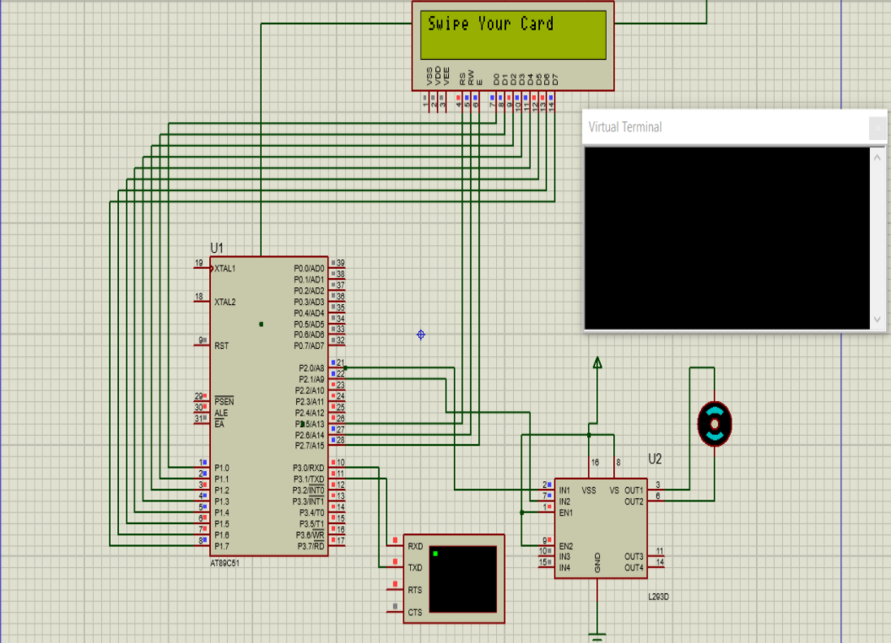

Now user entered his Id and if the ID matches with the pre-programmed data in the microcontroller the door opens and closes and the DC motor which is connected will rotate simultaneously clock wise and anti-clockwise for opening and closing of doors respectively. Here user entered his ID and it has matched with the pre-programmed microcontroller data so LCD displays “ASSOCIATION MEMBER VAISHNAVI SLOT”.

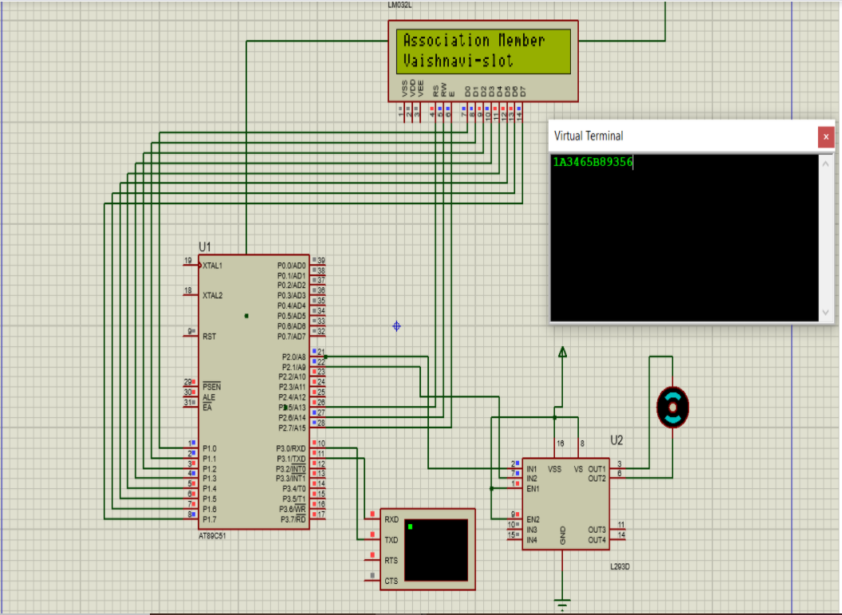

Since the user is an existing member, the door has to open

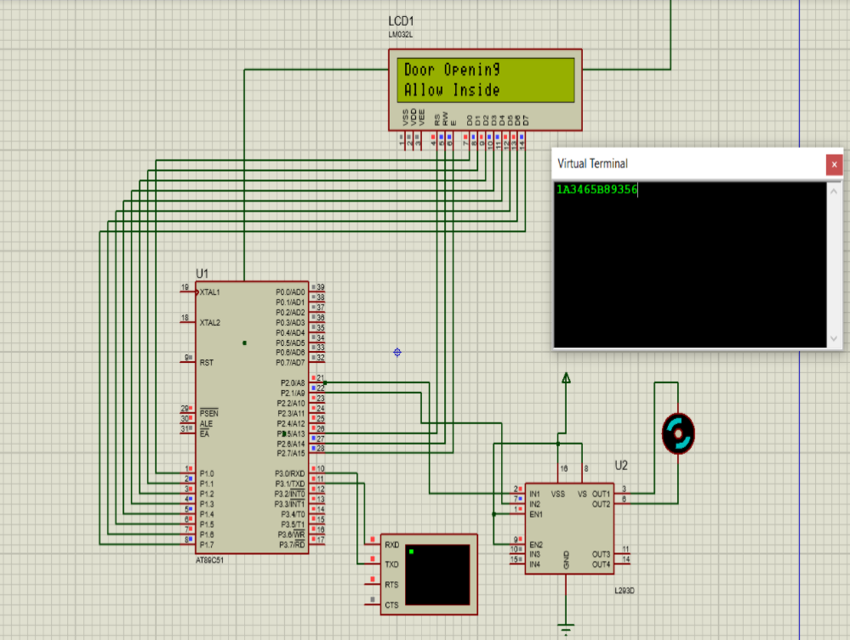

After the member enters the door will close after some time and same routine continues

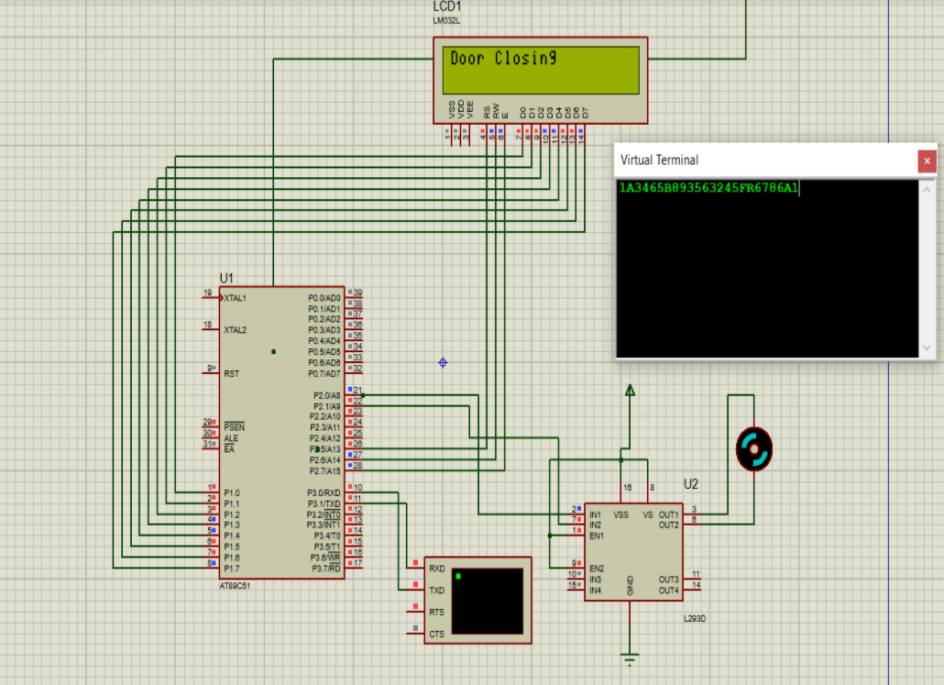

If an un-authorised person tries to enter, it’ll restrict him to enter and says “**OUTSIDE PERSON-NO SLOT FOR YOU**”

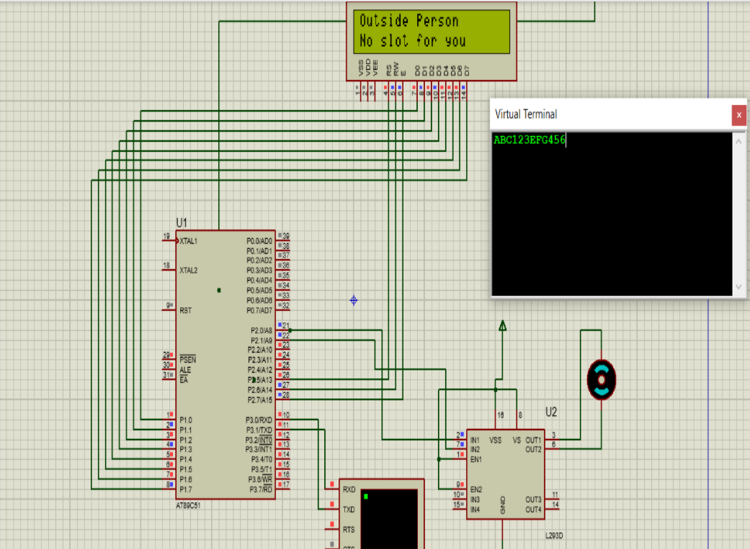

**ADVANTAGES AND APPLICATIONS**

* RFID based Car Parking System is implemented in this project and can be used to eliminate the hassle of manual operation of parking system.
* This system can help in reducing cost, increase in productivity and saves time.
* Accurate timing details are measured with the help of RTC Module.
* Prepaid and postpaid cards can be integrated with the system for easy payment options.
* Analyze traffic patterns to maximize facility utilization.
* Increase security within the parking facility.
* Manage staffing for peak traffic periods.
* Save time for parking.
* Improve customer service.

**CONCLUSION**

The project offers a new solution to the evolving technology such as: saving time and manual effort, problem of illegal parking, reduction of traffic jam and more safety parking high

**REFERENCE**

[1] Rosario Salpietro , Luca Bedogni, Marco DiFelice, Luciano Bononi“Park Here! A Smart Parking System based on Smartphones’ Embedded Sensors and Short Range Communication Technologies” Department of Engineering and Computer Science, University of Bologna, 978-1-5090-0366-

[2] Mrs. D.J.Bonde, Rohit SuniKetan Suresh Gaikwadl Shende, “Automated Car Parking System Commanded By Android Application” International Conference on Computer Communication and Informatics (ICCCI -2014), Jan. 03 – 05, 2014, Coimbatore ,University of Pune MMIT – Lohgaon Pune, India

[3] Hongwei Wang and Wenbo He, “Reservation-based SPS” The first international workshop on cyber-physical networking systems, Dept .Computer, Electrical Eng, University of Nebraska-Lincoln, NE, USA, 978-1-4244-9920-5/11. IEEE, 2011

[4] Kianpisheh, Norlia Mustaffa, Pakapan Limtrairut and Pantea Keikhosrokiani “SPS Architecture Using Ultrasonic Detection” International Journal of Software Engineering and Its Applications, University Sains Malaysia (USM), Malaysia, Vol. 6, No. 3, July, 2012

[5] Hilal Al-Kharusi, Ibrahim Al-Bahadly, “Intelligent Parking Management System Based on Image processing “World Journal of Engineering and Technology, School of Engineering and Advanced Technology, Massey University, Palmerston North, New Zealand,2,55-67 ,2014

[6] Abhijith,  S.,  Jajoo,  S., Prasad,  S. G.  R., &  Mungara, J.  “Low  cost Intelligent Parking management and Guidance System”, 4(4), 11297–11300.2015

 [7] Surbhi Maggo, 2Reema Aswani “AUTOPARK: A Sensor Based, Automated, Secure and Efficient Parking Guidance System” Jaypee Institute of Information Technology, India IOSR Journal of Computer Engineering (IOSRJCE) ISSN: 2278-0661, ISBN: 2278- 8727Volume 8, Issue 3 (Jan. - Feb. 2013), PP 47-56.

[8] Vaibhav Hans, Parminder Singh Sethi, Jatin Kinra “An Approach to Iot Based Car Parking and Reservation System on Cloud” International Conference on Green Computing and Internet of things (ICGCIoT),Centre of information Technology University of Petroleum & Energy Studies Dehradun, 978-1-4673-7910-6/15 IEEE 2015, India

[9]Thanh Nam Pham, Ming-Fong Tsai1,Der-Jiunn Deng2“A Cloud- Based Smart-Parking System Based on Internet-of-Things Technologies” 2169-3536 2015 IEEE. Translations, Department of Information Engineering and Computer Science, Feng Chia University, Taichung 407, Taiwan 2015

[10] Phillips, T.,  Karygiannis, T.,  & Kuhn,  R. “Security standards for the RFID  market”.  IEEE  Security  and  Privacy,  3,  85–89.  2005. <http://doi.org/10.1109/MSP.2005.157>.

[11]Yang, K., Alkadi, G., Gautam, B., Sharma, A., Amatya, D., Charchut, S.,  & J ones, M.  “Park-A-Lot :  An  Automated Parking Management System”,  1(4),  276–279.  2013. <http://doi.org/10.13189/csit.2013.010406>.