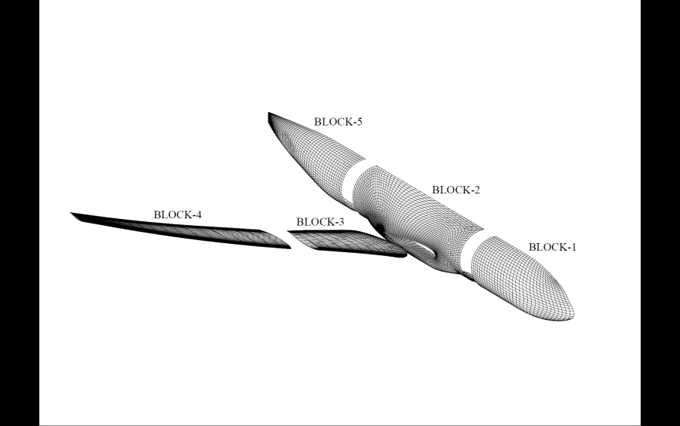**6th AIAA**

### CFD Drag Prediction

**Workshop**

**Sponsored by the**

**Applied Aerodynamics TC**

2-Day Workshop Preceding

**AIAA AVIATION 2016**

**Washington, D.C. USA**

**June 11-12, 2016**

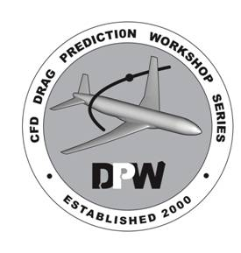

**For more information**

**and results from past workshops,**

**visit the DPW website at:**

[***http://aaac.larc.nasa.gov/tsab/***](http://aaac.larc.nasa.gov/tsab/)***cfdlarc/aiaa-dpw/***

**or send email to:**

***aiaa***[***dpw@gmail.com***](mailto:dpw@gmail.com)

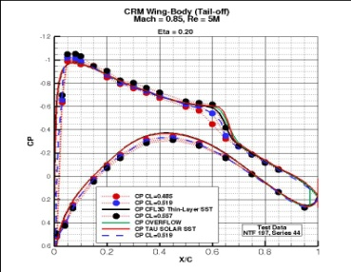**CFD Drag Prediction Workshop VI**

*In addition to* ***CFD practitioners****,* ***flow-solver developers*** *and* ***grid-generation experts…***

*The DPW Organizing Committee invites members of the*

***Solution-Adaptation*** *&* ***Aero-Elastic***

*communities to participate in DPW VI.*

## Focus

The focus of this workshop will be the NASA Common Research Model (CRM) with wind-tunnel measured wing twist; both wing-body and wing-body-pylon-nacelle configurations will be considered. CFD predictions of absolute and incremental force and moment values will be examined and compared. The workshop will include grid convergence and code verification studies. Additionally, an angle-of-attack sweep with static aero-elastic deformations will be considered. Grids will be made available for all required cases.

Optionally, participants are invited to perform solution-adaptation calculations and/or a coupled aero-structural simulation of the CRM wing-body configuration. A finite element model will be made available to participants to calculate twist/deflection due to aerodynamic load.

**CFD Drag Prediction Workshop VI**

## Organizing Committee

**John Vassberg, Ben Rider, Mori Mani***The Boeing Company*

**Olaf Brodersen, Stefan Keye***DLR*

**Martin Gariepy***École Polytechnique de Montréal*

**Mitsuhiro Murayama***JAXA*

**Joseph Morrison, Richard Wahls***NASA Langley Research Center*

**David Hue***ONERA*

**Edward Tinoco***Retired*

**Edward Feltrop, Kelly Laflin**  
*Textron Aviation*

**Dimitri Mavriplis***University of Wyoming*

**Chris Roy**  
*Virginia Tech*

**Dates**

*Check the DPW website for additional information and updates.*

Release Geometry Jun 1, 2015

Release Standard Grids Aug 1, 2015

Notice of Intent to Participate Dec 1, 2015

Abstract Deadline Apr 1, 2016

Data Submittal Deadline May 1, 2016

**Workshop registration will be handled through normal AIAA procedures.**

Workshop presentations will not be official AIAA papers; however, several participants will be invited to support a special session on drag prediction to be held during the AIAA SciTech Meeting, January 2017.

**CFD Drag Prediction Workshop VI**

**Objectives**

1. To build on the success of past AIAA Drag Prediction Workshops.
2. To assess the state-of-the-art computational methods as practical aerodynamic tools for aircraft force and moment prediction of industry relevant geometries.
3. To provide an impartial forum for evaluating the effectiveness of existing computer codes and modeling techniques using Navier-Stokes solvers.
4. To identify areas needing additional research and development.

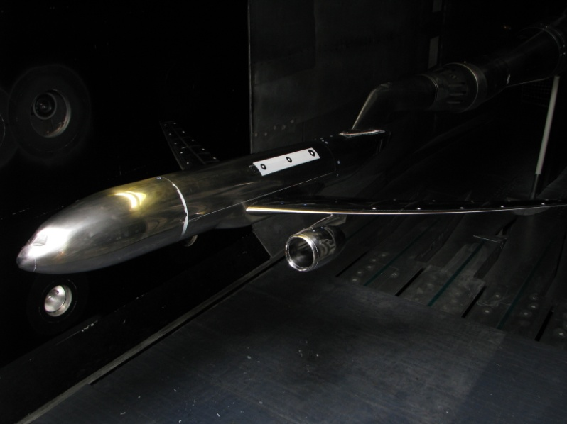

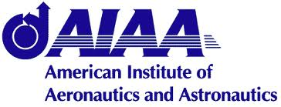**NASA Common Research Model (CRM)CFD Drag Prediction Workshop VI**

**General Information**

1. This workshop is open to participants worldwide. Efforts will be made to ensure representation from all areas of industry, academia and government laboratories.
2. Participation in the drag studies is not required to attend the workshop. Everyone is welcome!
3. Open forums will be included in the workshop to discuss the solutions and modeling techniques.
4. Results will be made available after the workshop in a report and on the DPW website.
5. A nominal registration fee will be required for attendance.
6. AIAA membership is not required

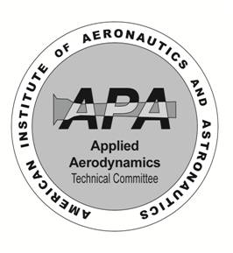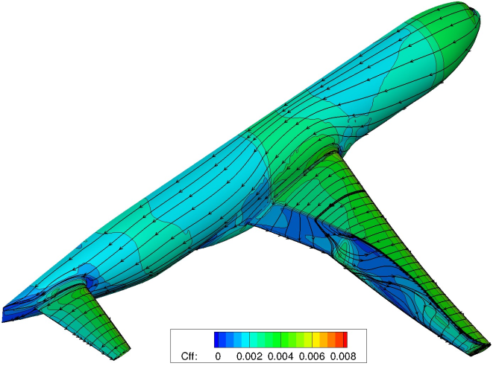**CFD Drag Prediction Workshop VI**

**Test Cases**

*Check the DPW VI website for additional details and updates.*

**Required**

**Case 1: 2D Code Verification Study**

**Case 2: CRM Nacelle-Pylon Drag Increment / Grid Convergence Study (single condition on a family of grids)**

**Case 3: CRM Wing-Body Static Aero-Elastic Effect (7 solutions on 7 grids)**

**Optional**

**Case 4: CRM Wing-Body Solution Adaptation and/or a 2D Solution Adaptation Study**

**Case 5: CRM Wing-Body Coupled Aero-Structural Simulation (FEMA supplied)**

**Case 6: Participant Generated Grids**

All participants are encouraged to build their own grids using ‘best practice’ techniques. IGES and STP models are available for grid construction. Grid size requirements can be found on the DPW VI website. All grids used for results presented at the workshop must be submitted to the DPW Organizing Committee to be made available to all interested parties. *Note: All results and grids will be published electronically on the DPW website*:

[*http://aaac.larc.**nasa.gov/tsab/cfdlarc/aiaa-dpw/*](http://aaac.larc.nasa.gov/tsab/cfdlarc/aiaa-dpw/)