ANNOUNCEMENT

4th AIAA CFD Drag Prediction Workshop
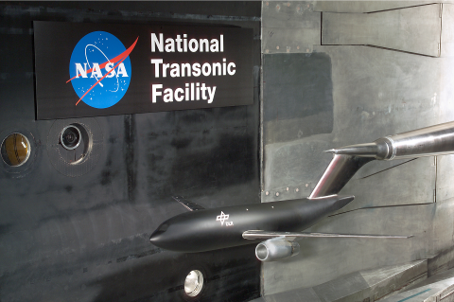
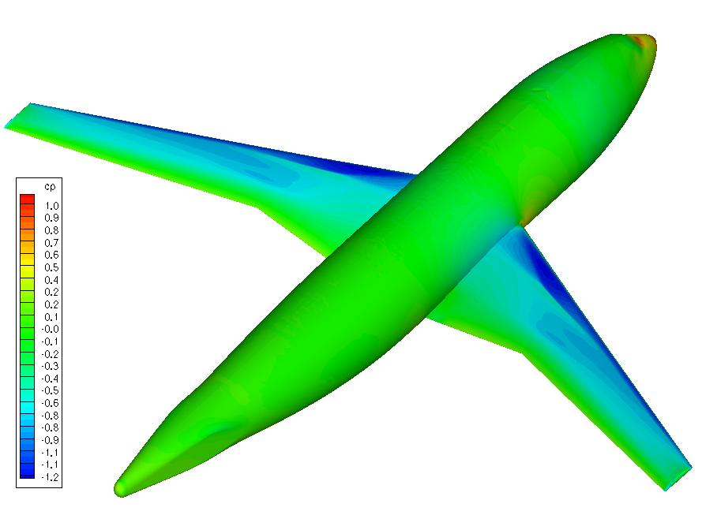
Sponsored by the

Applied Aerodynamics TC

to be held with the
27th APA Conference, Summer, 2009
San Antonio, TX

Objectives  - To assess the state-of-the-art computational methods as practical aerodynamic tools for aircraft force and moment prediction of industry relevant geometries.  - To provide an impartial forum for evaluating the effectiveness of existing computer codes and modeling techniques using Navier-Stokes solvers.  - To identify areas needing additional research and development. | General Information  - This workshop is open to participants worldwide. Efforts will be made to ensure representation from all areas of industry, academia and government laboratories.  - Participation in the drag studies is not required to attend the workshop. Everyone is welcome!  - Open forums will be included in the workshop to discuss the solutions and modeling techniques.  - AIAA membership is not required.
Committee  John Vassberg, Ed Tinoco, Mori Mani  The Boeing Company  Bernhard Eisfeld, Olaf Brodersen  DLR  Mitsuhiro Murayama  JAXA  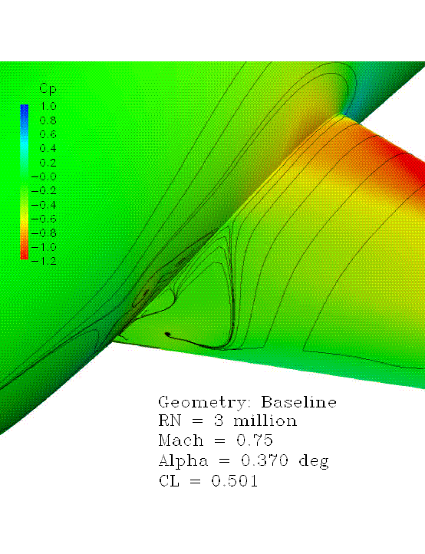  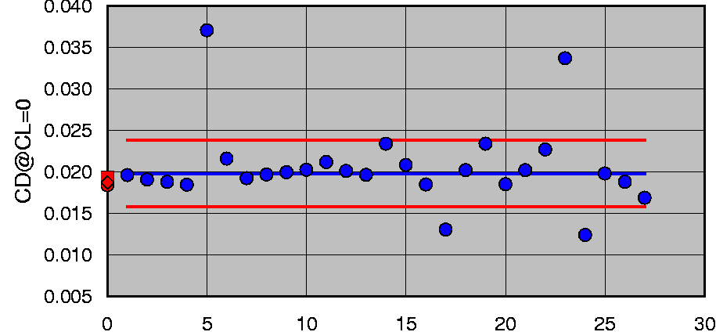  Dimitri Mavriplis  University of Wyoming  Rich Wahls, Joe Morrison  NASA Langley Research Center  Tom Zickuhr, David Levy  Cessna Aircraft Company | Dates:  Release Geometry/Test Cases: 2Q, 2008  Release Standard Grids: 3Q, 2008  Abstracts Due: 1Q, 2009  Data Submittal: 2Q, 2009  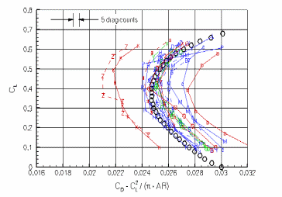  Workshop registration will be handled through normal AIAA procedures

For more information and results from past workshops, visit the DPW website at:

http://aaac.larc.nasa.gov/tsab/cfdlarc/aiaa-dpw
or send email to: dpw@cessna.textron.com

