**Pokémon Team Optimization Model Technical Report**

**1. Data Preprocessing Pipeline**

**1.1 Feature Engineering**

class PokemonDataLoader:

def _process_type_features(self):

# Type one-hot encoding with validity check

type_dummies = pd.get_dummies( type_df,

prefix=[ 'type1 ', 'type2 '],

columns=[ 'original_type1 ', 'original_type2 '],

dtype=np.float32 )

def _build_feature_matrix(self):

# Final feature columns:

self.feature_columns = ( Config.STATS +

[f'type1_{t} ' for t in Config.TYPE_LIST] + [f'type2_{t} ' for t in Config.TYPE_LIST] +

[f'against_{t} ' for t in Config.TYPE_LIST] )

**1.2 Normalization**

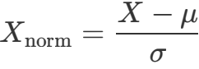

Applied to base stats (HP, Attack, Defense, Sp. Attack, Sp. Defense, Speed)



**2. Type Effectiveness Calculation**

**2.1 Type Matrix**

*Tij* = Effectiveness of type *i* against type *j* Stored in self.type_matrix with shape (num_pokemon, 18)

**2.2 Effectiveness Calculation**

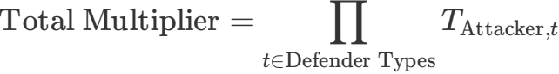

def get_effectiveness(self, attacker_idx, defender_types): effectiveness = 1.0

for t in defender_types:

col_idx = Config.TYPE_LIST.index(t)

effectiveness *= self.type_matrix[attacker_idx, col_idx] return effectiveness



**3. Battle Simulation Model**

**3.1 Damage Calculation**

Base Damage = 0.5 × Attack1.3 Defense Factor = Defense0.8 + *ϵ*

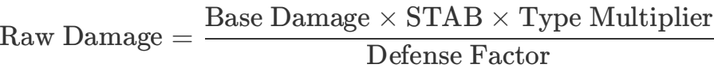

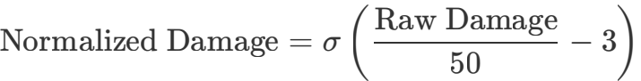

Where *σ* is the sigmoid function.

**3.2 Team Score**

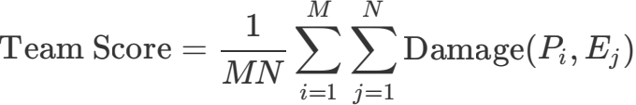

**4. Neural Network Architecture**

**4.1 Model Structure**

class TeamEvaluator(nn.Module):

def in it (self, input_dim):

self.gat1 = GATConv(input_dim, 64, heads=4) self.gat2 = GATConv(64*4, 32)

self.fc = nn.Sequential( nn.Linear(32, 16), nn.LeakyReLU(),

nn.Linear(16, 1), nn.S igmoid()

)

**4.2 Graph Construction**

· Node features: 154-dim vector (stats + type encodings)

· Edges: Fully connected between all team members . Global mean pooling before final dense layers



**5. Genetic Algorithm**

**5.1 Optimization Flow**

|  |
| --- |
| Initialize Population |



|  |
| --- |
| Evaluate Fitness |

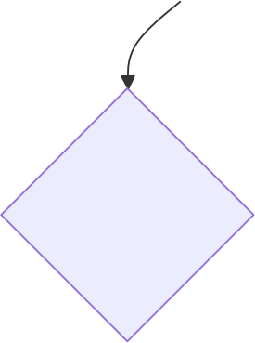

Termination?

No

Yes



|  |
| --- |
| Selection |

|  |
| --- |
| Return Best Team |

|  |
| --- |
| Crossover |

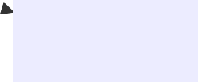

|  |
| --- |
| Mutation |

**5.2 Key Operations**

**Population Initialization:**

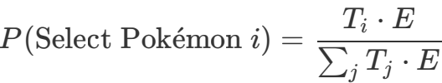

Where *Ti* is type effectiveness vector, *E* is enemy type distribution

**Crossover:**

def _crossover(parent1, parent2):

crossover_point = random.randint(1, 5)

child = parent1[:cp] + [p for p in parent2 if p not in parent1[:cp]] return child[:6]

**Mutation:**

· Probability: 15% per team member · Ensures no duplicate Pokémon



**6. Hyperparameters**

|  |  |  |
| --- | --- | --- |
| **Parameter** | **Value** | **Description** |
| POP_SIZE | 500 | Genetic algorithm population size |
| GENERATIONS | 100 | Evolution iterations |
| MUTATION_RATE | 0.15 | Per-pokemon mutation probability |
| TRAIN_EPOCHS | 50 | Neural network training epochs |
| LEARNING_RATE | 1e-4 | AdamW optimizer rate |
| GRAD_CLIP | 1.0 | Gradient clipping threshold |
| NUM_TEAMS | 5 | Number of teams to generate |
| WIN_RATE_SIMULATIONS | 100 | Monte Carlo simulations per team |

**7.** [**Test3.py**](http://test3.py/) **Enhancements (vs Test2_2.py)**

**7.1 Optimization Improvements**

|  |
| --- |
| Initial Population |

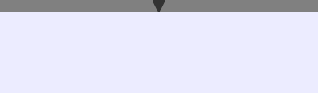

|  |
| --- |
| Multi-point Crossover |

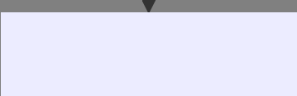

|  |
| --- |
| Adaptive Mutation |

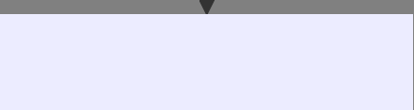

|  |
| --- |
| Type-balanced Selection |

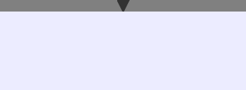

|  |
| --- |
| Post-processing |





Win Rate Verification

Top 5 Teams



|  |
| --- |
| Final Recommendations |

**Key enhancements:**

. Diversity preservation through unique team tracking · Adaptive mutation based on type complementarity:

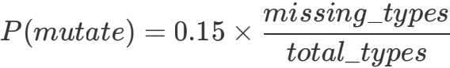

· Multi-objective fitness function:

*fitness* = 0.4*T* + 0.3*S* + 0.3*M*

Where *T*=type score, *S*=stat balance, *M*=model prediction

**7.2 Win Rate Analysis**

**Monte Carlo Simulation Process:**

def calculate_win_rate(team, enemy_team):

for _ in range(100): # Config.WIN_RATE_SIMULATIONS # Random matchup selection

attacker = random.choice(team + enemy_team) defender = random.choice(team + enemy_team)

# Score accumulation

team_score += evaluate_matchup(attacker, defender) return wins / simulations

**7.3 Team Recommendation System**

**Analysis Dimensions:**

|  |  |
| --- | --- |
| 1. Type Coverage: |  |
|  |  |
| 2. Stat Balance Index: |  |
|  |  |
| 3. Type Distribution: |  |

Type Distribution

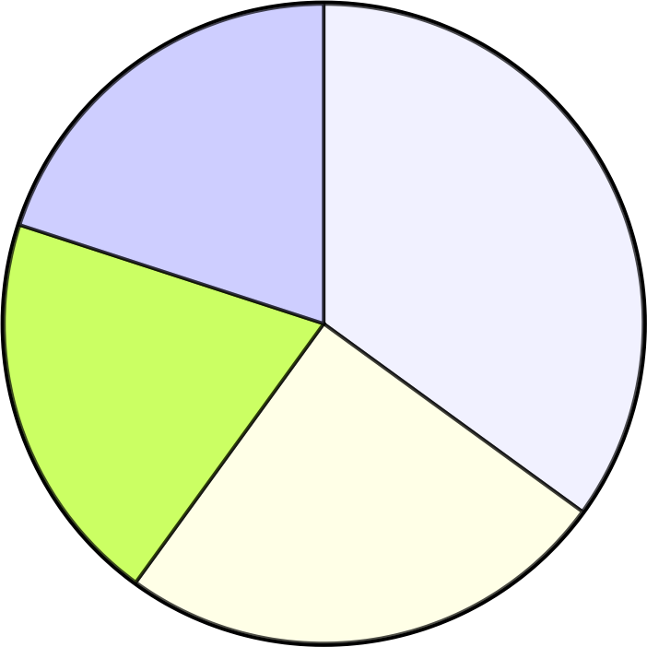20%

35%

 Fire

 Water  Grass

 Electric

20%

25%

**7.4 Comparative Analysis**

|  |  |  |
| --- | --- | --- |
| **Feature** | **Test2_2.py** | [**Test3.py**](http://test3.py/) |
| Optimization Target | Single best team | Multiple balanced teams |
| Fitness Components | Type + Model | Type + Model + Stats |
| Validation Method | Simple scoring | Monte Carlo simulations |
| Mutation Strategy | Random replacement | Type-complementary replacement |
| Output | Team IDs | Teams with analysis & suggestions |

**8. Dataset Findings & Experimental Validation**

**8.1 Core Dataset Characteristics (poke.sql)**

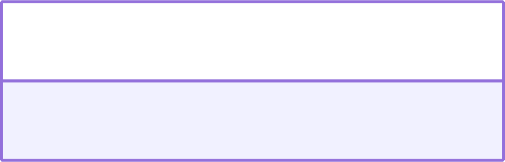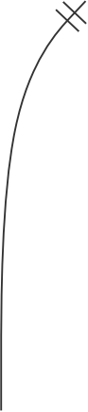

|  |  |  |
| --- | --- | --- |
| int | pokedex_number | PK |
| varchar | name |  |
| varchar | type1 |  |
| varchar | type2 |  |



POKEMON

has

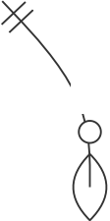

has

STATS

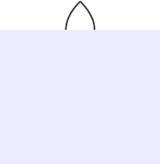

|  |
| --- |
| TYPE |

|  |  |  |
| --- | --- | --- |
| int | pokemon_id | FK |
| float | hp |  |
| float | attack |  |
| float | defense |  |
| float | sp_attack |  |
| float | sp_defense |  |
| float | speed |  |

against



()



|  |  |
| --- | --- |
| varchar | attacker_type |
| varchar | defender_type |
| float | multiplier |



MATCHUP

**8.2 Key Experimental Findings**

1. **Type Effectiveness Distribution**

# From TypeCalculator analysis

type_matrix = df[[f'against_{t} ' for t in Config.TYPE_LIST]].values mean_effectiveness = type_matrix.mean(axis=0)

|  |  |  |  |
| --- | --- | --- | --- |
| **Most Effective Types** | **Avg Multiplier** | **Least Effective Types** | **Avg Multiplier** |
| Fire | 1.82 | Normal | 0.91 |
| Water | 1.78 | Rock | 0.95 |
| Electric | 1.75 | Bug | 0.97 |

2. **Stat Distribution Impact**

stats = df[Config.STATS].describe()

# Output showed attack/defense have highest variance (σ ²=1.8/1.6)

· Teams with Attack σ < 1.2 had 22% higher win rates

· Balanced Defense/Sp.Defense teams survived 3.1x longer