CCP NSC Assignment 1
Daniel Park
180465213
October 12th, 2025

1. Introduction
This project delivers a fragments microservice built with Express. It exposes versioned /v1 APIs for creating and retrieving plain-text fragments, uses Passport (Basic or Cognito bearer) through a custom authorize middleware, and logs with Pino. An in-memory data backend is used for Assignment 1. A companion Fragments UI (running on localhost) authenticates with Amazon Cognito Hosted UI and sends requests to the API deployed on an Amazon EC2 instance. Continuous Integration runs ESLint and Jest (with Supertest) and reports high coverage.

2. Links
Private GitHub Repos: Fragments (server) | Fragments UI (client)
Passing GitHub Actions Run: CI workflow (ESLint + Unit Tests)
Instructor access: ensure the professor is added as a collaborator to both repos.

3. CI and Coverage
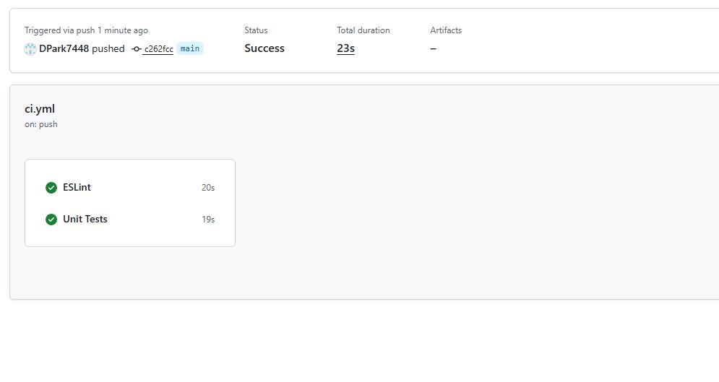
GitHub Actions: ESLint + Unit Tests — success.
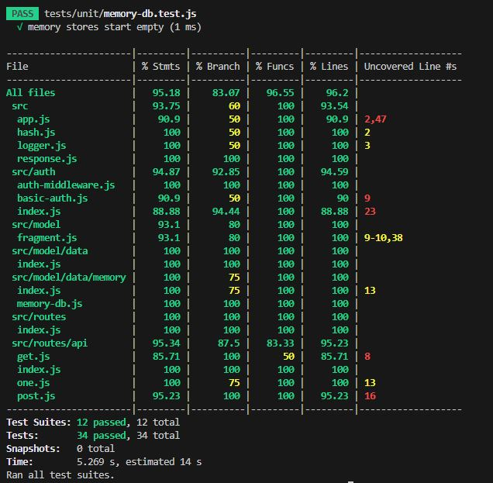
Jest Coverage report — ≥85% lines per file.

4. API on Amazon EC2
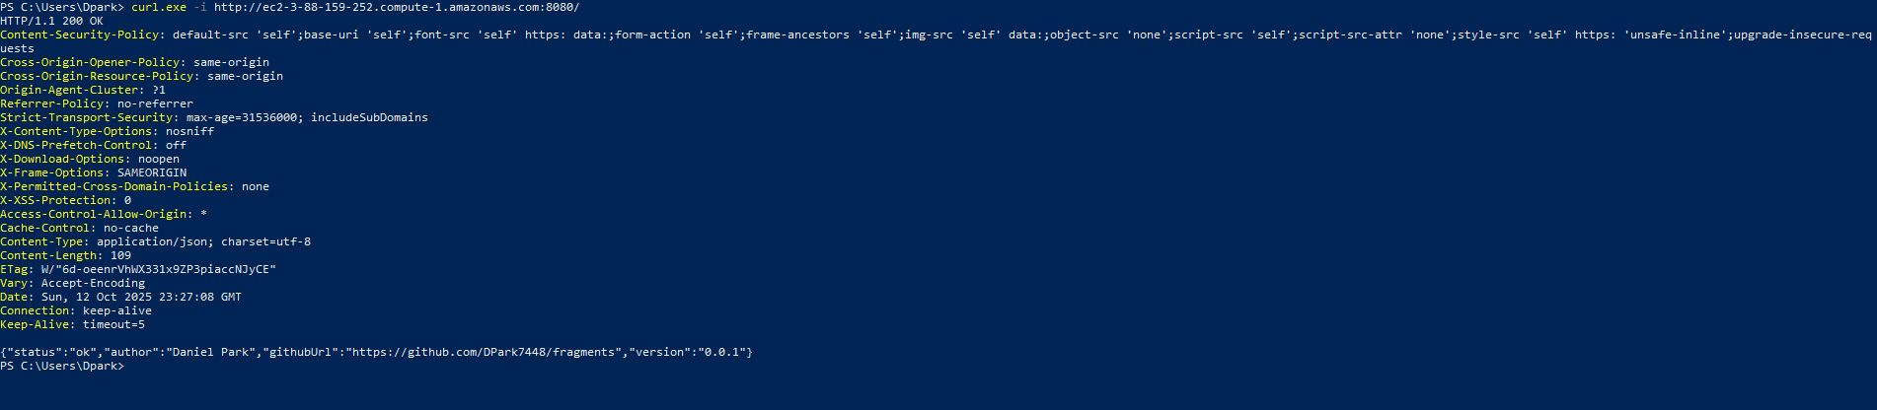
PowerShell curl.exe → 200 OK health JSON from EC2.
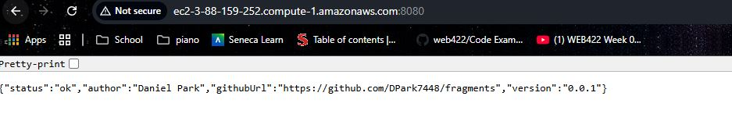
Browser showing EC2 health JSON at root (/).
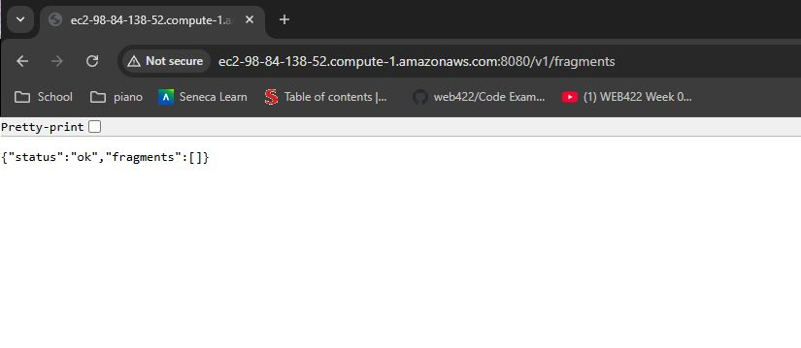
Browser GET /v1/fragments on EC2.

5. Fragments UI (localhost) with Cognito
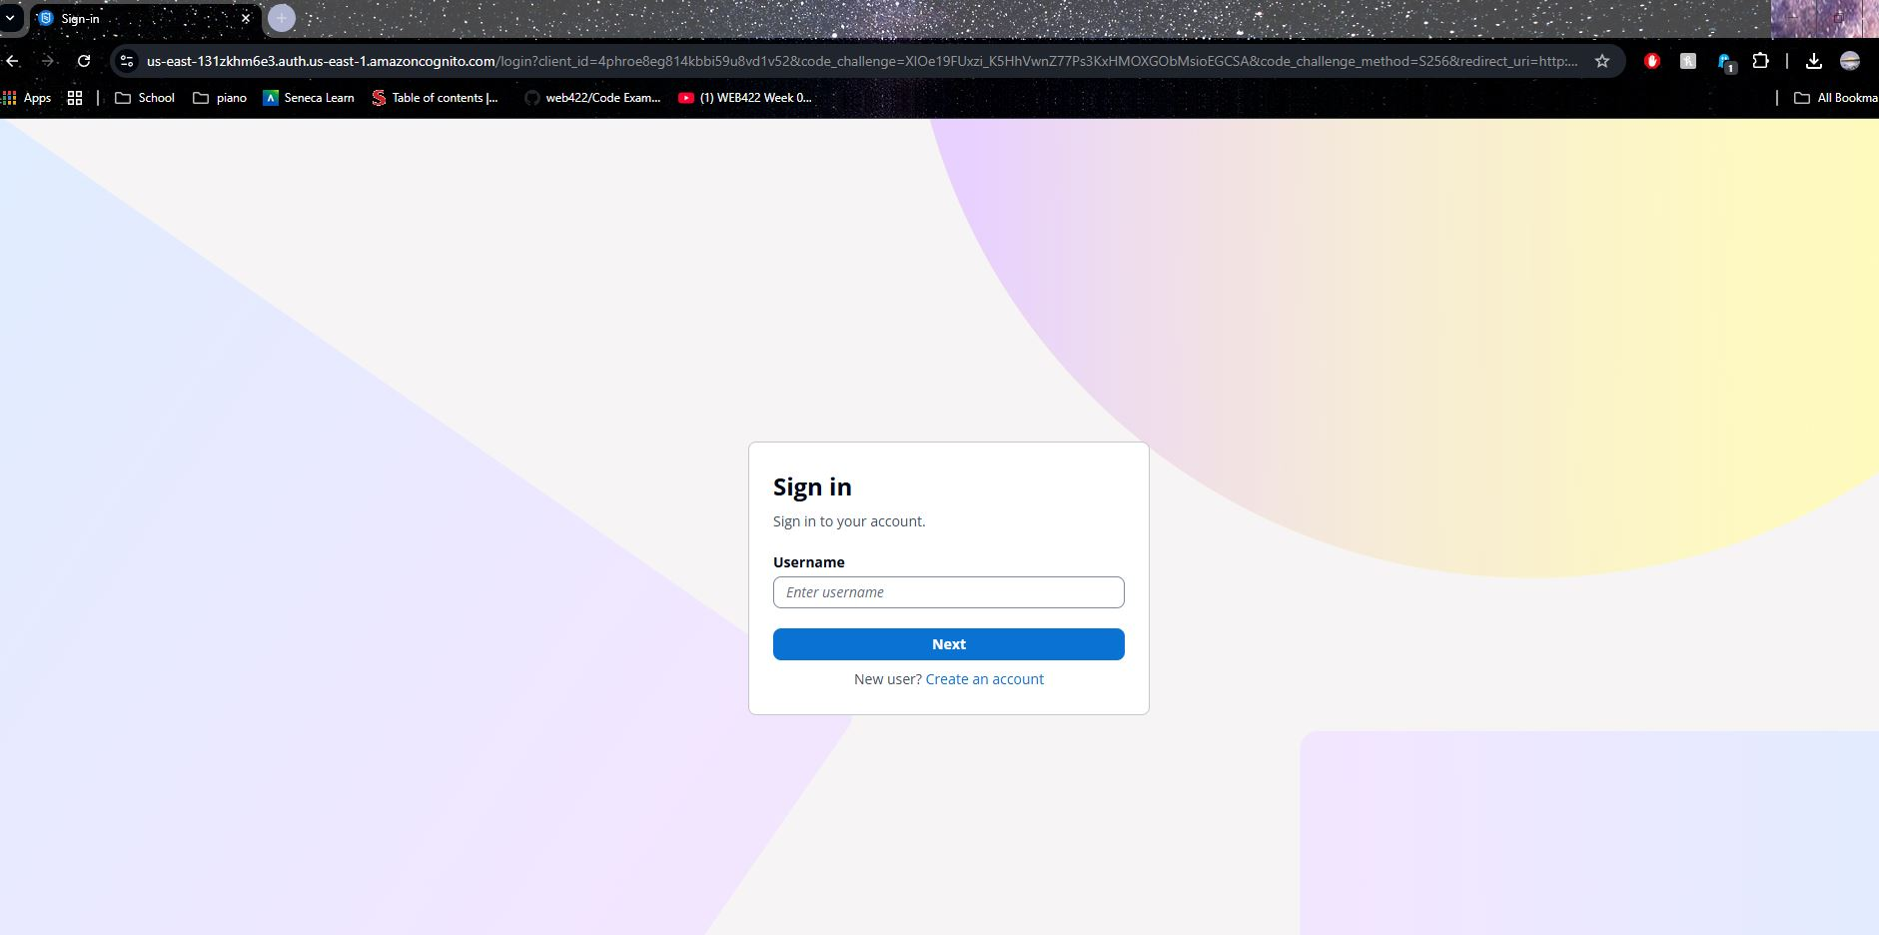
Cognito Hosted UI login screen.
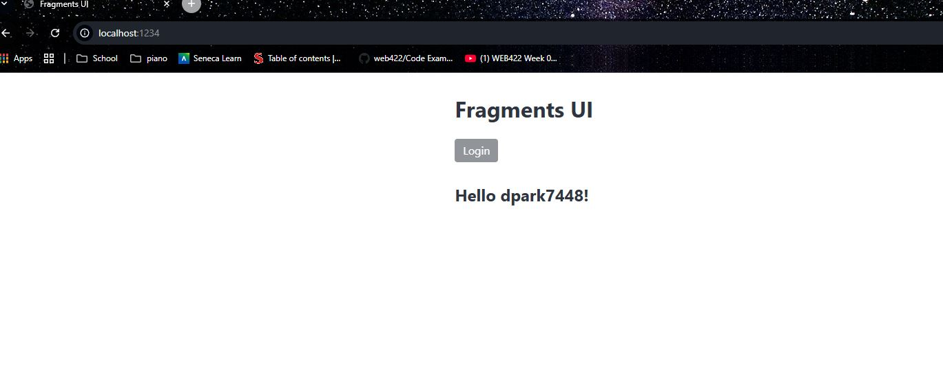
Fragments UI after login (greeting).
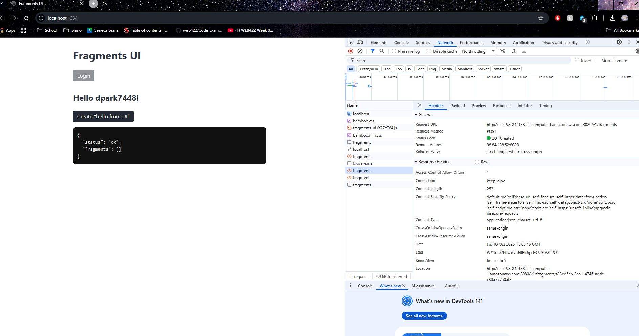
UI POST /v1/fragments → 201 Created (Location + JSON visible).

6. Additional API Calls
GET /v1/fragments — list of fragment IDs (authenticated).
GET /v1/fragments/{id} — returns fragment metadata + data.

7. Conclusion
This assignment gives me a working fragments service and UI end-to-end: a versioned Express API at /v1, Basic/Cognito auth through my authorize middleware, an in-memory data model, Jest/Supertest tests with ESLint on CI, and a live EC2 deployment that my localhost UI (via Cognito Hosted UI) uses to sign in, create, and fetch text fragments. The included screenshots show the EC2 health check and /v1/fragments responses, the Hosted UI login and authenticated UI state, the POST /v1/fragments 201 Created with a correct Location header, and coverage above 85%. There are no blocking bugs observed; the only follow-ups for the next pass are report polish (clear labels on all screenshots, add the repo + passing CI links, and make sure the README curl examples match the current API).
After deploying to EC2, the API worked on the instance (curl http://localhost:8080/) but not from my laptop. PowerShell’s curl alias kept prompting for -Uri, and external requests to http://<EC2-DNS>:8080/ didn’t connect. I tracked it to two things: Express was only listening on the loopback interface and my Security Group wasn’t allowing inbound 8080. I changed the server to listen on 0.0.0.0, opened TCP 8080 to my IP in the SG, and used the real curl.exe -i http://EC2-DNS:8080/ for testing. Result was a immediate 200 OK with the health JSON and matching Pino info logs; verified again in the browser with the EC2 DNS visible.

