**BUG: Invalid counting down if the timer is set between 1000 and 10000**

*Tested on browser: Google Chrome Version 108.0.5359.125 (Official Build) (64-bit)*

*Tested on browser: Firefox 108.0.1 (64-bit)*

*Expected behavior:* According to the documentation (Help and Settings page), the expected behavior is that time can be set directly in the URL and if there is no unit set, then seconds are by default.

*Current behavior:* During calling URL: https://e.ggtimer.com/1000 where time is set to 1000, the system starts to count down "11 hours 58 minutes 3 seconds" (43,083 seconds) instead of 1000 seconds (16 minutes 40 seconds).

Notification: Same behavior can be reproduced for any number between 1000 and 9999.

For any number, less than 1000 or bigger than 9999 system works as expected.

**Steps for reproduction:**

1. Go to the URL: https://e.ggtimer.com/1000
2. Click enter

*Screenshots:*

Calling the URL: <https://e.ggtimer.com/999>

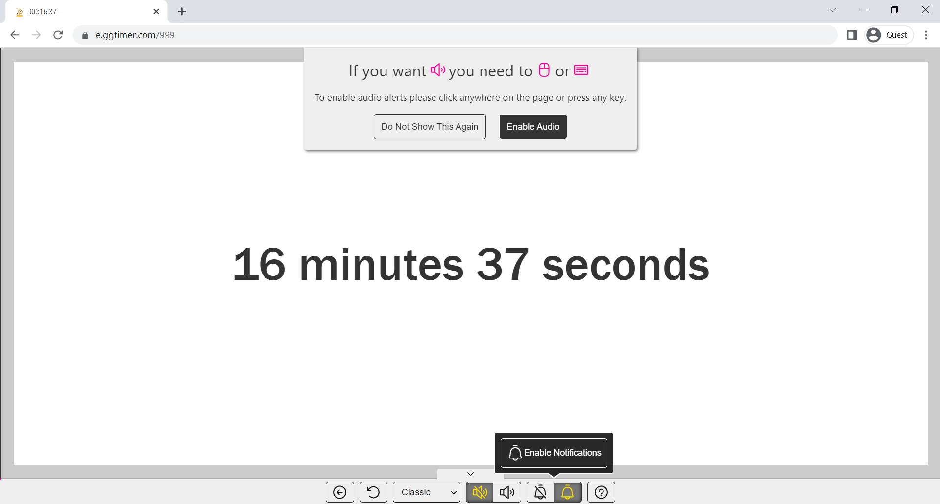

Calling the URL: <https://e.ggtimer.com/1000>

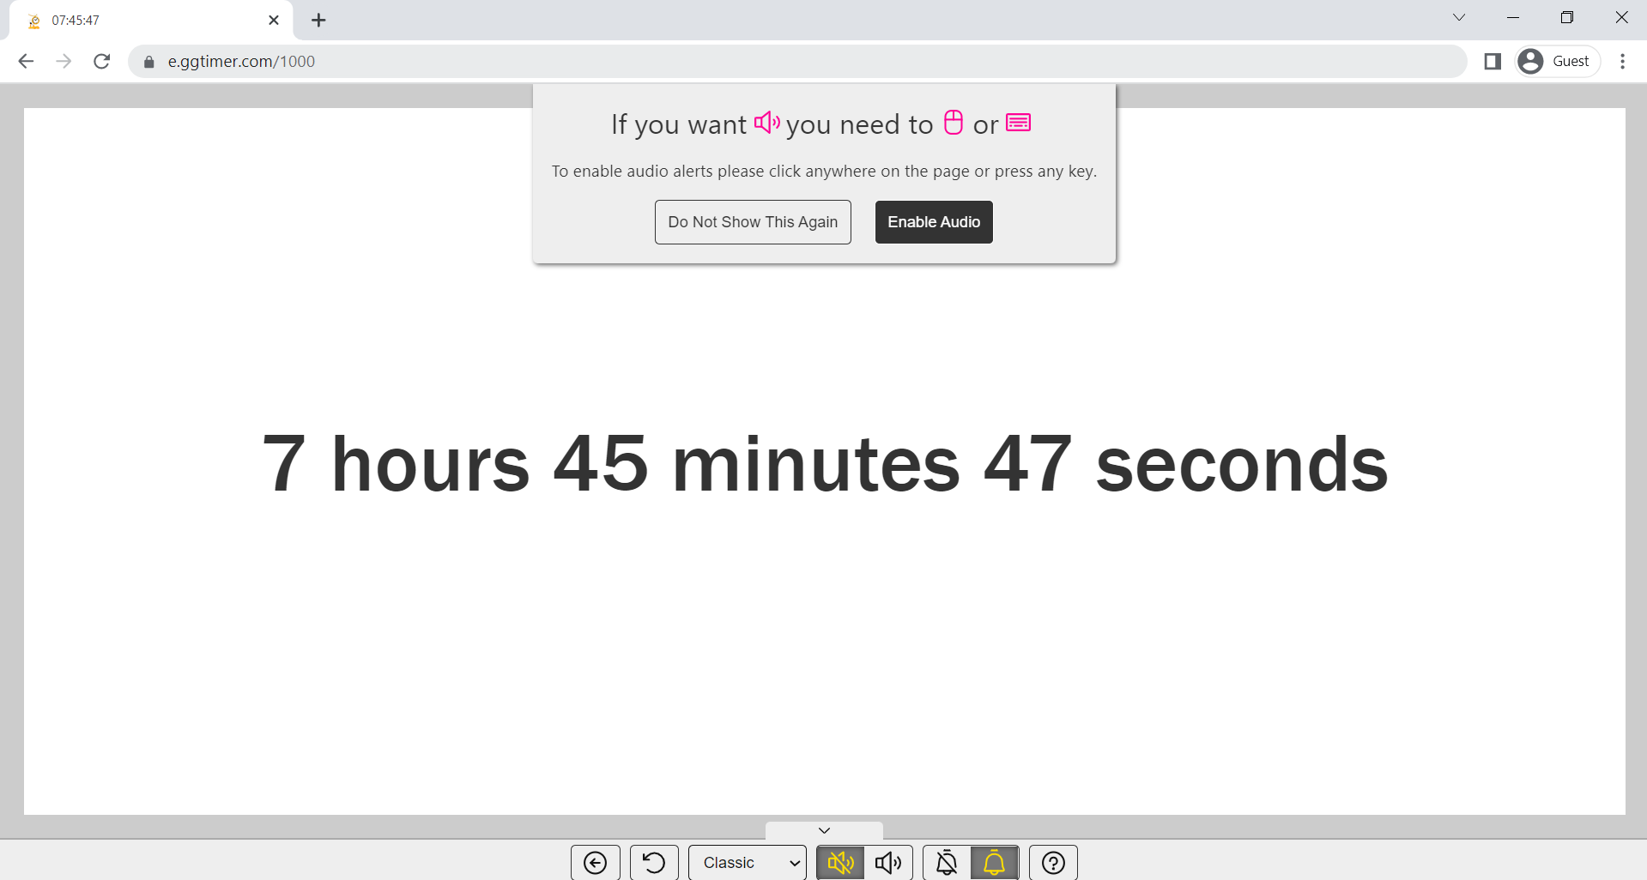

Calling the URL: <https://e.ggtimer.com/9999>

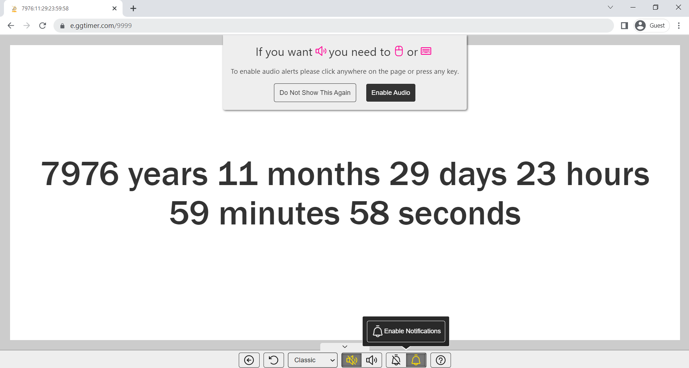

Calling the URL: <https://e.ggtimer.com/10000>

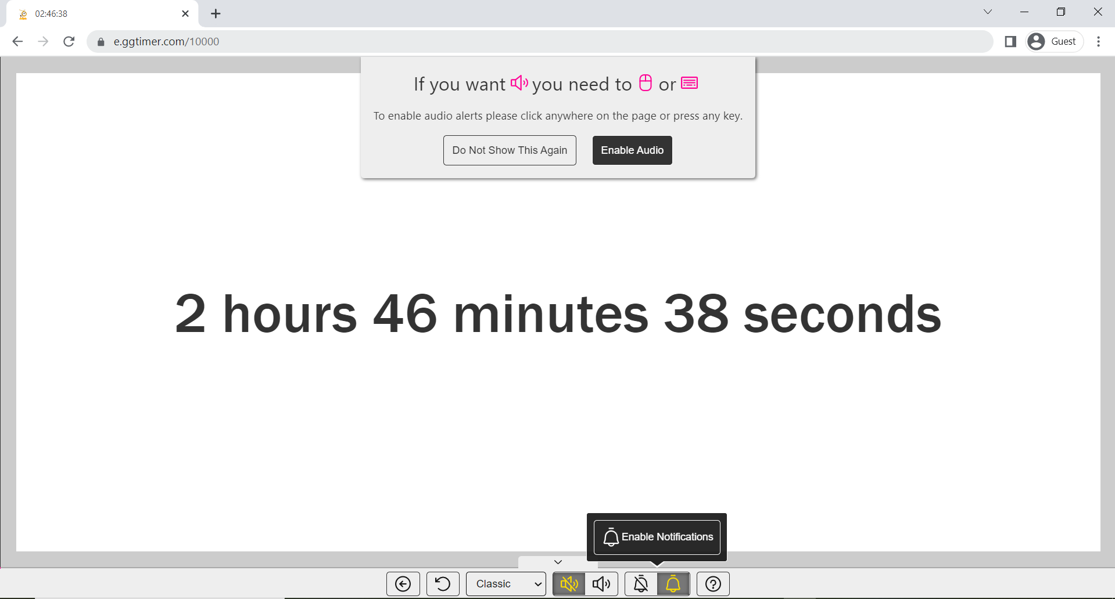

**BUG: The tooltip stays when the modal disappears**

*Tested on browser: Google Chrome Version 108.0.5359.125 (Official Build) (64-bit)*

*Tested on browser: Mozilla Firefox 108.0.1 (64-bit)*

When the countdown page is opened there is a modal that appears with information on how to enable sound. On the modal, there are 2 buttons. On the button "Do Not Show This Again" there is a tooltip when the mouse is hovering button.

*Expected behavior:* When the modal disappears, the tooltip disappears also.

*Current behavior:* Modal disappears after 13 seconds but if the mouse stays on the hovered button "Do Not Show This Again" during the disappearing modal, the tooltip stays on the page even if the modal disappears.

*Notification: This issue cannot be reproduced on the Firefox browser.*

**Steps for reproduce:**

1. go to the URL: https://e.ggtimer.com/
2. Set some time bigger than 13 seconds in the URL e.g.: https://e.ggtimer.com/15
3. When the modal appears, hover the button "Do Not Show This Again" and the tooltip should appear
4. Wait for the modal to disappear while still hovering over the button
5. When the modal disappears, the tooltip stays on the page.

*Screenshots:*

During the visibility of modal

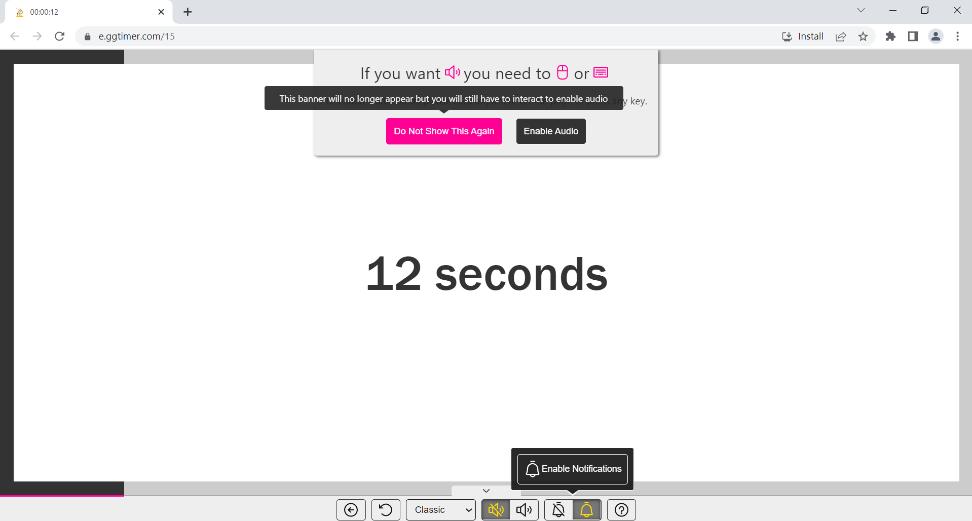

When modal disappears

