Analysis

- Description of the problem being solved

The problem I have chosen is to improve the current policing finance spreadsheet system to make it more secure and easier to do calculations, sort, search and read.

I have chosen this because for a possible future career I would like to do cyber security or join the police/army. My dad and sister are also part of the police so it is ideal to do a policing type project as they know exactly what is required of a system for their type of finances.

Cyber security is a major part of modern life as almost all information about our daily lives is online. So instead of just having a database full of tables of financial records that the user can load, sort, search and save, I wanted to create a secure login with passwords and security questions like a police database would. When interviewing for this project an issue with the current system that raised as quite a major improvement was that they would like to see a timeout function that automatically saves and logs the user out after 10 minutes or so. This is because if they leave to go to the toilet or take a phone call then they have to log themselves out to prevent others going through the data.

- End-user

Stephen Pereira Finance Director

- Researched product

Current system has the ability to:
- Load data – from spreadsheets all saved under different names
- Save data – to update individual months
- Sort data – by units or compare months for different units
- Do calculations entered – they manually enter calculations or have to write them down or use another system to do them

My system:
- Load data – from a database so all tables in the same place so they won’t be lost or duplicated
- Save data – to update individual months (saved in the database)
- Sort data – by units or compare months for different units
- Do calculations quickly – instead of having to manually enter calculations they will be performed by a click of a button for efficiency and to use less time

- Researched relevant websites and books (if appropriate for your project)

“A can help keep your finances organized while controlling the amount of debt you might require to live the way you want. Budgets help you plan for your monthly expenses, activities, needs, and even your financial future … a person benefits from using a spreadsheet for their finances because it places all the information in one easy-to-read place. This helps you to see how much income you have, as well as how your money is spent, which allows you to budget your money appropriately for your needs” (https://www.thebalance.com/free-budget-spreadsheet-sources-1294285)

From this website it gave a good explanation that my spreadsheet needs to be easily readable, with every month clearly shown for each category to be organised and to show where expenses are too high and where you have extra/spare money which could be used in another area to make up for the deficit to prevent negatives per month.
Most finance spreadsheet templates have categories in columns and months in rows to easily pinpoint areas like reading from a graph as it won’t be hard to read.

- Discussion with end-user

In the interview the main point that came up is a timeout function which automatically saves and signs the user out after 10 minutes. This is because the data they are storing is sensitive and should not be seen by anyone other than himself and his boss. The current system they have to log themselves out every time the go to the toilet or take a phone call.

They also said that they like how the data is presented at the moment so they would like to keep the format similar, but they would like a simple search/compare function to easily see data relevant to their current issue e.g. compare of yearly totals of Officers and Dog Unit.

Finally the last main point was that some spreadsheets are saved into different areas of their storage, so to improve this I would create a database to store all tables into the same area.

- Questionnaire with end-user

What is it used for?
Collating, recording and allocating data

What does it need to do?
Add total expenses by category. Calculate VAT

What can be improved from the current system?
Time out after 10mins

How often do you use it?
Weekly data collating, monthly reporting

How many people can access it?
Him and boss

Is the current system very easy to read?
Very easy to read

Would you benefit from the calculations being performed by a button?
Yes

Is the current system easy to search for specific data?
Yes

Is the current system easy to sort data?
Yes

What would you like to keep the same?
Layout

- Made prototype of key/critical areas

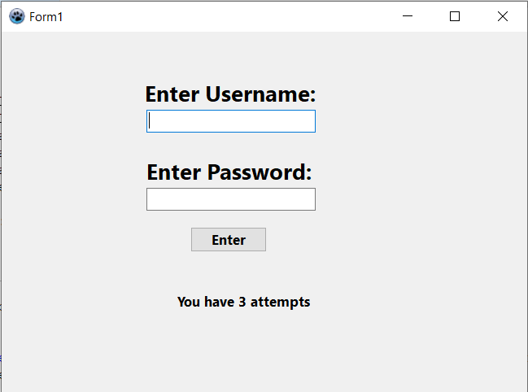
As seen in the screenshot, the user will first have to enter their login. The password will be blocked out by ‘*’ so anyone looking at their screen cannot see it. They are also told how many attempts they have before the program closes.

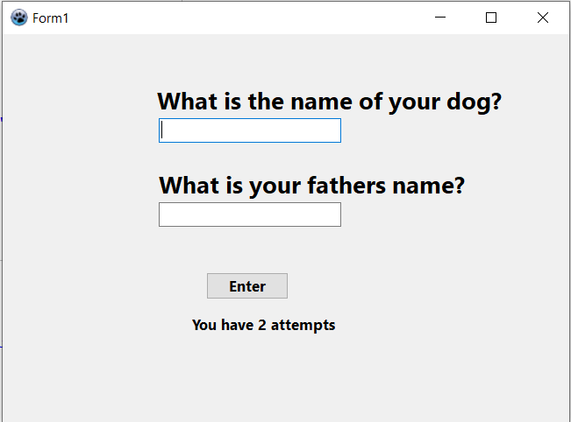
If they enter the correct username and password then they will have to answer two security questions. Again they are shown how many attempts they have.
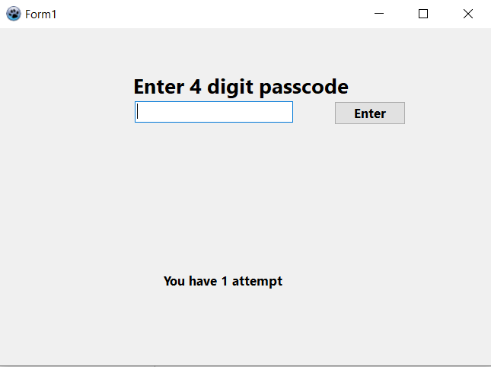
Final layer of security is the passcode, again showing attempts.

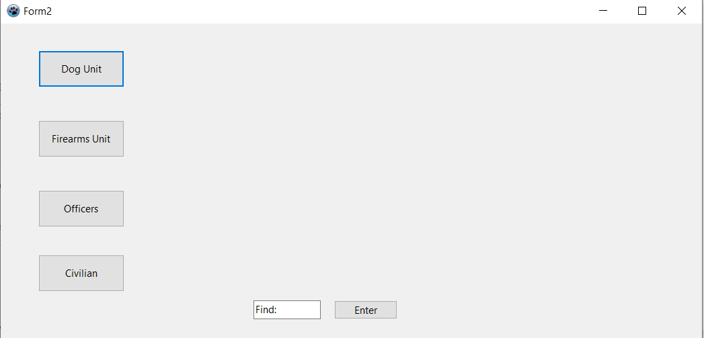
When they have entered all the correct details the second form/unit will load which gives them a menu option for what data they want to see. This also has a search option for comparing.

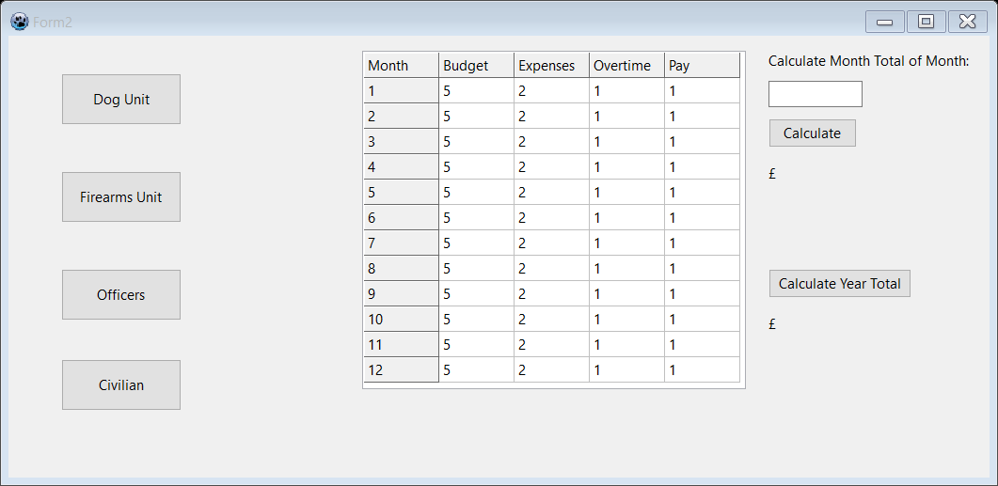
When they select the unit they want the information for that unit is shown and they can calculate a total for a single month or the whole year.

- Why the third party would understand the problem being solved

The third party has full understanding as he uses the current finance documentation system every month to fill out reports, check the data is correct and be able to find areas which they have spare/extra money to spend on other aspects of their office or other units who may have gone over budget.
This means that in my program I will need features that allow the data stored to be loaded, edited and saved. There will need to be a searching algorithm to compare budgets etc. as well as calculations to be able to show totals for the months and year as a whole.

- Formulae being used/description of database

Database → tables: Dog unit, Officers, Firearms, Civilian
Each table → months – expenses, budget, overtime, pay

Month total = Budget – (expenses + overtime + pay)
Year total = all month totals added
Month average = (all month totals added) / 12

- Objectives

  - System start
- Login unit should load
- Username entry box should load with label
- Password entry box should load with label
- Enter button should load

  - Login
- User able to enter username and password
- Password should be hidden with ‘*’ when typed
- Only given 3 attempts to enter this stage
- If correct it should load a file with security questions
- Enter two security questions
- Only have 2 attempts for security questions
- If correct load pin code
- Enter pin code
- Only 1 attempt
- If after the stated amount of attempts they are wrong then the program should close

  - Selection unit
- If all login details were correct then the selection unit should load
- 4 options should load that the user gets to select to see the information
- A search button should also be available

  - Database
- The 4 options in the selection unit should load to a database which has linked tables
- Depending on what the user selects to search in the table the database will link to another table under that selection which will give an overview
- The user can then select to load the whole data from a linked table to that table which will then show the data for every month

  - Load onto sheet
- When data selected it will be loaded onto the sheet
- They will have the option to calculate monthly totals
- They will have the option to calculate the year total
- They will have the option to search and compare specific months from different units

  - Saving
- When data is entered they can save it back and update the database
- When they want to exit the program they have the option to save their data
- When they exit they have the option to exit without saving
- When data is saved, the next time they load the program the new data is loaded from the database

  - Exit
- When they want to exit the program they have the option to save their data
- When they exit they have the option to exit without saving
- Exit closes and logs out whole program

  - Auto exit
- If the program is left for 10 minutes then the program will automatically save and logout
- When mouse is being used then timer resets

