Quick Report on Gun Murders: an edited copy of the work by Rafael Irizarry

David Pershall

11/14/2020

## Introduction

This is a quick report on 2010 gun murder rates obtained from FBI reports. The original data was obtained from [this Wikipedia page](https://en.wikipedia.org/wiki/Murder_in_the_United_States_by_state). I have added a few things to the original project by Rafael Irizarry. This is part of my learning in the “Harvardx: Professional Certificate in Data Science” mooc.

I am using the following R libraries: tidyverse, ggplot, ggrepel, ggthemes, & dplyr.

Load the wrangled data from rda/murders.rda

## Murder rate by state per 100,000 in population.

Note the large state to state variability by generating a barplot showing the gun murder rate by state:

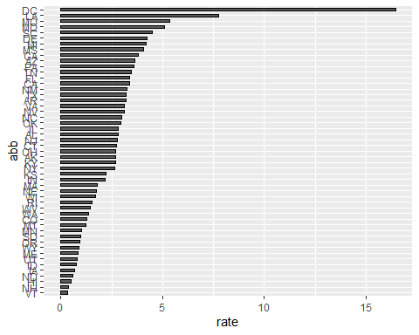

## US Gun Murders 2010 average rate per million.

I compute the average murder rate per million in population.

## [1] 30.34555

## Visualize the data

A color coordinated graph of each state compared to the average gun murder rate in log scale.

