DIEGO PORTELLA

**BomberMania**

**Diego Portella**

2024-01-18

Copyright Information

Contents

**2 Executive Summary** 2

**3 Game Description** 2

**3.1 Overview** 2

**3.2 Quest** 2

**3.3 Main Character** 3

**3.4 Sketch of Main Character** 4

**3.5 Opponents** 4

**3.6 Sketch of Opponents** 5

**3.7 Environment** 5

**3.8 Sketch of World** 6

**3.9 Menus** 6

**3.10 Controls** 7

**3.11 Sounds** 8

**4 Summary** 9

# **2 Executive Summary**

**BomberMania** is a thrilling multiplayer arcade game inspired by the classic Bomberman. Developed using C++ and SFML, the game focuses exclusively on multiplayer experiences, offering fast-paced and strategic gameplay. Players engage in explosive battles, strategically placing bombs to outwit opponents and claim victory. With a vibrant and dynamic environment, BomberMania brings nostalgia to a new level, delivering an engaging and competitive multiplayer experience.

# **3 Game Description**

## **3.1 Overview**

**BomberMania** immerses players in an exhilarating gaming environment characterized by collaborative multiplayer interactions. Situated within expansive arenas, participants engage in strategic competitions by strategically placing bombs. This gameplay concept draws inspiration from the timeless classic Bomberman yet integrates contemporary elements to enhance the multiplayer experience.

Within this virtual realm, competitors strategically place bombs to gain a competitive edge over opponents. The gameplay is distinguished by its fusion of nostalgic charm and modern multiplayer dynamics, where each strategic decision influences the match's outcome. Multiplayer interaction is not merely a feature but the central element of BomberMania, fostering intense rivalries.

**BomberMania** presents a visual design that pays tribute to the timeless aesthetic of the classic Bomberman, embracing a 2D graphical presentation. While adhering to the inherent simplicity of the retro era, the game seamlessly integrates modern visual elements, crafting a visually engaging environment that serves as a compelling backdrop for the game's dynamic gameplay.

**BomberMania** transcends the realm of a mere game, offering players an immersive journey into competitive nostalgia. The strategic bomb placements and collaborative multiplayer dynamics combine to create a unique gaming experience. Welcome to BomberMania – a convergence of past and future, where triumph is a well-placed explosion away.

## **3.2 Quest**

In **BomberMania**, the primary quest unfolds as a dynamic and strategic multiplayer experience to emerge as the last remaining bomber in each round. Players engage in a thrilling journey within the arena, strategically navigating their surroundings, overcoming obstacles, and employing clever tactics to outmaneuver opponents and claim victory.

The multiplayer quest revolves around the systematic destruction of blocks to reach adversaries, initiating a battle of wits and agility. Players must skillfully deploy bombs to strategically dismantle the obstacles obstructing their path, all while anticipating and countering opponents' moves.

The quest for supremacy unfolds in a continuous cycle of rounds, with each new match offering a fresh opportunity for players to refine their strategies and adapt to the evolving dynamics of the arena. The journey to become the last bomber standing is not only a test of skill but a progression through a strategically layered multiplayer experience, where every move and decision contributes to the ultimate goal of achieving victory in the explosive battleground of **BomberMania**.

## **3.3 Main Character**

In **BomberMania**, the main character closely resembles the iconic Bomberman – a classic, affable character recognized for its simplicity and effectiveness in gaming. Players embody this familiar figure within the multiplayer arena, a steadfast bomber ready to engage in explosive confrontations.

The main character possesses a standard set of abilities inherent to the Bomberman archetype. This includes strategically placing bombs to clear paths, destroy obstacles, and outwit opponents. The character's precise and responsive movements allow players to navigate the dynamic arena with agility and tact.

In terms of perspective, the game adopts the traditional 2D top-down view synonymous with Bomberman games. This viewpoint provides players with a comprehensive and strategic outlook on the multiplayer battlefield, enabling them to make informed decisions and execute well-timed bomb placements.

As gameplay progresses, the character's abilities evolve organically by acquiring power-ups scattered across the arena. These power-ups enhance the character's bomb range and speed and introduce additional strategic elements to the gameplay. The main character's evolution is thus intricately linked to the strategic decisions made by the player during the course of the match.

Unlike the customization approach, this representation of the main character maintains the nostalgic essence of Bomberman, ensuring that players feel connected to the classic gaming experience. The simplicity and familiarity of the main character in BomberMania harken back to the roots of the arcade classic while providing a platform for engaging and competitive multiplayer action.

## 

## **3.4 Sketch of Main Character**

## **3.5 Opponents**

In **BomberMania**, the primary opponents are embodied by rival players, each adopting the appearance of a bomber akin to the main character. The primary distinction lies in color variations to facilitate easy differentiation between Player 1 and 2. This intentional design choice ensures clarity in the chaotic and dynamic multiplayer arena.

Opponent intelligence is programmed to be controlled by the second p;ayer, reflecting the unpredictable nature of human players. While not exhibiting advanced AI behaviors, opponents showcase a level of tactical decision-making, responding to the evolving dynamics of the game.

Despite sharing a visual resemblance with the main character, opponents contribute to the competitive nature of **BomberMania** by adopting varied strategies. The color-coded distinction between Player 1 and 2 serves as a visual cue, allowing players to quickly identify and react to their opponent's movements and tactics amid explosive chaos.

## **3.6 Sketch of Opponents**

## **3.7 Environment**

**BomberMania** Multiplayer Madness unfolds within a captivating and dynamic setting, immersed in fields designed with destructible blocks that serve as the canvas for explosive gameplay. The environment eschews futuristic or fantastical elements, opting for a grounded and relatable backdrop that resonates with the aesthetics of the present day.

The game's arenas are expansive, presenting players with open fields where strategic maneuvering is essential for survival. The landscape is reminiscent of familiar outdoor spaces, such as parks or open fields, ensuring a connection to the everyday environments players encounter.

The defining feature of the environment is the presence of destructible blocks strategically scattered throughout the landscape. These blocks serve as both obstacles and opportunities for players, offering strategic cover and serving as a means to navigate the arena. The destruction of these blocks not only shapes the battlefield dynamically but also reveals power-ups that enhance the gameplay experience.

Visually, the environment adopts a clean and vibrant aesthetic. The color palette is lively, contributing to the overall energetic atmosphere of the game. The simplicity of the outdoor setting complements the fast-paced and strategic gameplay, ensuring that players can easily navigate and focus on the core multiplayer experience.

## **3.8 Sketch of World**

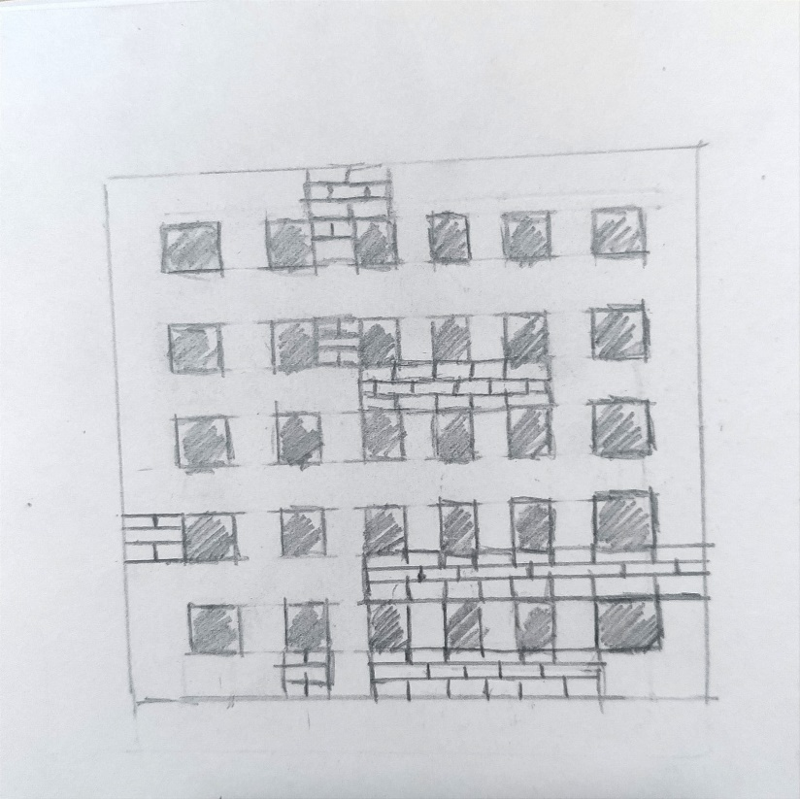

## **3.9 Menus**

Upon launching the game, players are greeted by a visually appealing and straightforward initial menu screen. The **BomberMania** logo takes center stage, exuding a sense of energy and anticipation. Surrounding the logo are menu options presented in a clean and easily readable font, ensuring accessibility for players of all levels.

* **Play:**

The "Play" option serves as the primary entry point for players eager to jump into multiplayer action. Upon selection, players are seamlessly directed to the multiplayer lobby, where they can connect with friends or engage in online matches.

* **Options:**

The "Options" menu provides players with customization settings, allowing adjustments to audio preferences, display settings, and controls. This section is designed for both novice and experienced players, ensuring a personalized gaming experience.

* **How to Play:**

The "How to Play" option offers a concise yet comprehensive guide, providing players with an overview of the game's controls, objectives, and power-ups. This section caters to both newcomers and seasoned players, ensuring everyone is on the same explosive page.

## **3.10 Controls**

**BomberMania** employs a straightforward and accessible control scheme designed to accommodate both Player 1 and Player 2, each utilizing a standard keyboard setup. The controls are intuitively mapped to ensure a seamless and enjoyable gaming experience.

* **Player 1 Controls:**

**Movement:**

W: Move Up

A: Move Left

S: Move Down

D: Move Right

**Bomb Placement:**

Spacebar: Drop Bomb

**Special Abilities:**

Numeric Keypad (1-9): Activate Special Abilities

* **Player 2 Controls:**

**Movement:**

Arrow Up: Move Up

Arrow Left: Move Left

Arrow Down: Move Down

Arrow Right: Move Right

**Bomb Placement:**

Numeric Keypad 0: Drop Bomb

**Special Abilities:**

Numeric Keypad (1-9): Activate Special Abilities

Players automatically move at a standard pace. There is no specific "Run" function.

The primary action is to strategically place bombs using the designated key (Spacebar for Player 1, Enter for Player 2). The strategic placement of bombs is the key mechanic for both offensive and defensive strategies.

The game maintains a consistent pace, with no dedicated "Fast" or "Slow" controls. The dynamics of the gameplay naturally intensify as players strategically navigate the arena, place bombs, and engage in multiplayer battles.

## **3.11 Sounds**

**BomberMania** offers a rich auditory experience, immersing players in a world where every action resonates with distinctive sounds. The carefully curated soundscape complements the gameplay, enhancing the overall atmosphere and providing audio cues essential to strategic decision-making.

* **Background Music:**

A dynamic and energetic background music track sets the tone for the multiplayer mayhem. The music adapts to the intensity of the gameplay, seamlessly transitioning between moments of anticipation and explosive action. The soundtrack is designed to be engaging, enhancing the overall gaming experience without overpowering crucial in-game sounds.

* **Footsteps:**

Each step taken by the characters produces audible footstep sounds. This subtle yet immersive detail adds a layer of realism to the gameplay, allowing players to gauge their movements and those of their opponents.

* **Bomb Placement:**

Placing a bomb emits a distinctive sound, providing players with immediate feedback on their actions. This audio cue is essential for strategic decision-making, allowing players to gauge the timing and placement of their bombs strategically.

* **Bomb Explosion:**

The detonation of bombs is accompanied by a dynamic explosion sound. The intensity of the explosion corresponds to the bomb's power level, creating a satisfying auditory feedback loop for successful strategic maneuvers.

* **Character Victory:**

When a character is defeated, a distinct sound signals the event. This audio cue not only notifies players of the outcome but also adds an emotional layer to the multiplayer experience, heightening the sense of competition.

* **Special Abilities:**

Activation of special abilities is accompanied by unique sound effects, adding a layer of distinction to each player's actions. These sounds contribute to the overall strategy, allowing players to identify and respond to the utilization of special powers by opponents.

* **Menu Interactions:**

Navigating through menus is accompanied by subtle button press sounds, providing tactile feedback to players as they navigate options and customize their gaming experience.

# **4 Summary**

**BomberMania** invites you to a riveting gaming experience where nostalgia meets innovation in explosive multiplayer battles. Immerse yourself in dynamic arenas, strategically placing bombs to outwit opponents and emerge as the last bomber standing. With a classic 2D visual style reminiscent of the iconic Bomberman, the game introduces modern twists, keeping the essence of the past while embracing the energy of the present.

Engage in thrilling multiplayer mayhem with intuitive controls, captivating background music, and a meticulously crafted soundscape that enhances every strategic move. Customize your bomber's appearance, unlock power-ups, and adapt your tactics as you progress through diverse levels filled with destructible blocks.

**BomberMania** is more than a game; it's an immersive journey where every step, bomb placement, and explosion matter. The competitive atmosphere, color-coded opponents, and vibrant environments create a gaming experience that is both accessible for all players and deeply engaging for seasoned veterans.

Join the madness, relive the nostalgia, and experience the exhilaration of becoming the ultimate bomber in **BomberMania**. Whether you're a fan of classic arcade games or seeking a modern multiplayer challenge, this is the game that will keep you hooked, bomb after bomb. Don't miss out – ignite the explosive fun now!