- RETENTION RATE
- The year-over-year cohort analysis of this dataset reveals a highly stable customer retention rate, hovering consistently near 67% across the entire dataset.
WITH ActiveCustomers AS (
SELECT DISTINCT years, customer_id
FROM Sales
),
PreviousYearTotals AS (
SELECT years, COUNT(customer_id) AS total_customers
FROM ActiveCustomers
GROUP BY years
),
RetainedCustomers AS (
SELECT
Curr.years AS current_year,
COUNT(Curr.customer_id) AS retained_count
FROM ActiveCustomers Curr
JOIN ActiveCustomers Prev
ON Curr.customer_id = Prev.customer_id
AND Curr.years = Prev.years + 1
GROUP BY Curr.years
)
SELECT
R.current_year AS Years,
P.total_customers AS Previous_Year_Customers,
R.retained_count AS Retained_Customers,
ROUND((R.retained_count * 100.0 / P.total_customers), 2) AS Retention_Rate
FROM RetainedCustomers R
JOIN PreviousYearTotals P
ON R.current_year = P.years + 1
ORDER BY R.current_year;
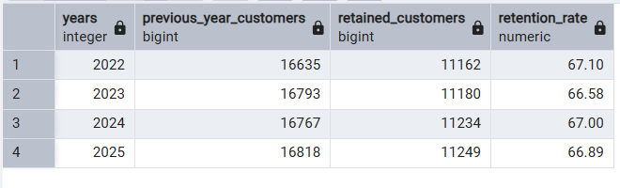
- LOST TO RETURNED & CANCELLATION:

with cte1 as (
select years, sum(net_sales) as Total_Sales
, sum(case when return_status = 1 then net_sales end) as Lost_to_returns
, sum(case when return_status = 1 then 1 end) as Order_Returned
,sum(case when cancelled = 1 then net_sales end) as Lost_to_Cancelled
,sum(case when cancelled = 1 then 1 end) as Order_Cancelled
from sales
group by years
), cte2 as (
select years, Total_Sales,Lost_to_returns,Order_Returned,Lost_to_Cancelled,Order_Cancelled, (Lost_to_returns+Lost_to_Cancelled) as Total_Loss
from cte1
)
select years, Total_Sales,Order_Returned,Lost_to_returns,Lost_to_Cancelled,Order_Cancelled, Total_Loss
,round((Total_Loss*100/Total_Sales) :: numeric, 2) as percentage
from cte2;
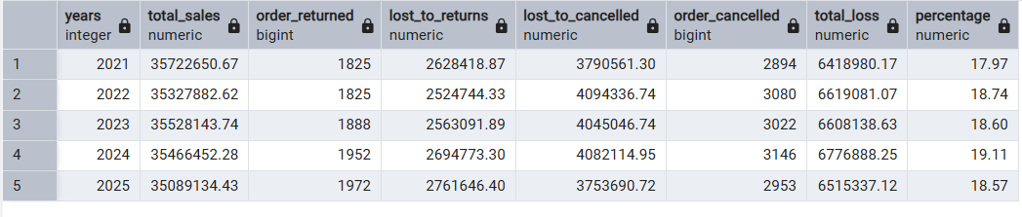

- LOST TO DISCOUNT/PROMOTION:

with cte as(
SELECT
years,
SUM(net_sales) AS total_potential_sales,
SUM(discount_amount) AS lost_to_discounts
FROM Sales
GROUP BY years
ORDER BY years
)
select years, round(lost_to_discounts :: numeric, 2) as lost_to_discounts, round(((lost_to_discounts*100)/total_potential_sales):: numeric, 2) as Revenue_loss_percentage
from cte;
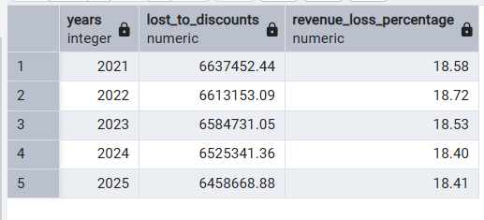
- LOST TO RETURNED(PRODUCT CATEGORY)

WITH cte AS(
SELECT
p.product_category,

-- Count the unique orders to avoid inflating order volume
COUNT(DISTINCT s.order_id) AS total_orders,

-- Count how many individual items from this category were returned
SUM(CASE WHEN s.return_status = 1 THEN 1 ELSE 0 END) AS total_returned_items,

-- Sum the specific item-level sales to avoid duplicating cart totals
SUM(o.net_sales) AS total_sales,
SUM(CASE WHEN s.return_status = 1 THEN o.net_sales ELSE 0 END) AS Lost_to_returned

FROM Product_Catalog AS p
JOIN Order_Items AS o
ON p.product_id = o.product_id
JOIN Sales AS s
ON o.order_id = s.order_id
GROUP BY p.product_category
ORDER BY total_sales DESC
)
SELECT product_category,total_orders,total_returned_items,total_sales,Lost_to_returned,
ROUND((Lost_to_returned*100/total_sales) :: numeric, 2) as percentage
FROM cte
ORDER BY percentage desc ;
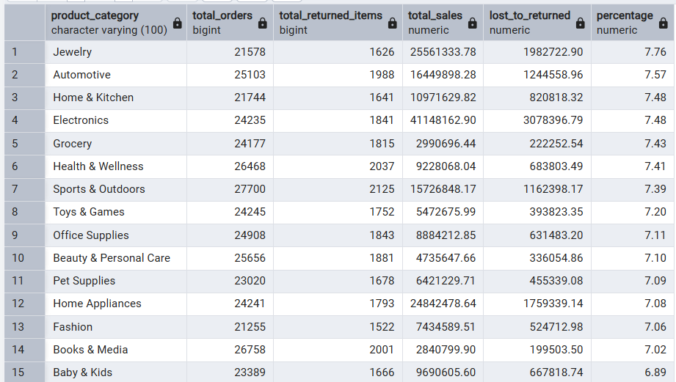

- LOST TO REVENUE(PRODUCT):
SELECT
p.product_id,
p.product_name,
p.product_category,

-- Context: How many times was this specific item purchased?
COUNT(o.order_id) AS total_qty_sold,

-- Volume: How many of those items came back?
SUM(CASE WHEN s.return_status = 1 THEN 1 ELSE 0 END) AS total_qty_returned,

-- Insight: The actual Return Rate for this specific product
ROUND((SUM(CASE WHEN s.return_status = 1 THEN 1 ELSE 0 END) * 100.0) / COUNT(o.order_id), 2) AS return_rate_pct,

-- The Financial Bleed: Exactly how much cash this product drained
ROUND(SUM(CASE WHEN s.return_status = 1 THEN o.net_sales ELSE 0 END)::numeric, 2) AS total_revenue_lost

FROM Product_Catalog AS p
JOIN Order_Items AS o
ON p.product_id = o.product_id
JOIN Sales AS s
ON o.order_id = s.order_id
GROUP BY
p.product_id,
p.product_name,
p.product_category

-- Filter: Only show products that have actually been returned
HAVING SUM(CASE WHEN s.return_status = 1 THEN 1 ELSE 0 END) > 0

-- Order: Put the biggest financial losers at the very top
ORDER BY total_revenue_lost DESC
LIMIT 20;

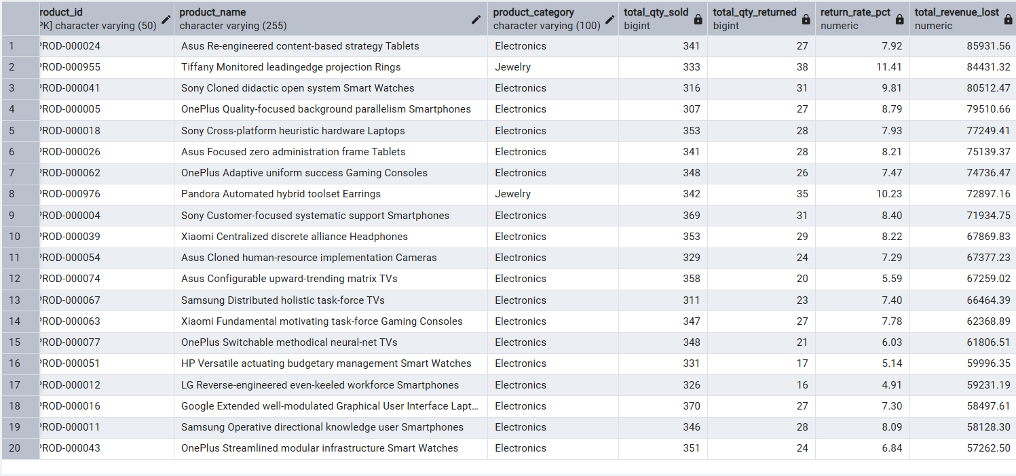

- GENERATE REVENUE BY CUSTOMER
Here is the exact math from your table proving your theory:
- Lynn Dougherty (Row 4): She kept 3 items totalling $1,312.37 in realized sales, meaning her average kept item cost $437.45. However, the 4 items she returned stripped $8,358.28 from your top line, meaning her average returned item cost $2,089.57. Her returned products were nearly 5 times more expensive than what she kept.
- Trevor Sawyer (Row 19): He kept 4 items for an average of $1,285.05 each, but the 3 items he returned averaged an astonishing $3,869.57 each.
- Kathryn Davis (Row 1): While she did keep 6 items for roughly $930 each, she returned 5 items that averaged over $2,000 apiece.

- Wardrobing: Buying high-ticket items (like a $2,000 designer jacket or expensive electronics) for a single event or weekend, and then treating the business like a free rental service by returning it on Monday.
- Bracket Buying: Because customers cannot try things on online, they buy the $3,800 item in three different sizes or colours, knowing with 100% certainty they intend to return two of them.
Actionable Suggestions for the Business
Based on this dashboard, I recommend you these following steps :
- Implement a High-Ticket Restocking Fee: Recommend an immediate policy update where any item over $1,000 incurs a 10% restocking fee. This instantly discourages "wardrobing" without penalizing everyday shoppers who return standard items.
- Create a "Serial Returner" Flag: Customers like Anthony Adams (Row 8), who ordered 4 items and returned all 4 for $0 in realized sales, are actively costing the company money in two-way shipping. Recommend a system flag that automatically removes free shipping privileges for accounts that hit a 100% return rate over a certain dollar threshold.

select c.customer_id, c.customer_name, sum(s.net_sales) as total_sales,
ROUND(SUM(CASE WHEN s.return_status = 0 THEN s.net_sales ELSE 0 END)::numeric, 2) AS realized_sales
,count(s.order_id) as totalOrders,
sum(case when s.return_status = 1 then 1 else 0 end) as total_returned,
sum(case when s.return_status = 0 then s.profit else 0 end) as profit_by_customer
from Customers as c
join Sales as s
on c.customer_id = s.customer_id
group by c.customer_id, c.customer_name
order by total_returned desc;
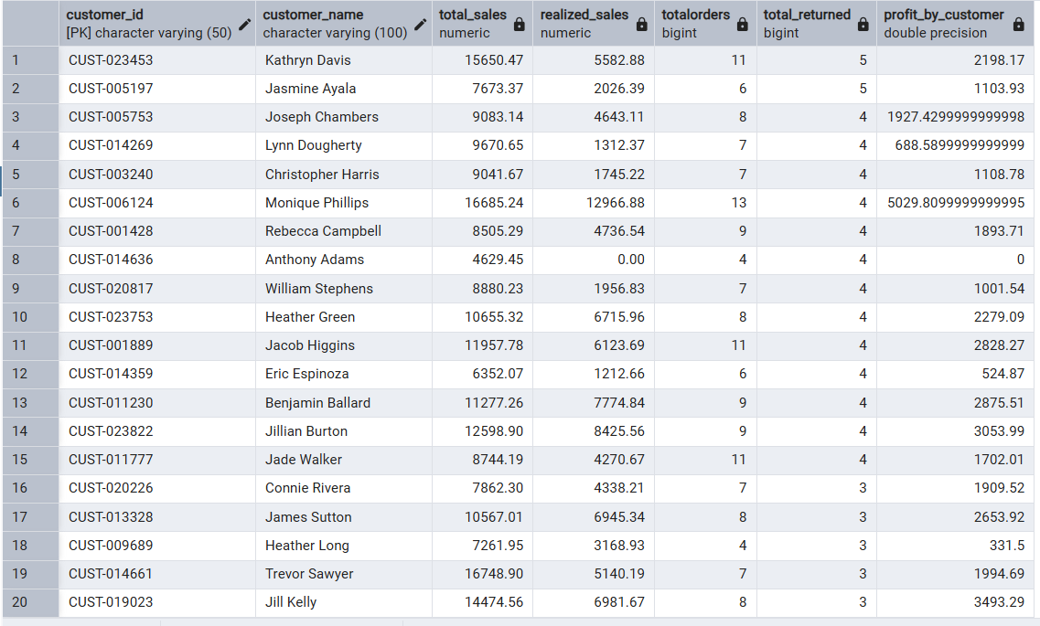

- CUSTOMER LIFETIME VALUE VS. ACQUISITION COST (LTV:CAC)
- Calculate CAC (Customer Acquisition Cost):
Formula: Total Marketing Spend / Total Customers Acquired
select round(((acquisition_cost)/cust):: numeric, 2) as spend_per_customer
from(select count(distinct customer_id) as cust, sum(customer_acquisition_cost) as acquisition_cost
from customers);
We found earlier that the average CAC is $42.16.
ACQUISITION COST- what spend by the company through marketing channels to acquire a customer. In modern e-commerce, individual Customer Acquisition Cost (CAC) is almost never calculated inside the core sales database. It is calculated upstream by an Attribution Engine (like Google Analytics, Meta Ads Manager, or tools like Triple Whale) and then injected into your PostgreSQL database when the customer profile is created.
- Calculate LTV (Lifetime Value / Realized Profit):
Average Realized Profit per Order: From our earlier analysis, the company retains roughly $526.23 in true profit on every successfully completed order. Avg realised profit per successful order.
select AVG(case when cancelled = 0 then profit end) as net_relised_profit
from sales
Average Successful Orders: After filtering out the returns and cancellations, the average customer in your database successfully completes roughly 4.5 orders in their lifetime. (Total successful order/ total customer)
select count(case when cancelled = 0 then order_id end)/count(distinct customer_id) as avg_successful_order
from sales
The Calculation: $526.23 × 4.5 = $2368.03 average LTV.
- Calculate the Ratio:
Formula: LTV / CAC
Your Data: $2368.03 / $42.16 = 56.7:1

- TOP 5 DEFFECTIVE SUPPLIER
SELECT
p.supplier,

-- Context: How many times was this specific item purchased?
COUNT(o.order_id) AS total_qty_sold,

-- Volume: How many of those items came back?
SUM(CASE WHEN s.return_status = 1 THEN 1 ELSE 0 END) AS total_qty_returned,

-- Insight: The actual Return Rate for this specific product
ROUND((SUM(CASE WHEN s.return_status = 1 THEN 1 ELSE 0 END) * 100.0) / COUNT(o.order_id), 2) AS return_rate_pct,

-- The Financial Bleed: Exactly how much cash this product drained
ROUND(SUM(CASE WHEN s.return_status = 1 THEN o.net_sales ELSE 0 END)::numeric, 2) AS total_revenue_lost

FROM Product_Catalog AS p
JOIN Order_Items AS o
ON p.product_id = o.product_id
JOIN Sales AS s
ON o.order_id = s.order_id
group by p.supplier
order by total_revenue_lost desc
limit 5;
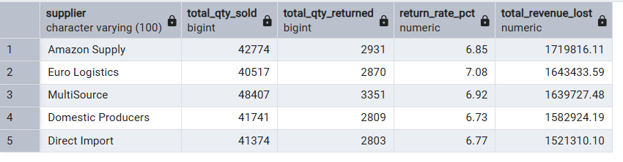

- REVENUE LOSS ANALYSIS BY GEOGRAPHYSIC REGION
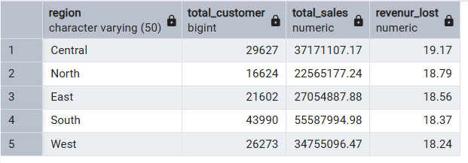
with cte as
(select c.region, s.customer_segment, s.payment_method, s.return_reason
from customers as c
join sales as s
on c.customer_id = s.customer_id
where c.region = 'Central' and return_status = 1
)
select return_reason, ROUND(
COUNT(*) * 100.0 / SUM(COUNT(*)) OVER (),
2
) AS pct_of_total_returns
from cte
group by return_reason
order by pct_of_total_returns desc
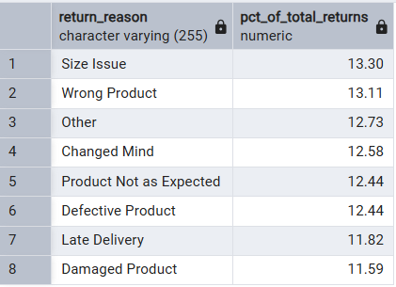

1. Size Issue (Customer Sizing Uncertainty) This is customer-side friction driven by fit anxiety and "bracket buying," where shoppers order multiple sizes with the intent of returning the ill-fitting ones.
- Implement Dynamic Sizing Tools: Integrate interactive fit calculators (e.g., asking height, weight, and fit preference) or display real customer feedback stating whether the item runs "small," "true to size," or "large."
- Standardize Measurement Specs: Upgrade product detail pages with explicit garment dimensions (chest, waist, inseam) and model specifications (e.g., "Model is 6'1" wearing size L") rather than generic S/M/L charts.
2. Wrong Product (Fulfilment & Warehouse Inaccuracy) This is a purely internal operational failure that burns two-way shipping costs and damages customer trust, as the warehouse dispatched an incorrect SKU.
- Enforce Scan-to-Pack Verification: Mandate barcode scanning at the final packing station where the system matches the physical item barcode against the order manifest before generating a shipping label.
- Audit High-Error SKUs and Bins: Identify whether specific warehouse locations or multi-pack bundles suffer from mislabelling or vendor UPC barcode mix-ups.
3. "Others" (Data Taxonomy Blind Spot) When a vague category like "Others" ranks in the top three, your return portal is suffering from survey leakage. Customers select it either because the actual reason is missing or because the return process allows lazy inputs.
- Refine Category Granularity: Expand your drop-down taxonomy to include missing common reasons such as "Found a better price," "Arrived too late," or "Item duplicate."
- Make Sub-Reasons Mandatory: Require a secondary dropdown or a brief 10-character explanation whenever a customer selects "Other" before approving the return label.

- TOP 5 WAREHOUSE WHERE HIGHER NO OF RETURN PRODUCT:
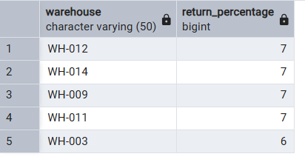
- Based on return reason like ‘Wrong Product’, ‘Defective Product’ & ‘Damaged Product’ there are other warehouses comes under the list are WH-008 & WH-010
- SOLUTION:
  - As we discussed before about the wrong product issue and solution. In this way we should
schedule a meeting of the managers of these 7 warehouses to have a deep discussion about the matter and also ask if the supplier sold them the defective product.
- WHICH TYPE OF PAYMENT METHOD HAS HEIGHEST NO OF FAILED TRANSATION.
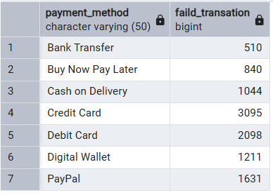

- ANALYSIS ON CUSTOMER SEGMENT:
• Enforce Minimum Spend Thresholds on VIP Discounts: Stop giving VIP and Premium shoppers automatic high-percentage discounts (~$332/order) on standard ~$1,390 carts. Require a minimum order value (e.g., "Spend $2,000 to unlock your VIP discount") so the discount forces a larger basket size that pays for itself.
• Replace Price Cuts with Low-Cost Loyalty Perks: Shift VIP and Premium rewards away from margin-destroying coupons and toward high-perceived-value perks—such as guaranteed express shipping, free extended warranties, or early access to new inventory—to bring their profit margin back up toward the 42.71% Consumer benchmark.
• Audit VIP Qualification Rules: Because VIP and Premium accounts generate less lifetime profit ($2,264.06 and $2,234.25) than standard Consumer accounts ($2,492.74), the business is assigning customers to top tiers without requiring high purchase frequency or spend volume.

SELECT
c.customer_segment,

-- 1. Your existing metrics
ROUND(
(SUM(CASE WHEN s.return_status = 1 THEN 1 ELSE 0 END) * 100.0
/ NULLIF(COUNT(CASE WHEN s.return_status = 0 AND s.delivery_status != 'Cancelled' THEN s.order_id END), 0))::numeric,
2
) AS percentage_return_order,

ROUND(
(SUM(CASE WHEN s.return_status = 0 AND s.delivery_status != 'Cancelled' THEN s.profit ELSE 0 END) * 100.0
/ NULLIF(SUM(CASE WHEN s.return_status = 0 AND s.delivery_status != 'Cancelled' THEN s.net_sales ELSE 0 END), 0))::numeric,
2
) AS percentage_gained,

-- 2. Check if VIP/Premium get bigger discounts on completed orders
ROUND(
AVG(CASE WHEN s.return_status = 0 AND s.delivery_status != 'Cancelled' THEN s.discount_amount END)::numeric,
2
) AS avg_discount_per_order,

-- 3. Actual Dollar Profit per Customer (LTV)
ROUND(
(SUM(CASE WHEN s.return_status = 0 AND s.delivery_status != 'Cancelled' THEN s.profit ELSE 0 END)
/ COUNT(DISTINCT c.customer_id))::numeric,
2
) AS realized_profit_per_customer,

-- 4. Test your hypothesis: Average price of a RETURNED order by segment
ROUND(
AVG(CASE WHEN s.return_status = 1 THEN s.net_sales END)::numeric,
2
) AS avg_returned_order_value

FROM Sales s
JOIN Customers c
ON s.customer_id = c.customer_id
GROUP BY c.customer_segment
ORDER BY percentage_gained DESC;
