1. List the HDFS contents of /user

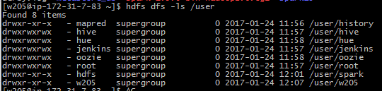

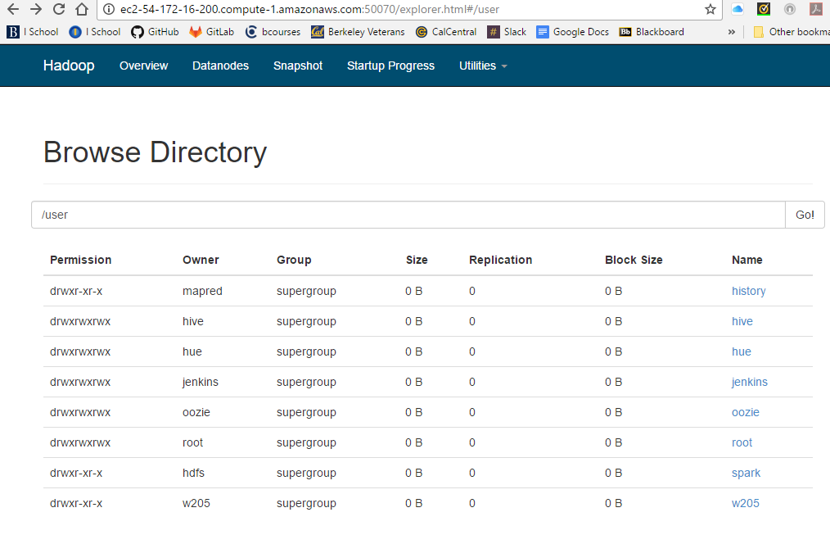

2. Inspect the output of the HDFS admin report and answer the following questions in a text file.

‐To generate this, exit from the w205 user and type: sudo ‐u hdfs hdfs dfsadmin ‐report

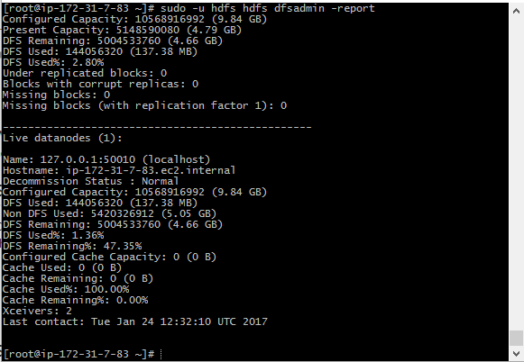

Q1: How many live datanodes are there?

**1**

Q2: How much non‐DFS storage is used?

**5.05 GB**

Q3: How much DFS storage is used?

**137.38 MB**