SafePhish🐬
“Detecting Phishing Links for Safer Browsing”
Purnima
2026

SafePhish🐬
Introduction
Nowadays, the internet is used everywhere for online shopping, banking, and social media. But along with this, cyber attacks are also increasing, especially phishing attacks. In phishing, fake links or websites are created to steal user information like passwords and bank details. Many users cannot identify whether a link is safe or not.
So, I made this project SafePhish. It helps to check whether a link is safe or phishing. It gives a score based on the link and shows the result like safe, suspicious, or phishing. This project helps users stay safe and avoid cyber fraud.

1. Problem Statement
With the rapid growth of internet usage, phishing attacks have become one of the most common cyber threats. Many users are unable to differentiate between legitimate and malicious websites, which leads to data theft, financial fraud, and privacy breaches. Attackers often create fake URLs that look similar to trusted websites, making it difficult for users to identify them.
- Lack of awareness about phishing attacks
- Difficulty in identifying fake or suspicious URLs
- Increasing cases of online fraud and data theft
- Need for a simple tool to verify website safety

2. Project Objective
The main objective of SafePhish is to provide a simple and effective solution to detect phishing links and help users stay secure online. The system analyzes URLs and provides a safety score based on phishing indicators.
- To detect whether a link is safe or phishing
- To generate a security score based on analysis
- To improve user awareness about unsafe links
- To provide quick and accurate results

3. Problem Explanation
Phishing attacks exploit human error rather than system vulnerabilities. Users often click on unknown links without verifying their authenticity. These links may redirect to fake login pages designed to steal sensitive information such as passwords, OTPs, and banking details.
This problem mainly affects:
- General internet users
- Students and beginners
- Online shoppers and banking users
If not addressed, phishing can result in identity theft, financial loss, and misuse of personal data. Therefore, an automated detection system like SafePhish is essential.

4. Proposed Solution
SafePhish is a web-based application that checks whether a given URL is safe or potentially harmful. It works by analyzing different characteristics of the URL and assigning a phishing score.
The system evaluates:
- Length of URL
- Presence of suspicious keywords or symbols
- Use of HTTPS protocol
- Domain structure and patterns
Based on these factors, the system:
- Calculates a phishing score
- Classifies the link as Safe / Suspicious / Phishing
- Provides feedback to the user

5. Project Features
SafePhish includes the following key features:
- Simple and clean user interface
- URL input field for analysis
- Real-time phishing detection
- Scoring system based on link behavior
- Result classification (Safe / Unsafe)
- Security suggestions for users
- Fast response and lightweight system

6. Technology Stack
The project is developed using modern web technologies:
- Frontend: HTML, CSS, JavaScript
- Tools: VS Code
- Platform: Web Application
- Version Control: GitHub

7. Working of the System
The SafePhish system follows a simple workflow. When a user enters a URL, the system processes it using predefined rules and algorithms.
Working steps:
- User enters a URL into the system
- The system analyzes URL structure and parameters
- Various phishing indicators are checked
- A score is generated based on risk level
- Final result is displayed with classification

8. Screenshots
The project includes screenshots to demonstrate functionality:
Code:
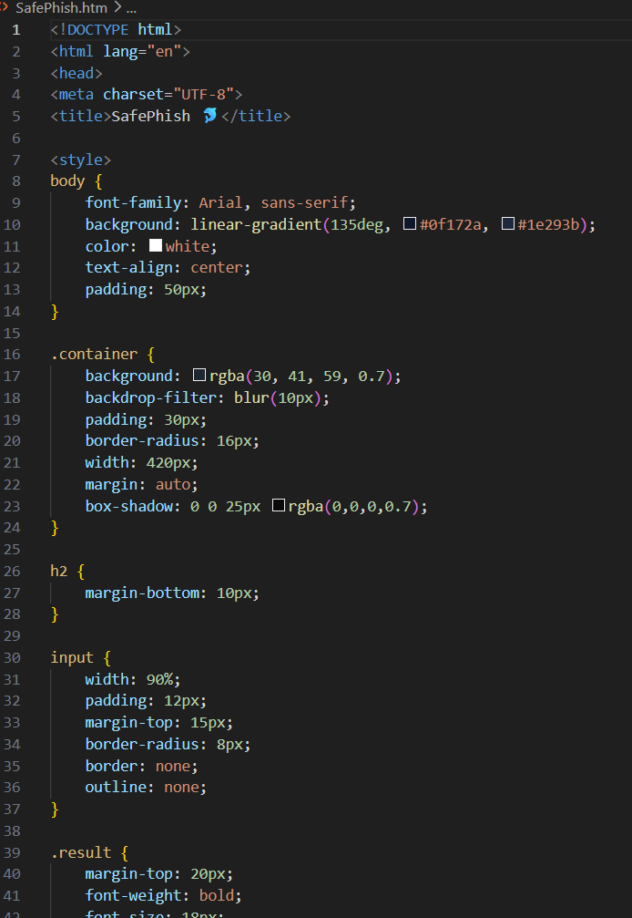
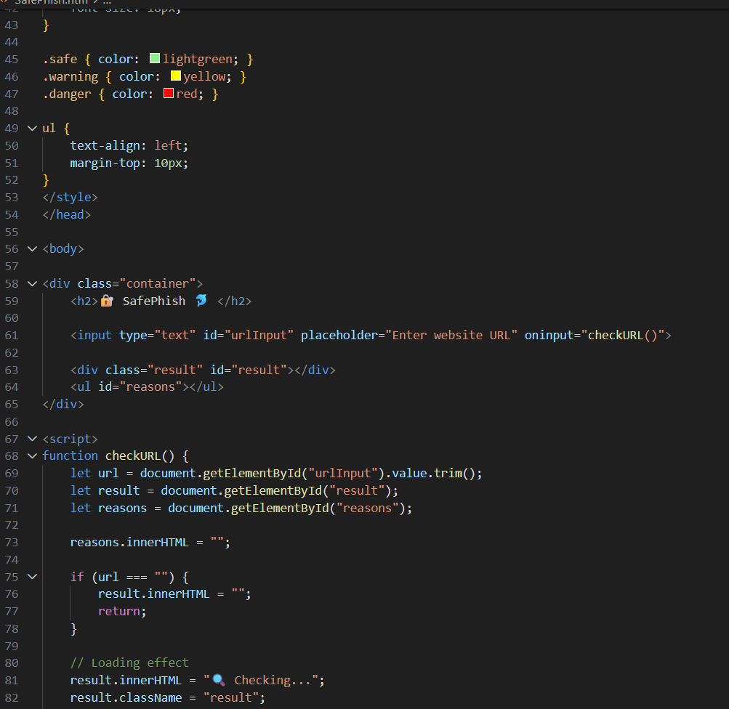
Front Page:
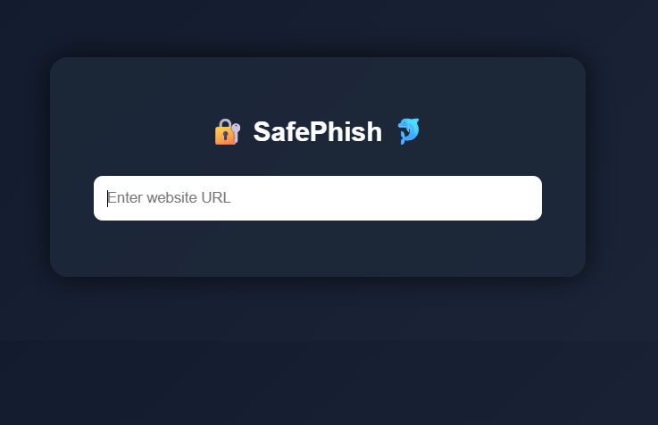
Safe URL:
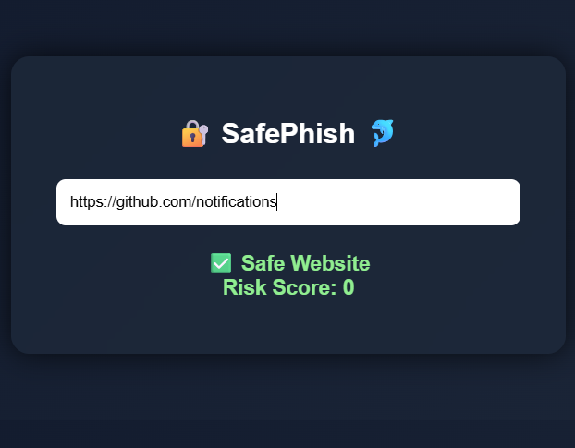

Suspicious Website (URLs):
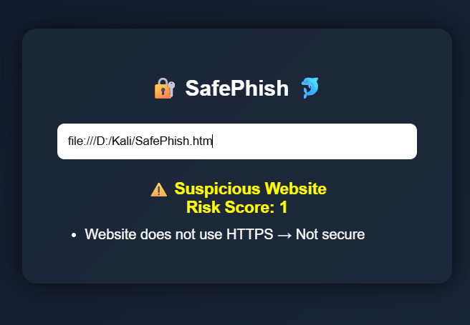
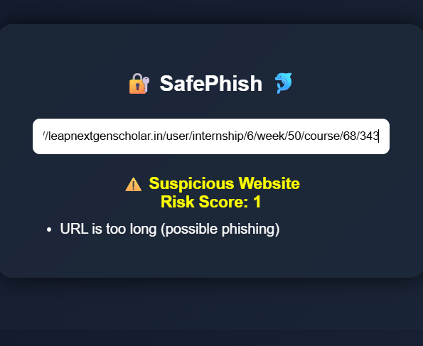

Invalid Format:
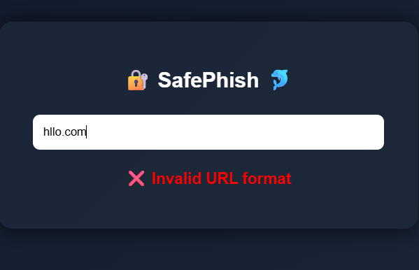

9. Open Source Code (GitHub)
The complete project is uploaded on GitHub for open access and evaluation.

10. Future Scope
SafePhish can be enhanced further with advanced features and technologies.
- Integration of Machine Learning for better accuracy
- Real-time database of phishing websites
- Browser extension for live protection
- Mobile application development
- Advanced URL scanning techniques

11. Conclusion
SafePhish is an effective tool for detecting phishing links and improving user awareness. It provides a simple interface and accurate results, making it suitable for beginners as well as general users. The project demonstrates the importance of cyber security and highlights how small tools can help prevent major cyber threats.

