Data Extraction

Data clean & process

Analytics:

1. Training?

Output:

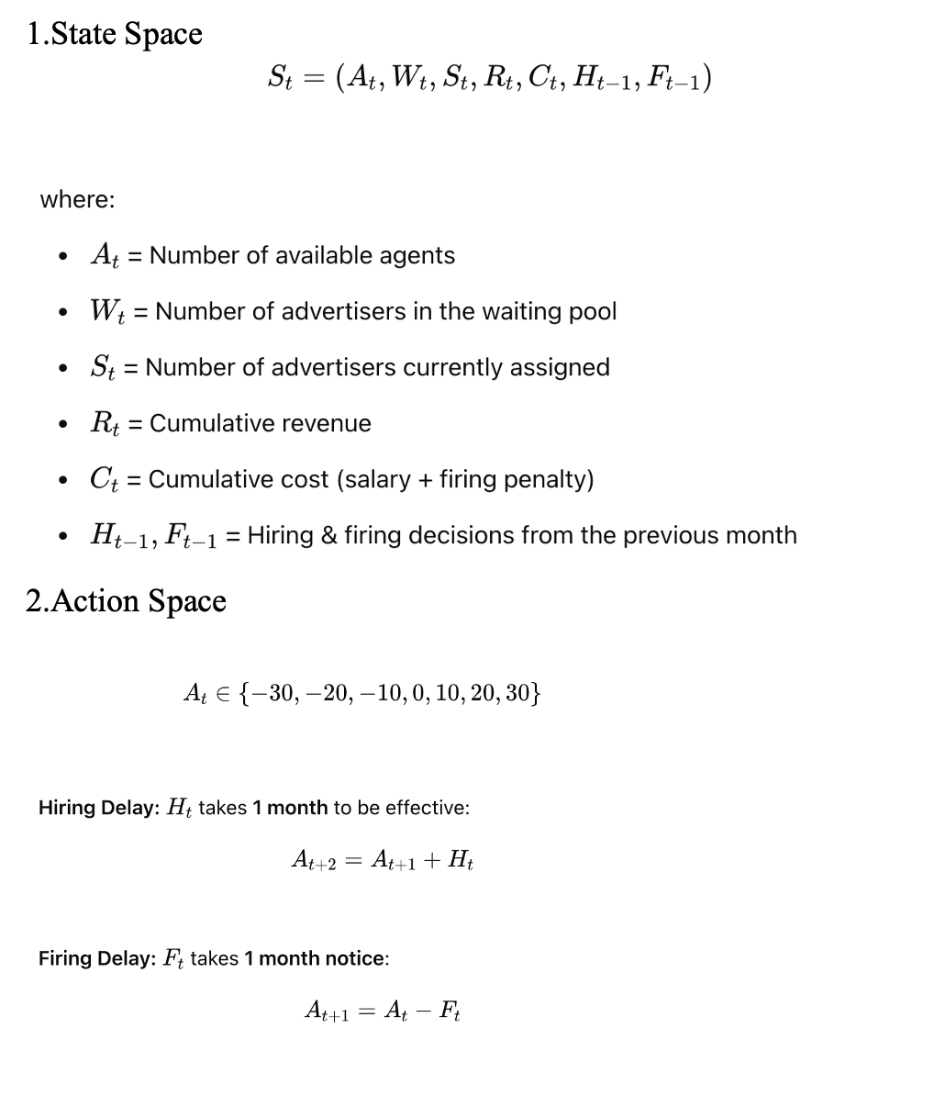

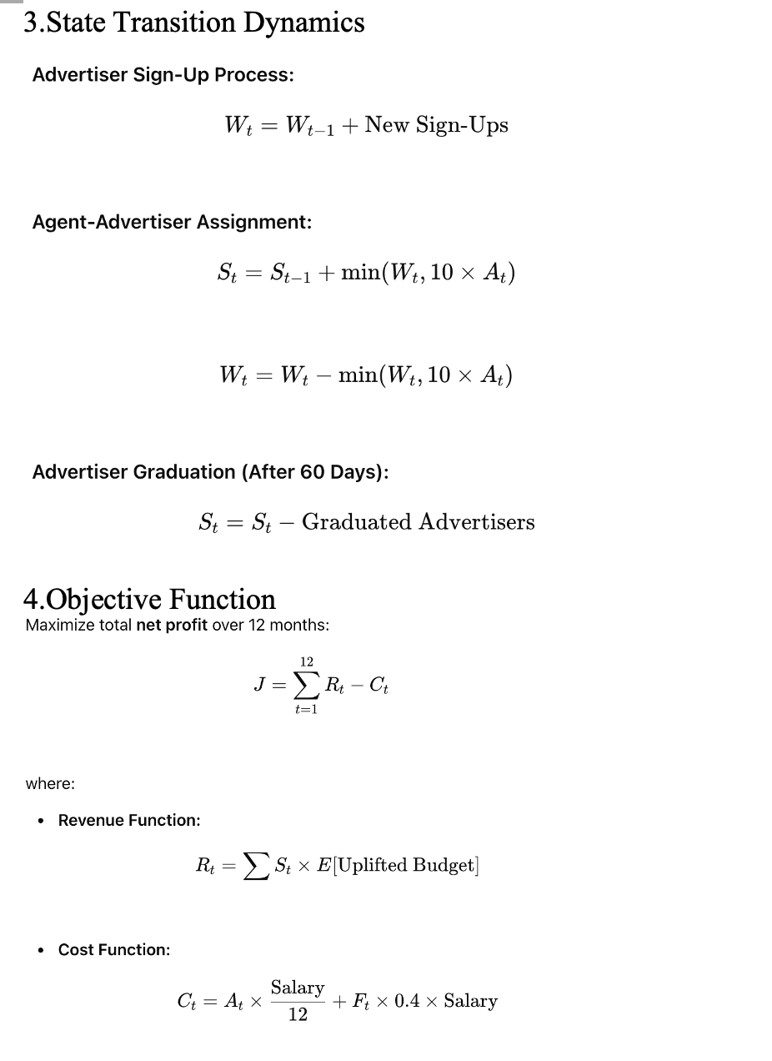

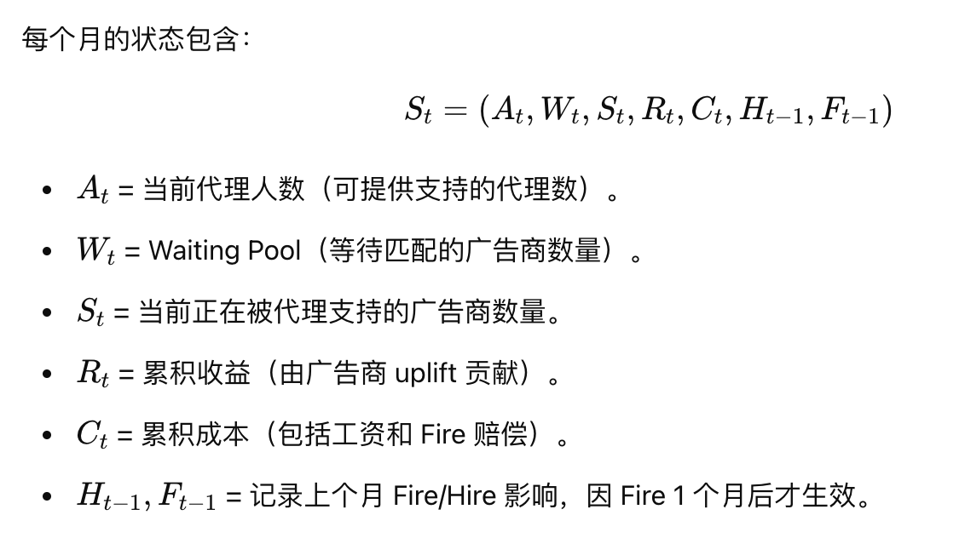

2）Action Space At

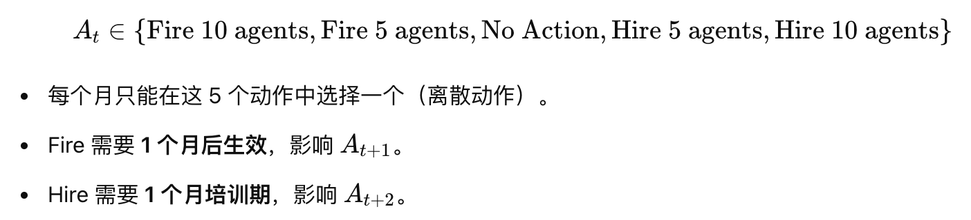

3）State Transition

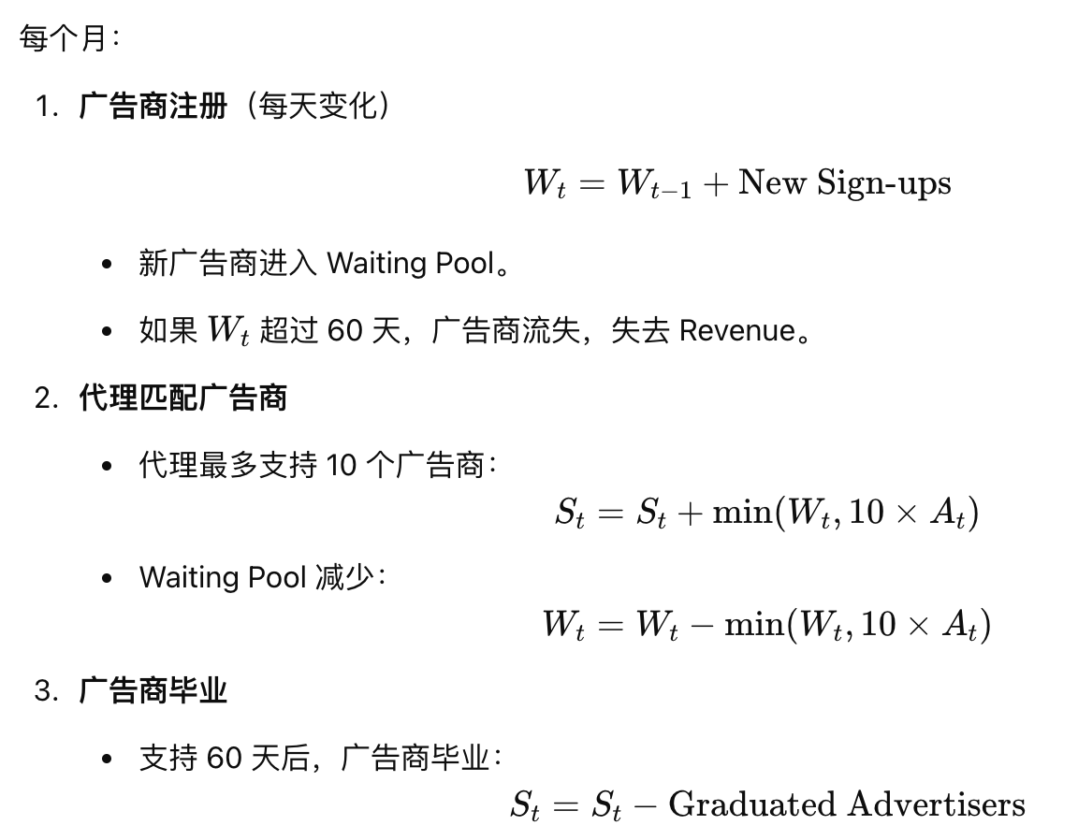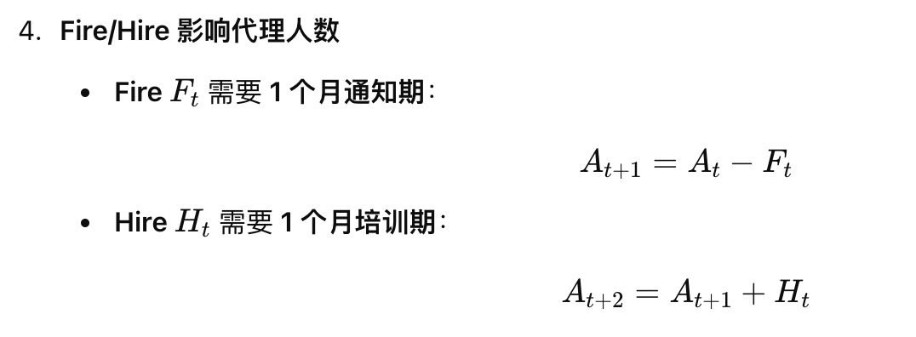

4）Activation Function Rt

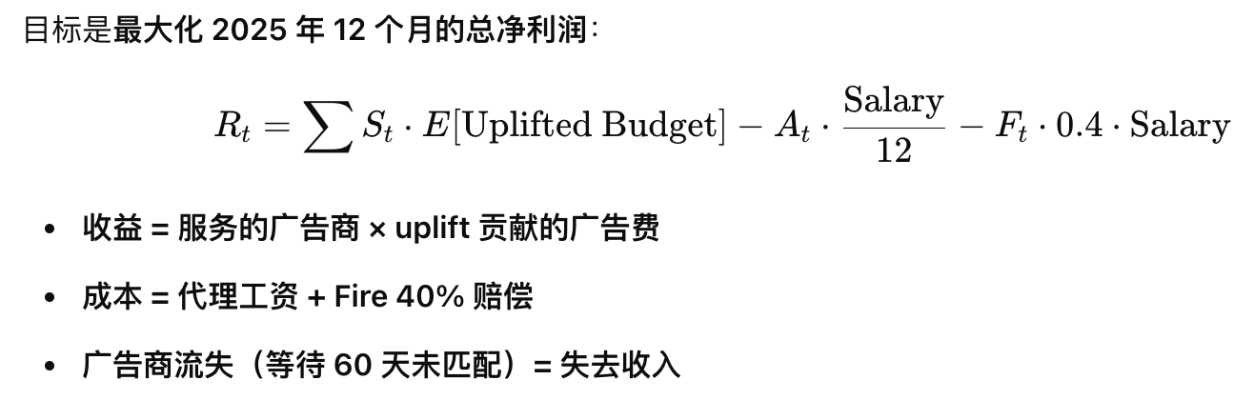

Optimization Model：

Decision variable：The number of agents we need in month t：At（t=1,2,3….12）

？？are hiring/firing number necessary

Atc​ : Total active agents in country c at month t

Htc​ : New agents hired in country c at month t

Ftc: Agents fired in country c at month t

Stc: Advertisers served in country c at month t

Utc: Unassigned advertisers (waiting pool) in country c at month t

Objective Function：



2 part：

（1）Revenue：Number of served advertiser \* E[uplifted budget] +Number of unserved in 60 days\* E[initial budget]

（2）Cost：firing cost（40%salary\*firing per month）+salary（annual salary/12\*At（t=1,2,3….12））

Constrains：

（1）Advertiser-Staffing Capacity(Each agent can handle at most 10 advertisers)  
Stc≤10⋅Atc

（2）Agent Hiring and Firing(Agent staffing updates based on hiring and firing decisions)  
At+1c=Atc+Htc−Ftc

（3）Hiring Delay(Hired agents become available next month)  
Htc only affects At+1

（4）Firing Notice & Compensation(Fired agents remain for one more month and incur 40% severance cost)

（5）Advertiser Waiting Pool(Waiting advertisers accumulate, and those exceeding 60 days exit)  
Ut+1c=Utc+(SignUpForecast tc−Stc)−Expired tc

（6）Penalty Terms

* Unused Agent Capacity Penalty: 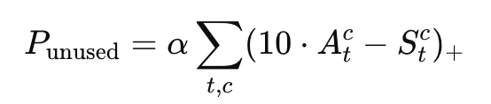

1）Penalty for Unused Capacity: If agents are underutilized (e.g., some have fewer than 10 advertisers), a penalty term could incentivize better resource allocation.

* Overloaded Waiting Pool Penalty: 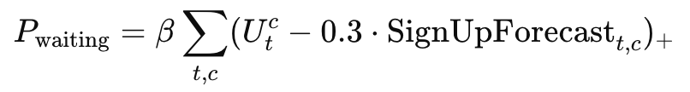

2）Penalty for Overloading the Waiting Pool: If the waiting pool exceeds a threshold (e.g., 30% of advertisers waiting >30 days), introduce a soft penalty to ensure better response times.

* Smooth Hiring/Firing Penalty:

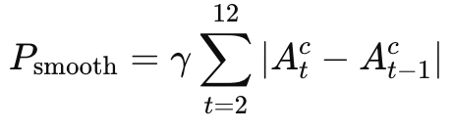

3）Monthly Smoothing Term: Firing too many agents in a single month may cause operational inefficiencies. Consider adding a penalty term for sudden staff reductions.

Sensitivity Analysis：

Use simulation（use given distribution）to simulate different conditions.

Assumption：

（1）If an employee learns that he or she will be fired next month, work status/productivity could decline that month, potentially affecting the uplift of the company they serve.

（2）Advertiser sign-up forecasts for 2025 could be derived from the 2023-2024 distribution.（Or has similar distribution）