BMI Program Test Plan Week 5 Assignment
Prepared By R.McCormick, Programmer
Date 9/27/2026
I chose pytest because it seemed the easiest and looked cleaner and faster to work with. I enjoy the ease-of-use especially if you want to run multiple tests on the same inputs. While I haven’t used them yet, the inclusion of plugins and HTML for pytest makes it the clear choice to start learning.
Test Cases
- This is a regular test that should pass and verify the formula is working and the code is rounding correctly, with a height of 60 and a weight of 120 the result should be 23.4.
- With a height of 70 and a weight of 180, the result should be 25.8, and this is another example of a pass condition where the inputs should be calculated correctly and valid.
- This tests that a number (60) is included in the range of the height table, and should return True upon success.
- This is a fail condition, passing in the values of a height of 60 and weight of 120 once more, but this time asserting the result is 30, and so we expect a fail in this case.
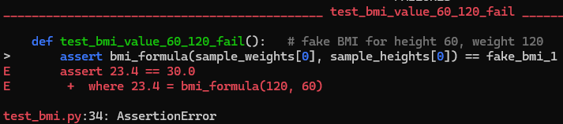
- This is another fail condition, this time using the values of 70 for height and 180 for weight again, but with an expected value of 20 this time. We expect this result to fail.
