Main Menu



Client List

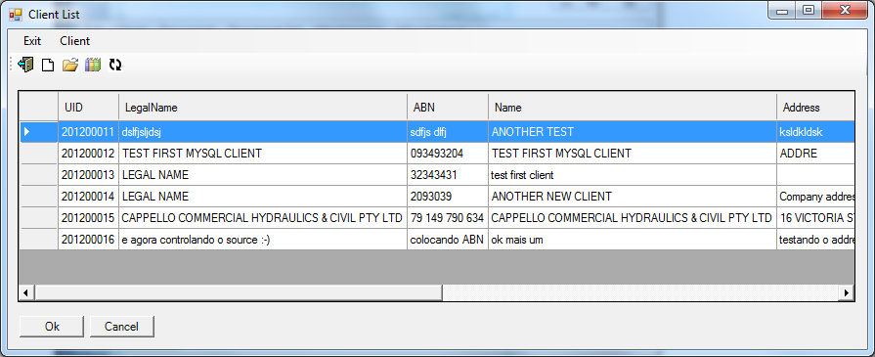

Client Details

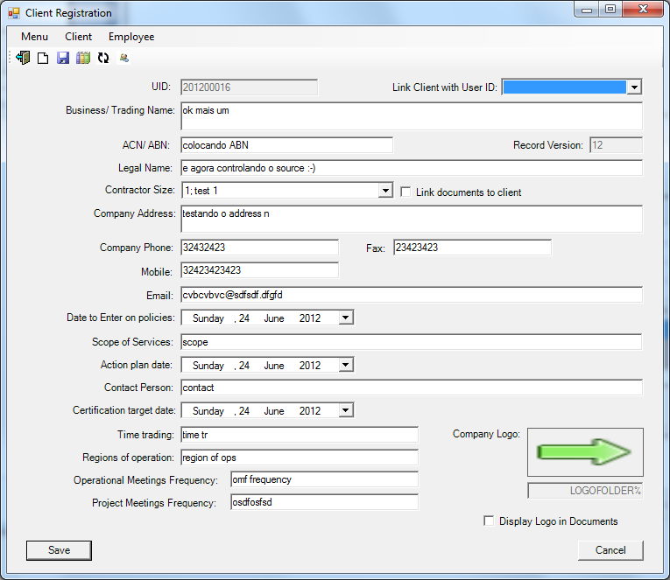

Document associated to a client - Many Document Sets can be associated to one client.

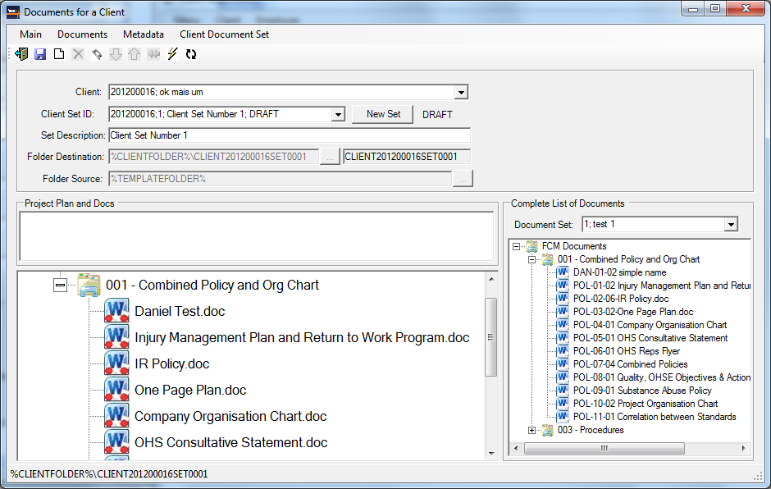

Options for each document. Red light on the left indicates the source wasn't found, the right side relates to client generated document. Both are red because the indicator is switched off. It is slow to check the existence of a file. It is controlled by system parms.

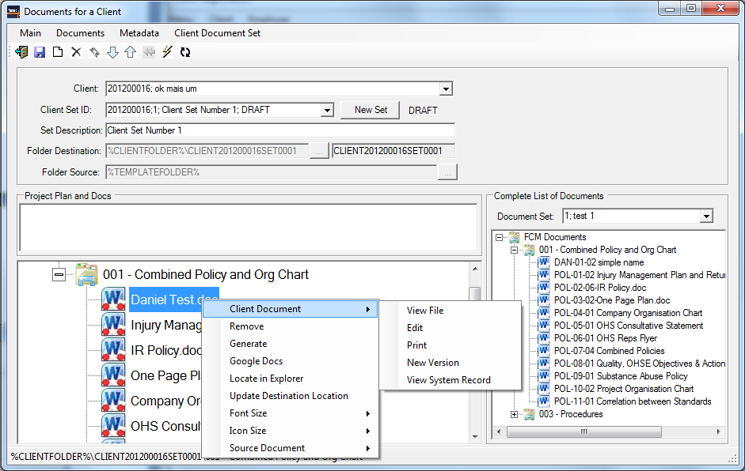

Metadata definition

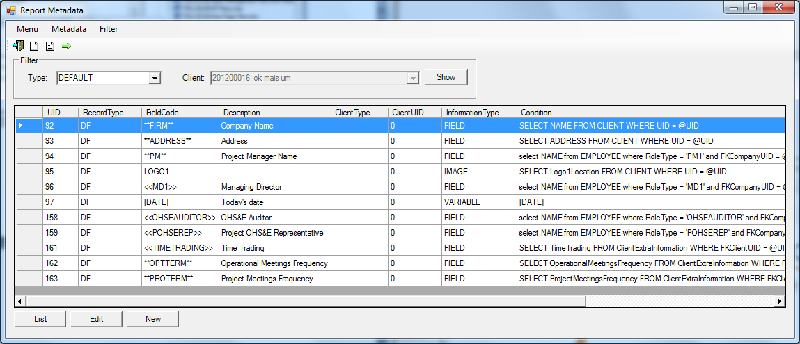

Reference Data

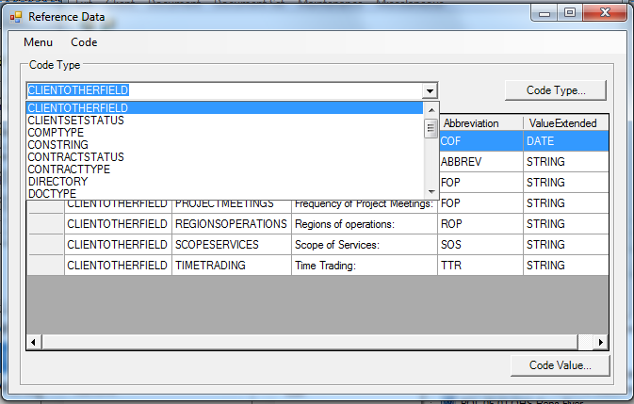

Document Version

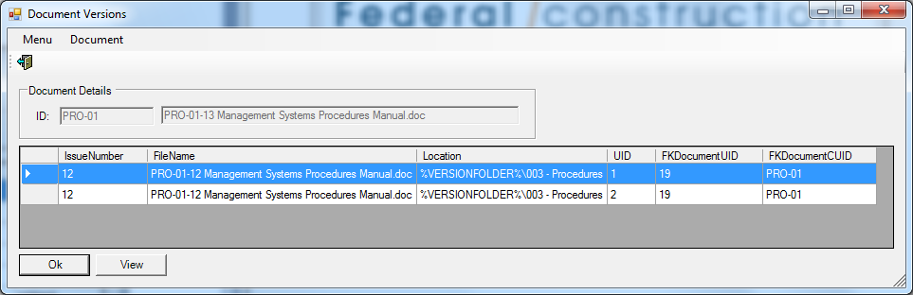

Generated Documents for a client

