RAMACHANDRA MUDALIAR (A.E.)

SANJAY JANARDAN (J.E.)

NAME - DINESH RAMACHANDRAN

BRANCH - MECHANICAL ENGG (4TH SEM)

COLLEGE - BIT DURG

ORDER NO - 168

SR.NO - 09

DEPT - OPERATION-2

**CONTENTS :**

* INTRODUCTION
* WATER TREATMENT PLANT
* DM WATER PRODUCTION
* COAL HANDLING PLANT
* BOILER SECTION
* TURBINE SECTION
* CONDENSER
* EXCITATION TRANSFORMER
* GENERATOR (TURBO ALTERNATOR)
* AUXILIARY TRANSFORMER AND GENERATING TRANSFORMER
* SWITCHYARD

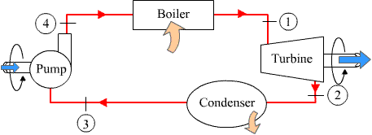

**iNTRODUCTION**

A **power station** (also referred to as a **generating station**, **power plant**, **powerhouse** or **generating plant**) is an industrial facility for the generation of electric power. At the center of nearly all power stations is a generator, a rotating machine that converts mechanical power into electrical power by creating relative motion between a magnetic field and a conductor. The energy source harnessed to turn the generator varies widely. It depends chiefly on which fuels are easily available, cheap enough and on the types of technology that the power company has access to. So on the basis of fuel, it can be classified as :

1. COAL BASED THERMAL POWER PLANT
2. HYDRO ELECTRIC POWER PLANT
3. NUCLEAR POWER PLANT
4. GEOTHERMAL POWER PLANT
5. BIOMASS FUELLED POWER PLANT
6. SOLAR POWER PLANT

* **COAL BASED THERMAL POWER PLANT** produces heat by burning coal in steam boiler. These steam drives the turbine blades which in turn drive the rotor of generator and thus cuts the magnetic field and thus produce alternating current (A.C)
* **HYDRO ELECTRIC POWER PLANT** uses water to rotate the turbine blade. Water is dropped from the great height which possesses the potential energy and converts into kinetic energy while striking the blade. And thus the connecting shaft rotates the rotor of the generator.
* **NUCLEAR POWER PLANT** use a nuclear reactor's heat that is transferred to steam which then operates a steam turbine and generator.
* **GEOTHERMAL POWER PLANT** use steam extracted from hot underground rocks.
* **BIOMASS FUELLED POWER PLANT** may be fuelled by waste from sugar cane, municipal solid waste, landfill methane, or other forms of biomass and are used to produce steam.
* **SOLAR POWER PLANT** use sunlight to boil water and produce steam which turns the generator.

**But nowadays , thermal power plants constitute about 60% of total installed capacity of the country .Because our country is having a number of coal deposits therefore the power production is more from coal based thermal power plants**.

**C.S.P.G.C.L KORBA (east) is a coal based power plant having 6 units**

|  |  |  |  |
| --- | --- | --- | --- |
| SR.NO | TYPE OF UNIT | NO OF UNIT | TOTAL |
| 1 | RUSSIAN (50 MW) | 4 | 4\*50 = 200MW |
| 2 | BHEL (120 MW) | 2 | 2\*120 = 240MW |
|  | TOTAL : | 6 | 440 MW |

WATER TREATMENT PLANT

Large amount of water is required for production of steam in boiler . it is essential to remove the metallic and gaseous substances present in raw water otherwise it will cause the following problems:

* **Scale and sludge formation**
* **Boiler corrosion**
* **Priming and foaming**
* **Caustic embrittlement**

The system which is used to remove the impurities present in raw water is called **water treatment plant .**the water treatment is sub divided as:

* **Pre treatment**
* **Post treatment**

**Pre treatment:** In this pre treatment almost all visible matters are separated from water. In practice , alum and lime are used for quick sedimentation. Alum makes the entire water acidic in nature and lime alkaline. Lime removes temporary hardness up to 0.6-0.8ppm whereas alum (Al+++ coagulant) ensures faster and effective flocculation and setting of suspended impurities .the treatment removes 90% of organic impurities and thus clarified water is obtained.

**Post treatment**: This is about dissolved impurities which are mostly salt of sodium, calcium and magnesium which are not removed from pre treatment. So the post treatment takes place with the help of DM WATER PLANT.

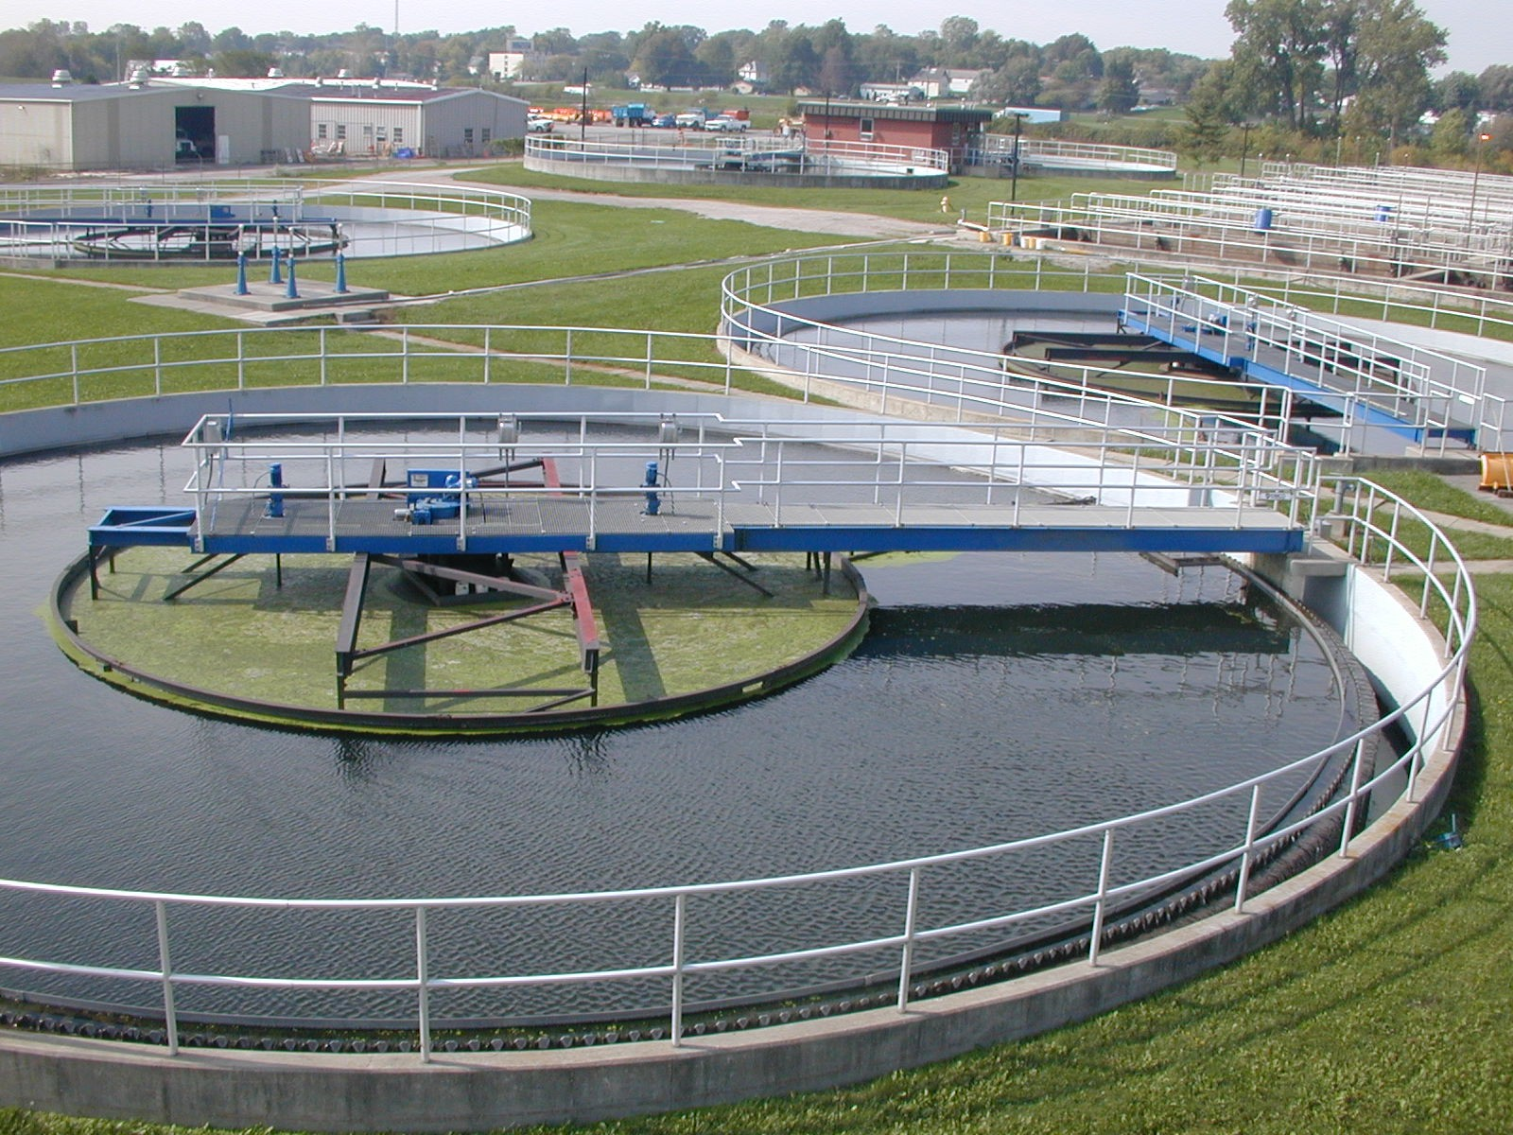

DM WATER PLANT (DEMINERALIZED)

Demineralization is the process of removing mineral salts from water by using the ion exchange process.

Mineral ions such as cations of sodium, calcium, iron, copper, etc and anions such as chloride, sulphate, nitrate, etc are common ions present in water. Deionization is a physical process which uses specially-manufactured ion exchange resins which provides ion exchange site for the replacement of the mineral salts in water with water forming H+ and OH- ions. Because the majority of water impurities are dissolved salts, deionization produces a high purity water that is generally similar to distilled water, and this process is quick and without scale buildup.

A DM Water System produces mineral free water by operating on the principles of ion exchange, Degasification, and polishing. Demineralized Water System finds wide application in the field of steam, power, process, and cooling.

**The following ions are widely found in raw waters :**

cations Anions

Calcium (Ca2+) Chloride ( Cl-)

Magnesium (Mg2+) Bicarbonate (HCO3-)

Sodium (Na+) Nitrate (NO3-)

Potassium (K+) Carbonate (CO32-)

There are two basic types of resin - cation-exchange and anion-exchange resins. Cation exchange resins will release Hydrogen (H+) ions or other positively charged ions in exchange for impurity cations present in the water. Anion exchange resins will release hydroxyl (OH-) ions or other negatively charged ions in exchange for impurity anions present in the water.

|  |
| --- |
|  |
|  |

In CSPGCL both types of deionization are used and thus water which is free from all types of minerals as well as impurities is obtained which is generally called as DEMINERALISED WATER.

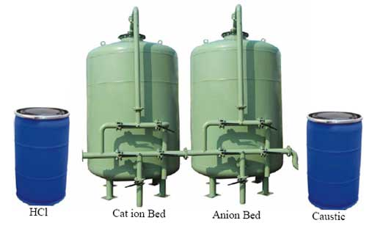

COAL HANDELING PLANT (CHP)

**Objective of CHP :-**

To supply the quanta of processed coal to bunkers of Coal mills for Boiler operation.

To stack the coal to coal yard

**Transportation of Coal :-**

Railways

Roadways







BOILER AND ITS AUXILIARIES

Boiler is a device for producing the operated steam to run the turbine and thus to produce the power. Various auxiliaries in boiler section are :

1. Coal feeder
2. Bowl mill
3. Furnace with water walls and boiling drum
4. Economizer
5. Superheater
6. Air preheater
7. Burners
8. Ignitrons
9. Fans
10. ESP (Electrostatic Precipitator)
11. Chimney

**Descriptions of above auxiliaries are as follows:**

* **COAL FEEDER**
* Coal feeder is an equipment by which coal is feeded from bunker to bowl mill
* It is special arrangement with which feeder can select different bunkers.
* **BOWL MILL-(2)**
  + Mills are used to pulverize the coal supplied by coal feeder from bunker.
  + In mills the crushed coal is generally reduced to fine powder.
  + In this power plant medium speed bowls are used.
* **FURNACE WITH WATER WALLS AND BOILER DRUM -(6)**
* the pulverized coal is admitted to the furnace through tangential burner located in the four corner of the furnace.
* the burner are to be aimed at an imaginary circle in the center of the furnace and the action of the adjacent fuel stream provided a highly turbulent conditions where coal particle and combustion air are intermixed and are very efficient combustion takes place
* water walls are the pipes forming the body of furnace
* **ECONOMIZER -(4)**
* Eco-1st stage and eco-2nd stage.
* An economizer is basically used to preheat the feed water (i.e from the l.p. heater )by utilizing the heat from the existing flue gases and then pass it to h.p heater.
* it helps in increasing the thermal efficiency of the plant.
* **SUPER HEATER - (4)**
  + TYPES :
    - * RADIENT SUPER HEATER
      * SCREEN SUPER HEATER
      * CONVECTIVE SUPER HEATER- 1ST stage and 2ND stage
* Its function is to super heat the steam to the desired temperature by removing the moisture from it.
* **AIR PREHEATER – (2)**
  + the air heater is an essential boiler auxiliary as hot air is necessary for rapid and efficient combustion in the furnace and also for drying coal in coal milling plant.
* **FANS**

a) F.D. FAN (FORCED DRAUGHT FAN) – (2)

* F.D. FAN takes air from the atmosphere at ambient temperature to supply the combustion air required.
* Lubrication oil system are provided for F.D.Fan.

b) I.D FAN (INDUCED DRAUGHT FAN) – (1)

* It is used in balance draft unit to suck the gases out of the furnace and throw them into the stack.
* With the help of this smoke are sucked out.

C) MILL FAN (2)

* Creates vacuum in the entire line of boiler section.
* **ELECTROSTATIC PRESIPITATE(ESP)**
* it consists of a cathode and a anode where anode is the filament
* The unwanted dust say ash particles are repelled by anode as there is a potential developed between the cathodic and anodic parts and are attracted by the cathode.
* And there exists a hammering device near the cathode which hammers down the dust and is sent to ASH DISPOSAL SYSTEM for further use.
* and the gases evolved are liberated through chimney.

TURBINE SECTION

* 1. Steam turbine is a form of engine which converts the heat energy of working fluid i.e steam into mechanical work and ultimately this mechanical energy is converted into electrical energy.
  2. In this power plant we have basically four units of 50MW and two units of 120MW.In 50MW we have one cylinder machine consisting of low pressure cylinder whereas 120MW consists of three cylinder machine consisting of high pressure (H.P),intermediate pressure (I.P)and low pressure (L.P).
  3. In CSPGCL NOZZLE CONTROL GOVERNING is used. In nozzle governing the flow rate of steam is regulated by opening and shutting of sets of nozzles rather than regulating its pressure. In this method groups of two, three or more nozzles form a set and each set is controlled by a separate valve. In actual turbine, nozzle governing is applied only to the first stage whereas the subsequent stages remain unaffected.
  4. Here we are using the mixed flow turbine i.e. impulse as well as reaction turbine.
  5. For the lubrication of bearing BEARING OIL is used and to decrease the temperature of this hot bearing oil water tubes are present around this oil and thus they decrease the temperature of it

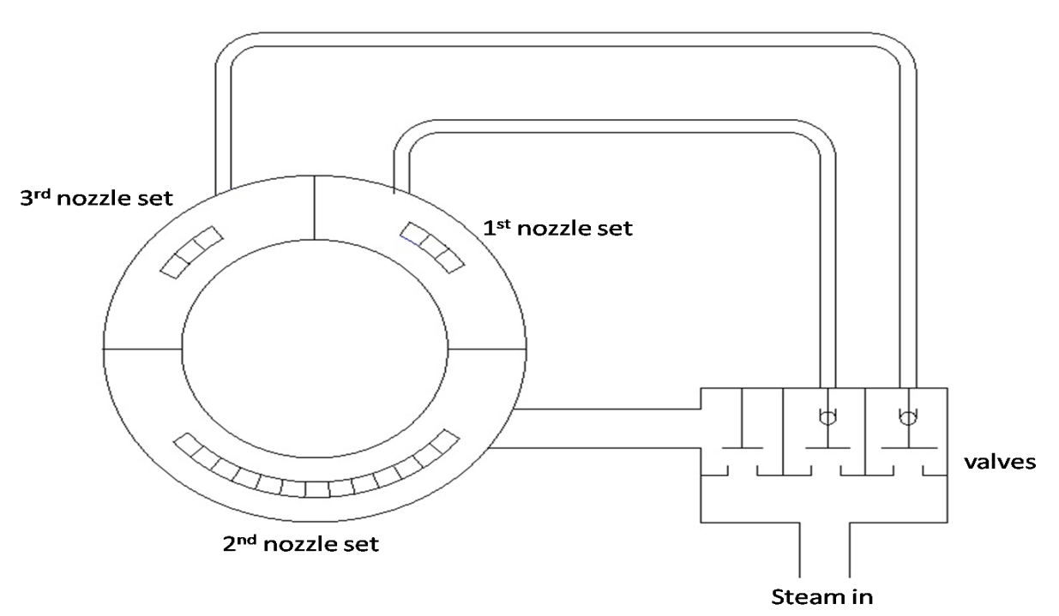

**NOZZLE CONTROL SETUP**

MAIN ELEMENTS OF TURBINE :

1. Nozzles
2. Blades
3. Rotors
4. Casing and cylinders
5. Valves
6. Bearings
7. Shaft glands

THERMODYNAMICS OF TURBINE

The steam turbine operates on basic principles of thermodynamics using the part of the **Rankine cycle**. Superheated vapor (or dry saturated vapor, depending on application) enters the turbine, after it having exited the boiler, at high temperature and high pressure. The high heat/pressure steam is converted into kinetic energy using a nozzle (a fixed nozzle in an impulse type turbine or the fixed blades in a reaction type turbine). Once the steam has exited the nozzle it is moving at high velocity and is sent to the blades of the turbine. A force is created on the blades due to the pressure of the vapor on the blades causing them to move. A generator or other such device can be placed on the shaft, and the energy that was in the vapor can now be stored and used. The gas exits the turbine as a saturated vapor (or liquid-vapor mix depending on application) at a lower temperature and pressure than it entered with and is sent to the condenser to be cooled.

**Isentropic turbine efficiency**

To measure how well a turbine is performing we can look at its isentropic efficiency. This compares the actual performance of the turbine with the performance that would be achieved by an ideal, isentropic, turbine. When calculating this efficiency, heat lost to the surroundings is assumed to be zero. The starting pressure and temperature is the same for both the actual and the ideal turbines, but at turbine exit the energy content ('specific enthalpy') for the actual turbine is greater than that for the ideal turbine because of irreversibility in the actual turbine. The specific enthalpy is evaluated at the same pressure for the actual and ideal turbines in order to give a good comparison between the two.

The isentropic efficiency is found by dividing the actual work by the ideal work.

\eta_t = \frac {h_3-h_4}{h_3-h_{4s}} 

* ***h3*** is the specific enthalpy at state three
* ***h4*** is the specific enthalpy at state four for the actual turbine
* ***h4s*** is the specific enthalpy at state four for the isentropic turbine

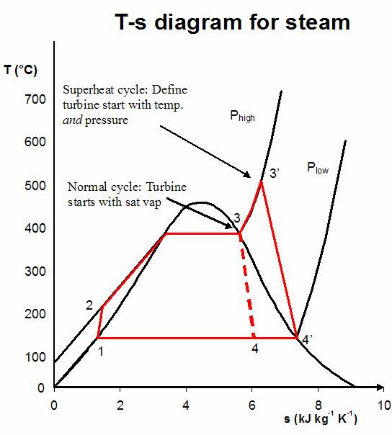

Rankine cycle with superheat  
Process 1-2: The working fluid is pumped from low to high pressure.  
Process 2-3: The high pressure liquid enters a boiler where it is heated at constant pressure by an external heat source to become a dry saturated vapor.  
Process 3-3': The vapour is superheated.  
Process 3-4 and 3'-4': The dry saturated vapor expands through a turbine, generating power. This decreases the temperature and pressure of the vapor, and some condensation may occur.

Process 4-1: The wet vapor then enters a condenser where it is condensed at a constant pressure to become a saturated liquid.

CONDENSER

#### **In systems involving heat transfer, a condenser is a device or unit used to condense a substance from its gaseous to its liquid state, typically by cooling it. In so doing, the latent heat is given up by the substance, and will transfer to the condenser coolant. Condensers are typically heat exchangers which have various designs and come in many sizes ranging from rather small (hand-held) to very large industrial-scale units used in plant processes. For example, a refrigerator uses a condenser to get rid of heat extracted from the interior of the unit to the outside air. Condensers are used in air conditioning, industrial chemical processes such as distillation, steam power plants and other heat-exchange systems. Use of cooling water or surrounding air as the coolant is common in many condensers.**

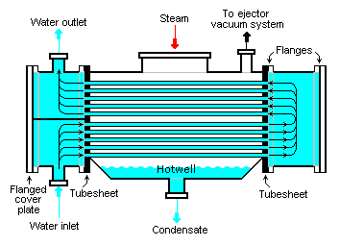

HEATERS AND PUMPS

1. **L.P.HEATERS** are basically low pressure heaters which heat the given steam at low pressure and raise the temperature of the steam from 30-50(degree Celsius).
2. **H.P.HEATERS** are basically high pressure heater which heat the steam coming from the economizer at high pressure and raise the temperature from 50-70(degree Celsius)
3. In CSPGCL (200MW)there are 5 L.P heaters and 3 H.P heaters.

* **BOILER FEED PUMP (BFP)-(2)**

Feed water pumps range in size up to many horsepower and the electric motor is usually separated from the pump body by some form of mechanical coupling. Large industrial condensate pumps may also serve as the feed water pump. In either case, to force the water into the boiler, the pump must generate sufficient pressure to overcome the steam pressure developed by the boiler. This is usually accomplished through the use of a centrifugal pump.

* **CONDENSATE EXTRACTION PUMP (CEP)-(2)**

Condensate pumps as used in hydro systems are usually electrically powered centrifugal pumps. As used in homes and individual heat exchangers, they are often small and rated at a fraction of a horsepower, but in commercial applications they range in size up to many horsepower and the electric motor is usually separated from the pump body by some form of mechanical coupling. Large industrial pumps may also serve as the feed water pump for returning the condensate under pressure to a boiler of a centrifugal pump.

EXICITATION TRANSFORMER

Excitation transformer is nothing but the source or minimum energy given to generator to generate voltage.  
  
As we know the principle of generator it convert mechanical energy into electrical energy, for this conversion it need magnetic flux lines which get cut by generator coil and produce EMF.

So to produce this magnetic field lines we require the D.C current . And therefore to produce the D.C current we require RECTIFIER which converts A.C into D.C.

The excitation voltage is directly taken from the generator through this transformer and is converted into D.C voltage .This is a step down transformer

Here in CSPGCL 10.3KV is produced and this stepped down to 6.6KV in 50MW UNITS.

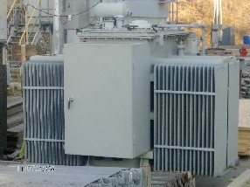

TURBO ALTERNATOR

An **alternator** is an electromechanical device that converts mechanical energy to electrical energy in the form of alternating current.

Most alternators use a rotating magnetic field with a stationary armature but occasionally, a rotating armature is used with a stationary magnetic field; or a linear alternator is used.

In principle, any AC electrical generator can be called an alternator, but usually the term refers to small rotating machines driven by automotive and other internal combustion engines. An alternator that uses a permanent magnet for its magnetic field is called a magneto. Alternators in power stations driven by steam turbines are called **turbo-alternators**.

Alternators generate electricity using the same principle as DC generators, namely, when the magnetic field around a conductor changes, a current is induced in the conductor. Typically, a rotating magnet, called the **rotor**turns within a stationary set of conductors wound in coils on an iron core, called the **stator**. The field cuts across the conductors, generating an induced EMF (electromotive force), as the mechanical input causes the rotor to turn.

The output frequency of an alternator depends on the number of poles and the rotational speed. The speed corresponding to a particular frequency is called the *synchronous speed* for that frequency.

The relation between speed and frequency is N=120f/P, where f  is the frequency in Hz (cycles per second). P is the number of poles (2,4,6...) and  N  is the rotational speed in revolutions per minute (RPM).

Here IN CSPGCL we are having frequency (f) 50Hz and no of poles as 2.

Therefore,

Synchronous speed would be

N = (120 \*50)/2 N = 3000RPM

Here it produce 10.3KV which is stepped to 220KVwith the help of step up transformer.

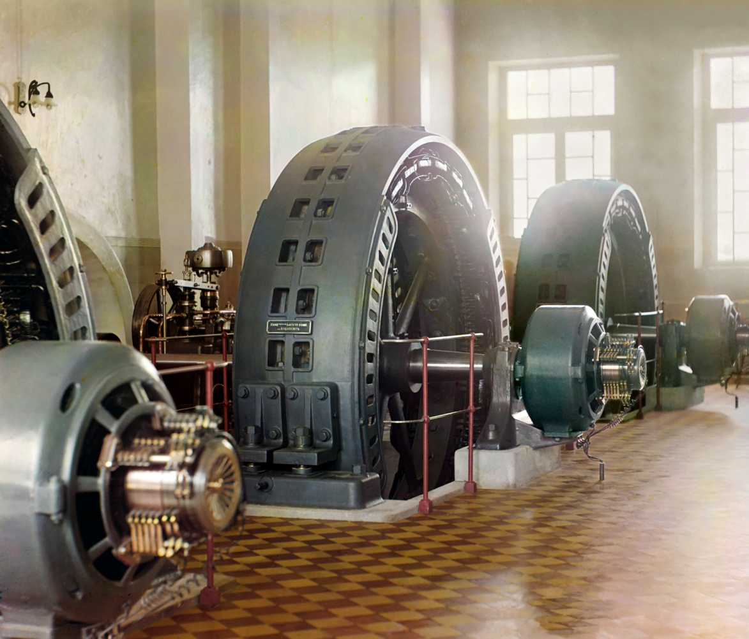

AUXILIARY TRANSFORMER AND GENERATING TRANSFORMER

**Unit Auxiliary Transformers (UAT)**

The Unit Auxiliary Transformer is the Power Transformer that provides power to the auxiliary equipment of a power generating station during its normal operation. This transformer is connected directly to the generator out-put by a tap-off of the isolated phase bus duct and thus becomes**cheapest source of power**to the generating station.

It is generally a**three-winding transformer** i.e. one primary and two separate secondary windings. Primary winding of UAT is equal to the main generator voltage rating. The secondary windings can have same or different voltages i.e. generally 10.3KV and or 6.6KV as per plant layout.

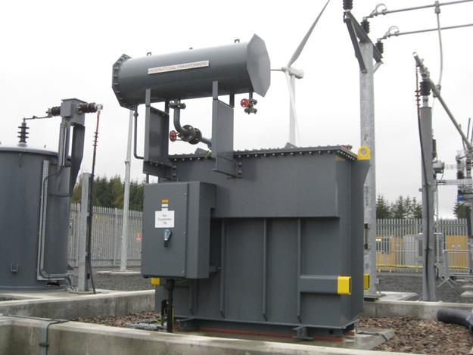

**GENERATING TRANSFORMER**

As an**essential element of all nuclear, thermal or hydraulic power stations**, generator transformers are step-up transformers with delta-connected LV windings energized by the generator voltage, while star connected HV windings are connected to the transmission lines.

Here in CSPGCL 10.3 KVA is stepped up to 220KVA guy the help of this step up GENERATOR TRANSFORMER.(50MW units)

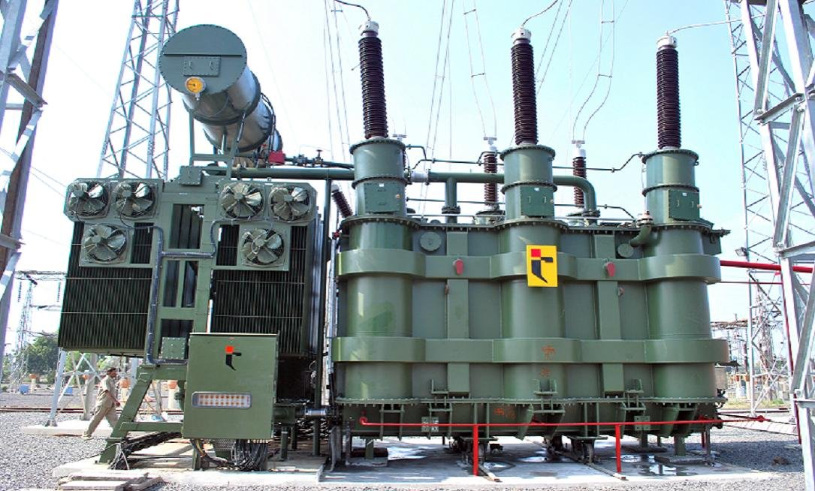

SWITCHYARD

The function of electrical switch yard is to deliver the generated power from power plant at desired voltage level to the nearest grid. Or In Another way we can say simply switching the received power supply from various generating stations to various locations with respect to their requirement.

