Open DRAM Compact Model User Guide
(Access Transistors & High-Voltage Periphery Transistors for 6F²/4F²/3D DRAM)
Developers: Kiseok Lee, Seongkwang Lim
PI: professor Shimeng Yu, Georgia Institute of Technology
June 13th, 2026

## License
This project is licensed under the Apache License 2.0.
It permits use, modification, and distribution for both academic and commercial purposes, while providing an explicit grant of patent rights from contributors.
Users are required to include the original license and provide proper attribution when redistributing this work.

Index
1. Overview ……2
2. Framework and Workflow ……3
3. Repository Structure ……4
4. Supported Cell Options (6F² / 4F² / 3D DRAM) ……5-14
4-1. 6F² ……5-8
4-1. 4F² ……9-12
4-1. 3D DRAM ……13-14
5. Supported Peri Options (high-voltage) ……15-19
6. SPICE Simulation Example ……20
7. References ……21

1. Overview
This repository provides open compact models for (i) DRAM access transistors (6F² BCAT/4F² VCT/3D DRAM GAA variants) and (ii) high-voltage periphery transistors used in DRAM sub wordline (WL) drivers (SWDs), sense amplifiers (BLSAs). The models are calibrated against TCAD device simulations, enabling SPICE-accurate evaluation of sense margin, timing, and disturbance mechanisms in advanced 6F²/4F²/3D DRAM architectures. The goal is to support reproducible research and architecture–circuit co-design by releasing reusable models and reference testbenches.
* In Version 1.0, this repository provides transistor compact models only. In subsequent releases, we plan to develop and distribute a full DRAM PDK that incorporates variability as well as array-level parasitics.
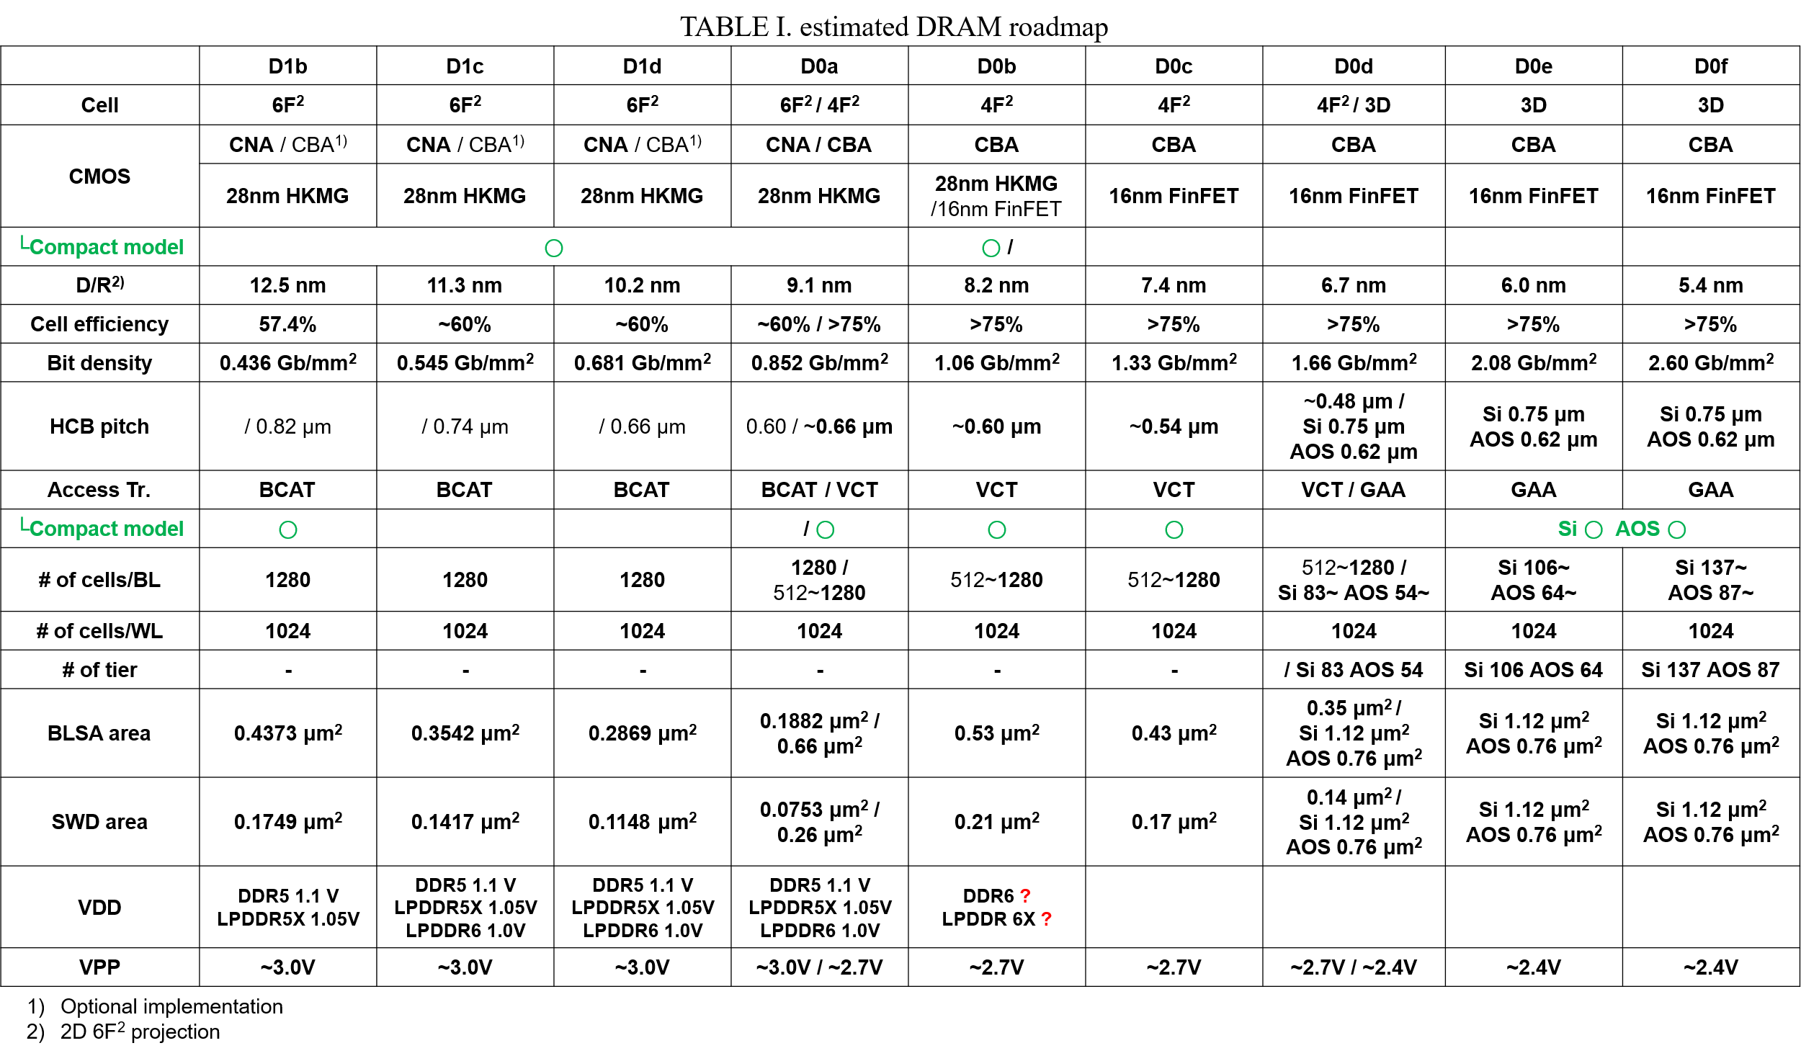

2. Framework and Workflow
End-to-end flow (device → array → circuit → PPAC):
- Define cell structures, dimensions, materials, and process integration.
- Extract access transistor characteristics via TCAD.
- Extract array parasitics (CBL, CWL, RBL, RWL) via TCAD.
- Comprehensive evaluation of cell and array design.
- Fit compact models to TCAD results across operating corners.
- Run SPICE simulation with periphery (BLSA, SWD) to evaluate sense margin and timing.
This mirrors the framework illustrated in the guide (Fig. 1)

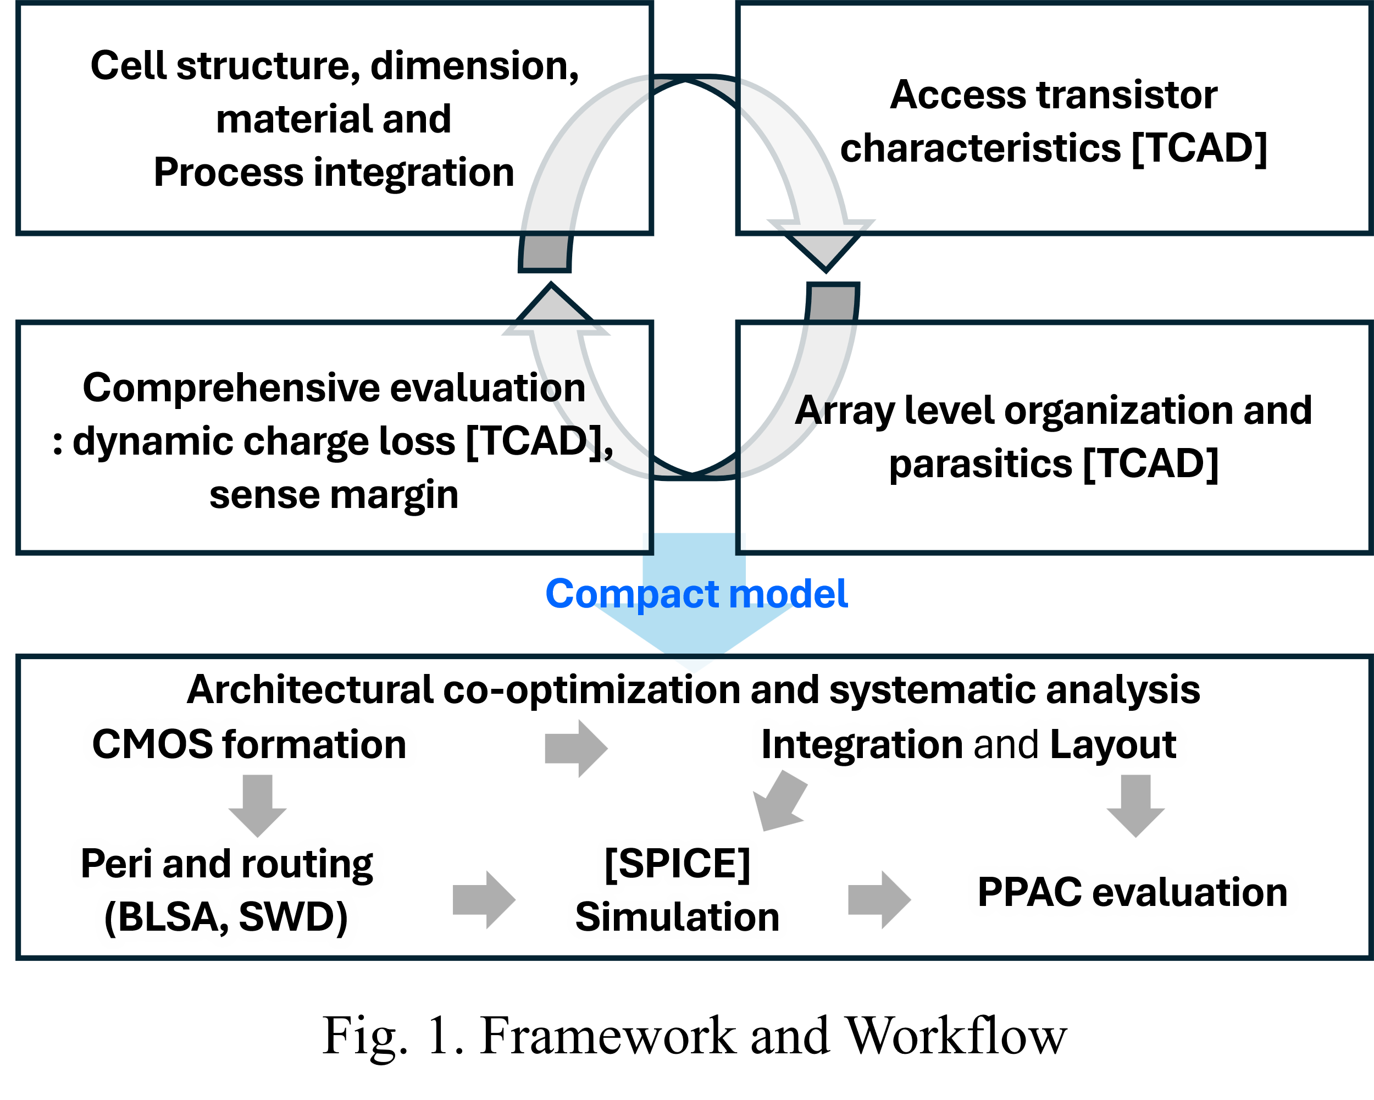

3. Repository Structure
/models
/access_tx
BCAT_125.inc # 6F² BCAT (D/R 12.5nm) access transistor compact model
VCT_125.inc # 4F² VCT (D/R 12.5nm) access transistor compact model
VCT_102.inc # 4F² VCT (D/R 10.2nm) access transistor compact model
VCT_091.inc # 4F² VCT (D/R 9.1nm) access transistor compact model
VCT_082.inc # 4F² VCT (D/R 8.2nm) access transistor compact model
3D_gaa_Si.inc # 3D DRAM Si channel GAA access transistor compact model
3D_gaa_AOS.inc # 3D DRAM AOS channel GAA access transistor compact model
/peri_tx
hv_peri_28_32.inc # High-voltage Peri transistor compact model
/bench # BLSA + SWD sensing testbench
data.dm
master.tag
sch.oa
/docs
user_guide_V1.0.pdf

4. Supported Cell Options (6F² / 4F² / 3D DRAM)
The guide includes 6F², 4F² and 3D DRAM options. Users can select W/L pairs in guideline criteria.
- Access transistor model description
The access transistor model is named ‘nfet’, and the number of fins should be set to ‘one’. The gate length is recommended to be varied within the criteria specified in the provided guidelines. The gate width can be adjusted by modifying the fin shape parameters within the model, and it is likewise recommended to vary it within the guideline criteria.

[6F²]
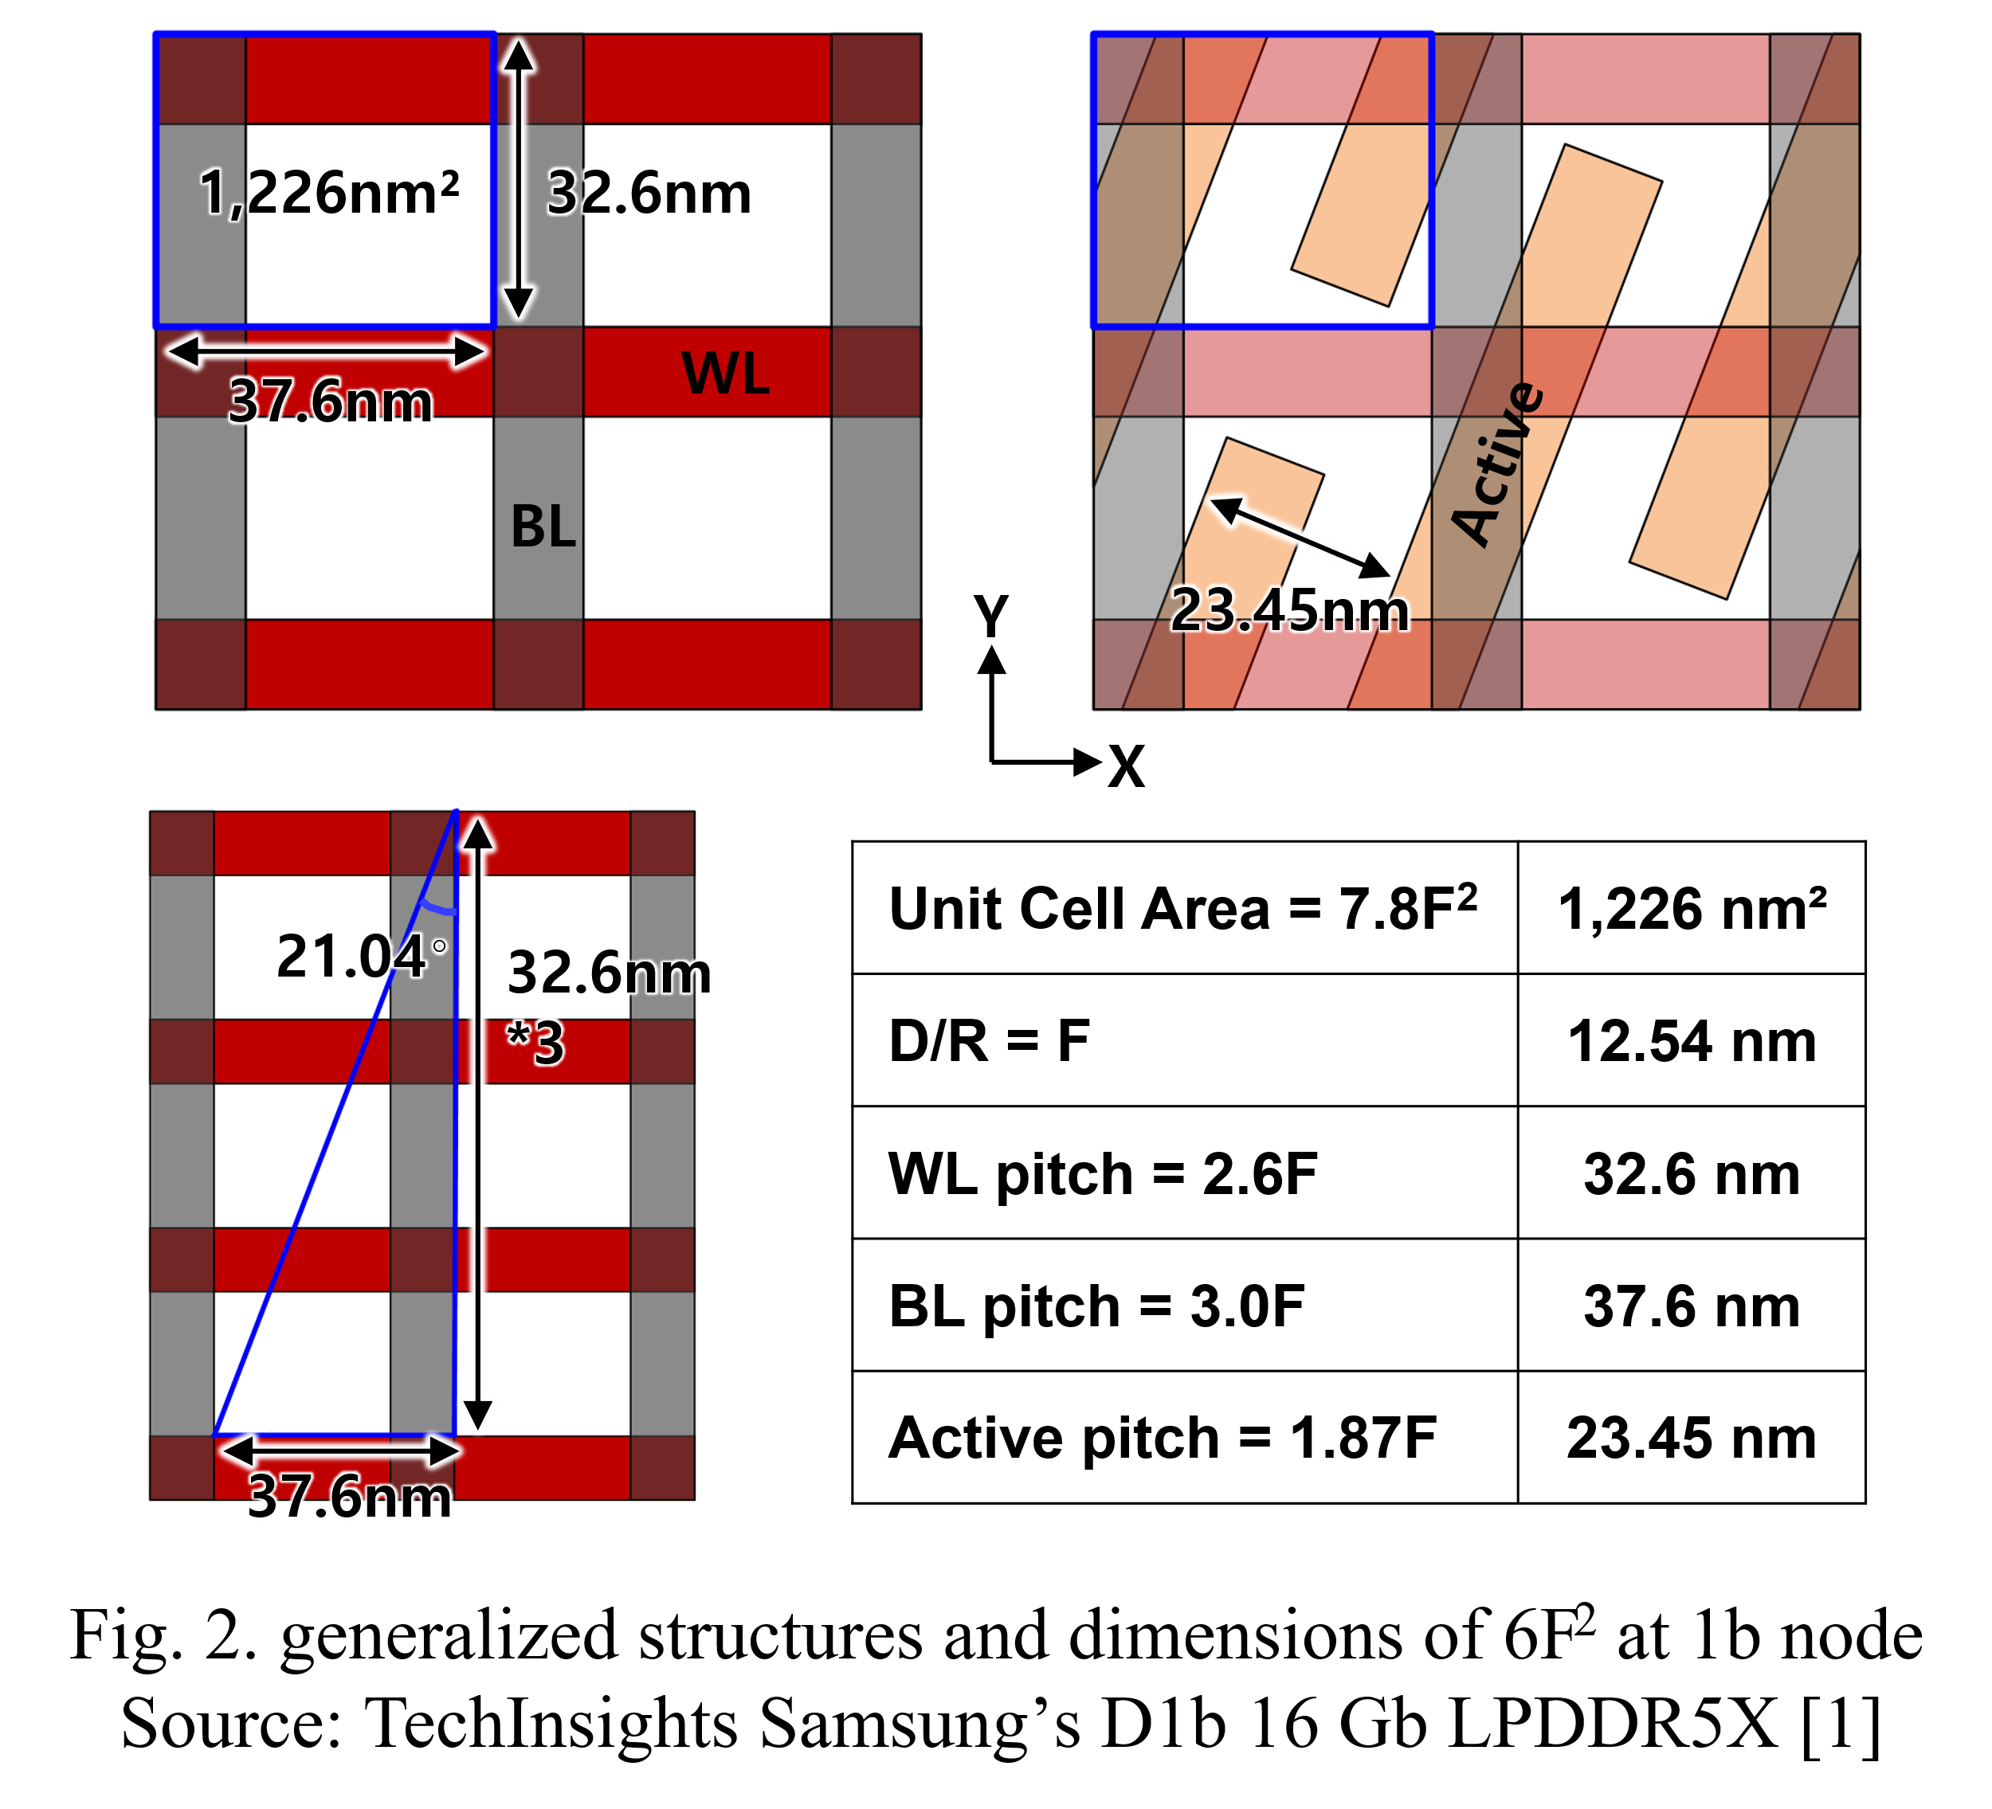
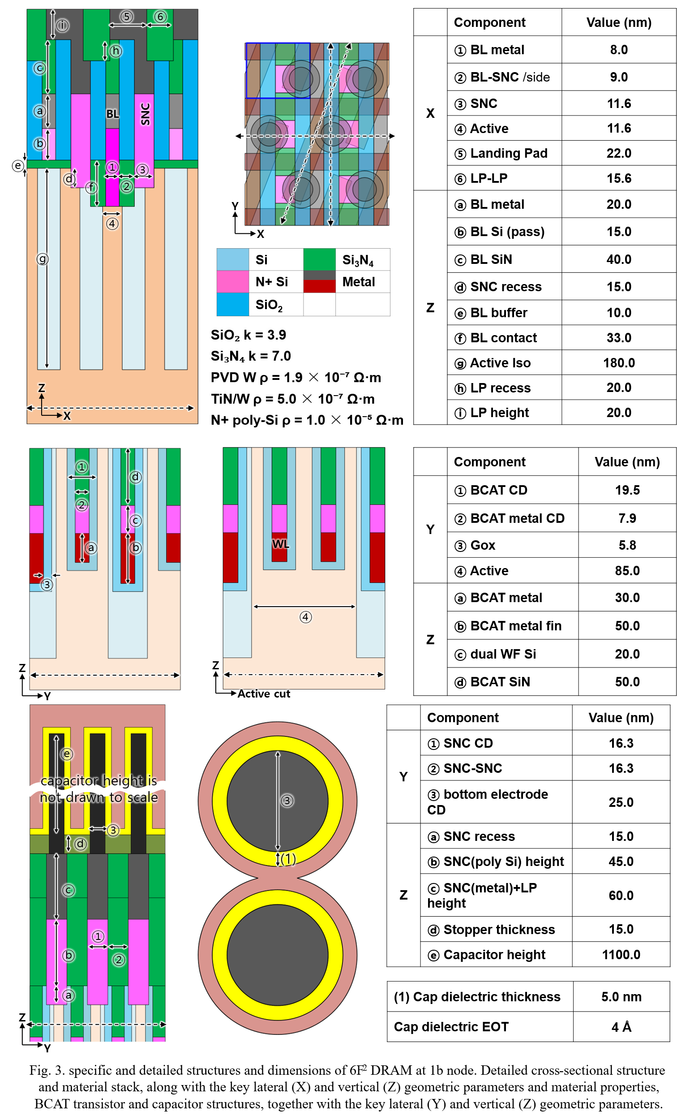
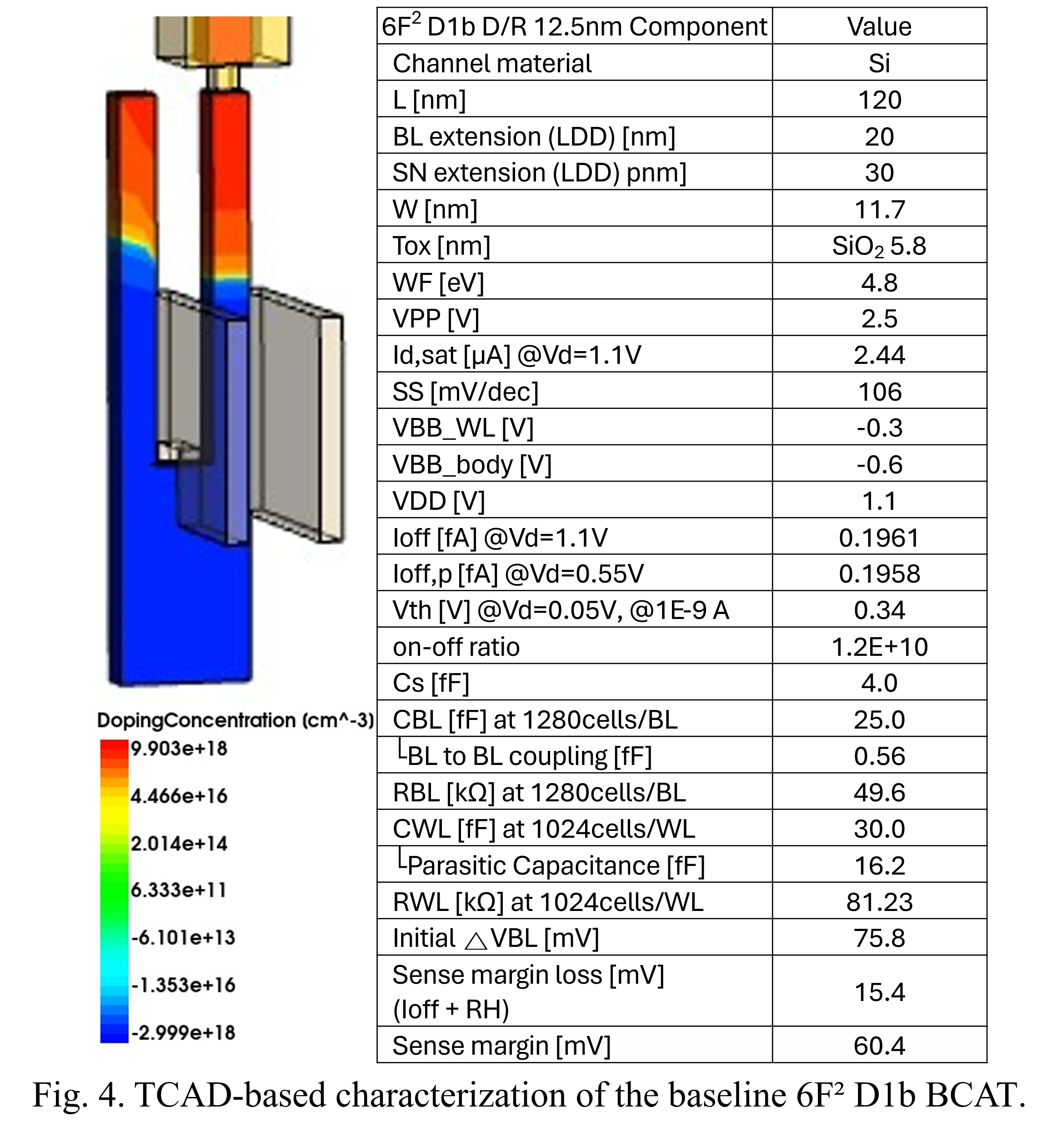
body doping: "BoronActiveConcentration" 3e+18
source doping: "NoReplace" "Eval" "source" 0.07 "evalwin" and "PhosphorusActiveConcentration" "PeakPos" 0 "PeakVal" 2.5e+19 "ValueAtDepth" 6e+13 "Depth" 0.011 "Gauss" "Factor" 0
drain doping: "NoReplace" "Eval" "source" 0.07 "evalwin" and "PhosphorusActiveConcentration" "PeakPos" 0 "PeakVal" 2.5e+19 "ValueAtDepth" 6e+13 "Depth" 0.011 "Gauss" "Factor" 0

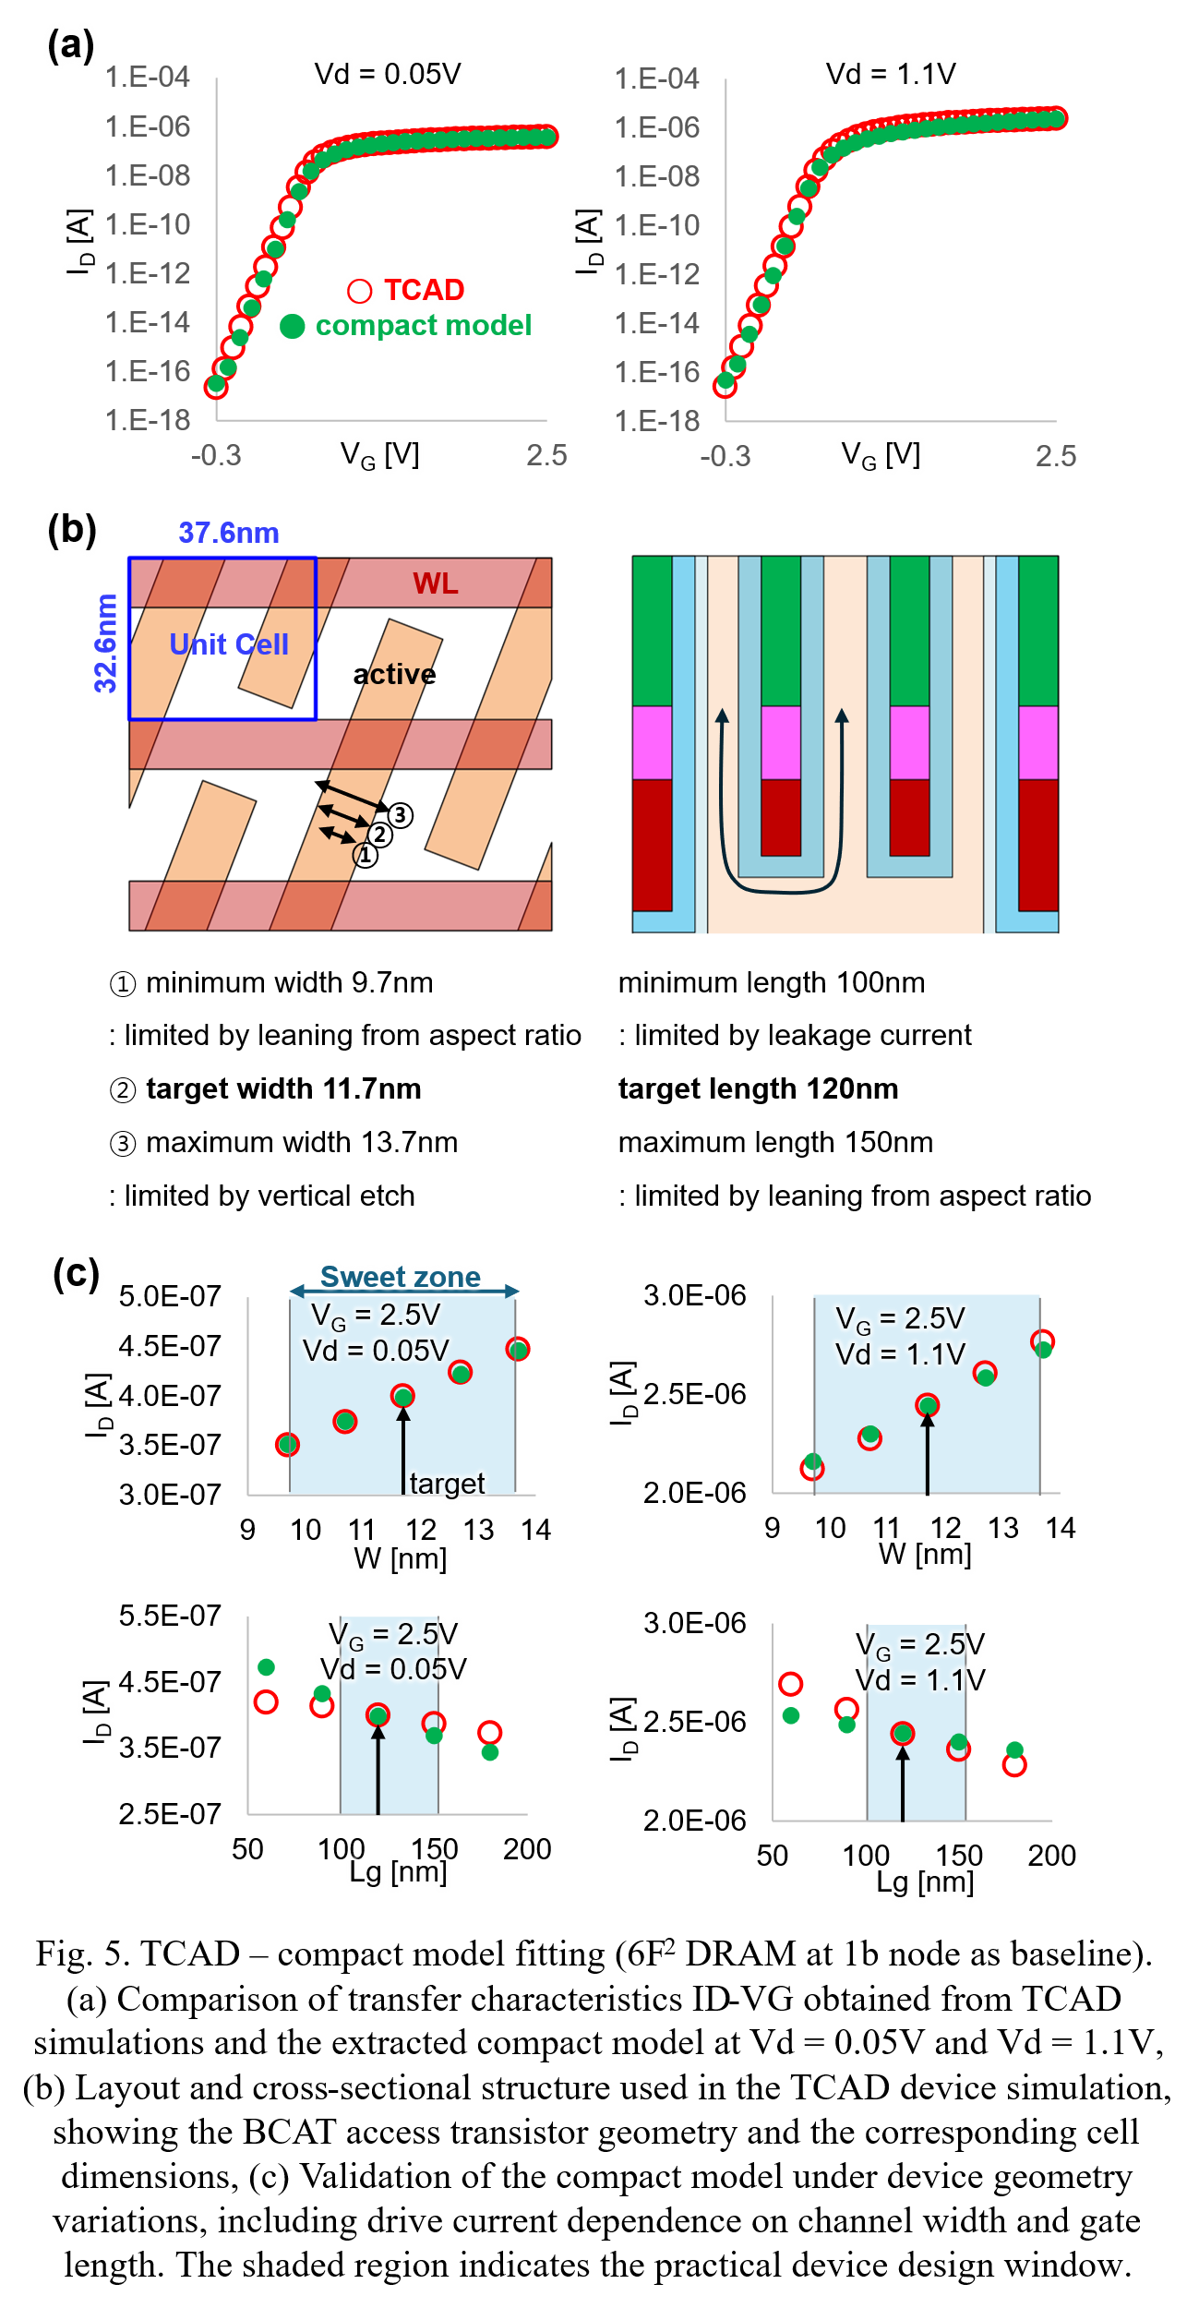
[4F²]
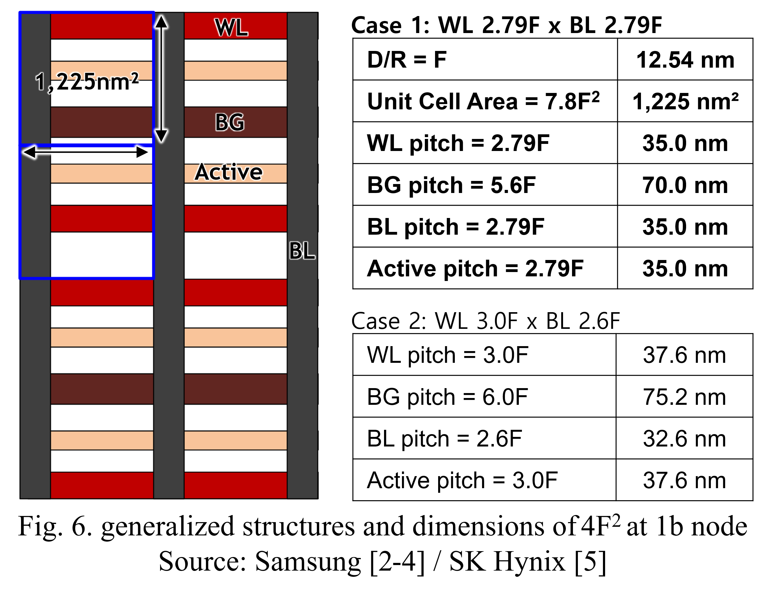

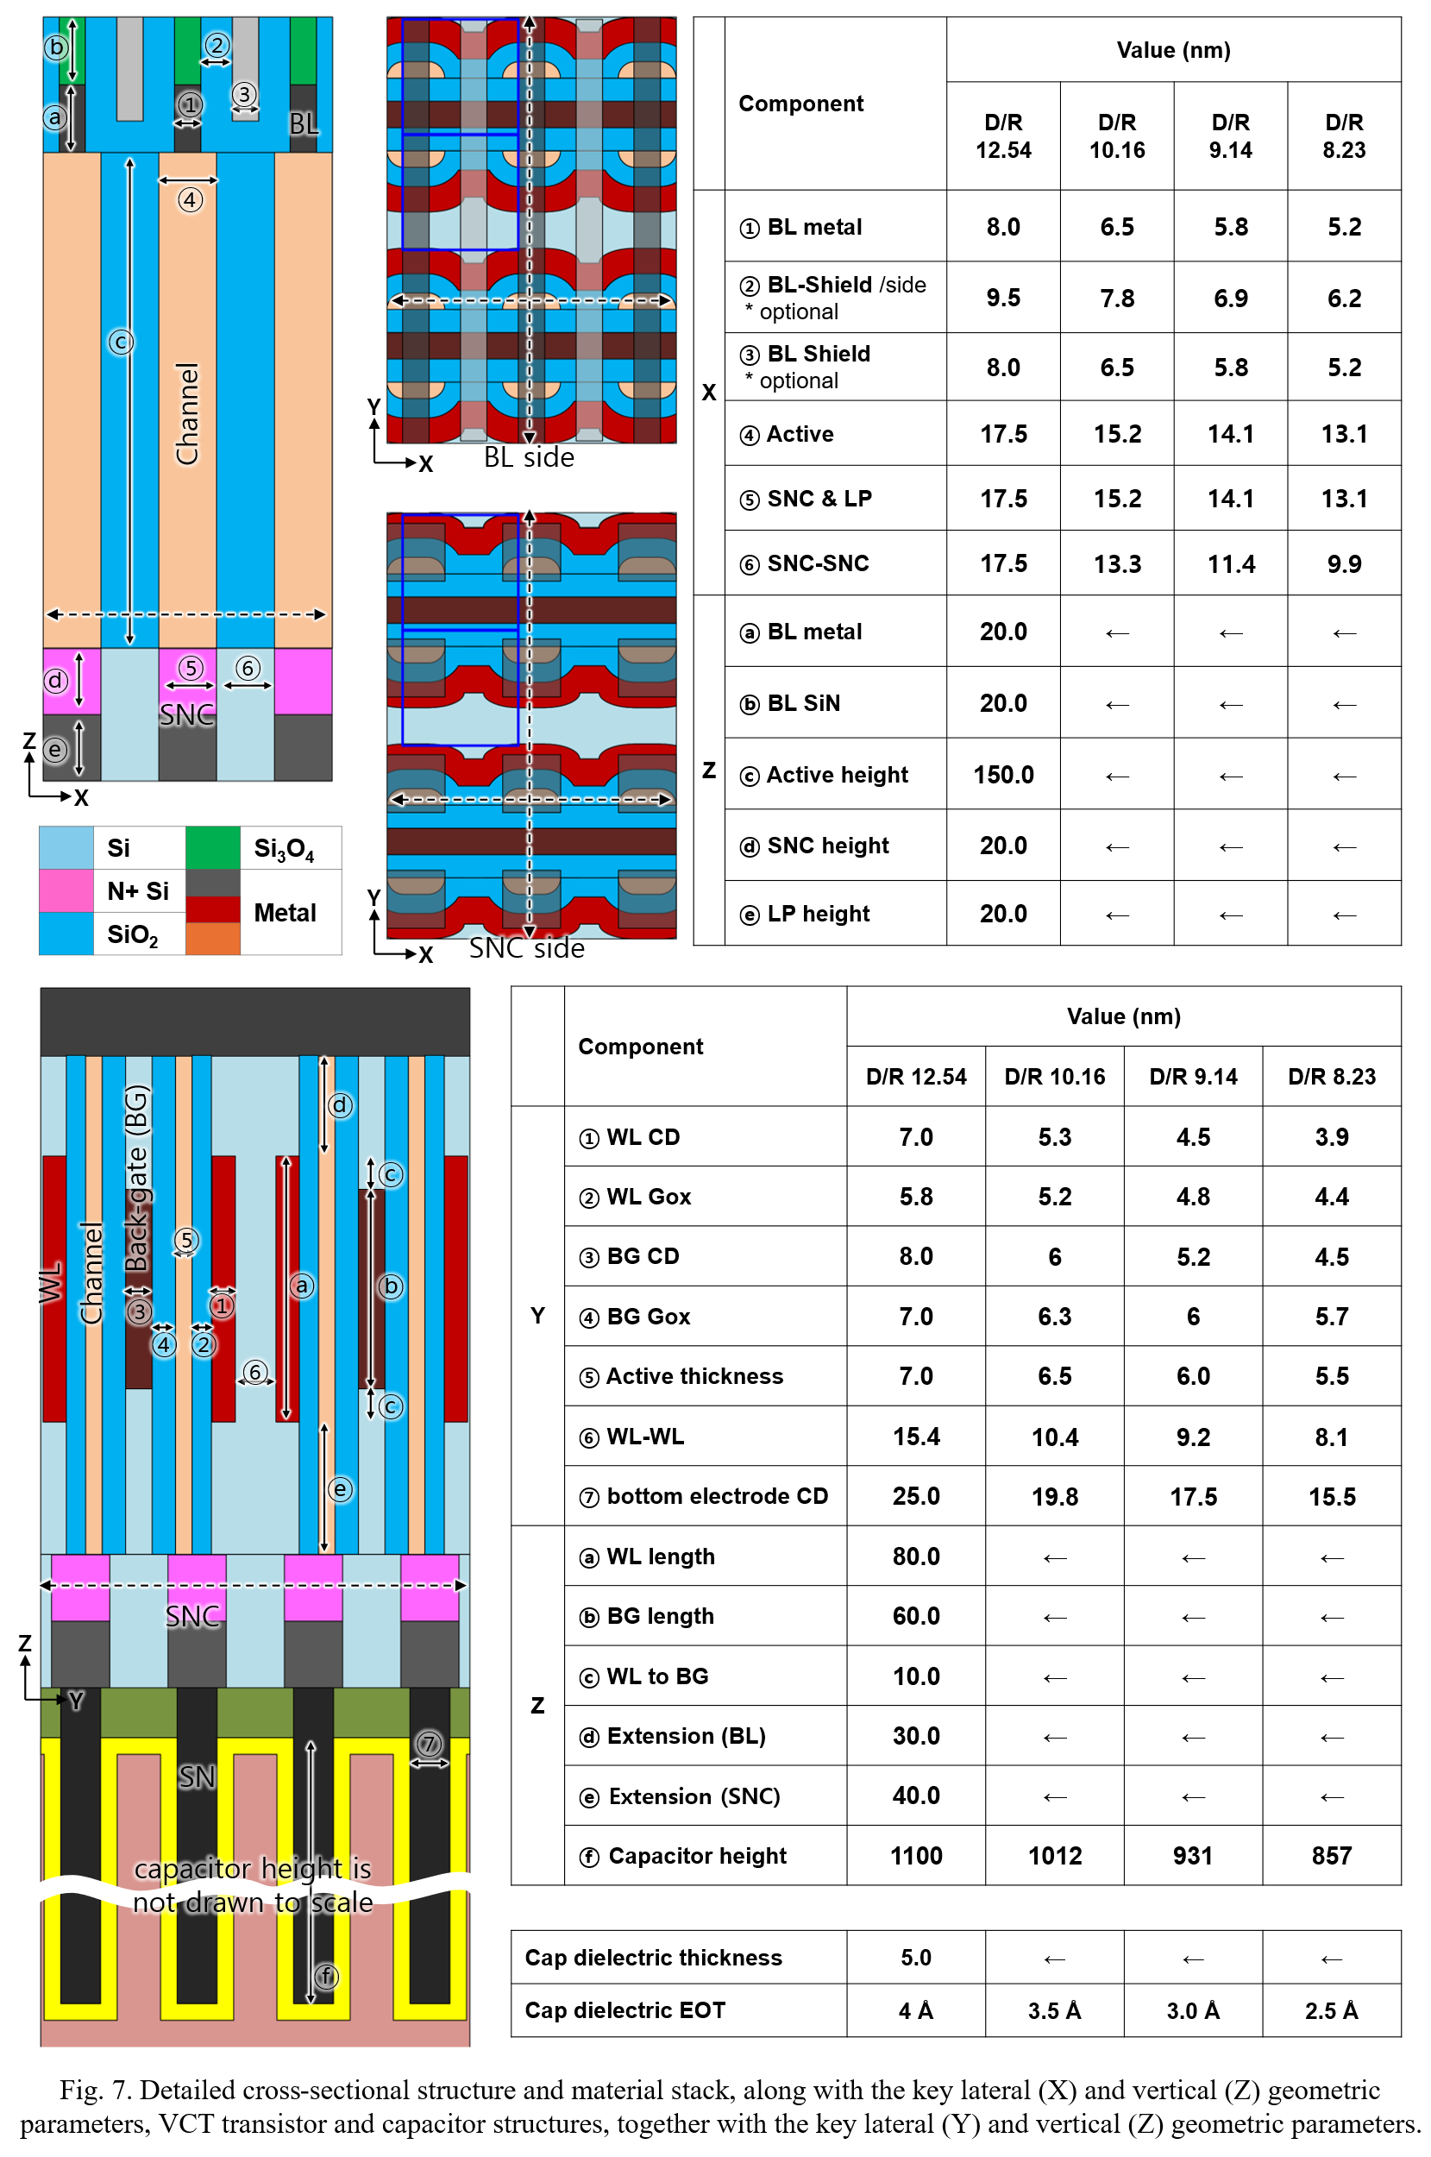
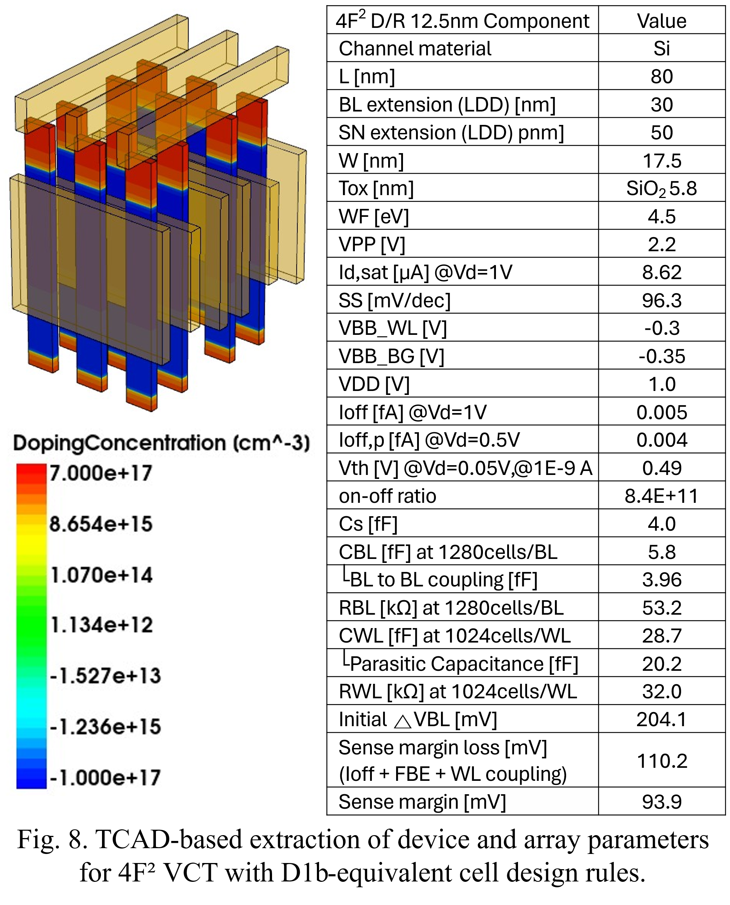
body doping: "BoronActiveConcentration" 1e+17
source doping: "NoReplace" "Eval" "source" 0.05 "evalwin" and "PhosphorusActiveConcentration" "PeakPos" 0 "PeakVal" 6e+19 "ValueAtDepth" 1e+12 "Depth" 0.02 "Gauss" "Factor" 0
drain doping: "NoReplace" "Eval" "source" 0.025 "evalwin" and "PhosphorusActiveConcentration" "PeakPos" 0 "PeakVal" 6e+19 "ValueAtDepth" 1e+12 "Depth" 0.03 "Gauss" "Factor" 0

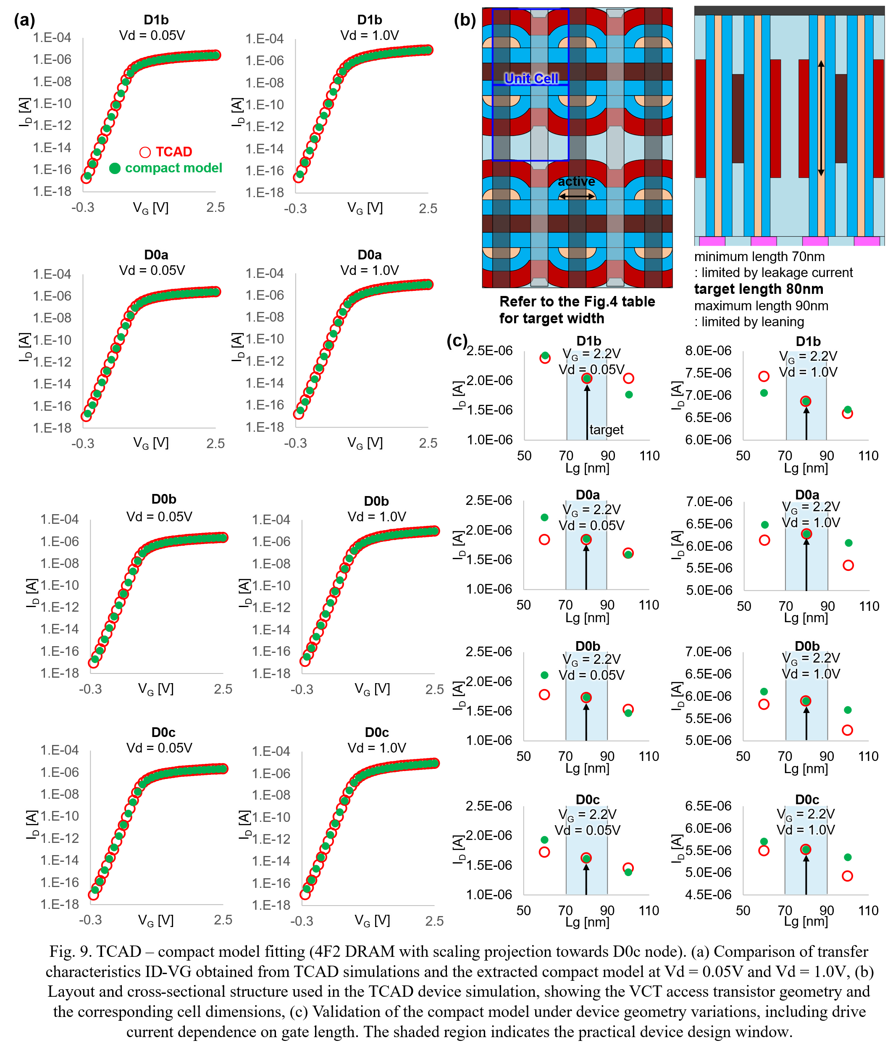

[3D DRAM]
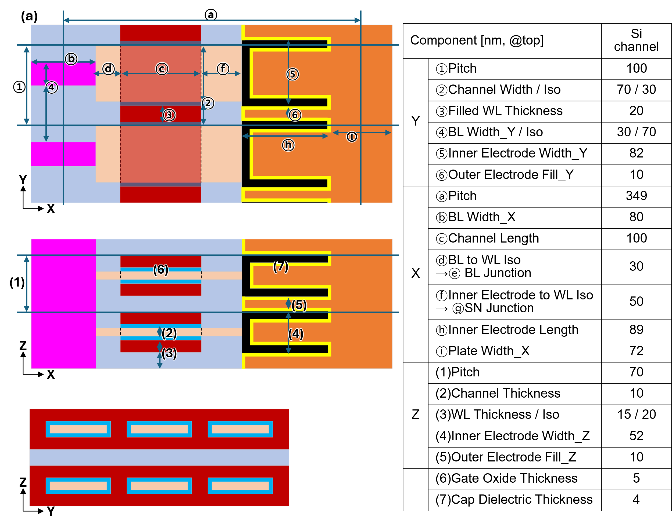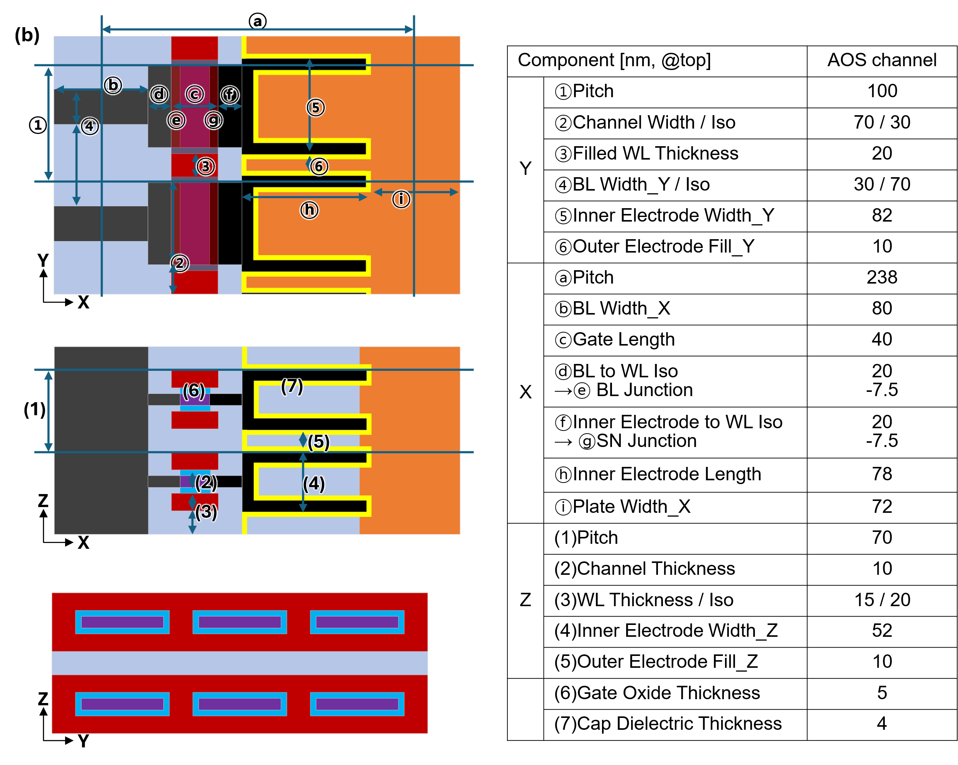
Fig. 10. Structures and dimensions of target 3D DRAM cells used for compact model construction. (a) Si channel, (b) AOS channel.
Source: [6], [7], [8], [9], [10], [11], [12], [13], [14]

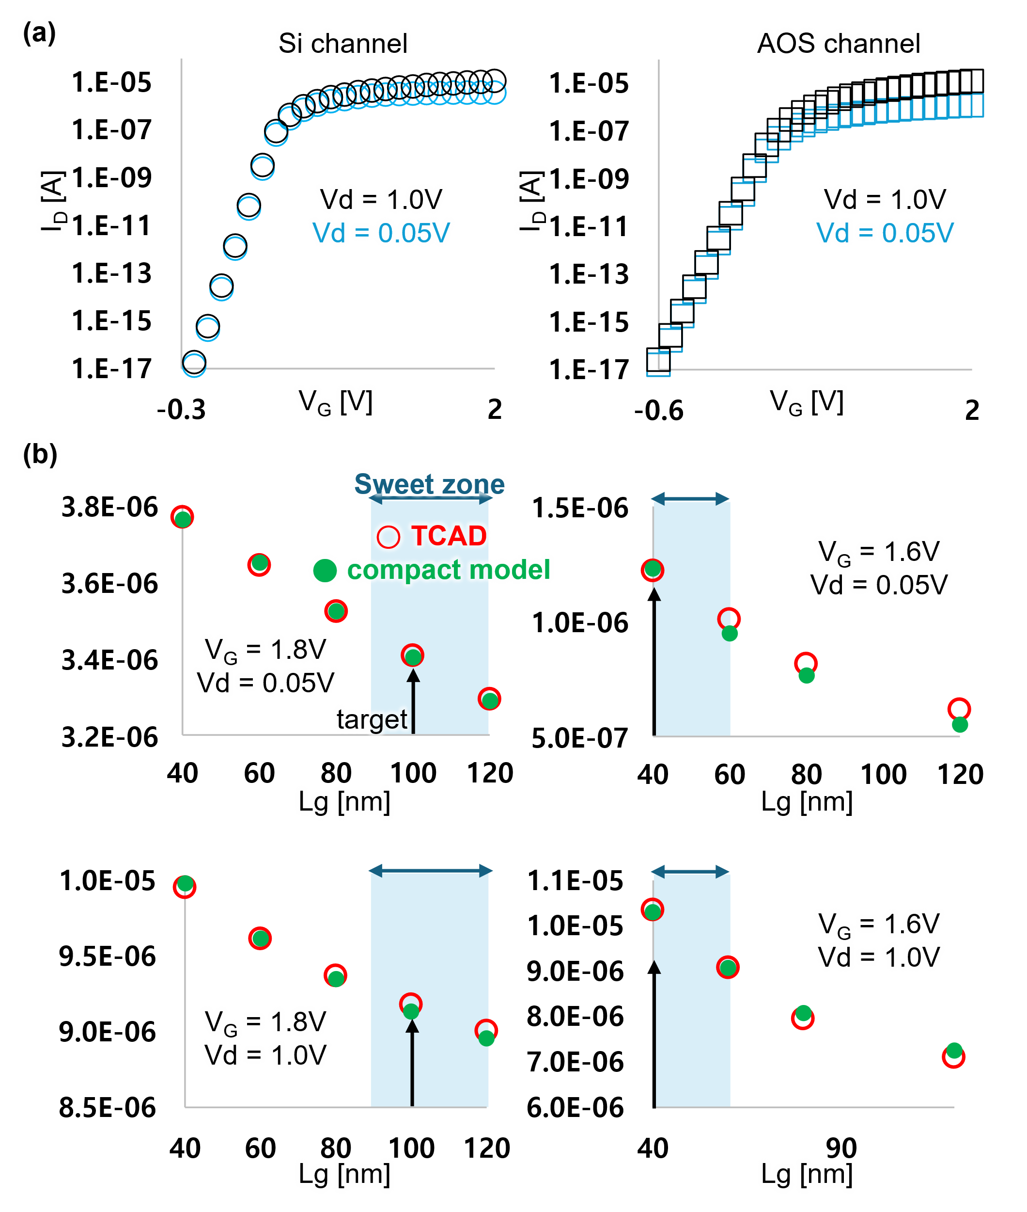
Fig. 11. TCAD-calibrated compact model validation for access transistors. (a) Transfer characteristics (ID–VG), and (b) validation of geometry-dependent behavior, showing Ion versus gate length. The shaded region indicates the recommended model usage (sweet zone) constrained by device performance and structural limits. The gate length is determined by the trade-off between on-current (Ion), off-current (Ioff), and structural constraints such as channel bending effects, which collectively define the viable design space. For the channel width, a target of approximately 70 nm is suggested, as it significantly influences bit density while offering a balanced compromise between scalability and electrical performance.

5. Supported Peri Options (high-voltage)
DRAM periphery transistors require thick-oxide/high-voltage models with breakdown-aware operating windows. The guide provides:
- Voltage domains (VDD, VPP, ISO/EQ/LA/LAB rails).
- Geometry presets for BLSA/SWD transistors.
- Reference schematics for BLSA and WL drivers.
* The high-voltage peripheral transistor models are named tnmos and tpmos.
* For peripheral transistors excluding the high-voltage devices, existing open-source or commercial PDKs can be utilized.

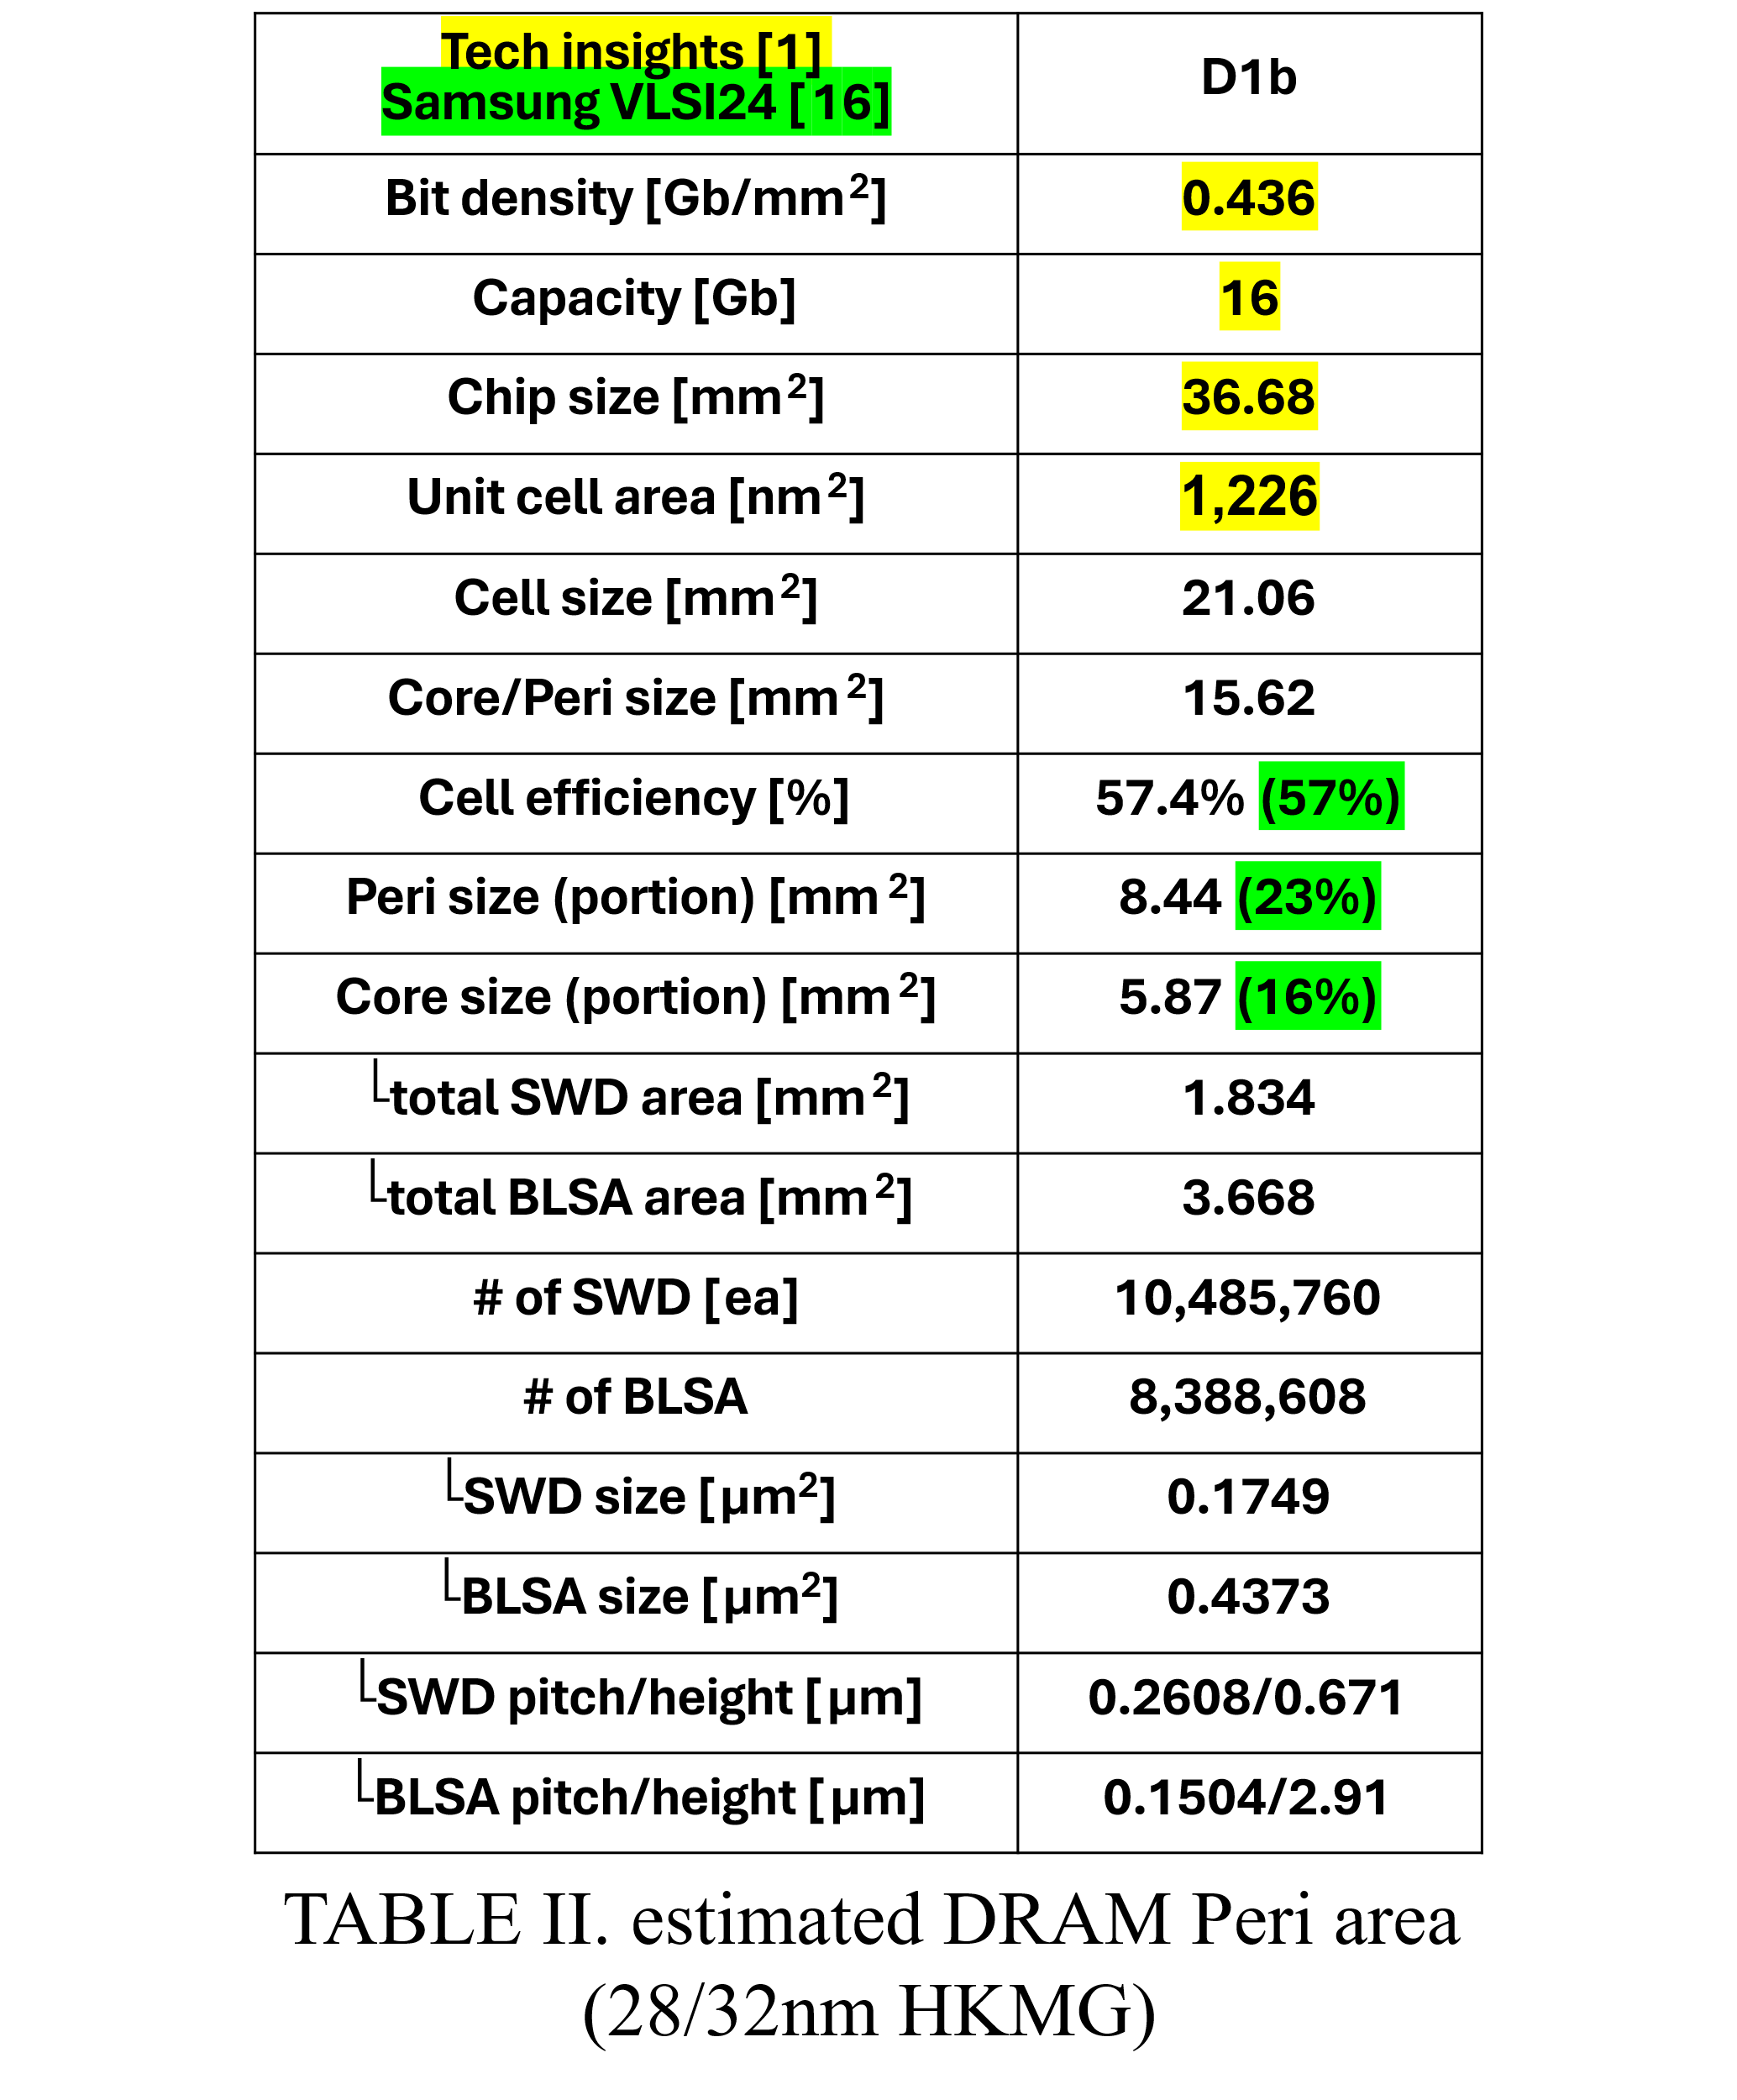

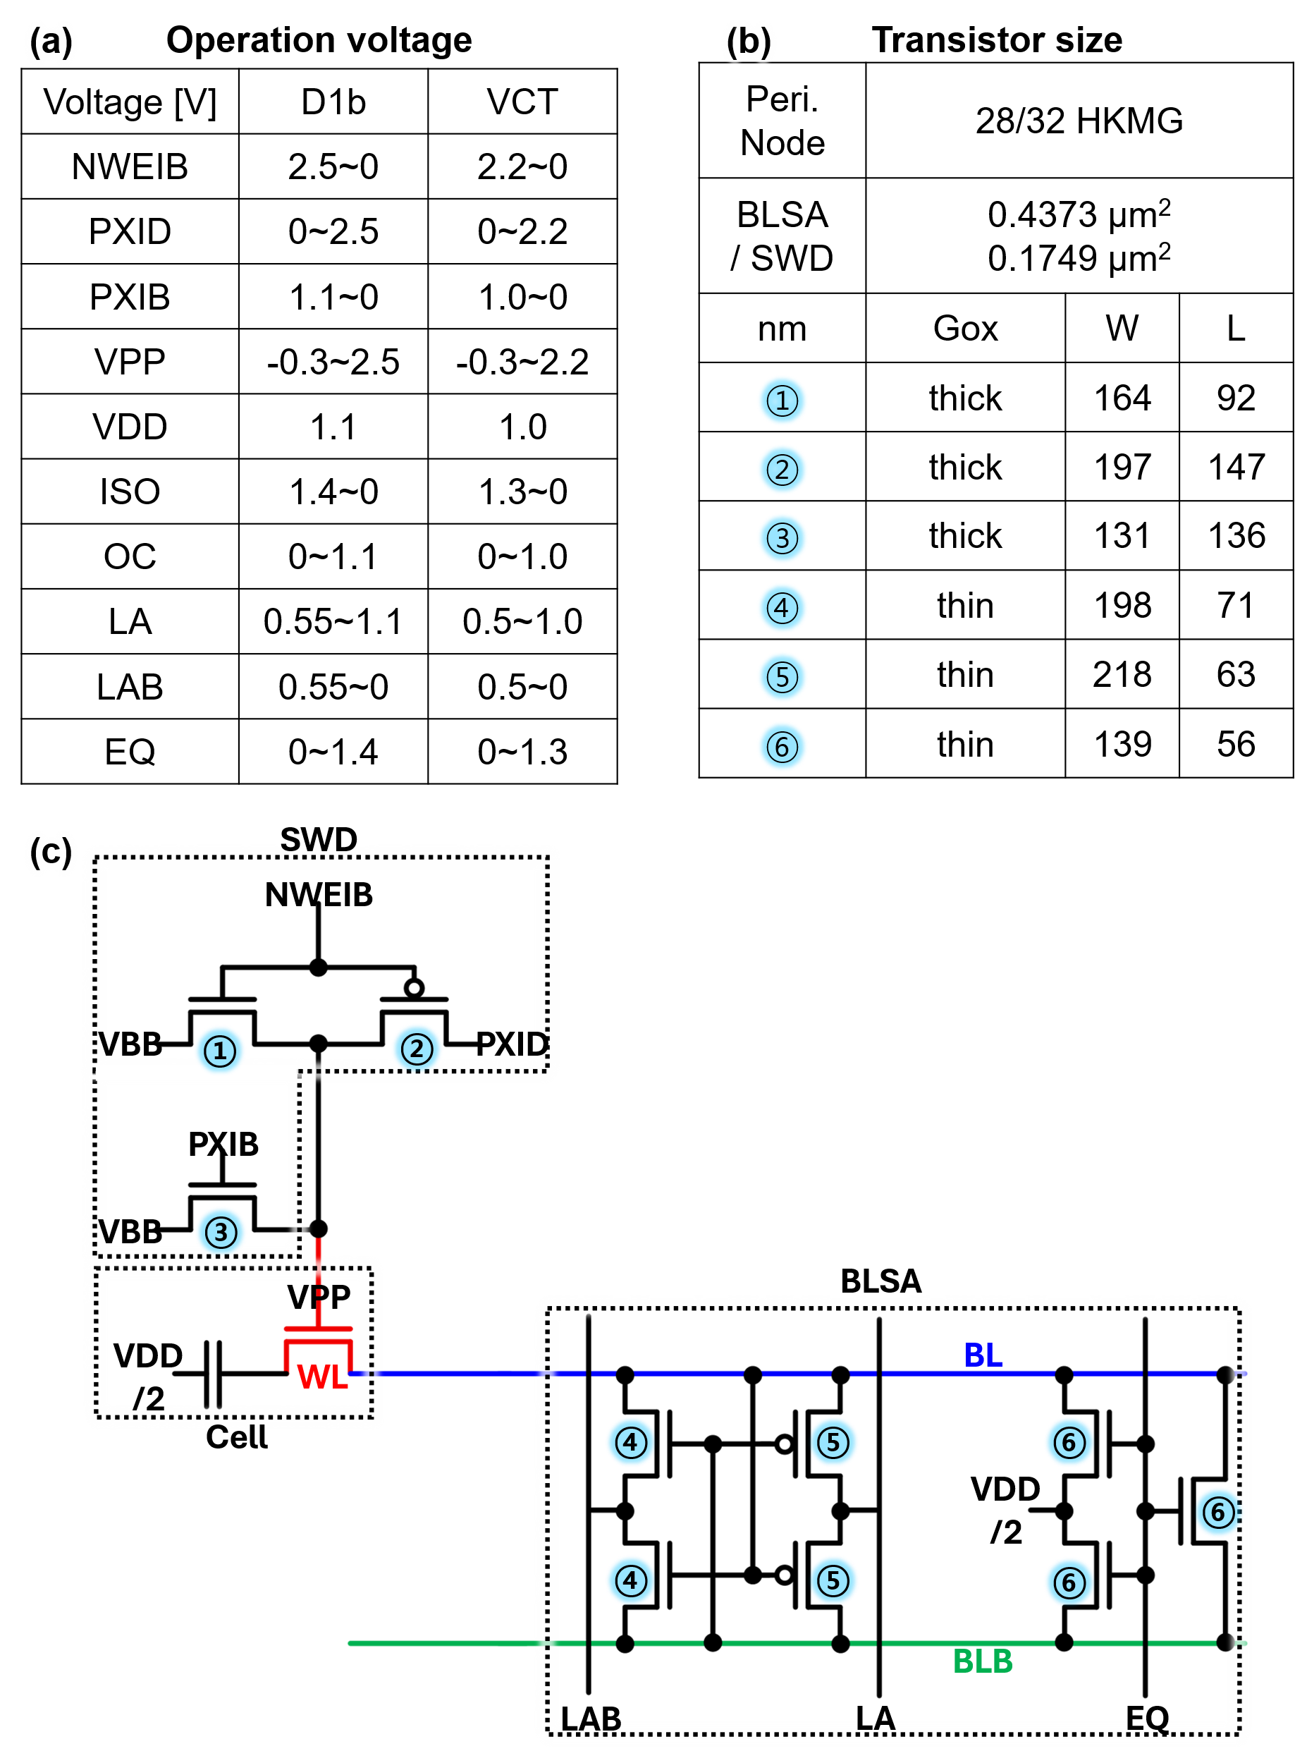
Fig. 12. Peripheral circuit-level abstraction for 2D DRAM. (a) Voltage operating ranges for key peripheral signals used in SWD and BLSA circuits, (b) transistor sizing and technology assumptions based on a 28/32 nm HKMG node, including gate oxide options and W/L configurations, and (c) circuit schematic illustrating the integration of SWD and BLSA.

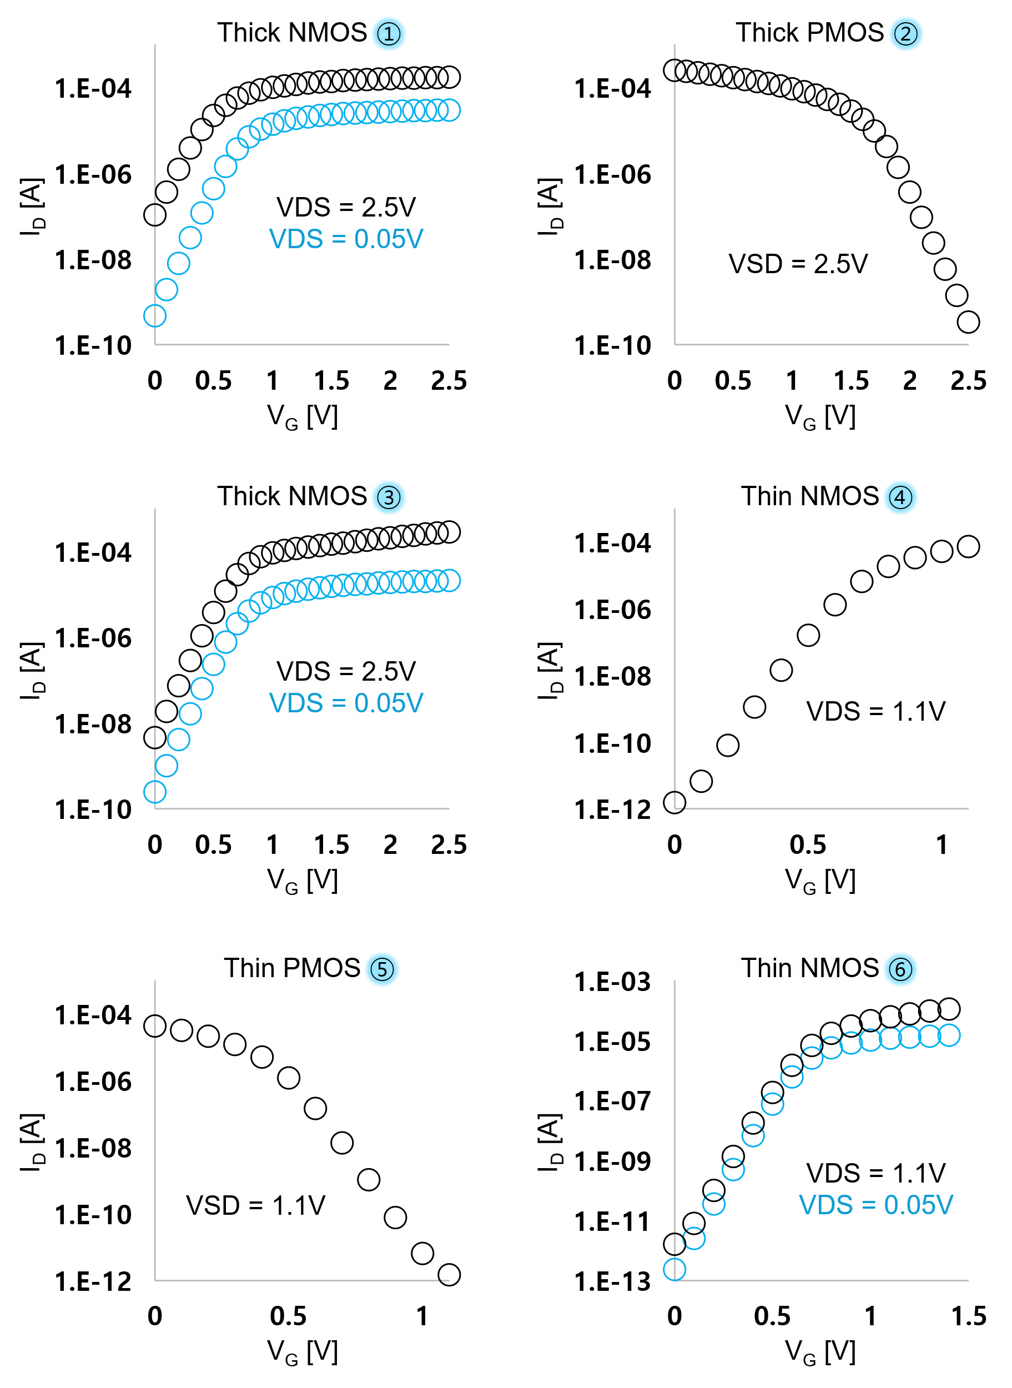
Fig. 13. Characterization of the periphery transistors.

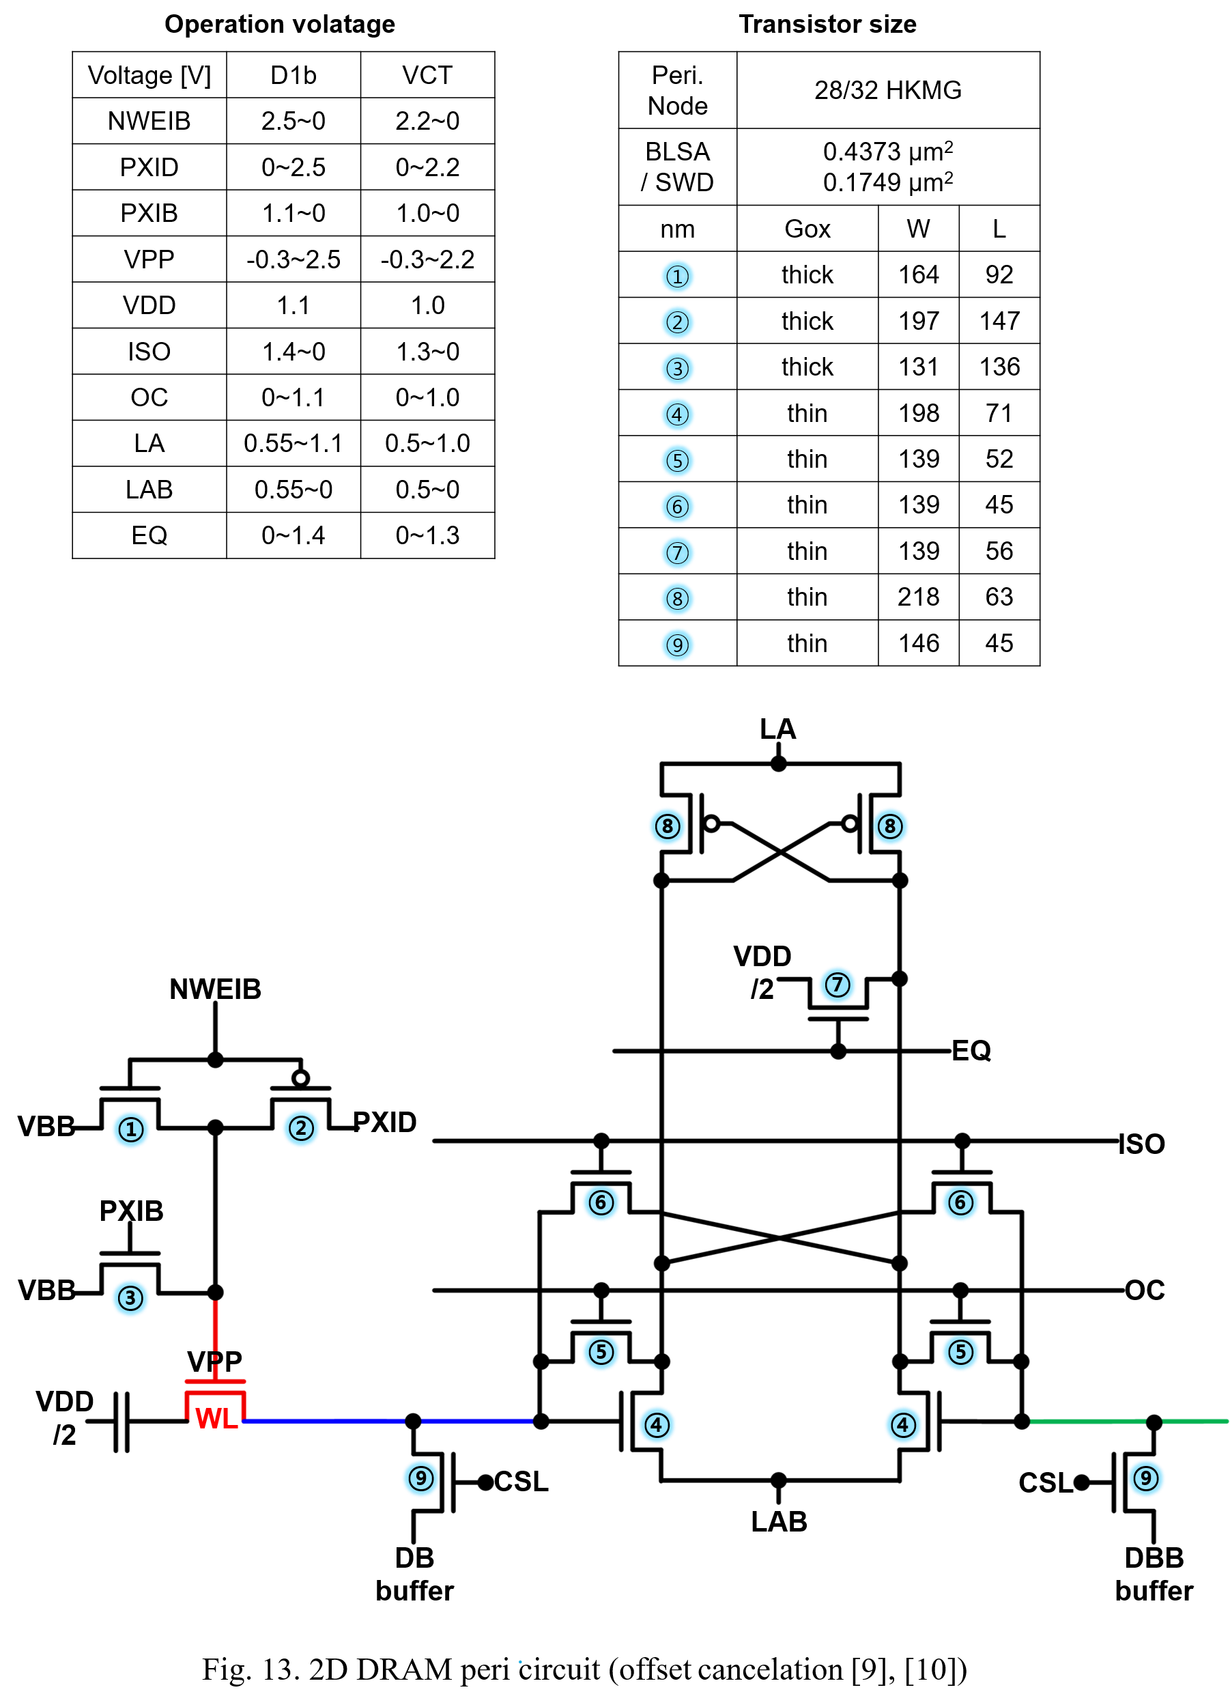
Fig. 14. 2D DRAM periphery circuit (offset cancelation [17], [18])

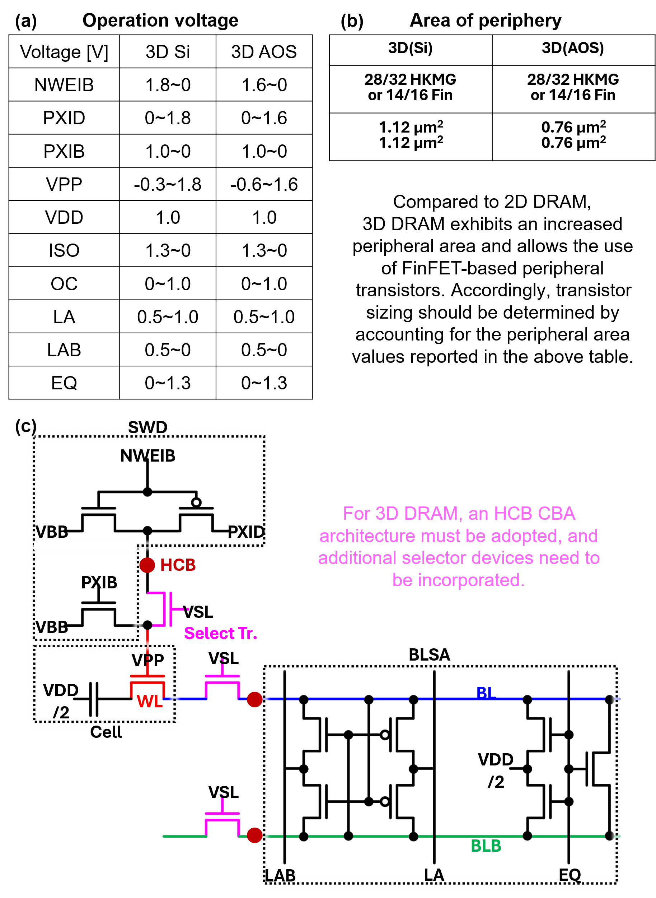
Fig. 15. Peripheral circuit-level abstraction for 3D DRAM under CBA architecture. (a) Voltage domains adapted for 3D Si and AOS channel devices, (b) estimated peripheral area and technology options for BLSA/SWD implementation, and (c) circuit schematic incorporating HCB-based CBA integration with additional selector devices for vertical routing.
Source: [19]

6. SPICE Simulation Example
* The Virtuoso schematic database (data.dm, master.tag, sch.oa) of this example is provided to enable full reproducibility of the SPICE test-bench.
1. After creating the schematic cell, save it.
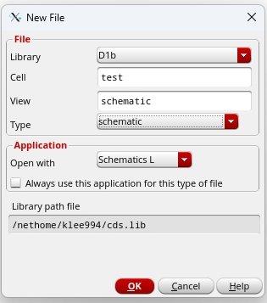
2. Place the "data.dm," "master.tag," and "sch.oa" files in the schematic folder.
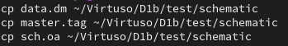
3. Schematic execution
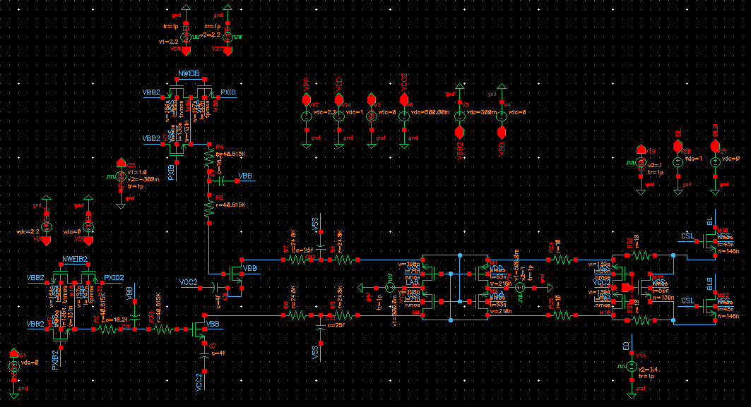
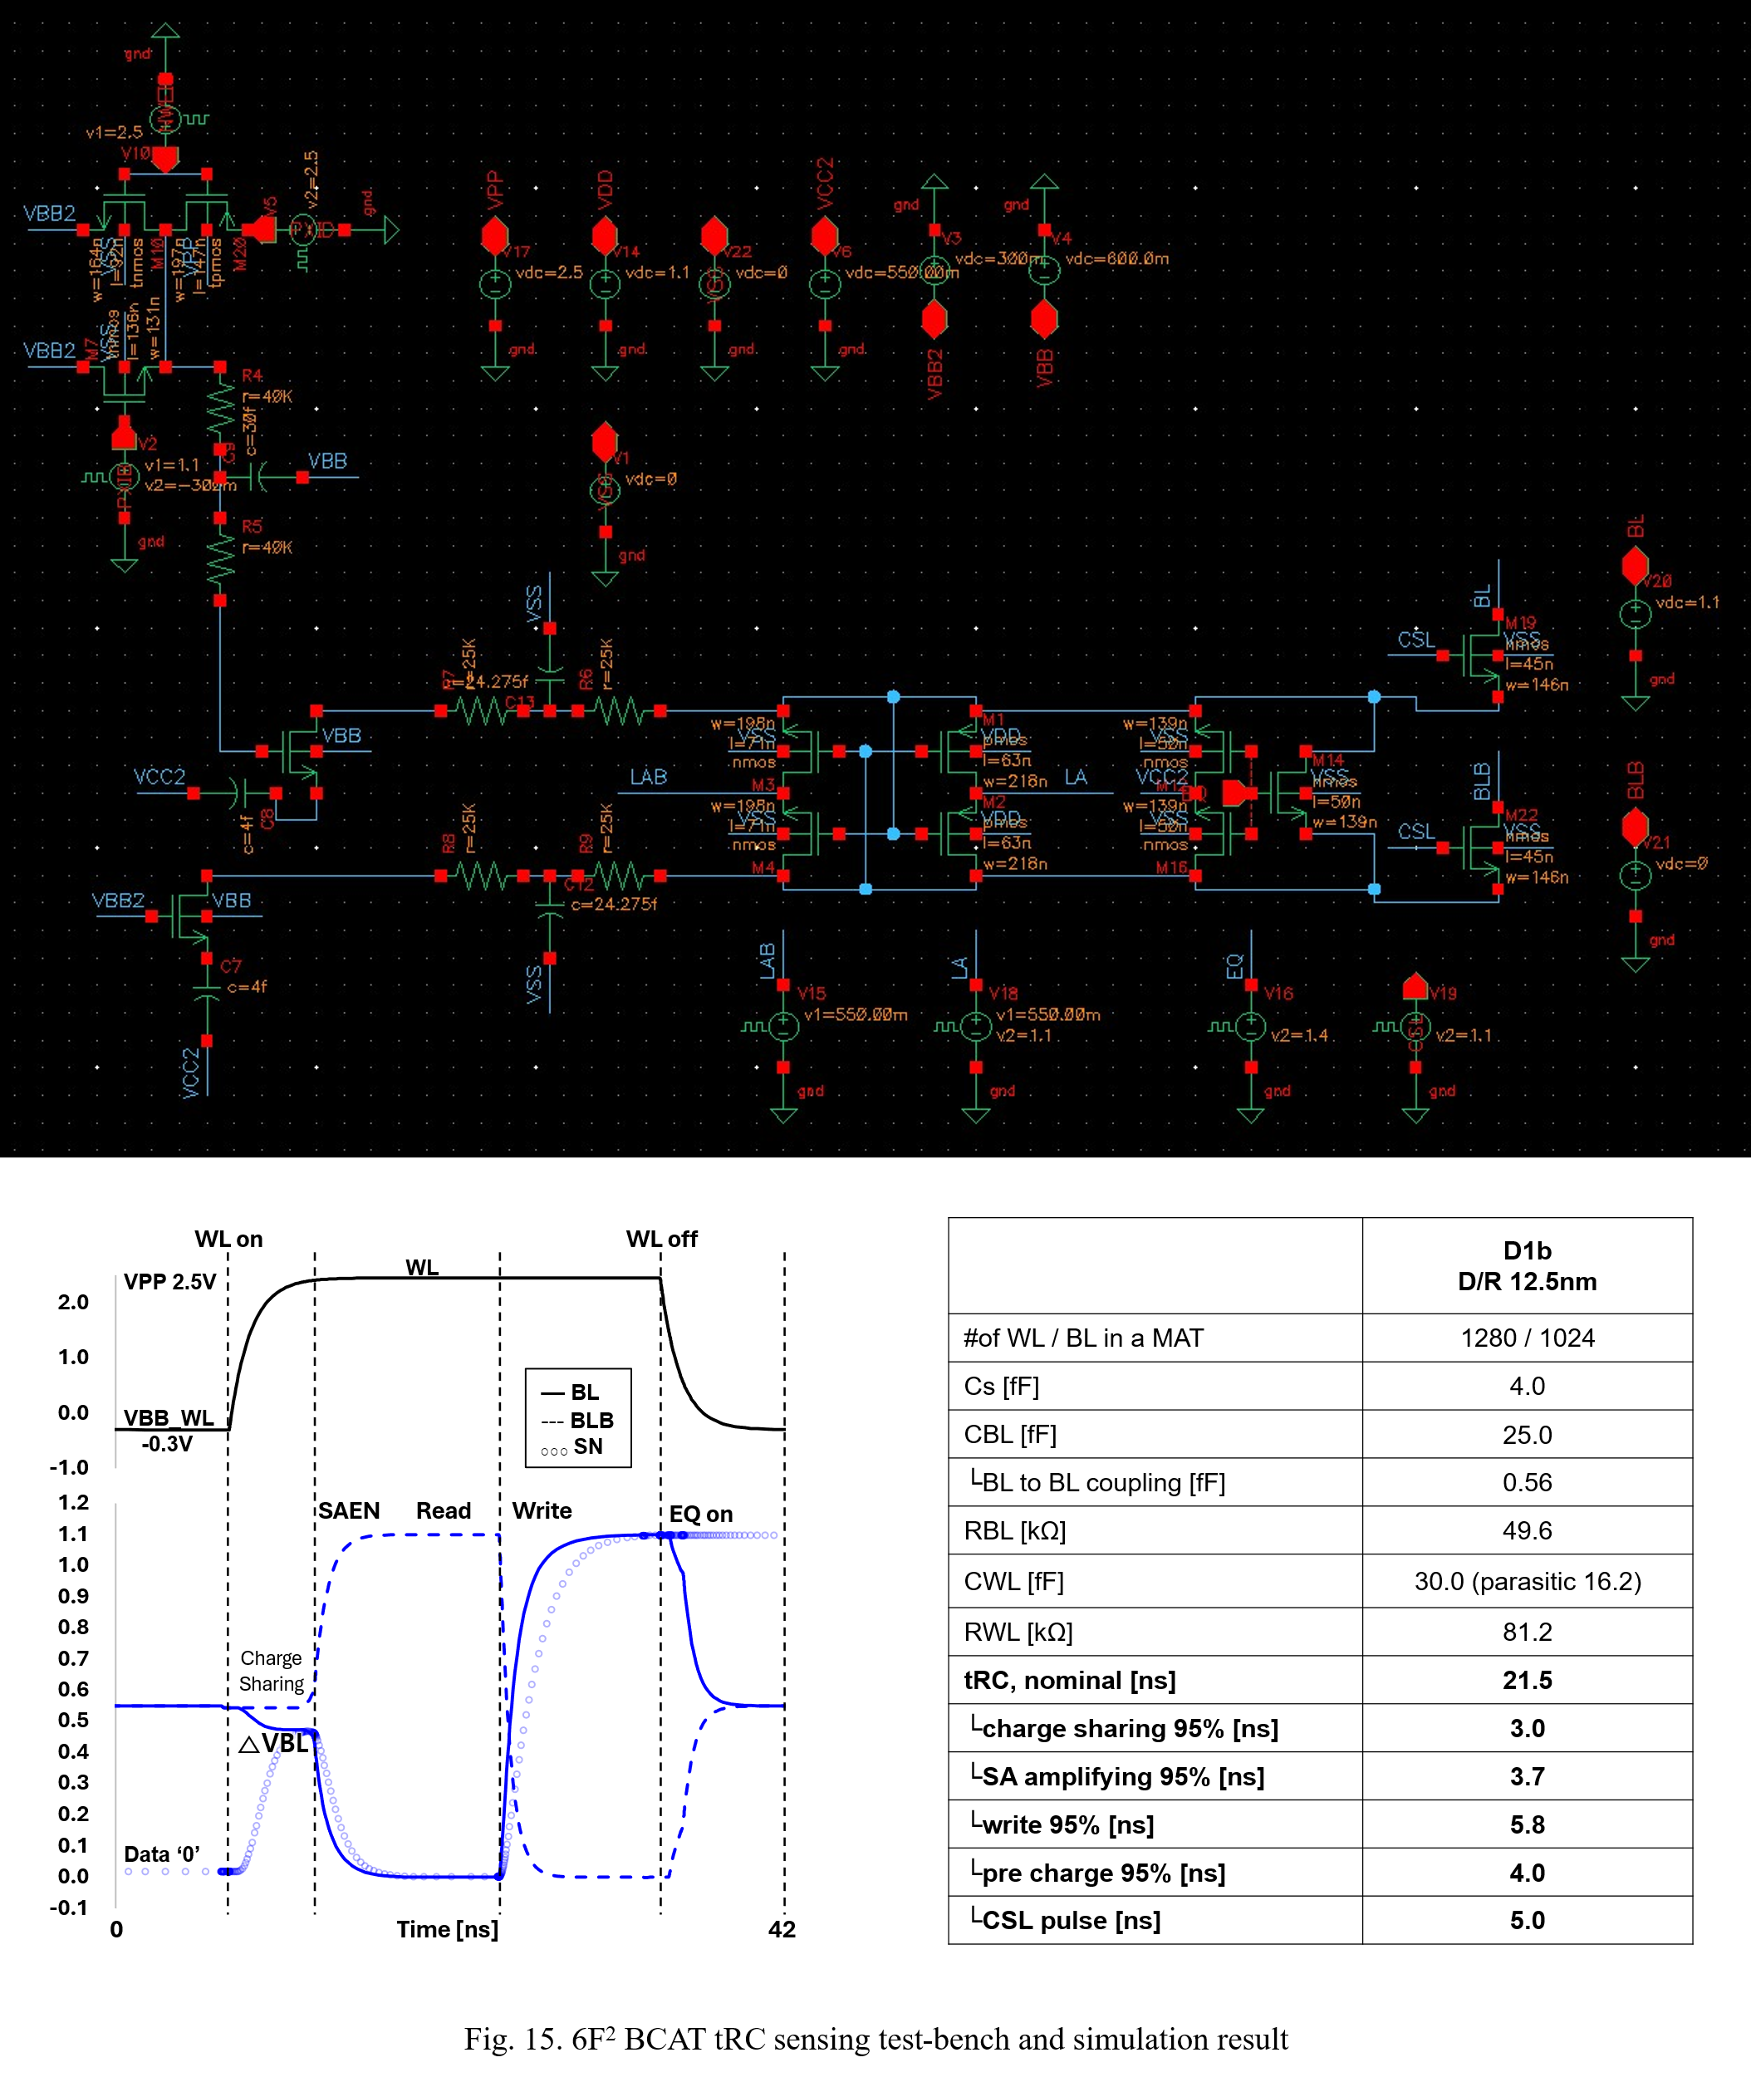
Fig. 16. 6F² BCAT tRC sensing test-bench and simulation result.

7. References
[1] J. Choe, TechInsights report, 2024. https://tinyurl.com/237zzgz7
[2] S. Park et al., IEDM, 2023. doi: 10.1109/IEDM45741.2023.10413704
[3] M. Jeong et al., IRPS, 2024. doi: 10.1109/IRPS48228.2024.10529491
[4] M. Jeong et al., IRPS, 2025. doi: 10.1109/IRPS48204.2025.10982816
[5] J. Park et al., VLSI, 2025. doi: 10.23919/VLSITechnologyandCir65189.2025.11075066
[6] K. Lee et al., TED, 2026. doi: 10.1109/TED.2026.3659106
[7] J.-W. Han, et al., VLSI, 2024. doi: 10.23919/VLSITechnologyandCir57934.2023.10185290
[8] K. S. Choi, et al., VLSI, 2024. doi: 10.1109/VLSITechnologyandCir46783.2024.10631471
[9] X. Ai, et al., IEDM, 2024. doi: 10.1109/IEDM50854.2024.10873307
[10] N. Rassoul, et al., VLSI, 2025. doi: 10.23919/VLSITechnologyandCir65189.2025.11075009
[11] D. Garbin, et al., IEDM, 2025. doi: 10.1109/IEDM50572.2025.11353614
[12] M. Okajima, et al., IEDM, 2025. doi: 10.1109/IEDM50572.2025.11353893
[13] S. Cho, et al., IRPS, 2026. (accepted)
[14] K. A. Aabrar, et al., VLSI, 2024. doi: 10.1109/VLSITechnologyandCir46783.2024.10631312
[15] K. Lee et al., IMW, 2026. (accepted)
[16] K. Lee et al., VLSI, 2024. doi: 10.1109/VLSITechnologyandCir46783.2024.10631320
[17] M. Marazzi et al., ISCA, 2024. doi: 10.1109/ISCA59077.2024.00020
[18] D. H. Kim et al., ISSCC, 2022. doi: 10.1109/ISSCC42614.2022.9731537
[19] K. Lee et al., arXiv, 2026. doi: https://doi.org/10.48550/arXiv.2603.12461

