Automated Restaurant Management System

Project Milestone M1 to M9

# CS243–Database

Spring – 2018

Submitted To

Mr. Najeeb-Ur-Rehman

Submitted By

Mr. M. Atif Bashir (16201519-009)

Mr. Daud Rauf (16201519-023) Section C

Due Date

Tuesday, June 5, 2018



Department of Computer Science

Faculty of Computing and Information Technology

University of Gujrat, Hafiz Hayat Campus

T-CODERS



Semester Project–Spring 2018

CS243 – Data Base System

Project Supervisor: Najeeb-Ur-Rehman, Assistant Professor, CS Dept.

Our proposed solution will help to improve the existing system by optimizing the methods already used. The management will be easier and less hectic. Updating records will be more efficient and centralized so that data integrity is maintained. There is a need for automated database management systems because small-scale businesses are failing to compete.

|  |  |
| --- | --- |
| **Group Members** | |
| **Roll Number** | **Name** |
| **16201519-009** | **Muhammad Atif Bashir** |
| **16201519-023** | **Daud Rauf** |

Automated Restaurant Management System

(ARMS)

Semester Project–Spring 2018 **Introduction (Project Idea):**

This Project Definition provides a brief overview of Automated Restaurant Management System (ARMS) to promote the computer-oriented automation.

Automated Restaurant management system is the system for management of the restaurant business more efficiently. There is a need for an automated database management system because small-scale restaurant businesses are failing to compete with multi-national food chains and thus, local restaurants are going out of business due to poor management methods. By using manual customer ordering it is difficult for waiter, keep the correct customer information and maybe loss the customer information. Our project will not only benefit the business authorities, but also help the employees in their jobs. Moreover, customers will also get benefit, as they will receive their orders on time. ARMS can help the restaurant administrator to manage restaurant management and for customers make their online ordering and reserving table. The project will address the solution of the problem that is commonly faced by small-scale restaurants i.e. check and balance of sales, stock and inventory, identifying trends etc. Other than that, this project is to upgrade the manual system and make the business easy to access and systematic.

**Project Objectives:**

* Efficient management
* Client friendly experience
* Easier updating of records
* Centralized Record Keeping
* Optimized Inventory Controlling **Features:**

Our model can be seen in three perspectives or views and each is different from one another as it is the requirement of our organization to have separate interfaces for different types of users; namely manager view, employee view, and a customer view. The description of those three views, in detail, is as follows:

**i) Manager View:**

The manger will have his login details to access the system. The manager can view the record of all employees, hire/add a new employee to the system, and fire/remove an existing employee from the system. Moreover, the manager can view the inventory and update it too. The manager, can also generate reports on a weekly/monthly basis of employee attendance, orders placed, and expenditure. **ii) Employee View:**

Any employee that is registered by the manager, can logon to the system and will be redirected to the employee’s view. The employee can view his attendance details, look for inventory items, and also check the incoming orders and finish them when delivered.

**iii) Customer View:**

A customer would first be required to register in the system, setting up his account by entering his personal information. Once, registered in the system, he can login to the system. After successfully logging in, the customer can now view the menu, from which he can place an order by selecting the desired items and their respective quantities. The selections would be added to a cart and a receipt will be generated on the screen, once the order is confirmed.

**Data Requirements:**

**Customer**

* Register to the portal.
* Information required is Name, Gender, contact number, Email, address etc.
* Login as authorized user.
* Customer can have order like biryani, burger etc.o Customer can make more than one order from a single login.o Customer should receive a receipt as the confirmation.o Employee will drive to the given address and make sure to deliver within 45 minutes.

**Employee**

* Registered as an employee from manager portal. o Information required is name, Gender, CNIC, address, Contact info and shift timings. o Employee can mark his/her attendance. o Salary of the employee based on the attendance.
* Employee can manage the orders as well as inventory details. o Complaints from customers are also manageable.

**Conceptual Design (Entity Relationship Diagram):**

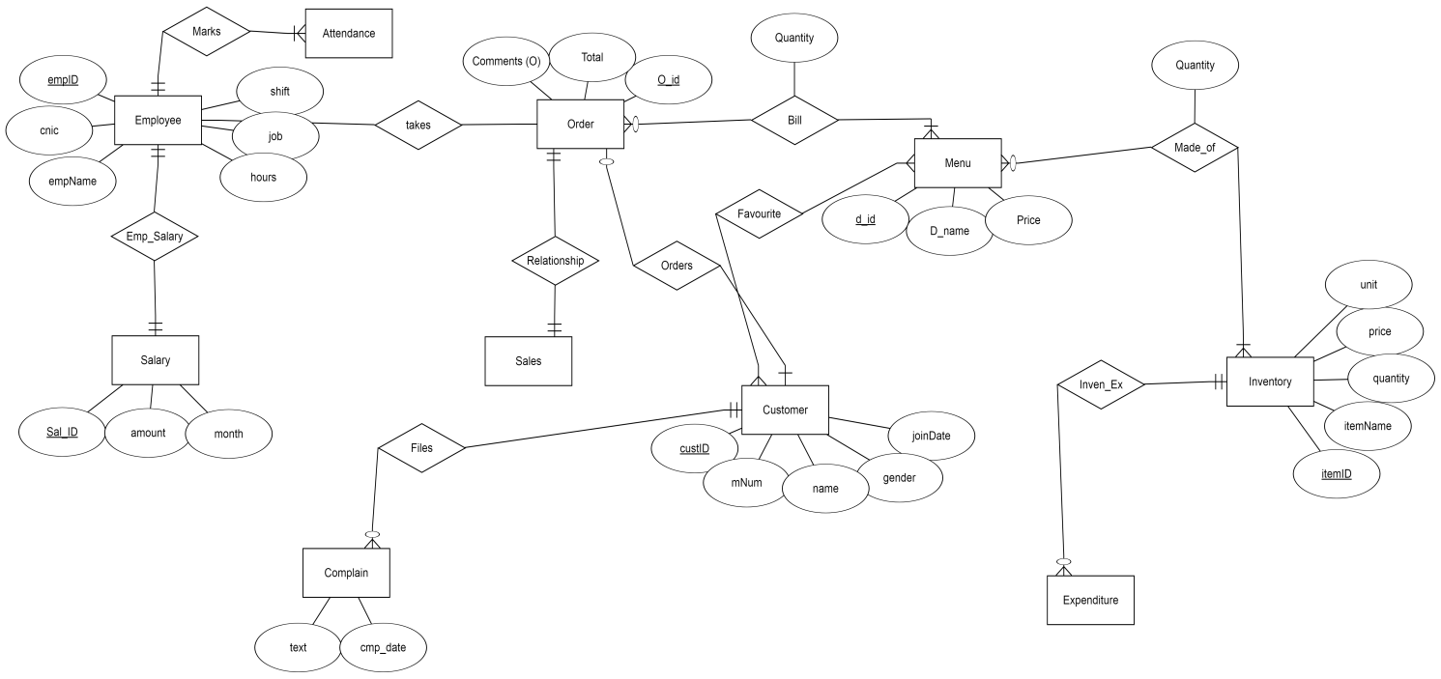

**ERD Explanation:**

In our system, a customer may place order but and order must be placed by a customer. A customer can place many orders at different times when he visits multiple times. A customer also have no or more favorite menu items. An order have multiple or one item from menu list, which is used to generate a bill. Bill also have a quantity of the menu items in that particular order. Sales of the restaurant are related to the total orders placed. An order must belong to the sales. An employee of the restaurant takes order from the customer. Employee marks his attendance. Employee also have his salary. Customer can file a complaint about services by using his order id. Each item in the menu is made up of one or many items in the inventory. Items in the inventory are purchased from vender which is included in expenditures of restaurant.

**Relational Schema:**

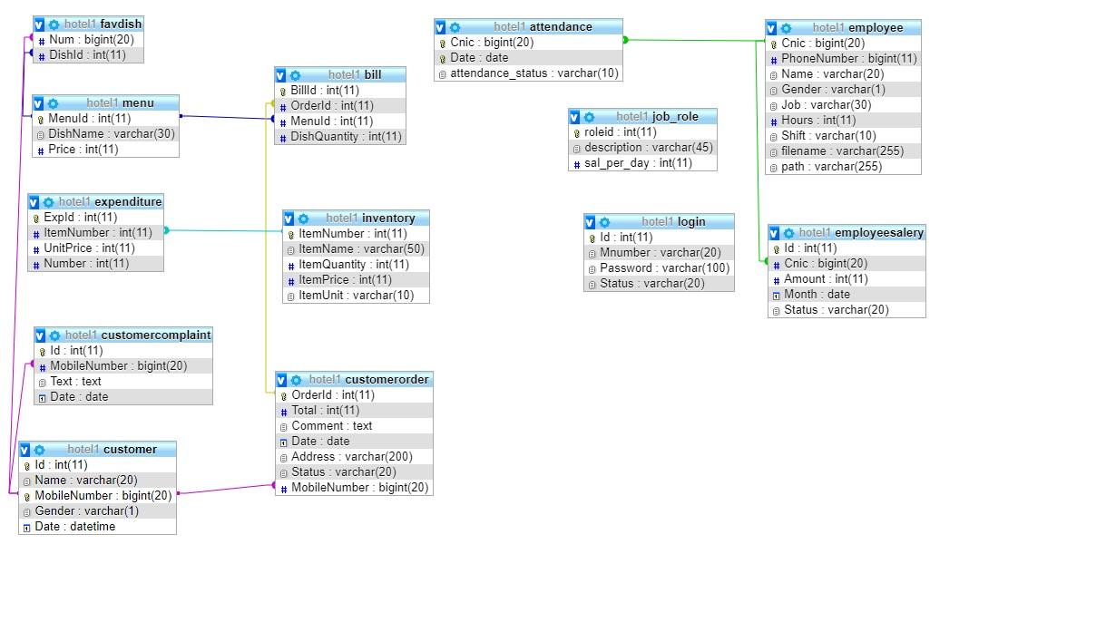

**Physical Database Design:**

CREATE TABLE attendance (

Cnic bigint NOT NULL, Date date NOT NULL,

attendance_status varchar(10) NOT NULL

)

CREATE TABLE bill (

BillId int NOT NULL,

OrderId int DEFAULT NULL,

MenuId int DEFAULT NULL,

DishQuantity int NOT NULL

)

CREATE TABLE customer (

Id int NOT NULL,

Name varchar(20) NOT NULL,

MobileNumber bigint NOT NULL,

Gender varchar(1) NOT NULL,

Date datetime NOT NULL

)

CREATE TABLE customercomplaint (

Id int NOT NULL,

MobileNumber bigint NOT NULL,

Text text NOT NULL,

Date date DEFAULT NULL

)

CREATE TABLE customerorder (

OrderId int NOT NULL,

Total int NOT NULL,

Comment text NOT NULL,

Date date NOT NULL,

Address varchar(200) NOT NULL,

Status varchar(20) NOT NULL,

MobileNumber bigint NOT NULL

)

CREATE TABLE employee (

Cnic bigint NOT NULL,

PhoneNumber bigint DEFAULT NULL,

Name varchar(20) NOT NULL,

Gende varchar(1) NOT NULL,

Job varchar(30) NOT NULL,

Hour int DEFAULT NULL, Shift varchar(10) DEFAULT NULL, filename varchar(255) NOT NULL, path varchar(255) NOT NULL

)

CREATE TABLE employeesalery (

Id int NOT NULL,

Cnic bigint NOT NULL,

Amount int NOT NULL,

Month date NOT NULL,

Status varchar(20) NOT NULL

)

CREATE TABLE expenditure (

ExpId int NOT NULL,

ItemNumber int NOT NULL,

UnitPrice int NOT NULL,

Number int NOT NULL

)

CREATE TABLE favdish (

Num bigint NOT NULL,

DishId int DEFAULT NULL

)

CREATE TABLE inventory (

ItemNumber int NOT NULL,

ItemName varchar(50) NOT NULL,

ItemQuantity int NOT NULL,

ItemPrice int NOT NULL,

ItemUnit varchar(10) NOT NULL

)

CREATE TABLE job_role ( roleid int NOT NULL, description varchar(45) NOT NULL, sal_per_day int NOT NULL

)

CREATE TABLE login (

Id int NOT NULL,

Mnumber varchar(20) NOT NULL,

Password varchar(100) NOT NULL,

Status varchar(20) NOT NULL

)

CREATE TABLE menu (

MenuId int NOT NULL,

DishName varchar(30) NOT NULL,

Price int NOT NULL

)

ALTER TABLE attendance

ADD UNIQUE KEY unique_index (Cnic,Date),

ADD KEY on emp table (Cnic);

ALTER TABLE bill

ADD PRIMARY KEY (BillId),

ADD KEY on order table (OrderId),

ADD KEY bill_ibfk_1 (MenuId);

ALTER TABLE customer

ADD PRIMARY KEY (MobileNumber),

ADD UNIQUE KEY Id (Id);

ALTER TABLE customercomplaint

ADD PRIMARY KEY (Id),

ADD KEY on custom table (MobileNumber);

ALTER TABLE customerorder

ADD PRIMARY KEY (OrderId),

ADD KEY customerM (MobileNumber);

ALTER TABLE employee

ADD PRIMARY KEY (Cnic);

ALTER TABLE employeesalery

ADD PRIMARY KEY (Id),

ADD KEY emp cnic (Cnic);

ALTER TABLE expenditure

ADD PRIMARY KEY (ExpId),

ADD KEY inventory (ItemNumber);

ALTER TABLE favdish

ADD KEY Num (Num),

ADD KEY favdishToMenu (DishId);

ALTER TABLE inventory

ADD PRIMARY KEY (ItemNumber);

ALTER TABLE job_role

ADD PRIMARY KEY (roleid);

ALTER TABLE login

ADD PRIMARY KEY (Id),

ADD KEY on mobile (Mnumber);

ALTER TABLE menu

ADD PRIMARY KEY (MenuId);

ALTER TABLE bill

MODIFY BillId int NOT NULL;

ALTER TABLE customer

MODIFY Id int NOT NULL ;

ALTER TABLE customercomplaint

MODIFY Id int NOT NULL ;

ALTER TABLE customerorder

MODIFY OrderId int NOT NULL ;

ALTER TABLE employeesalery

MODIFY Id int NOT NULL;

ALTER TABLE expenditure

MODIFY ExpId int NOT NULL ;

ALTER TABLE inventory

MODIFY ItemNumber int NOT NULL;

ALTER TABLE job_role

MODIFY roleid int NOT NULL;

ALTER TABLE login

MODIFY Id int NOT NULL ;

ALTER TABLE menu

MODIFY MenuId int NOT NULL;

ALTER TABLE attendance

ADD CONSTRAINT on emp table FOREIGN KEY (Cnic) REFERENCES employee (Cnic);

ALTER TABLE bill

ADD CONSTRAINT bill_ibfk_1 FOREIGN KEY (MenuId) REFERENCES menu (MenuId) ,

ADD CONSTRAINT on order tabl FOREIGN KEY (OrderId) REFERENCES customerorder (OrderId) ;

ALTER TABLE customercomplaint

ADD CONSTRAINT on custom table FOREIGN KEY (MobileNumber) REFERENCES customer (MobileNumber) ;

ALTER TABLE customerorder

ADD CONSTRAINT customerM FOREIGN KEY (MobileNumber) REFERENCES customer (MobileNumber) ;

ALTER TABLE employeesalery

ADD CONSTRAINT emp cnic FOREIGN KEY (Cnic) REFERENCES employee (Cnic);

ALTER TABLE expenditure

ADD CONSTRAINT inventory FOREIGN KEY (ItemNumber) REFERENCES inventory (ItemNumber);

ALTER TABLE favdish

ADD CONSTRAINT favdishToMenu FOREIGN KEY (DishId) REFERENCES menu (MenuId) ,

ADD CONSTRAINT favdish_ibfk_1 FOREIGN KEY (Num) REFERENCES customer

(MobileNumber);

All the Users Privileges are added in the Queries for table and column:

|  |  |
| --- | --- |
| **Privilege Statements** | **Privilege**  **Description** |
| DELETE | Allows a user to delete rows from tables within the schema |
| INSERT | Allows a user to insert rows of data into tables within the schema |
| REFERENCES | Allows a user to set up references to primary keys within the schema |
| SELECT | Allows a user to select rows from tables within the schema |
| TRIGGER | Allows a user to create triggers on tables within the schema |
| UPDATE | Allows a user to update rows in tables within the schema |
| EXECUTE | Allows users to execute functions or stored procedures within the schema |

**DDL Privileges are:**

CREATE TABLE attendance (

Cnic bigint NOT NULL, Date date NOT NULL,

attendance_status varchar(10) NOT NULL

)

CREATE TABLE bill (

BillId int NOT NULL,

OrderId int DEFAULT NULL,

MenuId int DEFAULT NULL,

DishQuantity int NOT NULL

)

CREATE TABLE customer (

Id int NOT NULL,

Name varchar(20) NOT NULL,

MobileNumber bigint NOT NULL,

Gender varchar(1) NOT NULL,

Date datetime NOT NULL

)

CREATE TABLE customercomplaint (

Id int NOT NULL,

MobileNumber bigint NOT NULL,

Text text NOT NULL,

Date date DEFAULT NULL

)

CREATE TABLE customerorder (

OrderId int NOT NULL,

Total int NOT NULL,

Comment text NOT NULL,

Date date NOT NULL,

Address varchar(200) NOT NULL,

Status varchar(20) NOT NULL,

MobileNumber bigint NOT NULL

)

CREATE TABLE employee (

Cnic bigint NOT NULL,

PhoneNumber bigint DEFAULT NULL,

Name varchar(20) NOT NULL,

Gende varchar(1) NOT NULL,

Job varchar(30) NOT NULL,

Hour int DEFAULT NULL, Shift varchar(10) DEFAULT NULL, filename varchar(255) NOT NULL, path varchar(255) NOT NULL

)

CREATE TABLE employeesalery (

Id int NOT NULL,

Cnic bigint NOT NULL,

Amount int NOT NULL,

Month date NOT NULL,

Status varchar(20) NOT NULL

)

CREATE TABLE expenditure (

ExpId int NOT NULL,

ItemNumber int NOT NULL,

UnitPrice int NOT NULL,

Number int NOT NULL

)

CREATE TABLE favdish (

Num bigint NOT NULL,

DishId int DEFAULT NULL

)

CREATE TABLE inventory (

ItemNumber int NOT NULL,

ItemName varchar(50) NOT NULL,

ItemQuantity int NOT NULL,

ItemPrice int NOT NULL,

ItemUnit varchar(10) NOT NULL

)

CREATE TABLE job_role ( roleid int NOT NULL, description varchar(45) NOT NULL, sal_per_day int NOT NULL )

CREATE TABLE login (

Id int NOT NULL,

Mnumber varchar(20) NOT NULL,

Password varchar(100) NOT NULL,

Status varchar(20) NOT NULL

)

CREATE TABLE menu (

MenuId int NOT NULL,

DishName varchar(30) NOT NULL,

Price int NOT NULL

)

ALTER TABLE attendance

ADD UNIQUE KEY unique_index (Cnic,Date),

ADD KEY on emp table (Cnic);

ALTER TABLE bill

ADD PRIMARY KEY (BillId),

ADD KEY on order table (OrderId),

ADD KEY bill_ibfk_1 (MenuId);

ALTER TABLE customer

ADD PRIMARY KEY (MobileNumber),

ADD UNIQUE KEY Id (Id);

ALTER TABLE customercomplaint

ADD PRIMARY KEY (Id),

ADD KEY on custom table (MobileNumber);

ALTER TABLE customerorder

ADD PRIMARY KEY (OrderId),

ADD KEY customerM (MobileNumber);

ALTER TABLE employee

ADD PRIMARY KEY (Cnic);

ALTER TABLE employeesalery

ADD PRIMARY KEY (Id),

ADD KEY emp cnic (Cnic);

ALTER TABLE expenditure

ADD PRIMARY KEY (ExpId),

ADD KEY inventory (ItemNumber);

ALTER TABLE favdish

ADD KEY Num (Num),

ADD KEY favdishToMenu (DishId);

ALTER TABLE inventory

ADD PRIMARY KEY (ItemNumber);

ALTER TABLE job_role

ADD PRIMARY KEY (roleid);

ALTER TABLE login

ADD PRIMARY KEY (Id),

ADD KEY on mobile (Mnumber);

ALTER TABLE menu

ADD PRIMARY KEY (MenuId);

ALTER TABLE bill

MODIFY BillId int NOT NULL;

ALTER TABLE customer

MODIFY Id int NOT NULL ;

ALTER TABLE customercomplaint

MODIFY Id int NOT NULL ;

ALTER TABLE customerorder

MODIFY OrderId int NOT NULL ;

ALTER TABLE employeesalery

MODIFY Id int NOT NULL;

ALTER TABLE expenditure

MODIFY ExpId int NOT NULL ;

ALTER TABLE inventory

MODIFY ItemNumber int NOT NULL;

ALTER TABLE job_role

MODIFY roleid int NOT NULL;

ALTER TABLE login

MODIFY Id int NOT NULL ;

ALTER TABLE menu

MODIFY MenuId int NOT NULL;

ALTER TABLE attendance

ADD CONSTRAINT on emp table FOREIGN KEY (Cnic) REFERENCES employee (Cnic);

ALTER TABLE bill

ADD CONSTRAINT bill_ibfk_1 FOREIGN KEY (MenuId) REFERENCES menu (MenuId) ,

ADD CONSTRAINT on order tabl FOREIGN KEY (OrderId) REFERENCES customerorder (OrderId) ;

ALTER TABLE customercomplaint

ADD CONSTRAINT on custom table FOREIGN KEY (MobileNumber) REFERENCES customer (MobileNumber) ;

ALTER TABLE customerorder

ADD CONSTRAINT customerM FOREIGN KEY (MobileNumber) REFERENCES customer (MobileNumber) ;

ALTER TABLE employeesalery

ADD CONSTRAINT emp cnic FOREIGN KEY (Cnic) REFERENCES employee (Cnic);

ALTER TABLE expenditure

ADD CONSTRAINT inventory FOREIGN KEY (ItemNumber) REFERENCES inventory (ItemNumber);

ALTER TABLE favdish

ADD CONSTRAINT favdishToMenu FOREIGN KEY (DishId) REFERENCES menu (MenuId) ,

ADD CONSTRAINT favdish_ibfk_1 FOREIGN KEY (Num) REFERENCES customer

(MobileNumber);

**DML privileges are:**

INSERT INTO attendance (Cnic, Date, attendance_status)

INSERT INTO bill (BillId, OrderId, MenuId, DishQuantity)

INSERT INTO customer (Id, Name, MobileNumber, Gender, Date)

INSERT INTO customercomplaint (Id, MobileNumber, Text, Date)

INSERT INTO customerorder (OrderId, Total, Comment, Date, Address, Status, MobileNumber)

INSERT INTO employee (Cnic, PhoneNumber, Name, Gender, Job, Hours, Shift, filename, path)

INSERT INTO favdish (Num, DishId)

INSERT INTO inventory (ItemNumber, ItemName, ItemQuantity, ItemPrice, ItemUnit)

INSERT INTO job_role (roleid, description, sal_per_day)

INSERT INTO login (Id, Mnumber, Password, Status)INSERT INTO menu (MenuId, DishName, Price)

  **User Manual**

**Version 1.0**

**01/07/2018**

Introduction

# 1. Introduction

Automated Restaurant management system is the system for management of the restaurant business. The main point of developing this system is to help restaurant administrator manage the restaurant business and help customer for online ordering and reserve table reservation. The project is developing because; many restaurants have a lot difficult to manage the business such as customer ordering and reserving table. By using manual customer ordering it is difficult for waiter keep the correct customer information and maybe loss the customer information. So, automated restaurant management system will be developed to help the restaurant administrator to manage restaurant management and for customer make their online ordering and reserving table. Other than that, this project is to upgrade the manual system and make the business easy to access and systematic.

## 1.1 Problem Statement

Automated Restaurant management system is the system for management of the restaurant business. The main point of developing this system is to help restaurant administrator manage the restaurant business and help customer for online ordering and reserve table reservation. The project is developing because; many restaurants have a lot difficult to manage the business such as customer ordering and reserving table. By using manual customer ordering it is difficult for waiter keep the correct customer information and maybe loss the customer information. So, automated restaurant management system will be developed to help the restaurant administrator to manage restaurant management and for customer make their online ordering and reserving table. Other than that, this project is to upgrade the manual system and make the Business easy to access and systematic.

## 1.2 Existing System

The existing system in our taken scenario is manual processing for taking orders, advance booking of table and order. Lot of paper work so that the data processing is very slow and we know after one month how many profit is by get the restaurant which is got by manual notes. For the inventory controls everything is managed by receipts taken from the venders, which not only a time taking process but also increase the chance of miscalculations of budget and profit. Keeping the track of the items left in the inventory is also a problem to be rectified because methods of manual counting are currently used which needs a lot of human effort and consumes time. Currently employed system puts a lot of burden on the manager as along with the problems of maintain records he also have to monitor the proper running of the restaurant. He needs to keep check that which table was handled by which employee and other issues like their salaries and attendance, which is a tiring and time taking process by using registers and other related paper work. Currently customers depend on spot booking which sometimes causes issues like time clash and fatigue for customers. Chef in the kitchen have to keep record on sticky notes for the orders in queue which increases the chance of errors. Hand written bills are given to customers where chances of errors and ambiguities are high.

Solution

# 2. Solution

To solve this problem, we came up with the idea of developing a computer based model that will replace the existing setup that is feasible and user-specific nature for the above mentioned organization. The implementation details and specifications of our restaurant management system are as follows:

## 2.1 Implementation details:

The obvious solution that came to our mind when solving the restaurant’s problem was to implement a database system designed specifically for their use and that would meet their requirements. To use a database, we also needed to develop a front-end user interface for the employees of the restaurant so that they can use the database in an efficient manner. The database is developed using MySQL and Front end is designed on HTML CSS by using PHP as server side programming language. All the relevant/useful information will be stored in the database in an optimal way that follow the database standards. The user interface would cover all the security aspects of the restaurant, meaning that the information that should be visible only to the manager would be accessible to him and, customers of the restaurant would have a limited view etc.

## 2.2 Specifications & Features:

Our model can be seen in three perspectives or views and each is different from one another as it is the requirement of our organization to have separate interfaces for different types of users; namely manager view, employee view, and a customer view. The description of those three views, in detail, is as follows:

**2.2.1 Manager View:**

The manger will have his login details to access the system. Themanager can view the record of all employees, hire/add a new employeeto the system, and fire/remove an existing employee from the system.Moreover, the manager can view the inventory and update it too. Themanager, can also generate reports on a weekly/monthly basis ofemployee attendance, orders placed, and expenditure.

**2.2.2 Employee View:**

Any employee that is registered by the manager, can logon to the system and will be redirected to the employee’s view. The employee can view his attendance details, look for inventory items, and also check the incoming orders and finish them when delivered.

**2.2.3 Customer View:**

A customer would first be required to register in the system, setting up his account by entering his personal information. Once, registered in the system, he can login to the system. After successfully logging in, the customer can now view the menu, from which he can place an order by selecting the desired items and their respective quantities. The selections would be added to a cart and a receipt will be generated on the screen, once the order is confirmed.

Solution

## 2.3 DOMAIN CONSTRAINTS (SYSTEM LIMITATIONS)

Various barriers and constraints exist when introducing a new system into restaurants. Such barriers are:

1. There is only one branch of the discussed restaurant.
2. There is only one manager controlling/supervising the restaurant.
3. All employees have equal right in terms of information access and working.
4. The payment method for customers is only cash on delivery (Cod).

## 2.4 Tools and Languages Used



# ENTITY-RELATIONSHIP DIAGRAM:

**3. ENTITY-RELATIONSHIP DIAGRAM:**

This ER diagram was generated using ERD plus, an online tool to make ERD diagram:

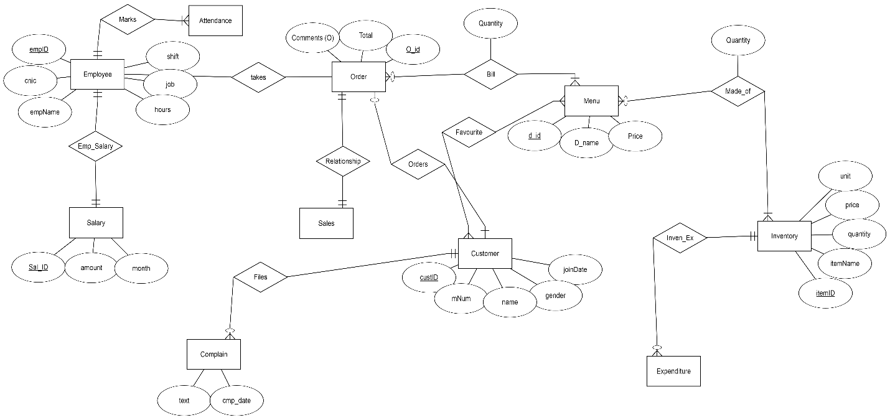

## 3.1 ERD Explanation

In our system, a customer may place order but and order must be placed by a customer. A customer can place many orders at different times when he visits multiple times. A customer also have no or more favorite menu items. An order have multiple or one item from menu list, which is used to generate a bill. Bill also have a quantity of the menu items in that particular order. Sales of the restaurant are related to the total orders placed. An order must belong to the sales. An employee of the restaurant takes order from the customer. Employee marks his attendance. Employee also have his salary. Customer can file a complaint about services by using his order id. Each item in the menu is made up of one or many items in the inventory. Items in the inventory are purchased from vender which is included in expenditures of restaurant.

# 4. System Feature (Screen Shots)

As early described we have three modules. Now showing each of them as follows. Manager View

## 4.1 Manager view

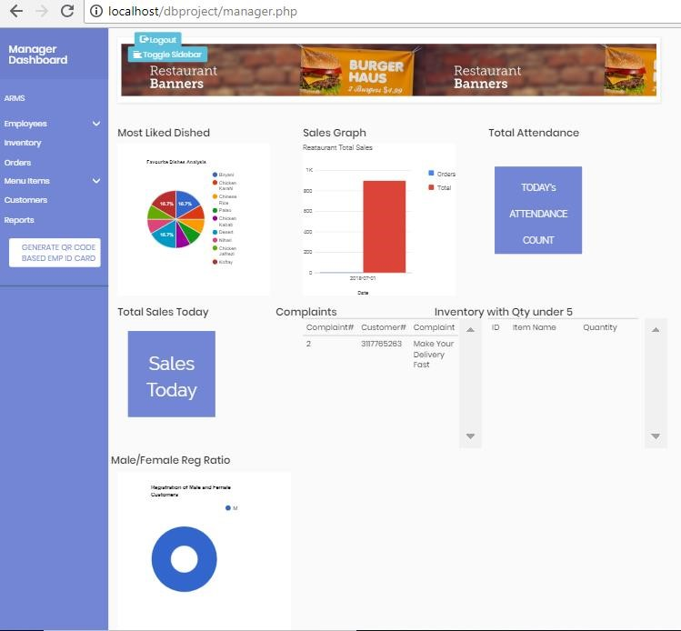

Manager View of Front End

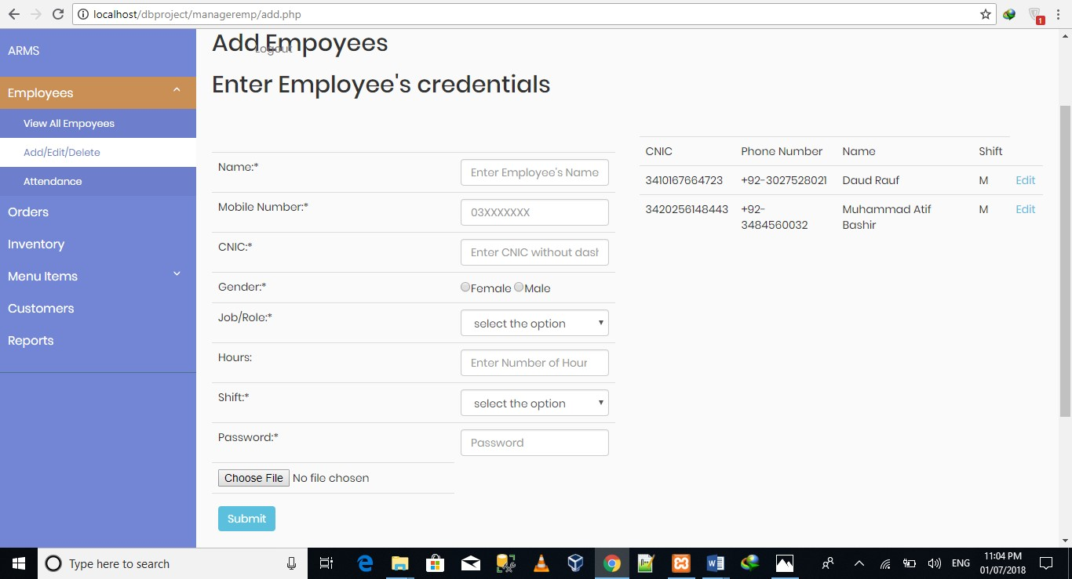

Manager adding Employee for his Restaurant

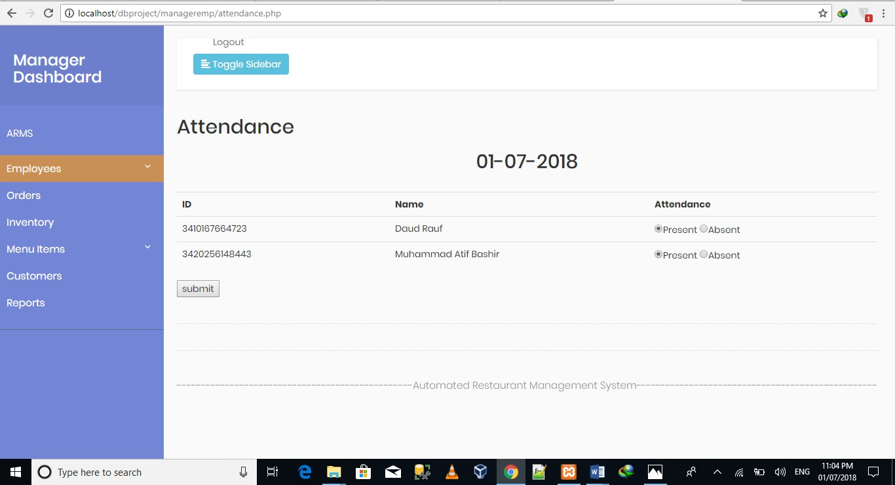

Manager Marking Attendance of Employees

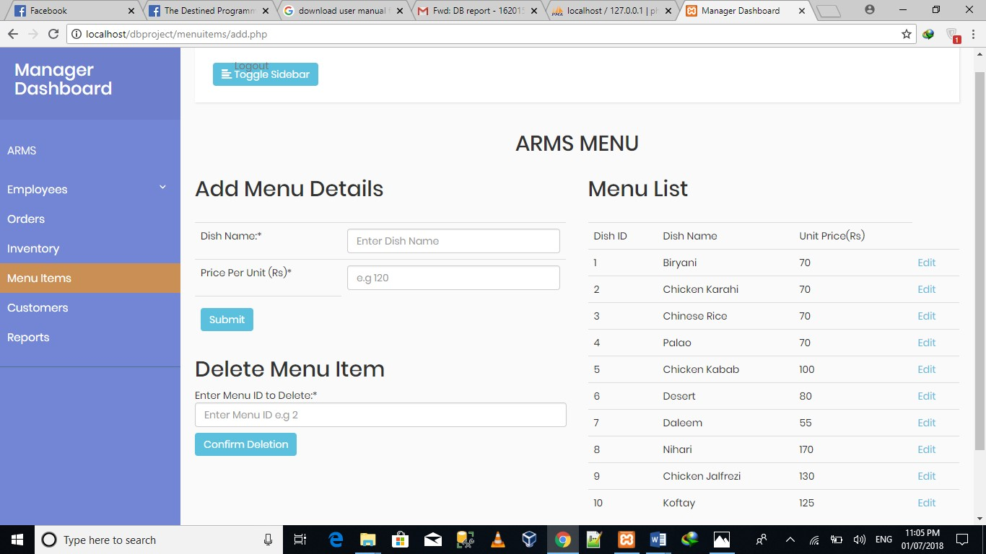

Manager Adding Menu Details

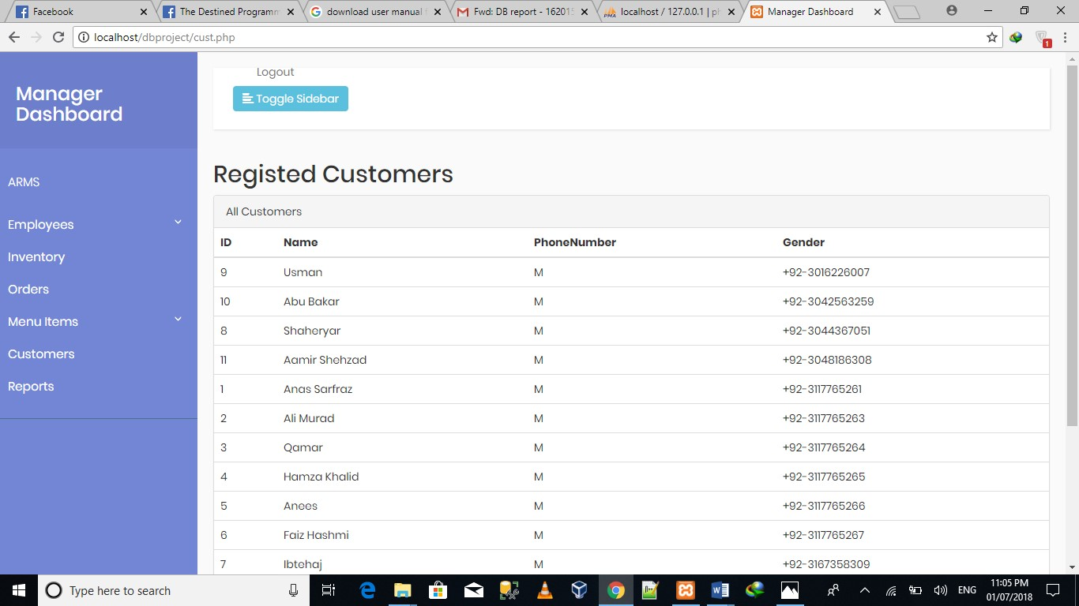

Manager Viewing the Customer which Registered

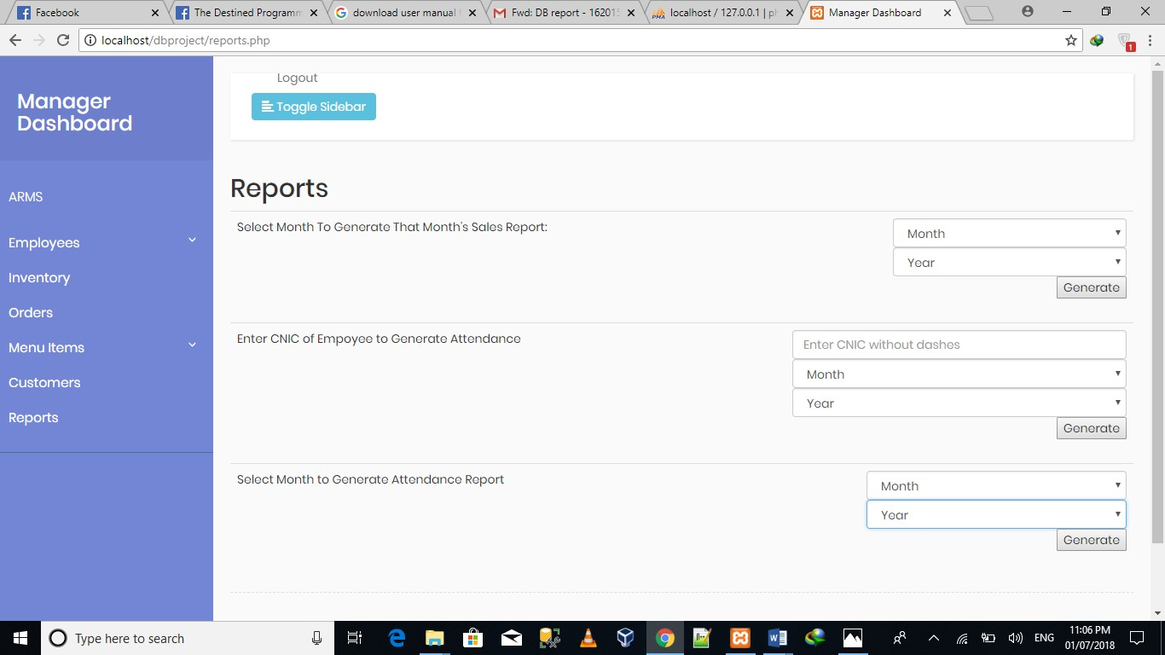

Manager Generating Different Reports

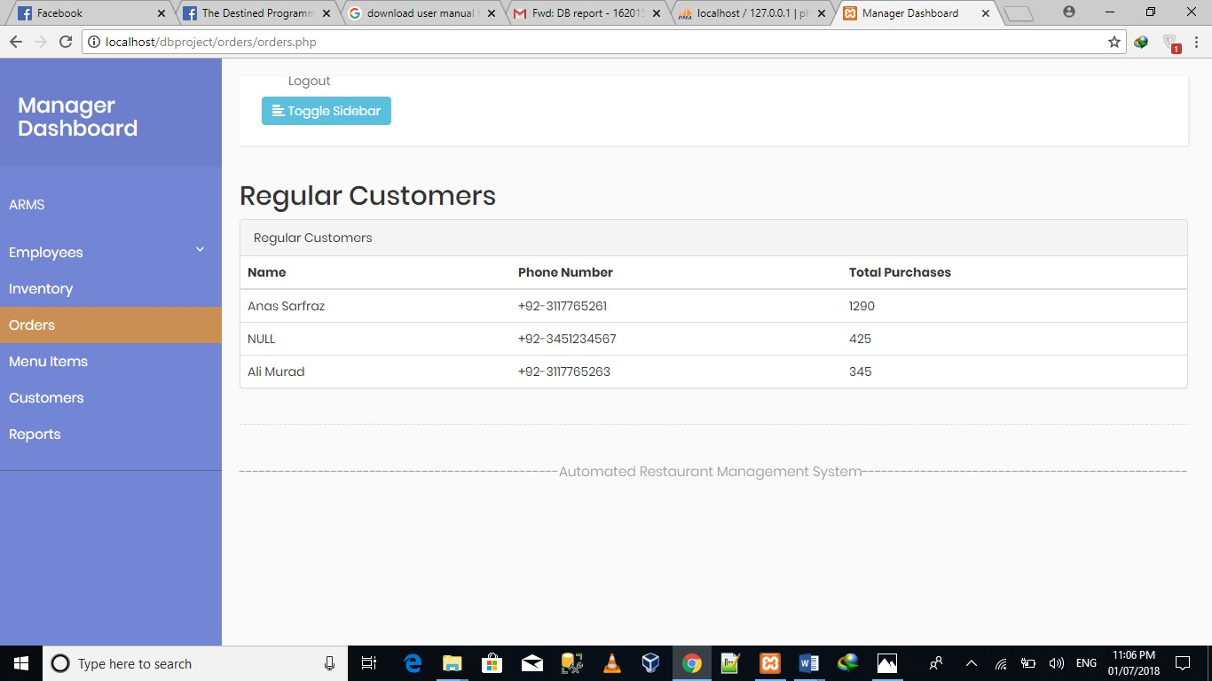

Manager viewing the Purchase by Regular Customers

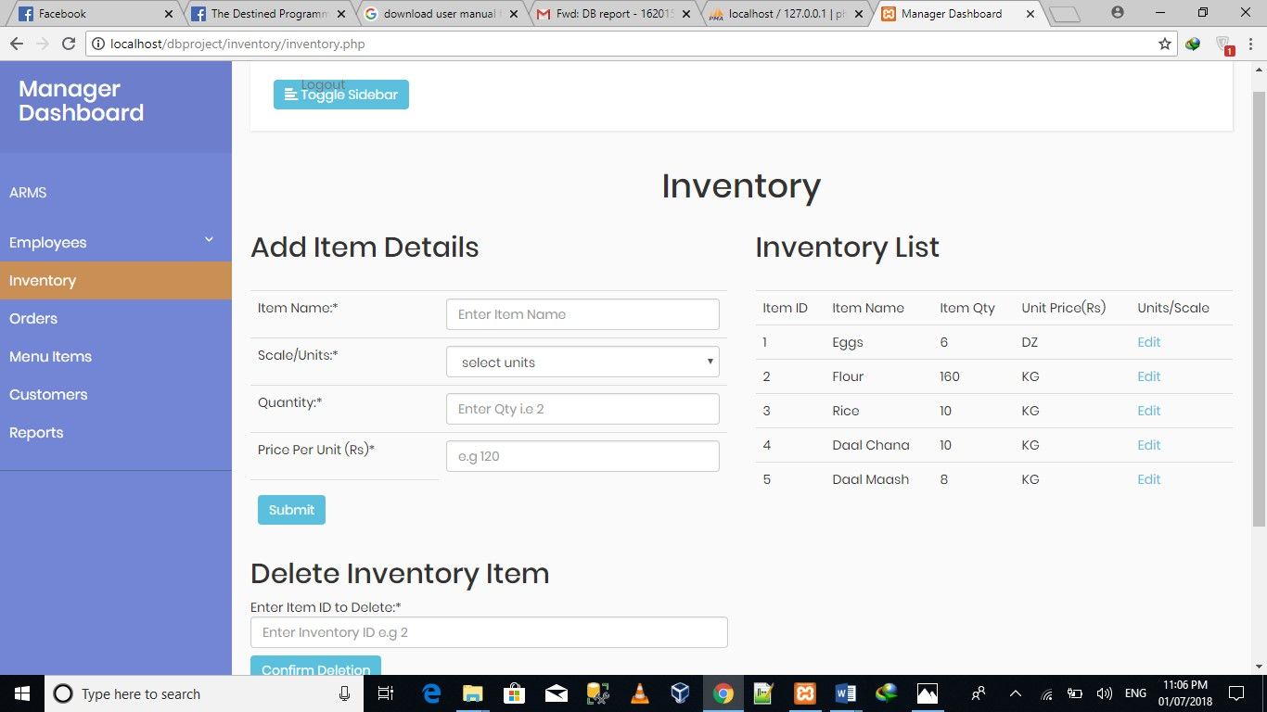

Manager Managing the Inventory Record

## 4.2 Employee View

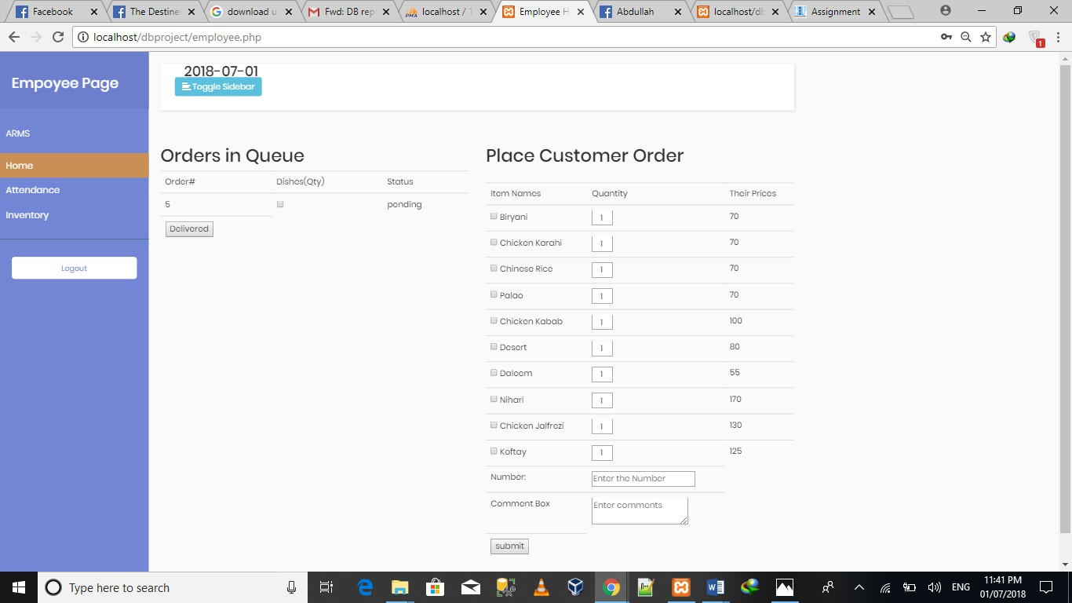

Employee view where he/she can 1. Make an Order.

2. Delivered the Order.

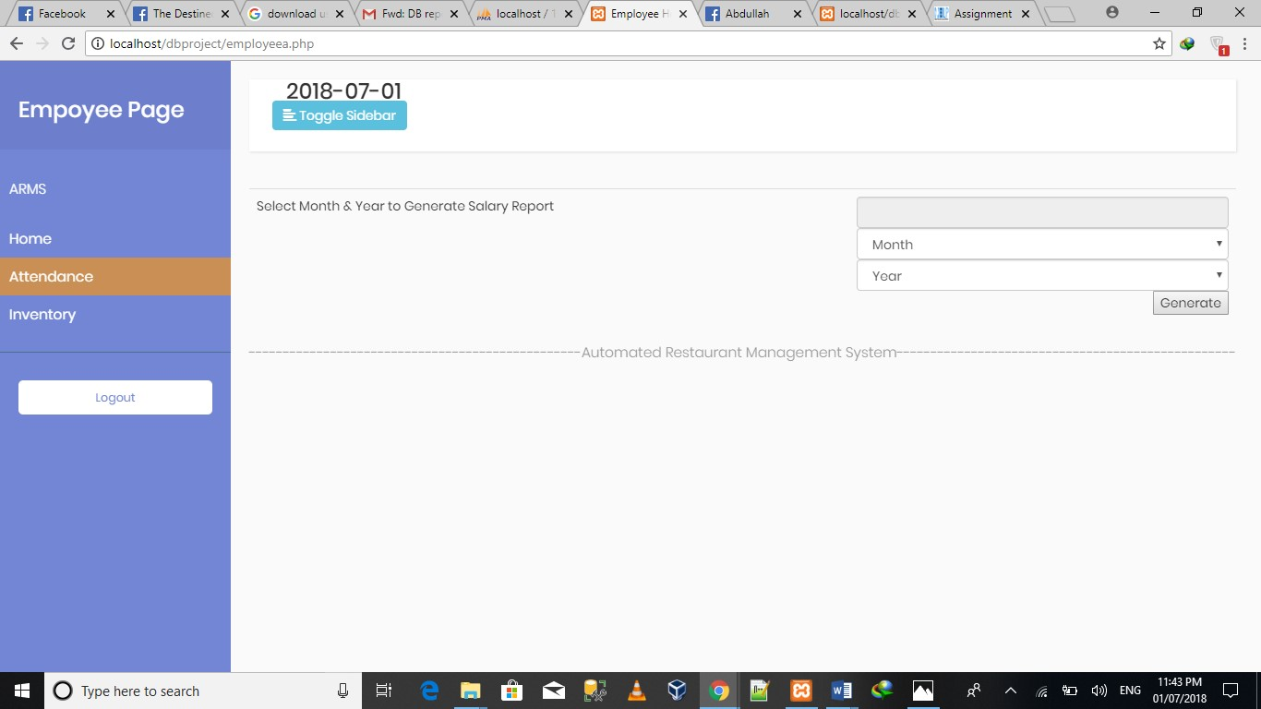

Employee Generating his/her Monthly Salary Report

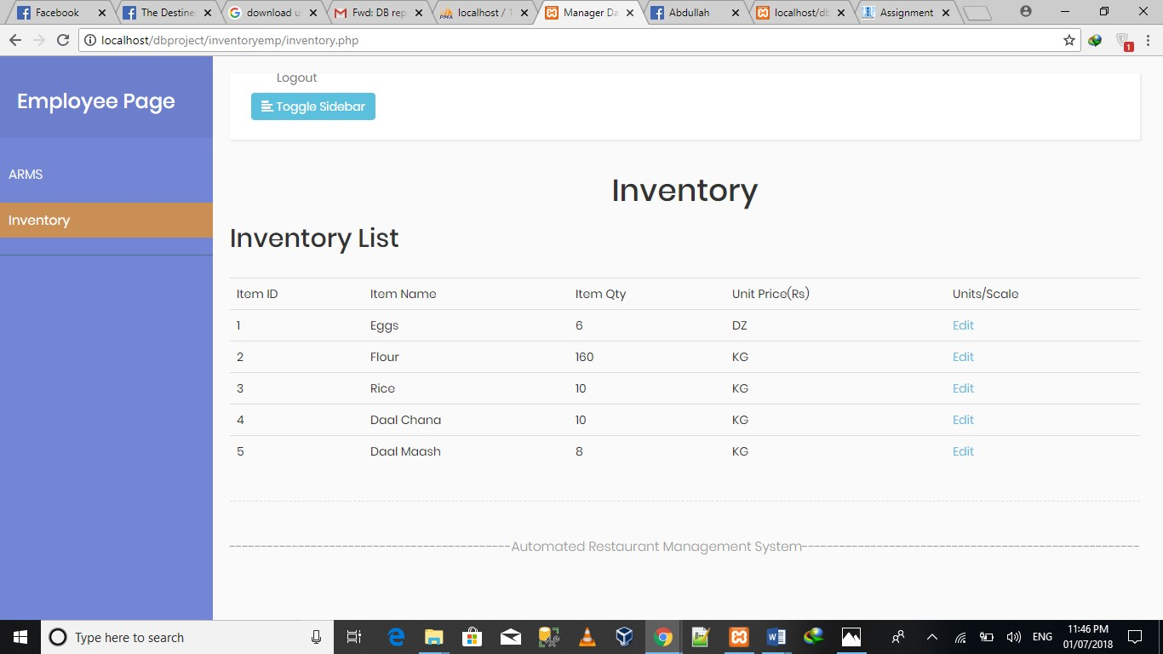

Employee Managing Inventory

kl

## 4.3 Customer View

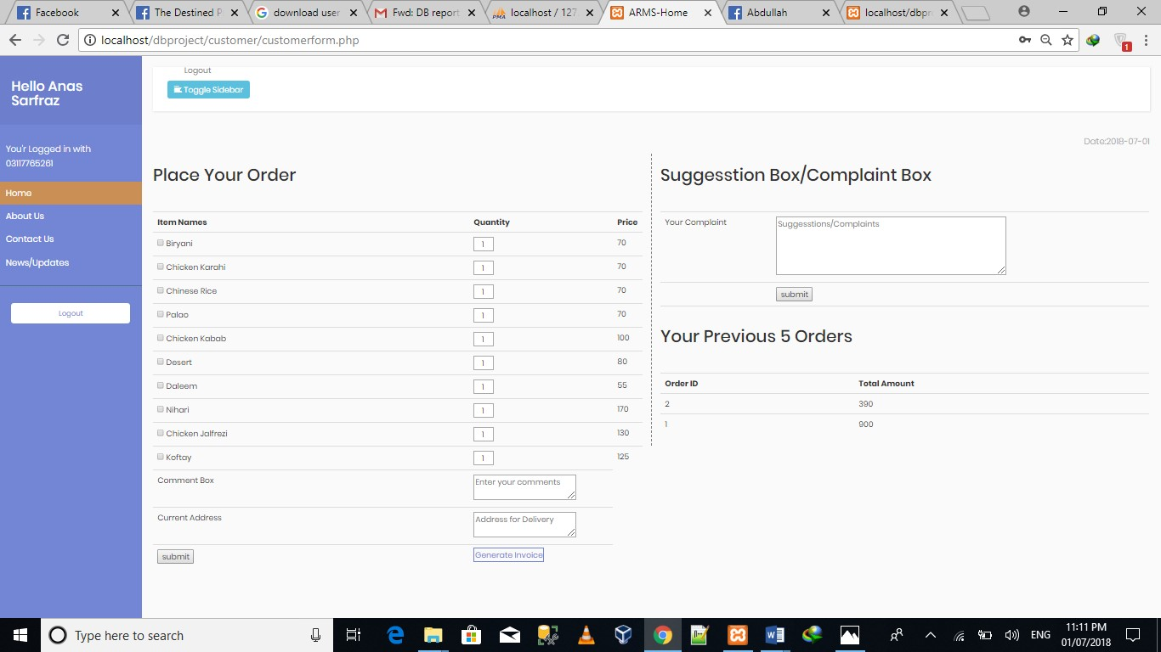

Customer view where he/she makes an Order also suggest or complain

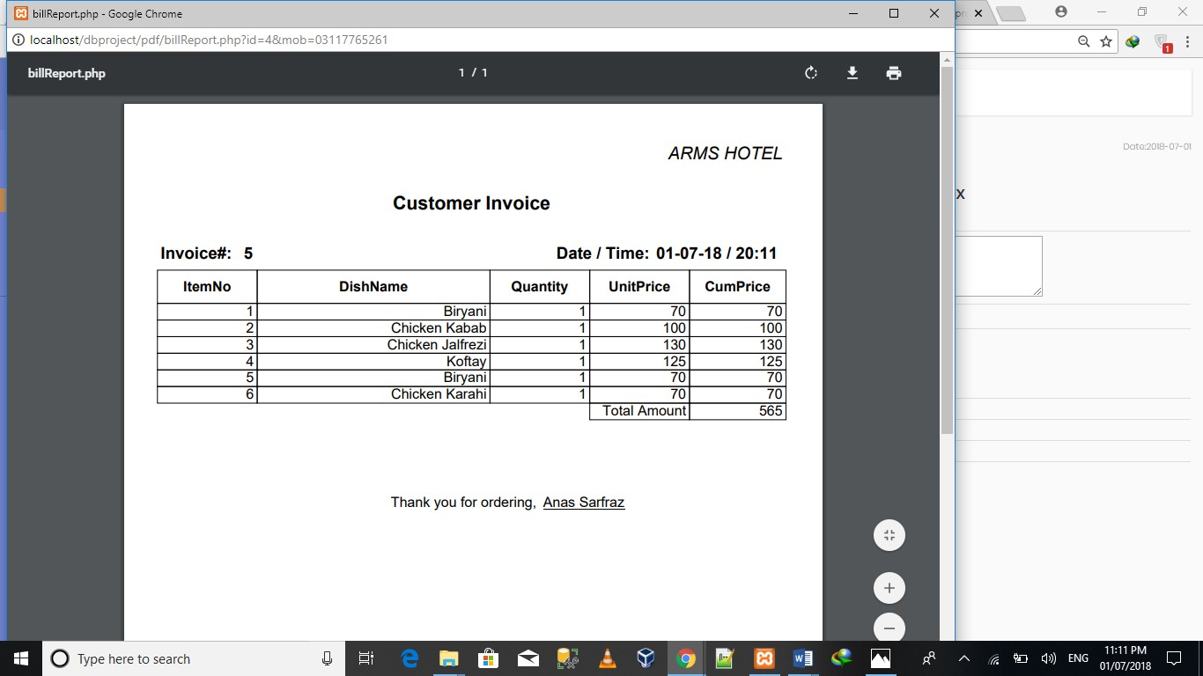

Customer Generating Bill Report/Slip

**Online deployment link**

Wwwarmscompk.000webhostapp.com

**Sample logins:**

**Manager login**

**User:** Atif

**Password:** 1234