P3MAI
METHOD MAP

Architecture & Design
Technical design of the P3MAI Method Map

Document | DOC-01 — Architecture & Design
Version | v1.0
Date | 1 August 2026
Author | Douglas Colvin, P3MAI
Classification | OFFICIAL
Applies to | P3MAI Method Map (PRINCE2 7)

Document control
Version | Date | Author | Change
v1.0 | 2026-08-01 | Douglas Colvin | Initial issue

Contents

(If the contents list is blank, click it and press F9 to update.)

1. Executive summary
The P3MAI Method Map is an interactive web application that renders a project-management method as a navigable network graph. Version 1 covers PRINCE2 7 — its 7 processes and 41 activities cross-referenced to the management team roles, practices, management approaches and management products they use, produce and are governed by.
It is built as a single-origin web application: a FastAPI backend serving a React single-page front end, backed by a SQLite database that auto-seeds from a bundled data file. The data model is deliberately framework-agnostic, so MSP or any other method can be added as a data file without code changes. The application is deployed as a Docker container on Render and is reachable at method-map.onrender.com (custom domain prince2.p3mai.com pending DNS).
This document describes the system architecture, data model, backend and front-end design, the graph and layout algorithms, security, deployment, and the key design decisions.

2. Introduction

2.1 Purpose
To provide the authoritative technical reference for the Method Map — enough for a developer to understand, maintain, extend and re-deploy the system.

2.2 Scope
Covers the application as built: backend, front end, data, deployment and security. Operational procedures are in the Operation Manual (DOC-03); end-user guidance is in the User Manual (DOC-02).

2.3 Audience
Developers and technical reviewers. Assumes familiarity with Python, JavaScript/React and containers, but not with the PRINCE2 method itself (see the glossary).

2.4 Definitions
Term | Meaning
Entity | A typed node in the graph — a process, activity, role, practice, management approach or product.
Relationship | A coded edge from an activity to a target entity.
Code | C/P/N for roles, practices and approaches; I/O/U/A for products (see §5.3).
Framework | A whole method (e.g. PRINCE2 7). The model supports several side by side.
SPA | Single-page application — the React front end.

3. System overview
The Method Map turns the PRINCE2 cross-reference — normally a dense spreadsheet grid — into an explorable network. Users can:
- explore the interdependencies as a graph in two fixed layouts (Matrix and Timeline);
- walk the project lifecycle stage by stage and watch each stage's elements light up;
- select any element to see every relationship it takes part in, with the standard codes;
- export views as PNG, a branded PDF, or CSV/Excel; and
- (for authorised editors) correct or extend the underlying data in place.

4. Technology stack
Layer | Technology | Role
Backend framework | FastAPI (Python 3.12) | REST API and SPA host
ORM / DB | SQLAlchemy + SQLite | Persistence (WAL + synchronous=NORMAL)
Validation | Pydantic | Request/response schemas
Server | uvicorn | ASGI server
Exports | openpyxl, reportlab | Excel/CSV and branded PDF generation
Front-end framework | React 19 + Vite | Single-page application
Graph | react-force-graph-2d | Canvas network rendering
Routing | react-router | Client-side views
Packaging | Docker (multi-stage) | Single-image build & deploy
Hosting | Render (Docker web service) | Production runtime

The stack deliberately mirrors the sibling PMO Service app so the two share conventions, brand and deployment pattern.

5. Solution architecture
The application runs as a single origin: in production the FastAPI backend serves the pre-built React bundle from frontend/dist, and the same process exposes the /api/* routes. There is no separate API host, so there are no cross-origin concerns in production.
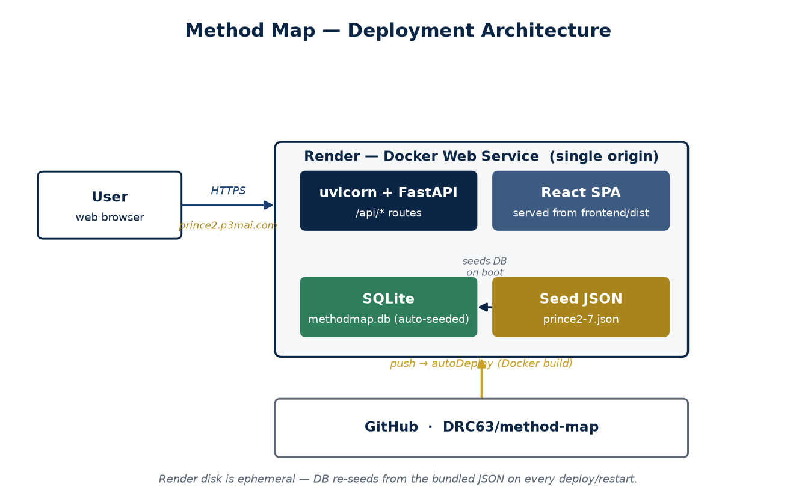
Figure 1 — Deployment architecture (single-origin Docker service on Render).

5.1 Components
Component | Responsibility
FastAPI app (app/main.py) | Wires routers, CORS, first-boot seeding, and the SPA fallback.
Routers | meta, frameworks, entities, relationships — the REST surface.
Graph builder (app/graph.py) | Turns stored entities/relationships into nodes + links for a view.
Serializers / CRUD | ORM ↔ Pydantic conversion and database operations.
Exports (app/exports.py) | CSV, XLSX and per-entity PDF generation.
Seed (app/seed.py) | Loads the bundled JSON into the database on first boot.
React SPA | Explorer, Lifecycle, Guide and Authoring views.

🔒 Single-origin, single-image
The multi-stage Dockerfile builds the React bundle in a Node stage, then copies it into the Python image. One container serves both the API and the UI — nothing else to run.

6. Data model
The model is framework-agnostic on purpose. A framework owns a set of entities, and relationships connect them. Adding MSP means adding a data file — no schema change.
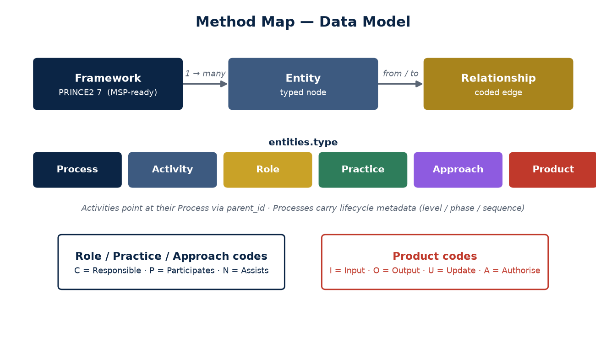
Figure 2 — Data model: framework → entities → relationships, with entity types and codes.

6.1 Entities
Field | Notes
type | process | activity | role | practice | approach | product
name, code | Display name; short code (e.g. SU, DP) where one exists
parent_id | Activity → its owning process (null for everything else)
subgroup | Products only: baseline | log | report
confidence | confirmed | indicative (activity-level data is a best-effort reconstruction)
lifecycle_level | Processes: directing | managing | delivering (swimlane)
lifecycle_phase | Processes: pre-project / initiation / delivery / stage-boundary / final / throughout
sequence | Processes: left→right lifecycle order (SU=1 … CP=7)
sort_order | Stable ordering within a type

6.2 Relationships
Every relationship goes from an activity to a target (role/practice/approach/product) and carries a code and a confidence. Processes are not endpoints of relationships — they own activities through parent_id.

6.3 The codes
Applies to | Codes
Roles, practices, management approaches | C = Responsible · P = Participates · N = Assists
Management products | I = Input · O = Output · U = Update · A = Authorise

★ Why activity-centric?
Storing every relationship as activity→target keeps the data honest and small (one row per real cross-reference mark). All higher-level connections — role↔product, process↔practice — are derived from these at query time, so nothing is duplicated or can drift out of sync.

7. Backend design

7.1 API surface
Method & path | Purpose | Auth
GET /api/health | Liveness probe | open
GET /api/meta | Entity types, code labels, subgroups | open
POST /api/auth/verify | Check the admin password | open
GET /api/frameworks | List frameworks + entity counts | open
GET /api/frameworks/{key}/entities | List entities (filter by type/search) | open
GET /api/frameworks/{key}/relationships | List raw relationships | open
GET /api/frameworks/{key}/graph | Build nodes + links for a view | open
GET /api/frameworks/{key}/lifecycle | Processes in sequence with activities | open
GET /api/entities/{id} | Entity detail with grouped relationships | open
GET …/export.csv, /export.xlsx | Cross-reference data export | open
GET …/entities/{id}/report.pdf | Branded per-entity PDF | open
POST/PUT/DELETE /api/entities | Create/edit/delete entities | admin
POST/PUT/DELETE /api/relationships | Create/edit/delete relationships | admin

7.2 The graph builder
build_graph() turns the stored data into the nodes and links a view needs, given the selected entity-type layers and whether indirect links are wanted. It emits three link kinds:
- contains — process → activity (structural, when both layers are visible);
- direct — activity → target, carrying the stored code (when the activity layer is visible);
- derived — an undirected co-occurrence link between two non-activity entities that share an activity (a process counts as an implicit participant of its activities).
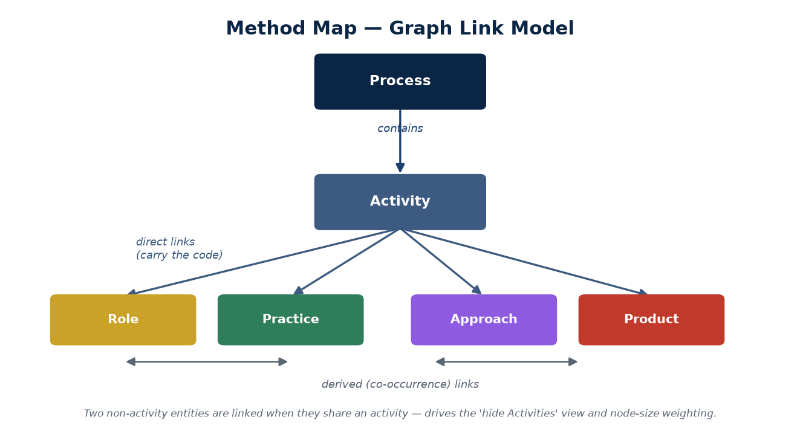
Figure 3 — The three link kinds the graph builder produces.

Derived links are what make the "hide Activities, show Roles↔Practices" view meaningful — the connection runs *through* the shared activities.

7.3 Node weighting
Each node carries two degree measures:
- degree — total edges touching it in the current view (view-dependent); used by the force sizing historically;
- direct_degree — the count of real C/P/N/I/O/U/A relationships the entity takes part in, computed view-independently (for processes: how many activities they contain). This is the stable "direct responsibilities" measure that drives node size in the fixed layouts (sqrt scale, so area ∝ count).

7.4 Exports & seeding
CSV/XLSX flatten the cross-reference (optionally focused on one entity); the PDF is a branded per-entity relationship summary via reportlab. Seeding loads every *.json file in app/seed_data/ on first boot; it is idempotent and skipped under tests.

8. Front-end design

8.1 Views
View | What it does
Method Explorer | The network graph, in Matrix or Timeline layout, with layers/search/detail.
Project Lifecycle | The canonical PRINCE2 process model as a swimlane; activities in sequence.
Guide | Plain-English explanation of the layers, codes and confidence flags.
Authoring & Admin | Password-gated editing of entities and relationships.

8.2 The two layouts
Both layouts pin every node's position (fx/fy) so d3-force holds them in place; there is no free-floating physics option. Colour-coded zone labels are drawn behind the nodes.
- Matrix — a fixed hierarchy: processes across the top, activities stacked beneath, products in a band below; roles pinned left, practices right, management approaches along the bottom.
- Timeline — echoes the Lifecycle view: processes in three swimlanes (Directing / Managing / Delivering) laid left→right by sequence; activities in each process's time-column; roles/practices/approaches/products as static resource bands below. A scrubber walks the lifecycle, lighting up each stage's sub-graph (spotlight or cumulative), with a play button.

8.3 Interaction
Selecting a node enlarges it with a gold glow halo and highlights its neighbourhood; the detail panel lists every relationship. Hovering highlights a node's neighbours. Search flags matches. Deep links (/?focus=<id>) select a node on arrival — used by the Lifecycle view.

9. Data provenance & seeding
The PRINCE2 dataset (app/seed_data/prince2-7.json, 91 entities / 206 relationships) was generated from the PRINCE2/MSP cross-reference spreadsheet by backend/scripts/extract_prince2.py. Manual corrections not present in the source spreadsheet live in a CORRECTIONS list in that extractor, so they survive regeneration.
⚠ Indicative vs confirmed
Process, role, practice, approach and product names are corroborated from public sources and marked *confirmed*. The 41 activities and their codes are a best-effort reconstruction (prince2.wiki, CC-BY 4.0) and are marked *indicative* (shown with a dashed ring). SME-verify against the licensed PRINCE2 manual before any formal use.

10. Security & access control
Read access is fully open — the app is a public reference tool with no personal data. Write operations (authoring) require a single shared password sent as an X-Admin-Password header and checked against the ADMIN_PASSWORD environment variable. This is a deliberate, lightweight gate — enough to stop casual edits, not a full account system.
🔒 Security posture
No authentication for reads (by design). Single admin password for writes. Single origin, so no third-party data egress. Revisit if the app ever holds sensitive or personal data.

11. Deployment architecture
Deployed via a Render Blueprint (render.yaml): a Docker web service, Starter plan, Oregon region, health check /api/health, ADMIN_PASSWORD as a dashboard secret. Pushing to the main branch of the GitHub repo auto-deploys. The database re-seeds on every boot, so a fresh or restarted container comes up populated.
Aspect | Value
Repository | github.com/DRC63/method-map (private)
Platform | Render — Docker web service, Starter, Oregon
URL | method-map.onrender.com (prince2.p3mai.com pending DNS)
Auto-deploy | On push to main
Persistence | Ephemeral disk — DB resets on redeploy; auto-seeds

⚠ Ephemeral database
Render's disk is ephemeral, so authoring-mode edits do not survive a redeploy. Move to a persistent disk or Postgres before relying on in-app edits.

12. Key design decisions
Decision | Rationale
Framework-agnostic data model | MSP and other methods drop in as data files, no code change.
Activity-centric relationships | One row per real cross-reference mark; higher links derived, never duplicated.
Self-contained JSON seed + auto-seed | Deploy is independent of the source spreadsheet; ephemeral hosts self-populate.
Two fixed layouts (no physics) | Positional meaning (hierarchy / lifecycle) reads better than an organic blob.
direct_degree node weighting | Size reflects real responsibilities, stable across layer/derived toggles.
Single admin password | Lightweight edit gate appropriate to an open, non-sensitive reference tool.

13. Non-functional considerations
- Performance — the dataset is small (~90 nodes); the graph renders on the client. SQLite runs WAL + synchronous=NORMAL. Locally the project sits under OneDrive, which adds a sync write latency that pragmas cannot remove — irrelevant in the deployed container.
- Scalability — comfortably handles multiple frameworks; the graph endpoint is O(edges).
- Portability — one Docker image; runs anywhere that runs containers.
- Extensibility — MSP-ready model; new export formats and layouts slot into existing seams.

14. Roadmap
- Populate and enable MSP 5th Edition as a second framework.
- Persistent storage (disk or Postgres) so authoring edits survive redeploys.
- Saved per-engagement tailored views (schema already anticipates this).
- Optional user accounts if the tool ever holds sensitive data.

Appendix A — Repository layout
method-map/
backend/app/ FastAPI app (main, models, schemas, crud, graph,
serializers, exports, seed, security, routers/)
backend/app/seed_data/prince2-7.json bundled dataset
backend/scripts/extract_prince2.py spreadsheet → seed extractor
frontend/src/ React app (pages/, components/, theme/, api/)
Dockerfile multi-stage build
render.yaml Render Blueprint
docs/ this documentation set

