P3MAI
METHOD MAP

User Manual
Using the P3MAI Method Map

Document | DOC-02 — User Manual
Version | v1.0
Date | 1 August 2026
Author | Douglas Colvin, P3MAI
Classification | OFFICIAL
Applies to | P3MAI Method Map (PRINCE2 7)

Document control
Version | Date | Author | Change
v1.0 | 2026-08-01 | Douglas Colvin | Initial issue

Contents

(If the contents list is blank, click it and press F9 to update.)

1. Welcome
The P3MAI Method Map turns PRINCE2 7 into an interactive picture. Instead of reading a cross-reference spreadsheet, you explore the method as a network: see which roles perform each activity, which practices and management approaches it draws on, and which management products it takes in or creates.
It is useful when tailoring a project, onboarding a team, or explaining PRINCE2 governance to a client — anywhere you need to see how one part of the method connects to the rest.

1.1 Who it is for
Anyone working with PRINCE2 — project managers, PMO staff, consultants and those learning the method. No technical knowledge is needed.

1.2 Getting in
Open the Method Map in a web browser at method-map.onrender.com (or prince2.p3mai.com once that address is live), or reach it from the Project Management card on the P3MAI website's Services page. Nothing to install, no login to read.
★ First visit may be slow
The app sleeps when idle to save hosting cost. The first page load after a quiet spell can take up to a minute while it wakes — after that it is instant.

2. The screen at a glance
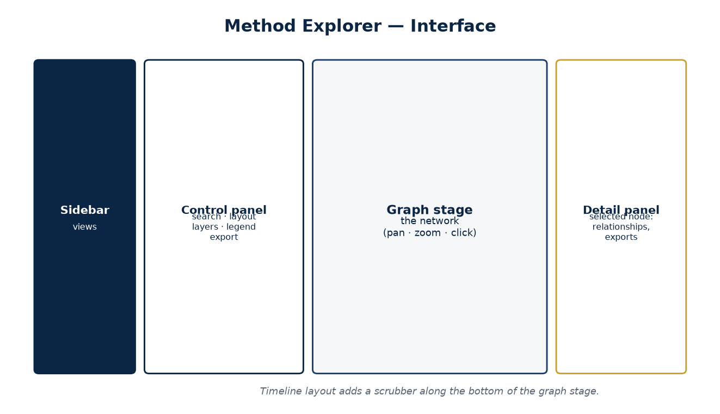
Figure 1 — The Method Explorer screen.

Area | What it holds
Sidebar (far left) | Switch between Method Explorer, Project Lifecycle, Guide and Authoring & Admin.
Control panel (left) | Search, layout switch, layer toggles, the legend, and export buttons.
Graph stage (centre) | The network itself — pan, zoom and click here.
Detail panel (right) | Appears when you select a node; lists its relationships and its exports.

3. Reading the codes and colours
Every connection in the map is labelled with a standard PRINCE2 cross-reference code. These are the most important thing to learn.
Where | Codes
Roles, practices, approaches | C = Responsible · P = Participates · N = Assists
Management products | I = Input · O = Output · U = Update · A = Authorise

Each type of element has its own colour, used consistently everywhere:
Colour | Element type
Navy | Processes
Steel blue | Activities
Gold | Management team roles
Green | Practices
Purple | Management approaches
Red | Management products

🔒 The dashed ring
A node drawn with a dashed ring is marked *indicative* — a best-effort reconstruction of the activity-level detail. Treat it as a well-reasoned first pass and verify against the PRINCE2 manual before using it as formal evidence.

4. The Method Explorer
The Explorer is the network graph. Two layouts are available — pick one with the Matrix / Timeline switch at the top of the control panel.

4.1 The Matrix layout
A fixed hierarchy that stays put so you always know where to look:
- Processes run across the top; Activities are stacked beneath their process;
- Products sit in a band below the activities;
- Roles are pinned to the left, Practices to the right, and Management approaches along the bottom.
Bigger nodes have more direct responsibilities — the more C/P/N/I/O/U/A relationships an element takes part in, the larger it is drawn. The Project Manager and the busy products (Business Case, Plan, the registers) stand out.

4.2 Moving around
To… | Do this
Pan | Drag an empty part of the graph
Zoom | Scroll (mouse wheel) or pinch
Move a node | Drag the node itself
See details | Click a node
Clear a selection | Click an empty part of the graph

4.3 Selecting a node
Click any node and it is highlighted with a gold glow and enlarged, its neighbours stay bright while everything else dims, and the detail panel opens on the right (see §6). Hovering (without clicking) does the same highlighting temporarily.

4.4 Layers
Under Layers you can switch any element type on or off — hide Products to study just roles and practices, for example. The count next to each layer shows how many of that type exist.

4.5 Indirect links
With Activities hidden, turn on Show indirect (co-occurrence) links to connect any two elements that share an activity — so you can study, say, which Roles work with which Products, without the activity detail in the way.

4.6 Search
Type in the Search box to highlight every element whose name matches — handy for finding a specific product or role in a busy graph.

5. The Timeline layout
The Timeline layout arranges the method like the project lifecycle: processes in three swimlanes — Directing, Managing, Delivering — laid out left→right in the order they run, with activities beneath each process and the roles/practices/approaches/products in bands below.
A scrubber appears along the bottom. Use it to walk the project stage by stage:
Control | Effect
▶ Play / ❚❚ Pause | Auto-advance through the seven processes, ~1.6s each
Slider / stage ticks | Jump to any stage (SU, DP, IP, CS, MP, SB, CP)
Spotlight | Highlight only the current stage's process, activities and what they touch
Cumulative | Highlight everything from the start up to the current stage — watch the footprint grow

★ Tell the story of a project
Switch to Cumulative and press Play. Watch products and involvement accumulate as the project moves from Starting Up through to Closing — a quick way to show a client how the method unfolds over time.

6. The detail panel
When you select a node, the detail panel lists everything it connects to, grouped and labelled with the codes:
- an activity shows what it uses and produces;
- a role, practice, approach or product shows the activities that reference it, and the process each belongs to;
- a process lists its activities in sequence.
Click any listed item to jump to it. Two export buttons let you save a PDF summary of the selected element or a CSV of just its relationships.

7. The Project Lifecycle view
The Project Lifecycle view (in the sidebar) is the classic PRINCE2 process model: time runs left→right (Pre-project → Initiation → Delivery stages ⟳ → Final stage) across the three swimlanes. Directing a Project spans the top; the delivery processes repeat.
Click any process to see its activities listed in the order they run. Each activity, and the process itself, links straight into the graph so you can explore its connections.

8. The Guide
The Guide page is a short, plain-English explainer of the six layers, the codes and the confidence flags — a good first stop for anyone new to the map or to PRINCE2.

9. Exporting
Export | How | Gives you
Graph image | Export → Graph as PNG (control panel) | A picture of the current view for slides/reports
Full data | Export → CSV or Excel | The whole cross-reference as a spreadsheet
Entity PDF | Detail panel → PDF summary | A branded one-element relationship summary
Entity CSV | Detail panel → CSV (this entity) | Just the selected element's relationships

10. Authoring mode (authorised users)
If you have the admin password you can correct or extend the data. Open Authoring & Admin, enter the password, and editing controls appear in the Explorer: an + Add entity button, and Edit / + Relationship / Delete in each node's detail panel. Set an item's confidence to *confirmed* once you have verified it against the manual — the dashed ring disappears. Full procedures are in the Operation Manual (DOC-03).
⚠ Edits are not permanent yet
On the current hosting, authoring edits are held in a database that resets when the app is redeployed. Treat in-app edits as provisional until persistent storage is added, and keep the authoritative corrections in the data file (see the Operation Manual).

11. Tips & FAQ
Question | Answer
The graph looks empty / faint | You may have hidden a layer, or dimmed everything by selecting a node — click empty space to reset, and check the Layers toggles.
It won't load first time | The app was asleep; wait up to a minute for it to wake.
What does the dashed ring mean? | The data is indicative (activity-level reconstruction) — verify before formal use.
Why is one node much bigger? | Node size reflects how many direct relationships it has — big nodes are the busy elements.
Can I get this as a spreadsheet? | Yes — Export → Excel, or CSV, from the control panel.

12. Glossary
Term | Meaning
Process | One of the seven PRINCE2 processes (SU, IP, DP, CS, MP, SB, CP).
Activity | A step within a process (there are 41).
Management team role | Executive, Senior User, Project Manager, etc.
Practice | Business Case, Plans, Risk, Quality, Progress, Organizing, Issues.
Management approach | A defined approach — Risk, Change, Quality, Communication, etc.
Management product | A document/baseline the method produces (PID, Business Case, registers, reports).
C / P / N | Responsible / Participates / Assists (roles, practices, approaches).
I / O / U / A | Input / Output / Update / Authorise (products).

