P3MAI
METHOD MAP

Architecture & Design
Structure & design of the P3MAI website

Document | DOC-01 — Architecture & Design
Version | v1.0
Date | 1 August 2026
Author | Douglas Colvin, P3MAI
Classification | OFFICIAL
Applies to | P3MAI Method Map (PRINCE2 7)

Document control
Version | Date | Author | Change
v1.0 | 2026-08-01 | Douglas Colvin | Initial issue

Contents

(If the contents list is blank, click it and press F9 to update.)

1. Executive summary
The P3MAI website is the public business site for P3MAI (Douglas Colvin's programme, project and PMO consultancy). It is a hand-built static site — five pages plus a standalone cost estimator — with no framework and no build step: plain HTML5, CSS3 and vanilla JavaScript. It carries the P3MAI brand (navy/gold, Poppins, a pyramid logo) and links out to the two P3MAI web apps. It is hosted on Rise and served at p3mai.com.

2. Introduction

2.1 Purpose & scope
The design and structure reference for the website. Visitor-facing guidance is in DOC-02; maintenance and publishing in DOC-03.

2.2 Audience
Whoever maintains the site — comfortable editing HTML/CSS, no framework knowledge needed.

3. Site overview
Five linked pages, a shared header/footer, and a standalone estimator:
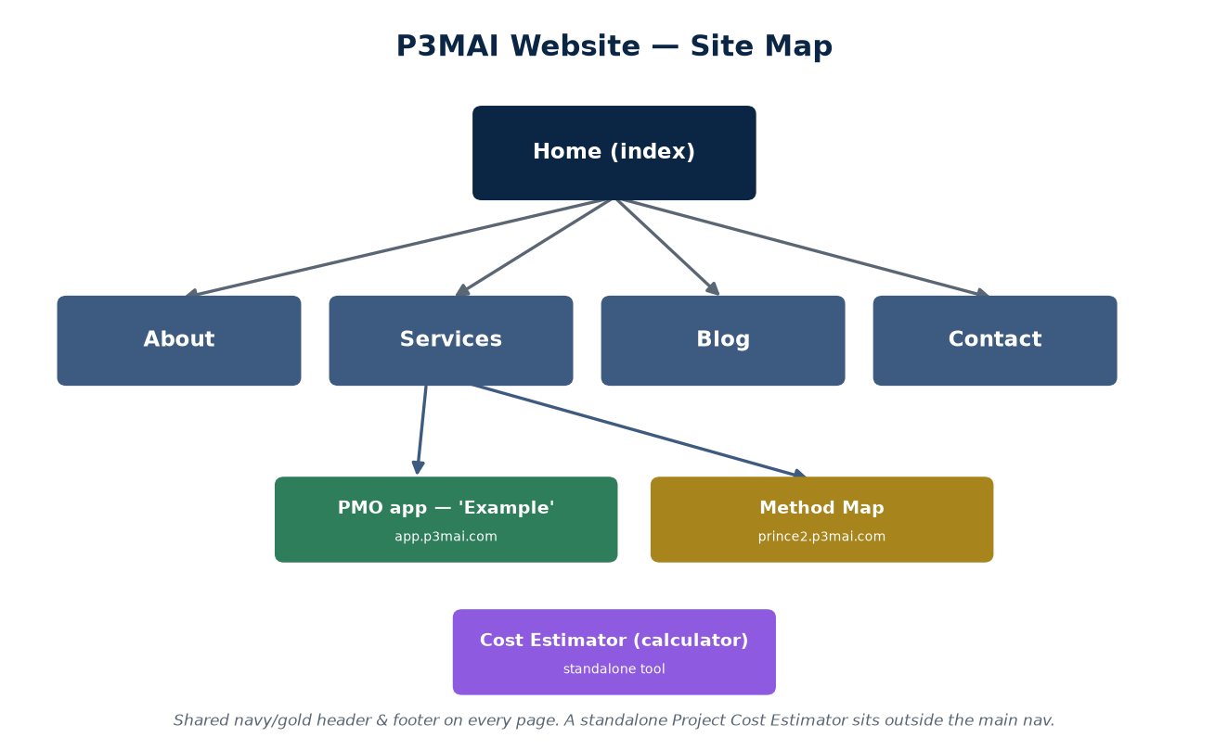
Figure 1 — Site map.

Page | Purpose
index.html | Home — hero, feature cards, CV-sourced track record, call to action
about.html | Bio and career timeline (from the CV), certifications, values
services.html | Programme / Project / PMO cards; links to the PMO app and Method Map; comparison table
blog.html | AI / project-management posts
contact.html | Validated contact form, contact details, map
calculator.html | Project Cost Estimator — a standalone interactive tool

An auxiliary dashboard.html productivity/notes page also exists outside the main navigation.

4. Technology
Aspect | Choice
Markup | Hand-written HTML5, one file per page
Styling | A single CSS design system (style.css)
Behaviour | Vanilla JavaScript (script.js) — no framework, no build
Fonts | Poppins (brand), system fallbacks
Assets | SVG logo set, optimised JP/PNG imagery
Hosting | Rise (UK shared cPanel/FTP)

🔒 No build step by design
The site is deliberately static and dependency-free — nothing to compile, nothing to break. Edit an HTML/CSS/JS file, preview, and publish.

5. Design system
Element | Value
Primary colour | Navy #0B2545 (with dark #071830)
Accent | Gold #C9A227
Background | Light grey #F6F7F9
Font | Poppins
Logo | Original plan-view pyramid mark + wordmark (navy on light, white on dark)

style.css holds the shared design system — layout, typography, buttons, cards, the sticky navigation and responsive breakpoints. The header and footer markup is byte-identical across every page (except the active nav item) so the site reads as one piece.

6. Front-end behaviour
script.js provides the interactions, all progressive enhancements over the static markup:
- Env-aware app links — rewrites the PMO and Method Map links to the live domains in production, leaving them at localhost in dev (see §7);
- Page-transition overlay — a soft fade between internal pages;
- Responsive navigation — a hamburger menu on small screens;
- Reveal-on-scroll animations for sections;
- Contact-form validation — client-side checks before submit;
- Smooth scrolling for in-page anchor links.

7. Integrations
The Services page links to the two P3MAI apps, both of which link back to the site:
Link | Dev | Production
PMO Service ('Example') | localhost:5173 | app.p3mai.com
PRINCE2 Method Map | localhost:5175 | method-map.onrender.com (→ prince2.p3mai.com)

⚠ Env-aware links — do not hardcode
The localhost hrefs in services.html are intentional dev defaults; script.js rewrites them to the live URLs in production. Replacing them with hardcoded URLs breaks local development.

The cost estimator directs enquiries to hello@P3MAI.com.

8. Hosting & deployment
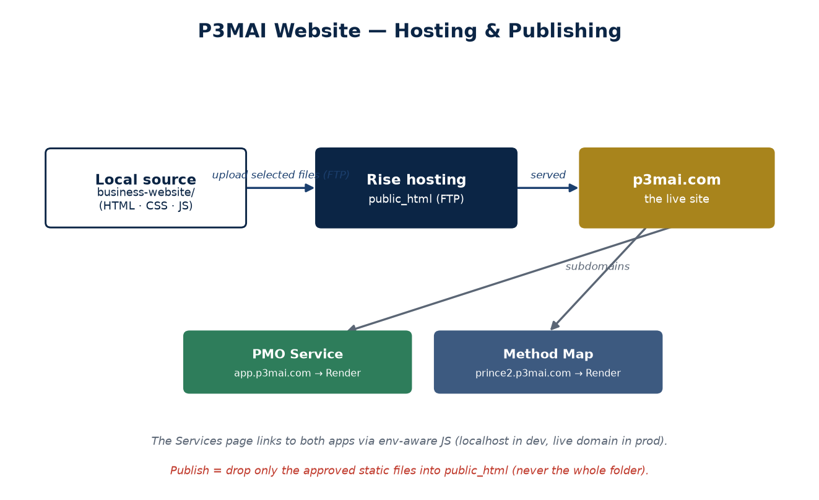
Figure 2 — Hosting: publish selected files by FTP into Rise's public_html.

The site is hosted on Rise (UK shared cPanel/FTP hosting). Publishing means uploading the approved static files into public_html. The two apps live on Render under subdomains (app.p3mai.com, prince2.p3mai.com). Full publishing steps are in DOC-03.
⚠ Publish only the approved files
Do not upload the entire project folder — it contains source assets, documents and memory that must never be public. See the Operation Manual for the exact allow-list.

9. Design decisions
Decision | Rationale
Static, no framework/build | Fast, robust, trivially hostable on shared hosting.
Byte-identical header/footer | One consistent shell; verify with a diff after edits.
Env-aware links in JS | Cross-links work in both dev and prod with no manual editing.
Original artwork only | Brand integrity; no copyright risk.
No fabricated content | Everything is grounded in the real CV — no fake testimonials or claims.

10. Non-functional considerations
- Performance — static files, minimal JS; fast to load.
- Responsiveness — mobile-first layout with a hamburger menu.
- SEO — per-page titles and meta descriptions.
- Maintainability — one file per page, one shared stylesheet and script.

11. Roadmap
- Switch the Method Map link to the branded prince2.p3mai.com once DNS resolves.
- Further blog content; optional analytics.

Appendix A — Files
business-website/
index / about / services / blog / contact .html the five pages
calculator.html standalone cost estimator
style.css shared design system
script.js shared interactions (env-aware links, etc.)
logo/favicon SVGs, imagery
docs/ this documentation set

