P3MAI
METHOD MAP

User Manual
A guide to the P3MAI website

Document | DOC-02 — User Manual
Version | v1.0
Date | 1 August 2026
Author | Douglas Colvin, P3MAI
Classification | OFFICIAL
Applies to | P3MAI Method Map (PRINCE2 7)

Document control
Version | Date | Author | Change
v1.0 | 2026-08-01 | Douglas Colvin | Initial issue

Contents

(If the contents list is blank, click it and press F9 to update.)

1. About this guide
The P3MAI website presents P3MAI's programme, project and PMO consultancy and links to its two web apps. This guide walks a visitor through the pages and the interactive Project Cost Estimator. Maintaining and publishing the site is covered in the Operation Manual (DOC-03).
The site lives at p3mai.com. Every page shares the same navy/gold header and footer, so navigation is consistent throughout.

2. Navigating the site
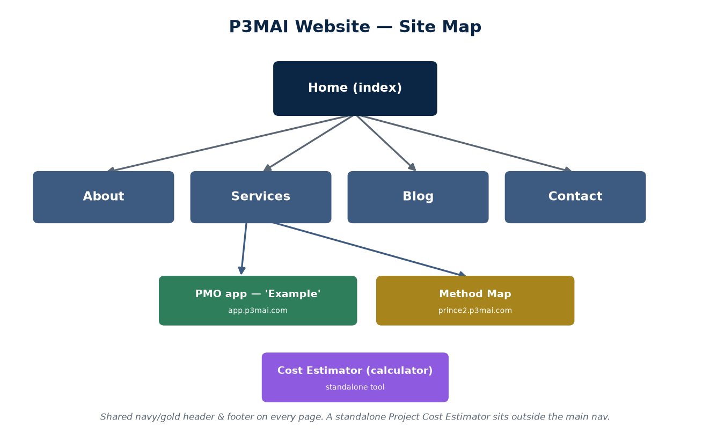
Figure 1 — Site map.

The top navigation bar links the five main pages: Home, About, Services, Blog and Contact. On a phone the menu collapses to a hamburger button.

3. Home
The landing page introduces P3MAI with the tagline *AI Program and Project Management Delivered at Scale*, three feature cards, a CV-sourced track record, and a call to action to get in touch.

4. About
Douglas Colvin's biography and career timeline (drawn from the CV), certifications and values — who is behind P3MAI and the depth of delivery experience.

5. Services
Three service cards — Program Management, Project Management and PMO — each with what it covers and a Get in Touch button, plus a comparison table of how each engages.
Two of the cards also demonstrate a live P3MAI tool:
- the Project Management card links to the PRINCE2 Method Map;
- the PMO card links (Example) to the PMO Service app.

6. Blog
Short articles on AI, programme and project management.

7. Contact
A validated contact form (it checks the fields before submitting), the business contact details, and a location map. The quickest way to start a conversation with P3MAI.

8. Project Cost Estimator
The calculator page is a standalone, interactive Project Cost Estimator. Choose the options that describe your project and it produces an instant estimate in real time, then points you to email hello@P3MAI.com to take it further. Nothing is stored — it is a quick, private guide to likely cost.
★ Use it as a conversation starter
The estimate is indicative — a starting point. Follow the on-screen prompt to get in touch for a tailored quote.

9. The two apps
From the Services page | Opens
PMO card → Example | The PMO Service — a live project-portfolio tool (app.p3mai.com)
Project Management card → PRINCE2 Method Map | An interactive PRINCE2 method explorer

Each app has its own Back to Website link to return you here.

10. Tips & FAQ
Question | Answer
How do I get in touch? | Use the Contact page form, or the details listed there.
Is the cost estimate binding? | No — it's indicative; contact P3MAI for a tailored quote.
What are the two apps? | The PMO Service (portfolio tool) and the PRINCE2 Method Map (method explorer).
Does it work on mobile? | Yes — the layout is responsive with a hamburger menu.

