P3MAI
METHOD MAP

Architecture & Design
Technical design of the P3MAI PMO Service

Document | DOC-01 — Architecture & Design
Version | v1.0
Date | 1 August 2026
Author | Douglas Colvin, P3MAI
Classification | OFFICIAL
Applies to | P3MAI Method Map (PRINCE2 7)

Document control
Version | Date | Author | Change
v1.0 | 2026-08-01 | Douglas Colvin | Initial issue

Contents

(If the contents list is blank, click it and press F9 to update.)

1. Executive summary
The PMO Service is an internal project-management-office tool for P3MAI. It tracks projects, milestones, resources, allocations and risks, and rolls them up into a dashboard and portfolio/project reports. It is a single-origin web application — a FastAPI backend serving a React single-page front end, backed by SQLite that auto-seeds a realistic sample portfolio on first boot.
It is deployed as a Docker container on Render at app.p3mai.com. Version 1 has no authentication by deliberate choice (single-user, non-sensitive demo/working data).

2. Introduction

2.1 Purpose & scope
The authoritative technical reference for the PMO Service — architecture, data model, backend and front end, and deployment. Usage is in DOC-02; operations in DOC-03.

2.2 Audience
Developers and technical reviewers familiar with Python, React and containers.

2.3 Definitions
Term | Meaning
RAG | Red / Amber / Green health status
Allocation | The share (%) of a resource assigned to a project
Risk score | likelihood × impact (1–25); ≥ 15 is high severity
SPA | Single-page application — the React front end

3. System overview
The PMO Service gives a delivery lead one place to see and manage a portfolio:
- Projects with code, category, owner, dates, budget, spend and RAG status;
- Milestones per project, with due dates and status (incl. overdue detection);
- Resources and their allocations across projects (with over-allocation visible);
- a risk register scored by likelihood × impact; and
- a dashboard and reports that aggregate the portfolio.

4. Technology stack
Layer | Technology | Role
Backend | FastAPI + SQLAlchemy (Python 3.12) | REST API and SPA host
Database | SQLite (pmo.db) | Persistence
Validation | Pydantic | Request/response schemas
Server | uvicorn | ASGI server
Front end | React 19 + Vite, react-router | Single-page application
Packaging | Docker (multi-stage) | Single-image build & deploy
Hosting | Render (Docker web service) | Production runtime

5. Solution architecture
A single origin: in production the FastAPI backend serves the built React bundle from frontend/dist and exposes the /api/* routes from the same process.
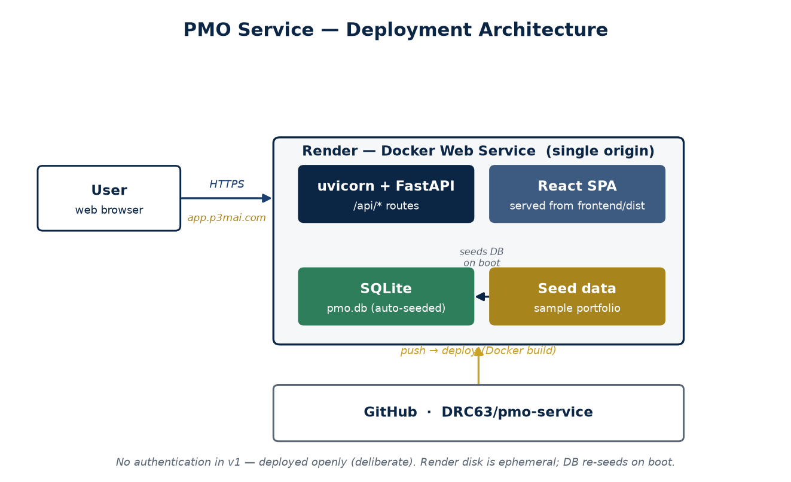
Figure 1 — Deployment architecture (single-origin Docker service on Render).

6. Data model
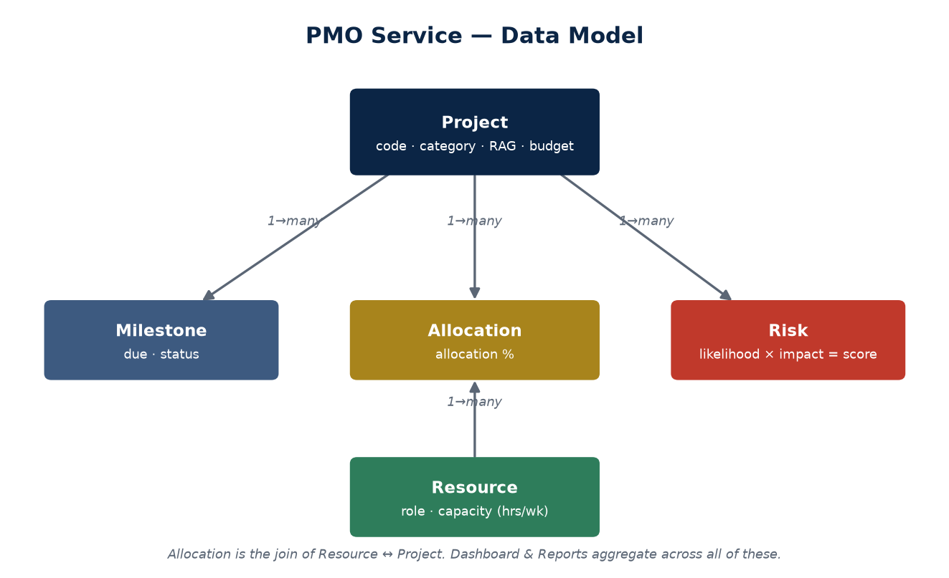
Figure 2 — Data model: Project with Milestones/Risks/Allocations; Resource via Allocation.

6.1 Entities
Entity | Key fields
Project | name, code, category, owner, start/end, budget, actual_spend, rag_status, description
Milestone | project, name, due_date, status, sort_order, notes
Resource | name, role, email, weekly_capacity_hours, active
Allocation | resource, project, allocation_pct, start/end (Resource↔Project join)
Risk | project, title, likelihood, impact, score, status, mitigation_plan, owner

6.2 Enumerations
Enum | Values
Project category | ai_infrastructure · transformation · banking · other
RAG status | green · amber · red
Milestone status | not_started · in_progress · complete · late
Risk status | open · mitigating · closed

★ Risk scoring
Risk score = likelihood × impact (each 1–5, so 1–25). A score of 15 or above is treated as high severity and surfaced on the dashboard.

7. Backend design

7.1 API surface
Router | Endpoints (CRUD unless noted)
projects | list/create/get/update/delete projects (+ nested detail)
milestones | list/create/update/delete milestones per project
resources | list/create/get/update/delete resources
allocations | list/create/update/delete allocations
risks | list/create/update/delete risks (filter by project/status/score)
dashboard | GET summary — RAG counts, upcoming milestones, high-severity risks, overdue count
reports | GET portfolio report; GET per-project report

A /api/health endpoint provides a liveness probe. ORM objects are converted to Pydantic responses by explicit serializers that add computed fields (owner names, is_overdue, percent-complete, etc.).

7.2 Dashboard & reports
The dashboard aggregates across the portfolio: RAG counts, the next upcoming milestones with days-until, the highest-severity open risks, and an overdue-milestone count. The reports produce a portfolio table (per-project percent-complete, open-risk count, top risk, budget vs spend) and a single-project drill-down.

8. Front-end design
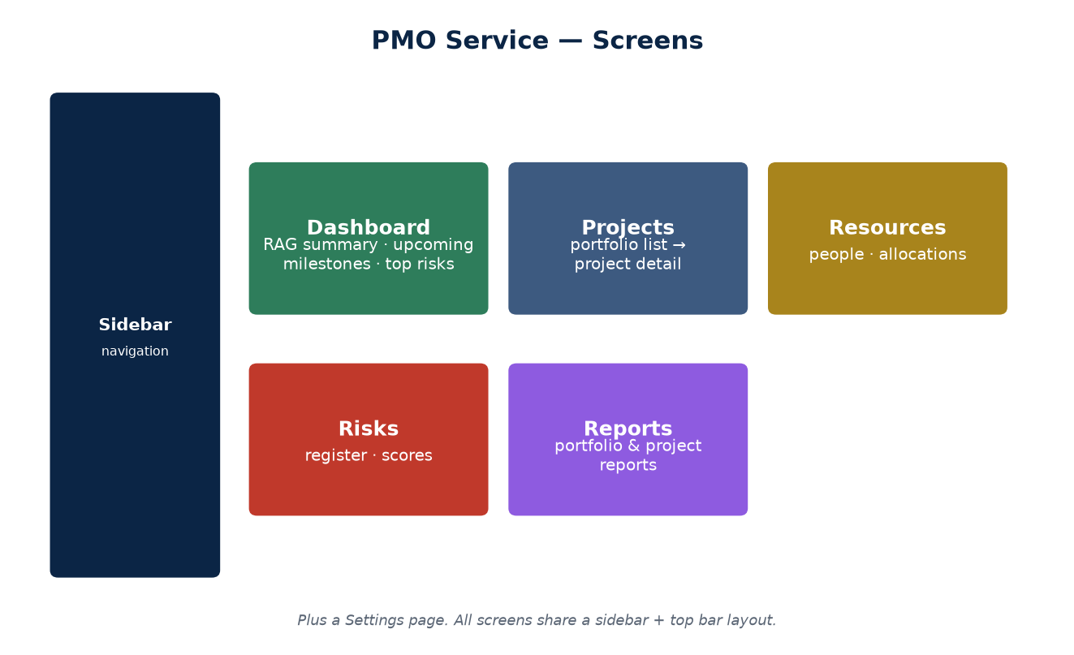
Figure 3 — The main screens.

Screen | Purpose
Dashboard | Portfolio health at a glance — RAG, upcoming milestones, top risks, overdue count.
Projects | Filterable portfolio list; a detail page per project with milestones, risks, allocations.
Resources | People, capacity and their allocations across projects.
Risks | The risk register with scores and status.
Reports | Portfolio and per-project reports.
Settings | App settings.

Shared UI: a sidebar + top-bar layout, reusable forms in modals (project, resource, risk), and status chips — RAG badges and a risk-score badge — for at-a-glance reading.

9. Seeding
On first boot against an empty database the app seeds a realistic sample portfolio (six resources; four projects — a GPU supercomputer build, a core-banking migration, a data-governance rollout and the AI-PMO pilot — with milestones, allocations and risks). Seeding is idempotent and skipped under tests.

10. Security & access control
⚠ No authentication in v1
The app has no login and is deployed openly at app.p3mai.com — a deliberate choice for a single-user tool holding non-sensitive demo/working data. Add authentication before it holds anything sensitive.

11. Deployment architecture
Deployed on Render as a Docker web service built from the multi-stage Dockerfile. The database re-seeds on every boot, so a fresh or restarted container comes up populated.
Aspect | Value
Repository | github.com/DRC63/pmo-service (private)
Platform | Render — Docker web service
URL | app.p3mai.com (Render: pmo-service.onrender.com)
Persistence | Ephemeral disk — DB resets on redeploy; auto-seeds

12. Key design decisions
Decision | Rationale
Single-origin Docker image | One container serves API + UI; nothing else to run.
SQLite + auto-seed | Zero-config persistence; ephemeral hosts self-populate.
No auth in v1 | Single-user, non-sensitive; keeps the tool frictionless (revisit later).
Explicit serializers | Computed fields (RAG, overdue, %-complete) added deliberately, not leaked from ORM.

13. Non-functional considerations
- Performance — small dataset, client-side rendering; comfortably fast.
- Portability — one Docker image; runs anywhere containers run.
- Extensibility — new entities/reports slot into the router + serializer pattern.

14. Roadmap
- Authentication and multi-user support before holding real data.
- Persistent storage (disk / Postgres) so data survives redeploys.
- Richer reporting and export (PDF/Excel).

Appendix A — Repository layout
pmo-service/
backend/app/ FastAPI app (main, models, schemas, crud, serializers,
enums, seed, database, routers/)
frontend/src/ React app (pages/, components/, layout/, api/, theme/)
Dockerfile multi-stage build
docs/ this documentation set

