P3MAI
METHOD MAP

User Manual
Using the P3MAI PMO Service

Document | DOC-02 — User Manual
Version | v1.0
Date | 1 August 2026
Author | Douglas Colvin, P3MAI
Classification | OFFICIAL
Applies to | P3MAI Method Map (PRINCE2 7)

Document control
Version | Date | Author | Change
v1.0 | 2026-08-01 | Douglas Colvin | Initial issue

Contents

(If the contents list is blank, click it and press F9 to update.)

1. Welcome
The PMO Service is P3MAI's project-management-office tool. In one place you can track your projects, their milestones, the people working on them and how they are allocated, the risks, and see it all rolled up on a dashboard and in reports.

1.1 Getting in
Open app.p3mai.com in a web browser, or use the Example button on the PMO card of the P3MAI website's Services page. There is no login. Nothing to install.
🔒 Sample data
The app comes pre-loaded with a realistic sample portfolio so you can explore every screen immediately. You can add, edit and delete freely.

2. The screen at a glance
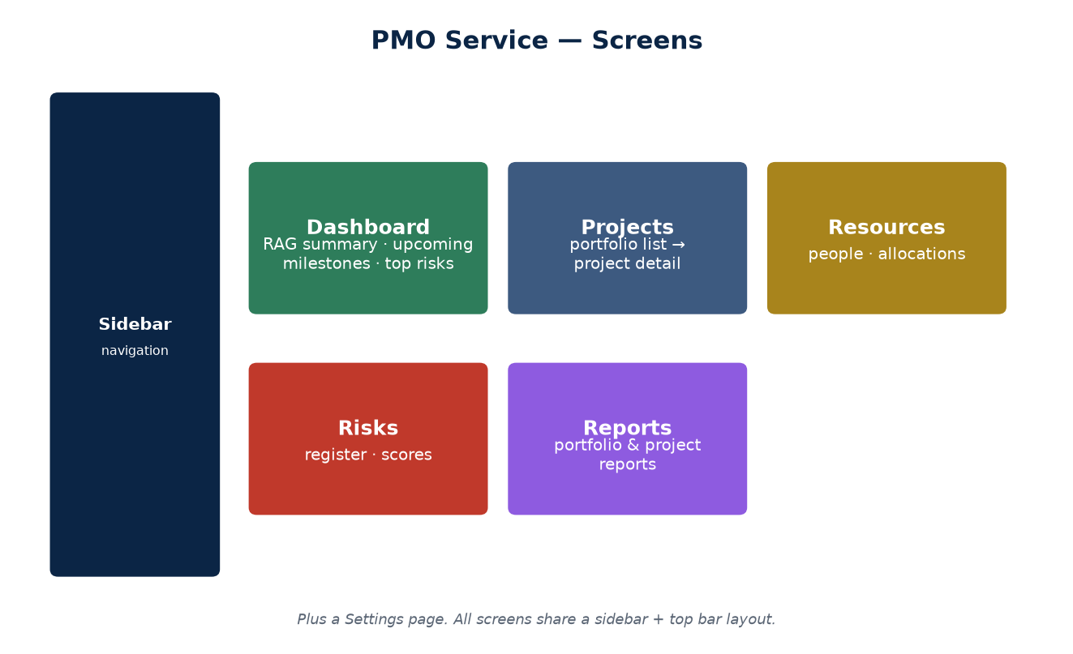
Figure 1 — The main screens.

A sidebar on the left switches between screens; the main area shows the selected screen. A Back to Website link returns you to p3mai.com.

3. The Dashboard
The landing screen gives portfolio health at a glance:
- RAG counts — how many projects are Green, Amber and Red;
- Upcoming milestones — the next ones due, with days remaining;
- High-severity risks — open risks scoring 15 or more;
- Overdue milestones — a count of anything past its due date.

4. Projects
The Projects screen lists the portfolio; filter it and open any project for detail.

4.1 Creating & editing a project
Use New project (or Edit on a row) to set the name, code, category, owner, dates, budget, spend, RAG status and a description. Save to update the list.

4.2 Project detail
Opening a project shows its milestones, risks and allocations together, plus budget vs. spend and percent-complete — the single view of one project.

5. Milestones
Add milestones to a project with a name, due date and status. Statuses are Not started, In progress, Complete and Late; anything past its due date and not complete is flagged overdue.

6. Resources & allocations
The Resources screen holds people — their role, email and weekly capacity. An allocation assigns a share (%) of a person to a project. Where someone's allocations across projects add up beyond their capacity, the over-allocation is shown so you can rebalance.

7. Risks
The Risks screen is the register. Each risk has a likelihood and impact (each 1–5); the app multiplies them into a score (1–25) and shows a coloured badge. Set a status (Open / Mitigating / Closed), an owner and a mitigation plan.
★ What counts as 'high severity'?
A score of 15 or more is high severity and appears on the dashboard. Reduce likelihood or impact (through mitigation) to bring the score down.

8. Reports
The Reports screen produces a portfolio report — every project with its percent-complete, open-risk count, top risk score and budget vs. spend — and a per-project report for a single drill-down.

9. Settings
The Settings screen holds application settings.

10. Reading the colours
Indicator | Meaning
Green / Amber / Red badge | Project RAG health — on track / at risk / in trouble
Risk-score badge | likelihood × impact (1–25); the higher and redder, the more severe
Overdue flag | A milestone past its due date and not complete

11. Tips & FAQ
Question | Answer
Is there a login? | No — v1 is open and single-user. Don't put sensitive data in it yet.
Can I get back to the website? | Yes — the 'Back to Website' link in the sidebar.
How is a risk score worked out? | Likelihood × impact; 15+ is high severity.
Why is a person shown over-allocated? | Their allocations across projects exceed their weekly capacity — rebalance.
Where do the sample projects come from? | The app seeds a sample portfolio on first run; edit or delete freely.

12. Glossary
Term | Meaning
Portfolio | The whole set of projects.
RAG | Red / Amber / Green health status.
Milestone | A dated checkpoint within a project.
Allocation | The % of a resource assigned to a project.
Risk score | likelihood × impact (1–25).

