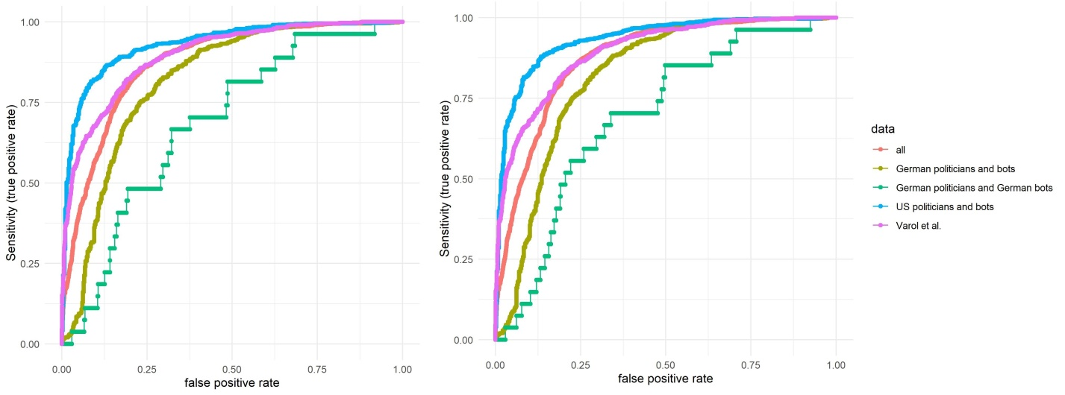
S1 Fig. Receiver Operating Characteristics curve for Botometer. The English score (left) and the English CAP (right). Average score over 3 months for each account.

