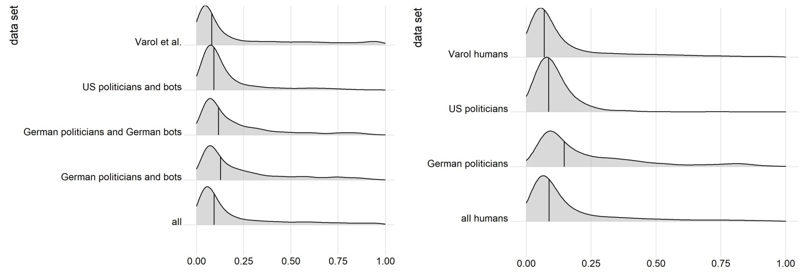
S5 Fig. Density plots for the different data sets. Left: Density plots for the different combined data sets in our analysis showing the distribution of Botometer’s English score. We used the resampled data sets with 15% bots and 85% humans with a total n=100,000 for each data set. Right: Density plots for the human accounts data sets. Lines indicate the median, a bandwidth of 0.04 was used for all data sets.

