Q1. install hadoop on the ubuntu. Configure as single node cluster.
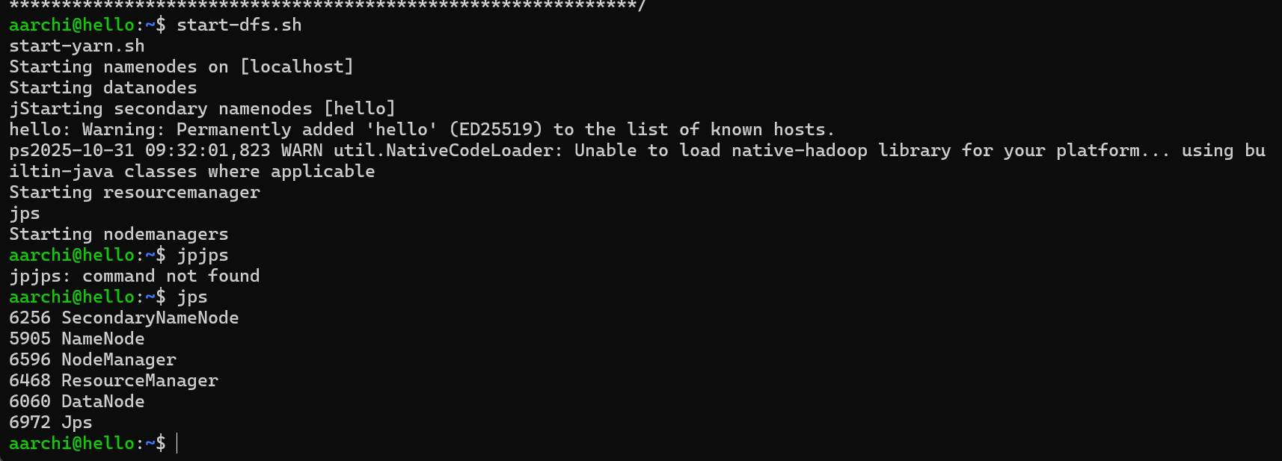

Q2. execute basic commands like ls,mkdir, cat 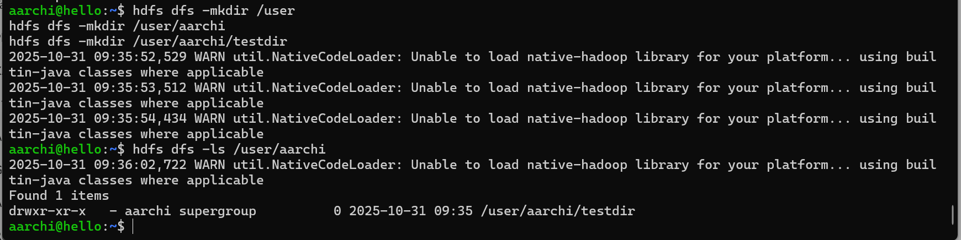

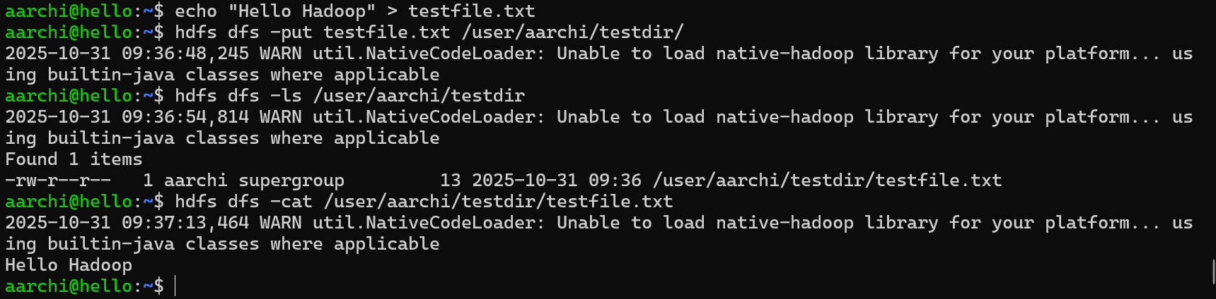
Q3. write and run mapreduce wordcount program.
