Install Hive in Hadoop Map Reduce Framework and execute the following operations
There is an employee table (empid, name, designation, year_of_joining, country). Use and
execute apache hive queries for following operations.
i) Create table employee with above attributes

ii)Consider a file.txt that consist of all data related to attributes and is located in
‘/home/exam/file.txt’. Insert the data from file.txt into table employee.

iii) Display all details of Employee table using select query.
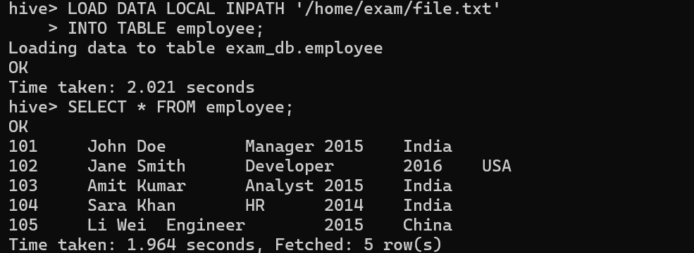
iv) add new columns to an existing employee table using alter query

v)Create table emp_partition using partition column year_of_joining.
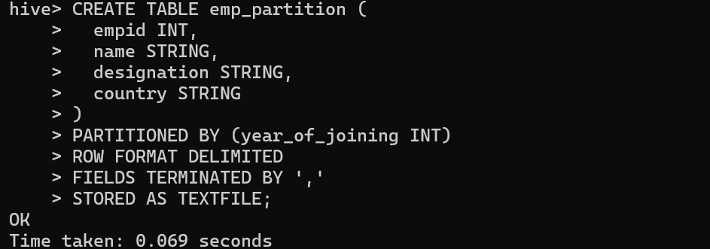
vi)Insert data into table emp_partition where year_of_joining is 2015 and country is India.
vii)Use HDFS command to list out partition created in “/usr/warehouse/emp_partition”
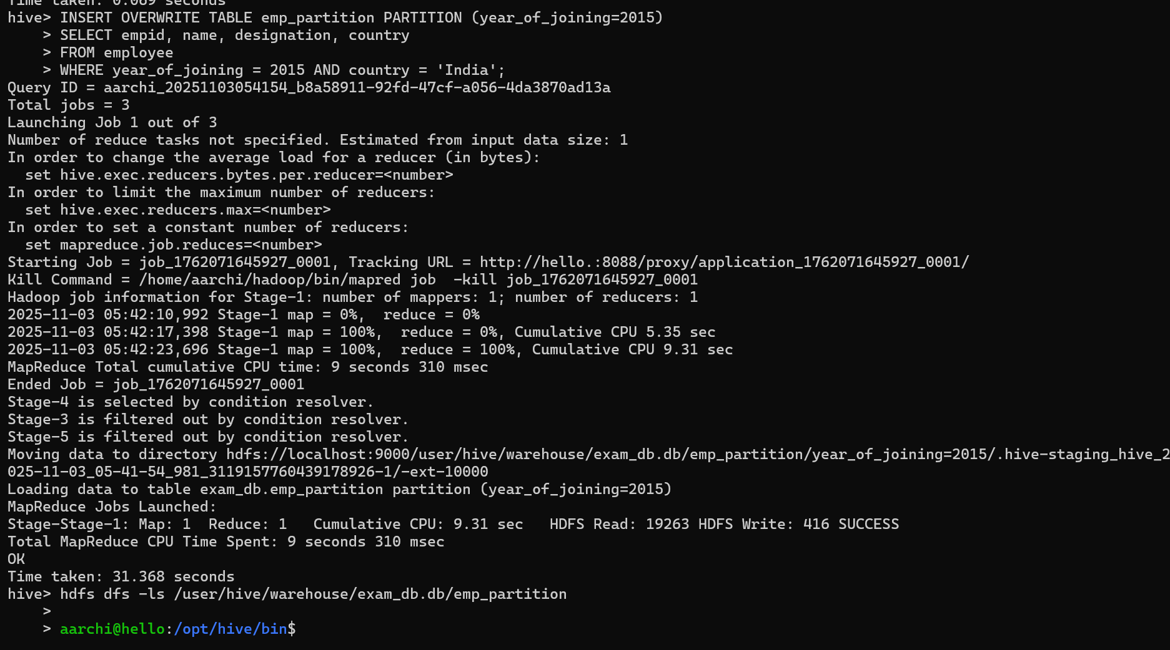

viii) After installation of Hive, modify the Metadata Configuration for MySQL as the storage for
metadata. Therefore, you need to modify the Hive configuration file.
