Use Hive in Hadoop Map Reduce Framework and execute the following operations
Q.1 There is an employee table (empid, name, salary, designation, department). Use and execute
apache hive queries for following operations.
1) Generate a query to retrieve the employee details who earn a salary of more than Rs
30000. Store the result in a view named emp_30000.
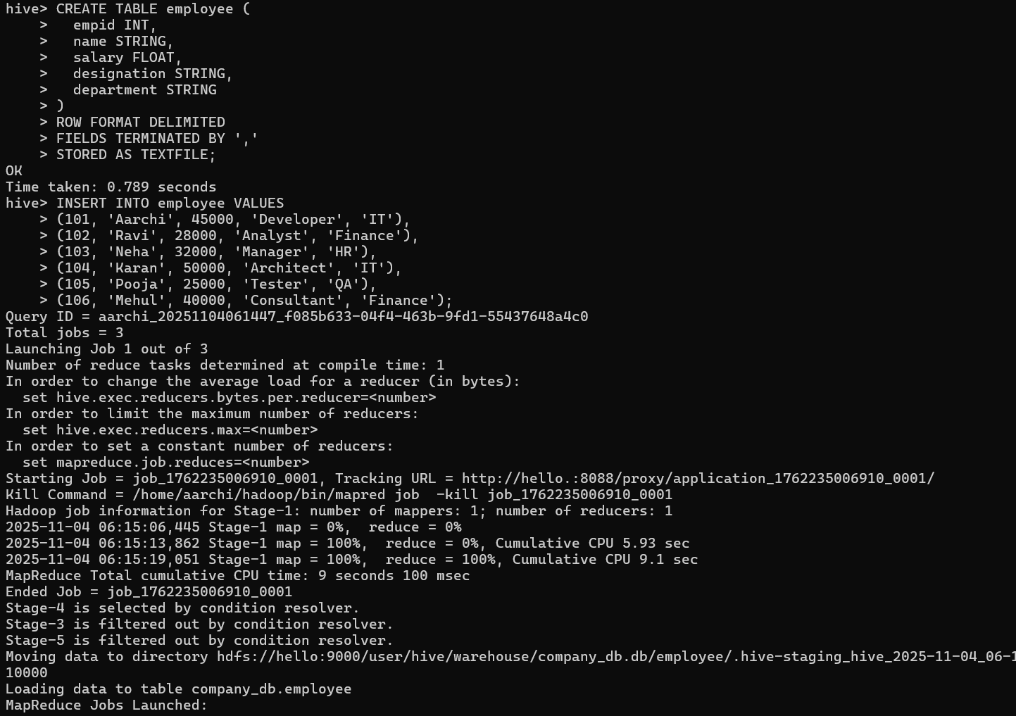
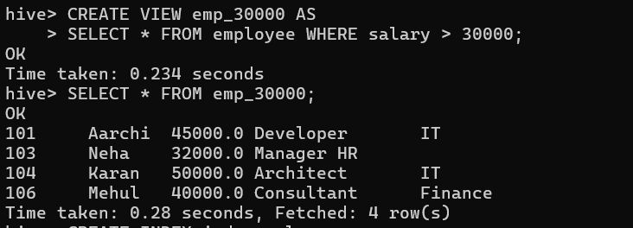
2) Create an index named index_salary on the salary column of the employee table.
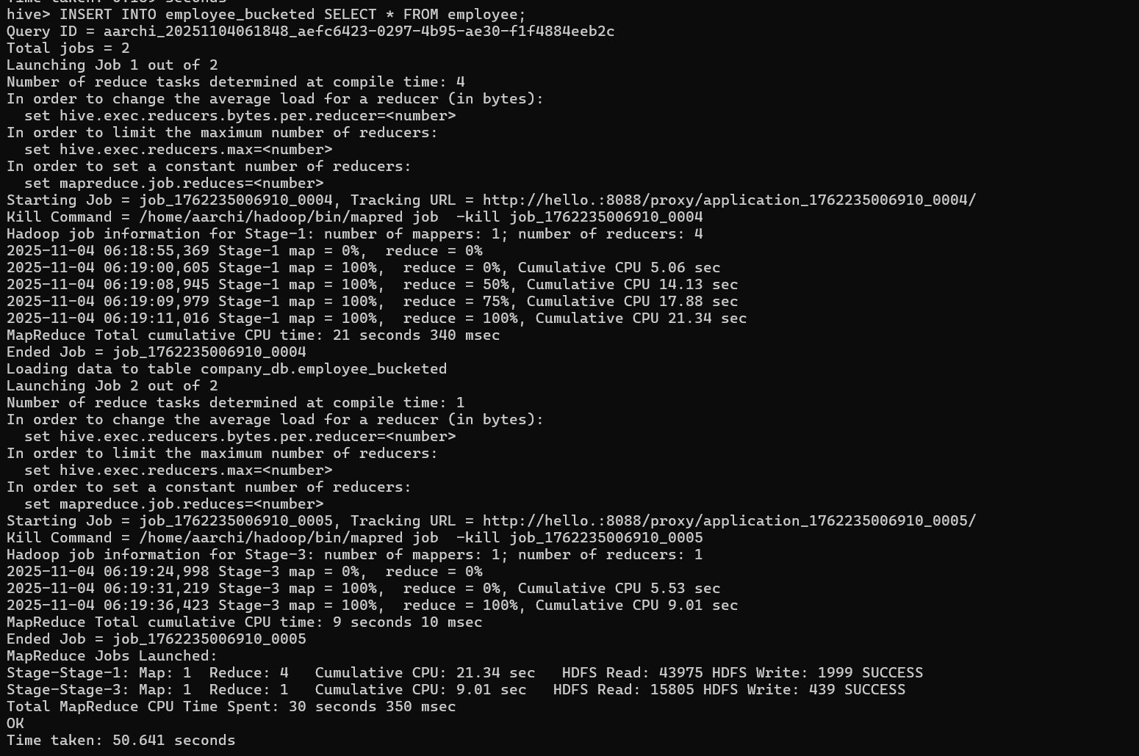
3) Write and execute a query to retrieve the employee details using order by clause and
descending; using salary
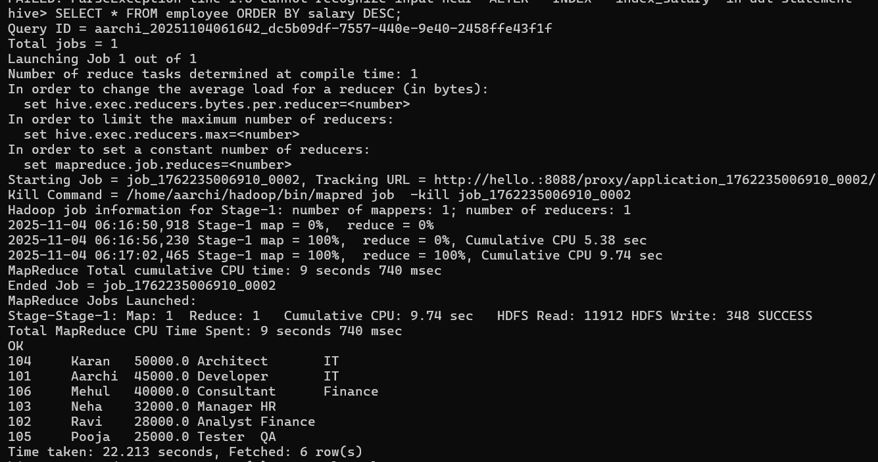
4) Write and execute a query a query to retrieve the number of employees in each
department using group by.
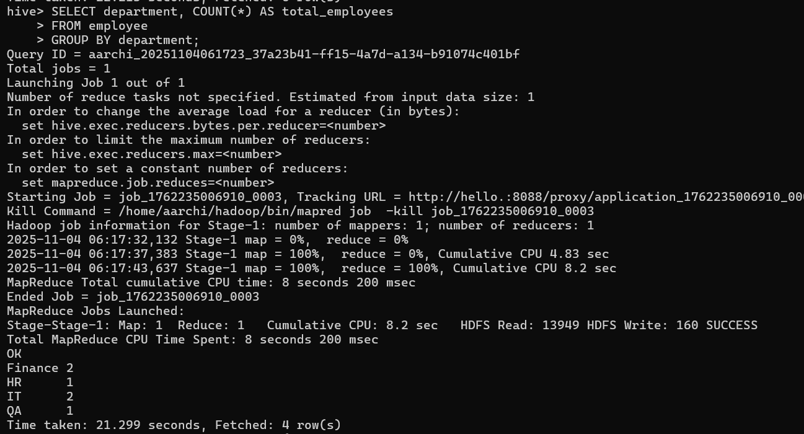
Q.2. Consider two tables, create and insert data in it with a common column. Perform different
types of joins such as Left, Right Outer join and Full Join.

