Co-simulation of vehicles and crowds for rescue trials

Yun-Pang Flötteröd1\*, Michael Behrisch1, Martijn Hendriks2, Jean-Benoît Bonne3, Erik Vullings4, Rinze Bruining4

1 German Aerospace Center (DLR), Institute of Transportation Systems, Germany

2 XVR Simulation, The Netherlands

3 Thales SIX GTS France, ThereSIS, France

4 The Netherlands Organisation for applied scientific research (TNO), The Netherlands

\*yun-pang.floetteroed@dlr.de

Abstract

In this paper, the focus is put on the integration of XVR, SE-Star and SUMO simulators via the Driver+ test bed, where XVR provides different learning environments for all levels of incident command, SE-Star handles crowd simulation and SUMO focuses on vehicular simulation and routing. With the test bed and the provided services these simulation tools can synchronically exchange information with each other, creating a common simulation space that offers more possibilities for CM-training, trials and tests. A simulation scenario around the train station in Rotterdam, the Netherlands is established for demonstration of the connected systems.

1. Introduction [DLR]

Crisis management (CM) is getting more and more attention worldwide. Different tools and solutions have been developed, but the interoperability between these applications is however still project-specific and needs to be enhanced in order to handle crisis situations with various aspects (e.g. rescue procedure, vehicle routing, crowd evacuation, flood prediction) in a complete manner. To facilitate efficient and effective CM-training, trials and tests the EU-funded project Driver+ has developed an open source cloud-based test bed, based on the distributed messaging platform Apache Kafka (Driver+, 2019). Different solutions and simulators were successfully connected to this test bed to meet the needs of proposed training and experiments.

In addition to develop a pan-European test bed for crisis management Driver+ also aims at capability development, emerging a portfolio of solutions and building a shared understanding in crisis management across Europe. To carry out these objectives four trials have been planned and executed in Poland, France, Austria and Netherlands respectively. Different solutions and simulators are tested according to the corresponding trial goals. Moreover, the annual Innovation for Crisis Management (I4CM) event takes place for knowledge/experience dissemination and sharing and addressing different crisis management issues.

This paper is to integrate three traffic/visualization-related simulators for establishing a common simulation environment, so that different issues of crisis incidents, e.g. crowd evacuation issue and vehicle routing issue, can be taken into account for trials and exercises. In Section 2, the Driver+ test bed, the concept to couple the simulators are firstly introduced. The adopted simulators and their main functions related to the test bed will then be explained. After that, the applied scenario for testing/demonstrating the coupling work is described in Section 3. The respective action plan is clarified and illustrated afterwards. In the end, conclusion is made and the planned work in the next phase is presented.

1. Test bed and simulators

To simulate a pre-defined crisis situation with different aspects the related simulators communicate and synchronize with each other via the Driver+ test bed Kafka. In the following, Kafka’s framework and its current development status and functions will be introduced. After that, the concept to couple the three simulators, XVR, SE-Star and SUMO, is explained. The main characters and applied functions of the simulators and the ways to connect them to Kafka are explained accordingly.

* 1. Driver+ Test bed [TNO]

Driver+ test bed Kafka is the essential technical infrastructure for all trials and exercises in the project. The objectives of the Driver+ test bed are not only to exchange information but also to test solutions with given fictitious incidents, created by simulators. The former one can be carried out with the Common Information Space (CIS) of the test bed, while the latter one can be achieved with the Common Simulation Space (CSS), as illustrated in the test bed framework in Figure 1. In the CSS, different simulators exist. They can operate independently or interoperate with other simulators, where the necessary couplings need to be established. There is a gateway to connect the CIS and CSS. With this gateway, the created fictitious incidents can be provided to the CIS and solutions can request changes to the simulation (Vullings, 2019). There are also additional tools in the test bed, such as time service and scenario manager (see Figure 1). These tools are available as Docker containers and can be easily used and combined in a Docker environment.

With regard to the flexibility of open source software and the available adapters to connect to the test bed the development of the CSS and CIS are based on the open source streaming platform, Apache Kafka. It can run easily in cloud with use of Docker. Avro schema is used to define the respective data schemas with use of JSON. Currently, the connecters in Java, C#, JavaScript, REST and Python are available in the Driver+ test bed for providing additional modelling and simulation functionality.



Figure Overview of the framework of the test bed Kafka (Vullings, 2019).

* 1. Coupling concept [DLR,XVR, Thales]

The main goal of the current coupling work is to carry out a common simulation environment with consideration of vehicles, pedestrians, and real-time vehicle dispatching, routing and positioning. This simulation environment can then be interactively used by trainees for crisis trials and exercises.

The whole coupling work is based on the test bed Kafka and illustrated in Figure 2. All simulators are synchronized with the time service provided by the test bed Kafka. There is a trial manager tool in the test bed for request sending and data exchanging. XVR (OS and RM) is used as visualization and training platform as well as request sender. As visualization and training platform XVR OS continuously updates crowd movements provided by SE-Star and interacts with trainees according to the pre-defined training procedure, while XVR RM sends requests for vehicle dispatching, routing or/and positioning. Vehicular positions and routes will be indicated in the XVR RM portal.

On the traffic simulation side, SUMO executes firstly the requests from the trial manager to start the simulation and then block roads upon request. During the simulation, SUMO sends vehicles into the simulation with the start and end positions, given by XVR. SUMO will also search the fastest route for certain vehicles and send back the respective route information, vehicle positions and traffic state according to the requests from XVR and the trial manager. On the crowd simulation side, SE-Star receives real-time obstacle positions from XVR and vehicle positions from SUMO for simulating crowd movements, and delivers crowd positions to XVR OS.

The main coupling work is finished. Some of the above mentioned functions, indicated in grey in Figure 2, will be implemented in the next phase.

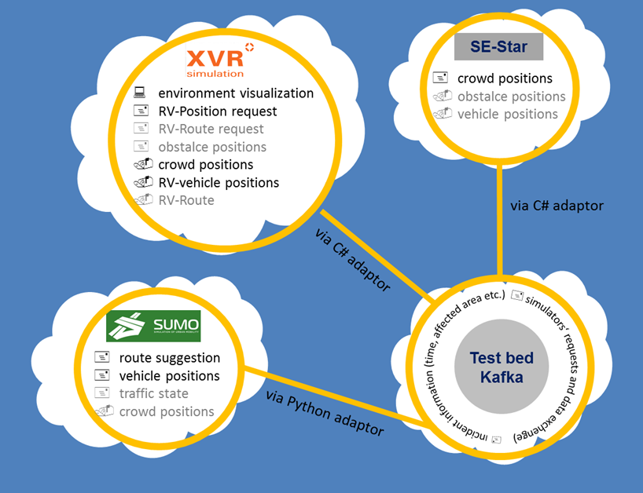

\*: RV: rescue vehicle; \*\*: functions in grey will be implemented in the next phase.

Figure The concept to couple XVR, SUMO and SE-Star.

* 1. SE-Star [Thales]

Since 2008, inside Data Science & Artificial Intelligence Labs of THALES, a Crowd Simulation engine, called SE-Star, has been designed. It is a life simulator managing: internal variables, motivations & emotions, stimuli, personality and behaviors. SE-Star uses a Biomimetic control architecture based on navigation (Hippocampus), action selection (Basal ganglia) and planning (Frontal cortex). Use-cases are: design of critical infrastructures and business processes, supervision (video & crowd) operators’ training, data generation for deep neural networks training (video & dataset generation), decision support, what-if scenario exploration and collaborative systems testbed. SE-Star can provide information from high level (density, alarms and situation reports) to low level (individual’s information, devices’ status). It can simulate between 5000 and 10000 peoples on one computer in real time and can work in distributed mode pushing limits (tested with 80000 peoples on 10 IntelTM NUC computers). SE-Star has been used in the EU projects (Opti-Alert, SECURE-Ed, iCore) and in THALES projects covering airports (Pisa), train stations (Gare du Nord) or crowded places (Mecca). Easily extendable, it has been connected to real systems (crowd monitoring, airport supervision) using standard interfaces and protocols (SAOP, REST, RTSP).

In the Driver+ project, the C# test bed adapter has been selected and extended to support SE-Star network messages. Those network messages allow to control the simulation, share Entities and Objects information and control them.

* Control the simulation: From the test bed time service, it’s possible to pause, play and change speed of the SE-Star simulation.
* Share Entities and Objects: SE-Star creates entities and objects relevant for the crowd simulation. Objects can be entry points for building (shops, restaurants, main entrances …) or security equipment like speakers for evacuation. SE-Star gets objects and entities that can impact the crowd simulation. It can be vehicles from XVR (ambulances) or SUMO (road traffic and sign) and entities from XVR like a firefighter.
  1. XVR [XVR]
* Brief introduction about XVR OS and XVR RM
* Connectors built for coupling with the test bed/SE-Star
* functions
  1. SUMO-Connector [DLR]

To be able to interact with other simulators during a simulation the SUMO component TraCI (Traffic Control Interface) is applied. TraCI can give access to a running road traffic simulation and allows to retrieve values of simulated objects, to manipulate their behaviors on-line and to change the usage status of the infrastructure, e.g. road/lane use and traffic light control (SUMO-TraCI, 2019). Currently, most of TraCI functions are implemented in Python. Therefore, the python test-bed adapter is adopted to connect SUMO and the test bed Kafka.

According to the defined coupling concept in 2.2 the required messages are divided into three categories.

* Configuration

In this category, the start and end times of a simulation and the simulation configure file name are defined. Moreover, the data aggregation intervals for the traffic in the whole network, each single vehicle and the traffic in the affected area are defined respectively, where the latter two intervals are optional items. The corresponding data will be sent back to the test bed Kafka at the pre-defined intervals.

* Affected areas

Each affected area is defined with ID, its polygon information as well as the begin and end times. Furthermore, the status of broken traffic lights in the area, i.e. true or false, and the restricted vehicle types also need to be defined. All roads in the affected areas will be closed for the defined restricted vehicle types according to the given begin and end times.

* Request

It is mainly to handle three requests: (1) to insert rescue vehicles in the simulation with the given start and end geo-coordinates; (2) to find the corresponding fastest routes and send them back to the test bed, and (3) to send the respective vehicle positions at each time stamp, which is configurable, back to the test bed.

The developed SUMO-Connector for the test bed and two scenario examples are available under <https://github.com/DRIVER-EU/sumo-connector>.

1. Scenario
   1. Description [DLR]

To test the proposed coupling work a synthetic scenario around the main railway station in Rotterdam, the Netherlands has been established. In this scenario, a vehicle incident has occurred at the main railway station. No trains are allowed to run. The surrounding roads need to be closed and the people inside and around the railway station need to be evacuated. An overview about the scenario is illustrated in Figure 3.

Furthermore, the crisis manager needs to dispatch the rescue team, police and medical staffs from different units to different locations at different times according to the rescue progress.

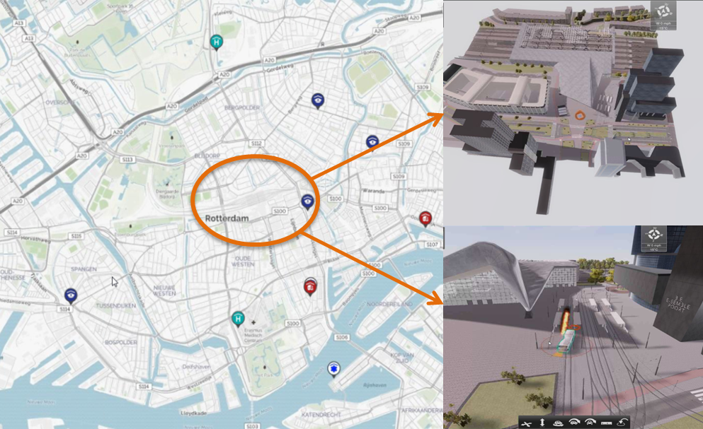

Figure Overview of the synthetic scenario at the main railway station in Rotterdam.

* 1. Simulation setup

OpenStreetMap is used as the basic map for all simulators. Moreover, the 3D map at the main railway station is also applied for crowd simulation and trial visualization. Regarding traffic demand, synthetic traffic, including passenger cars, buses, trucks, trams, bicycles and pedestrians, is generated. Figure 4 shows an overview about the simulated crowd movements with SE-Star, while Figure 5 shows the network for traffic simulation and the road closure area, indicated in yellow. During the road closure period only authority vehicles can run in the closed area. There is no change in traffic light control. Together with the crowd movements, vehicle positions, which are sent upon request, will be sent to the test bed. XVR will then receive these data and visualize them in the trial simulation environment (XVR OS) and the traffic information portal (XVR RM) accordingly. Figure 6 illustrates the trial simulation environment with XVR OS.

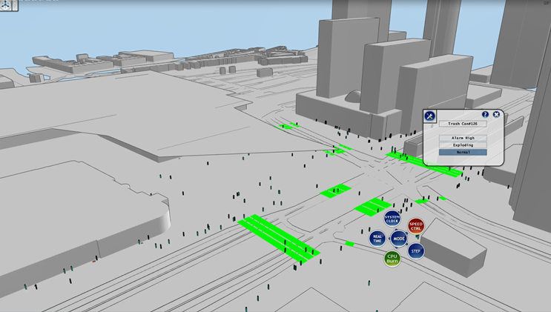

Figure Simulated crowd movements in the Scenario at the main railway station in Rotterdam.

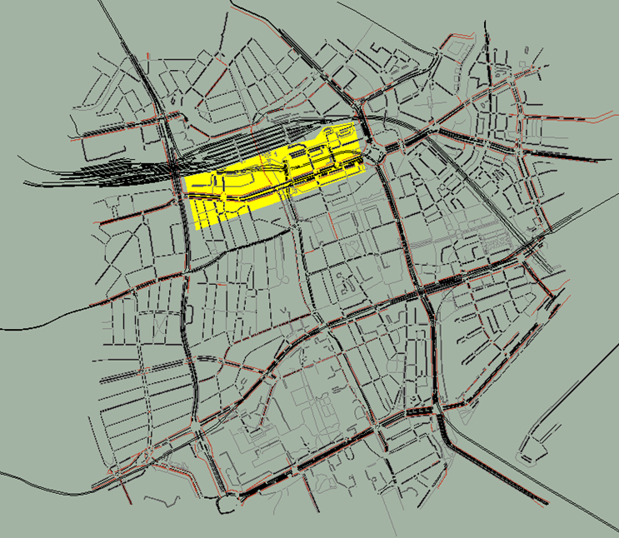

\* All the roads in the yellow area are closed due to the vehicle incident.

Figure Overview of the microscopic traffic simulation network.

Figure Illustration of the trial simulation environment with use of XVR OS.

* 1. Action plan [DLR]

According to the scenario description in 3.1 the corresponding action plan is developed for testing the coupling work. This plan covers from test-bed connecting, simulators starting, request sending, data sending to simulation ending. Figure 7 shows the sequence of all actions and the messages needed to be exchanged in the scenario. According to this action plan, the coupling test will be manually executed and demonstrated at the SUMO User Conference.

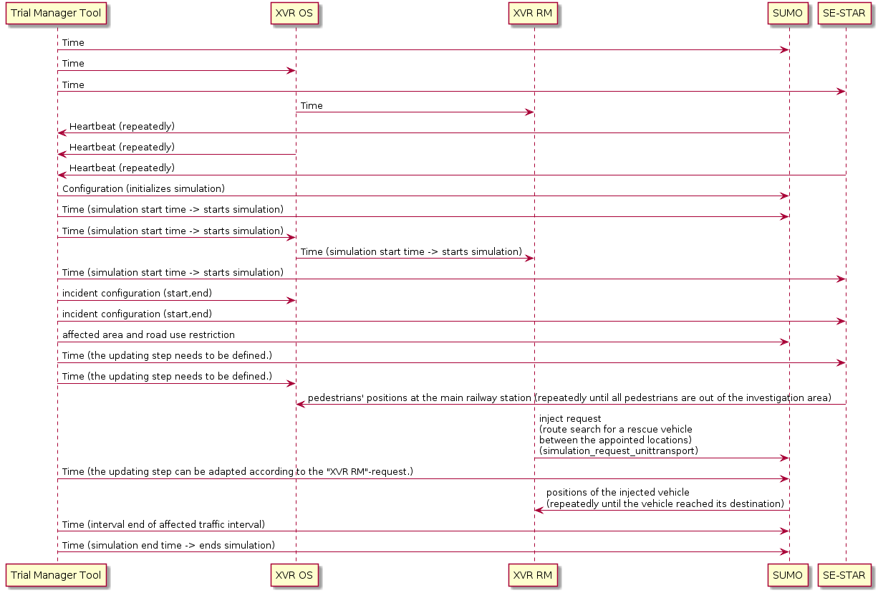

Figure Sequence diagram of the proposed action plan

1. Conclusion and future work [DLR, XVR, Thales, TNO]

The current main coupling work focuses on the basic communication and data exchange between XVR, SUMO and SE-Star and the visualization environment for trials and exercises. In the next phase, the required messages for the coupled simulation will be integrated into Driver+’s trial manager tool, so that users can use these three simulators for setting up a common simulation directly via the trial manager tool. Moreover, the planned functions, indicated in grey in Figure 2 will also be implemented to make a common simulation environment more completely. More functions can also be developed according to the users’ needs.

1. Acknowledgements

The authors gratefully acknowledge the funding of the DRIVER+ project received from the European Union’s 7th Framework Programme for research, technological development and demonstration under Grant Agreement no. 607798.

References

Driver+. (2019). DRIVER+ Objectives and activities. Retrieved 02 28, 2019, from https://www.driver-project.eu/driver-project/objectives-and-activities/

Vullings, Erik, van Campen, S., Hameete, P., Hendriks, M. (2019). Cloud-based M&S for Trails and Exercises. In *2019 30th International Forum for the Military and Civil Simulation, Training and Education Community (ITEC)*, May 14-16, Stockholm. (accepted)

Lopez, P. A., Behrisch, M., Bieker-Walz, L., Erdmann, J., Flötteröd, Y.-P., Hilbrich, R., … Wießner, E. (2018). Microscopic Traffic Simulation using SUMO. In *2018 21st International Conference on Intelligent Transportation Systems (ITSC)* (pp. 2575–2582). IEEE.

SUMO. (2019). *SUMO: TraCI*. Retrieved 02 28, 2019, from https://sumo.dlr.de/wiki/TraCI

Navarro, Laurent, Flacher, Fabien, Meyer, Christophe (2015). SE-Star: A Large-Scale Human Behavior Simulation for Planning, Decision-Making and Training. *In AAMAS 2015.*

Roelands, Marc & Van Raemdonck, Wolfgang & Ménoret, Stéphane & Navarro, Laurent & Bildea, Ana & Creiche, Sébastien. (2015). Effective Mission Management through Service-aware Streaming Infrastructure. *In AMBIENT 2015, The Fifth International Conference on Ambient Computing, Applications, Services and Technologies, At Nice, France, Volume: 978-1-61208-421-3*