**<C# Project>**

**System Design Specification (SDS)**

**Version 4.0**

**<2015年10月12日 星期一>**

Leon i330003033

Henry i330003022

Hazert i330003036

Dennis i330003019

Weber i330003039

Iris i330003029

**Computer Science and Technology Program**

**United International College**

1. Table of Contents

1. Table of Contents 2

2. Document Change Log 3

3. Introduction 4

3.1. Purpose 4

4. System Features 5

4.1. System Feature 1 5

4.2. System Feature 2 6

5. User Interface Design 11

5.1. UI Design 11

5.2. UI connection 25

6. Database Design 26

6.1. Database table 26

6.2. Database ER-Diagram 26

7. Other Nonfunctional Requirements 27

8. Appendix 28

1. Document Change Log

|  |  |  |  |
| --- | --- | --- | --- |
| ***Change Date*** | ***Changed By*** | ***Version*** | ***Change Description*** |
| *10/10/2015* | *Henry* | *1.0* | *Collect Document into SDS* |
| *10/11/2015* | *Leon* | *2.0* | *Changing “Data analysis for frequency” part* |
| *10/11/2015* | *Hazert* | *3.0* | *Translate Appendix into English* |
| *10/12/2015* | *Henry* | *4.0* | *Format adjusting* |
|  |  |  |  |
|  |  |  |  |
|  |  |  |  |
|  |  |  |  |
|  |  |  |  |
|  |  |  |  |

1. Introduction

## Purpose

This application is used to do some data analysis and help the company to predict their future business. Company should have every customer’s basic information (like name, phone and age) and their consumption record. Our software can use these data to show some result like “which product or items is the most popular in our shop”.

**Software Target Customer**

Our software is to analyze some customer’s basic information and consumption record, so the company should ask customer to register their information so that the company can use the software to do some analysis.

**Aim**

Let the company to know more about their selling condition.

Store the customer’s information and use the data do some long term prediction.

1. System Features

## System Feature 1

1. **Register**

Description：The application will allow the manager to record the information of the new members

REQ-1: Name (no more than 5 bits)

REQ-2: Gender (male or female)

REQ-3: Age

REQ-4: Telephone Number (EX: XXX-XXXX-XXXX)

REQ-5: Wechat Number

1. **Member consumption record**

Description: For the manager to record the consumption of the members

REQ-1：Consumption Items*

REQ-2：Consumption Amount*

REQ-3：Consumption Time*

## System Feature 2

1. **Data Analysis for frequency**

Description:

The owner of beauty salon can set up particular sales proposal for different customers, especially for those who came for consumption most. In this case, it is expected to reach the frequency for each customer and rank them in a list.

Idea:

The frequency we want here is how many times that each customer came for services during last month. The result can be obtained by counting up the figure of each customer. And it is also expected to present the top 10 customers.

Design Requirement:

REQ-1: The application should generate a table to present the final result.

REQ-2: The table should be in well-organized which means users can go through the data clearly.

Example:



1. **Data analyses for consumption capacity of costumers**

Description:

Having a good understanding about the capacity of costumers is quite necessary for the owner to set the price. Therefore, this application is expected to generate which price interval contains the majority of the number of costumer in order to provide the most affordable price for the publicity. The result can be obtained by analyzing the amount of consumption items and the price of them.

Design Requirement:

REQ-1: The application is supposed to draw a bar char and a table to show the result.

REQ-2: Users are able to have a general idea about the setting of price after viewing the outcome immediately.

Example:

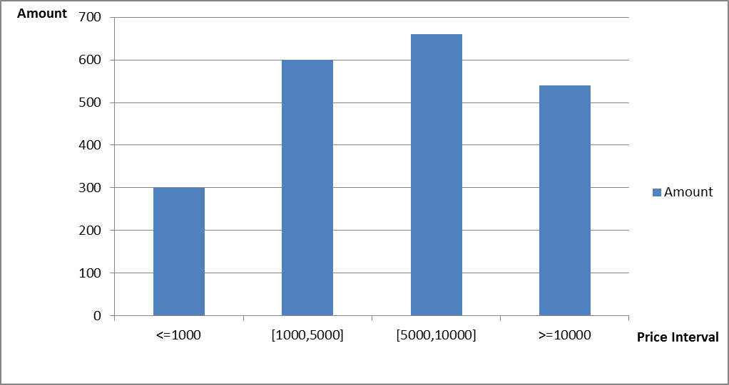

1. **Data analyses for The Most Famous Project**

Implementation description:

In this part, we aim at comparing the amount of customers of each project to others in a certain period. This helps owners of business find out the famous project clearly. In this function page, it uses the frequency of customers’ consumption from January to recent month. This will take the data of frequency of consumption from the database. It will calculate the ratio of each business project and then present result by pie chart. Owners can understand the different ratio of all projects and find out the most famous project.

Design Requirements:

REQ-1: The page of the programmer will show a table (pie chart) to present the amount of customers of each project and compare with the other project that will let owners of business know the ratio difference.

REQ-2: The table should be easy to understand and show the difference of each project.

Example:

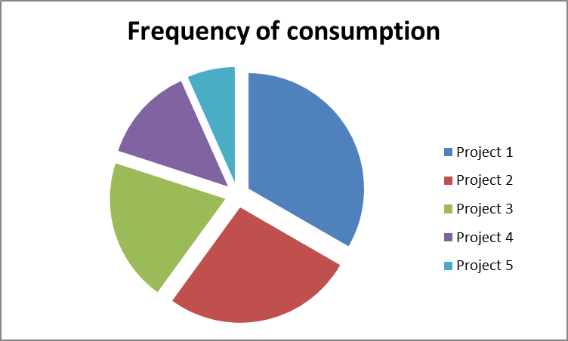

1. **Data analyses for The Future**

Implementation description:

The function aims at helping the owners of the business to determine the development or investment in each project for earning more profit. This function uses the data of frequency of consumption, the amount of customers and the consumption capacity of costumers to give a direct observation and objective data that let owners know the difference of profit of each project. The frequency of each project is multiplied by the price of each business project and then it can get the total income of each project from January to recent month. This will be presented by a table. Thus, owner can decide how to balance or focus the projects.

Design Requirements:

REQ-1: This function will form table that includes the data it needed to compute the net profit of each project. Thus, the owners can make business decision for the development.

REQ-2: The table should be easy to understand and show the difference of each project.

Example:



1. **Data analyses for customer flow**

Description:

We use line chart to show the customer flow’s change. First we record customer’s numbers every month. Then we use in January to now’s data to make a line chart. This chart can help us to improve our management of the company and formulate the development planning.

Design Requirements:

REQ-1: This data in the form of a line chart.

REQ-2: If the month was not full, we only use January to last month’s.

Example:

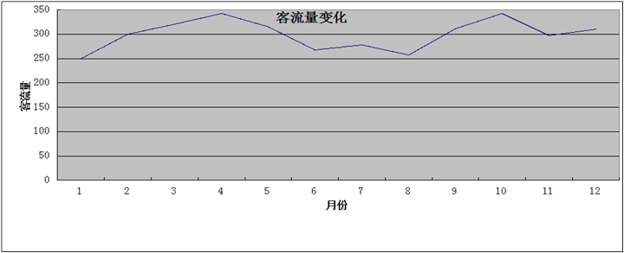

1. User Interface Design

## UI Design

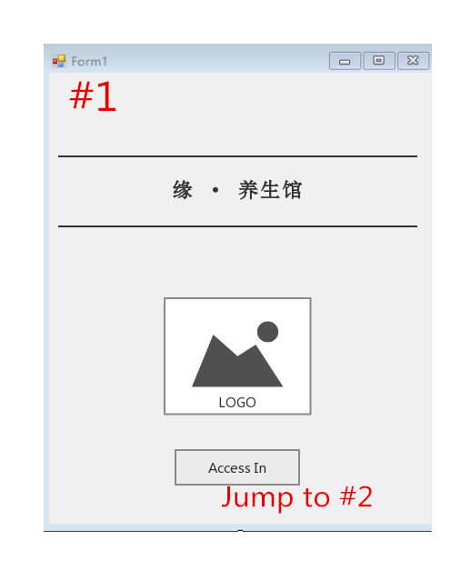

*Welcome Page of the software. When user open the software, they can see their shop’s name on the software and their logo.

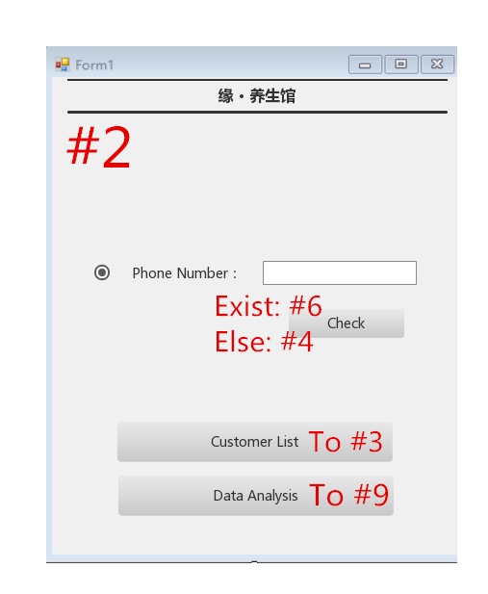

*“Customer List” is used to let the user view all the customer’s name and his/her phone number

*Click the “check” button can check if the customer exist or not.

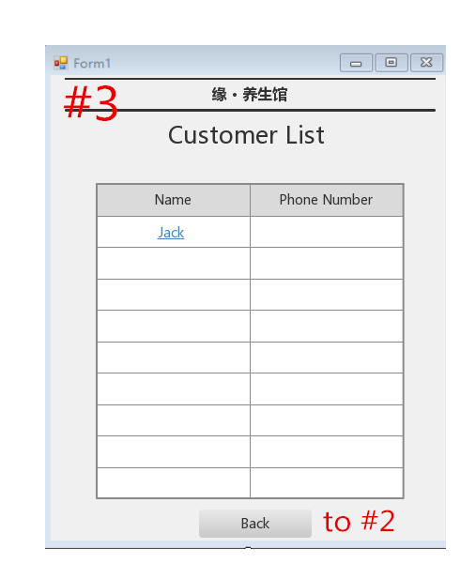

*To show all the customer’s name and phone number

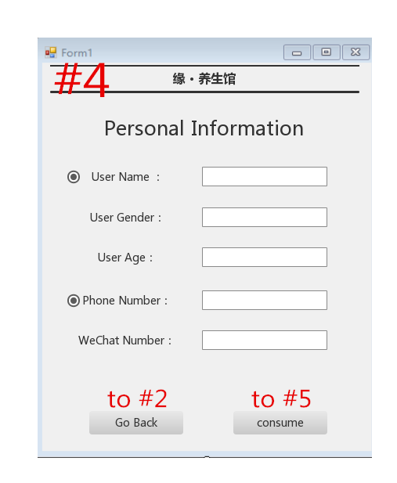

*Input basic information. Before analyzing the data, user should input all customer’s information, customer’s name ,gender, age and phone number are required

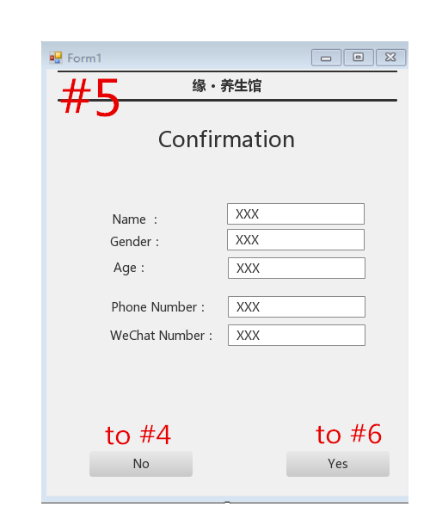

*Let the User confirm the information, if yes, jump to view this customer’s information, else jump back to the last page.

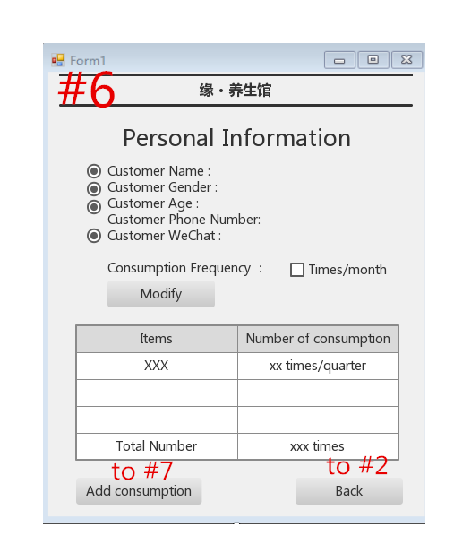

*If the customer exist, jump to this page directly, else they should create a new VIP then they can view their basic information

*User can edit the basic information, but the Phone number is not allow to be changed.

*After checking the basic information, user can add consumption.

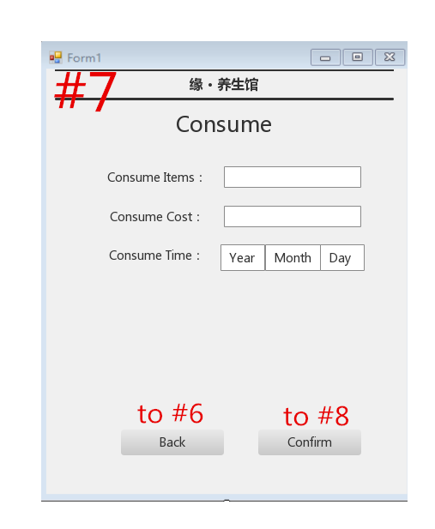

*Consume Part. After input the basic information, user should input some consume information into the computer.

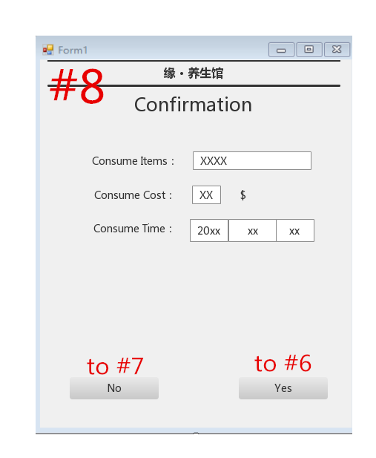

*Let User check whether they input the correct data. If it is OK, then go back to Basic information part, else go back to consume page

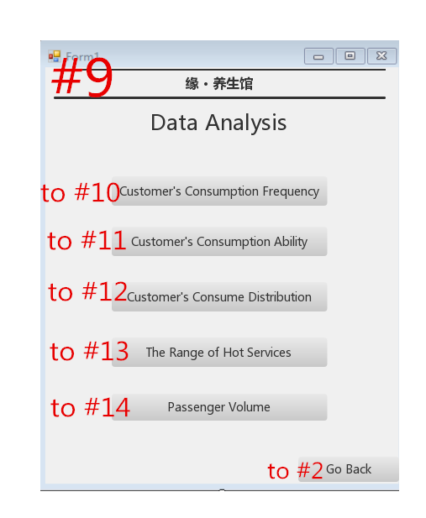

*Data Analyzing Part. It include customer’s consumption Frequency, customer’s consumption ability, customer’s consume distribution, the range of hot services and advises for development.

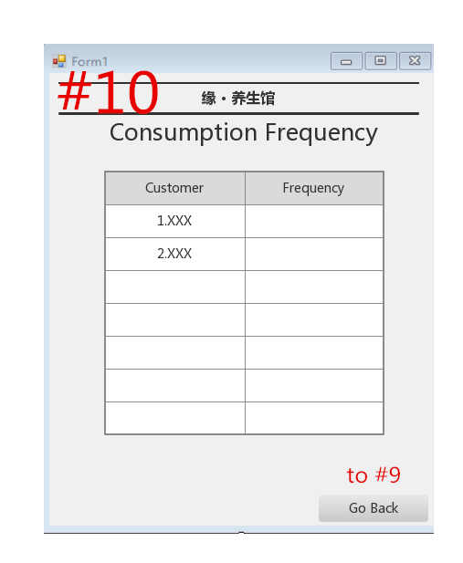

* Consumption Frequency. To analyzing the frequency of customer’s consumption, it will order by times/ month.

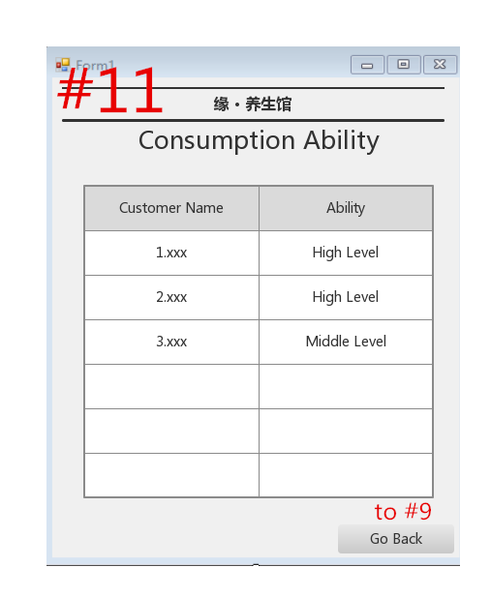

* Consumption Ability. From the consumption data we can check who do the expensive services and that will let him become high level customer.

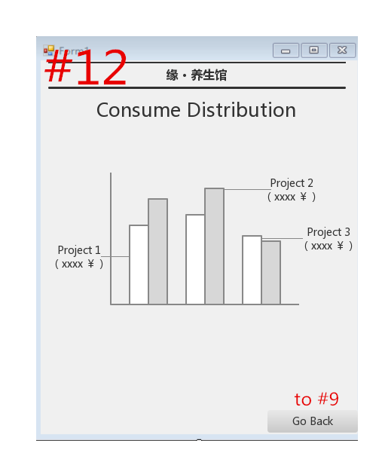

*Consume Distribution. Use the age data we can know the customer’s age distribution.

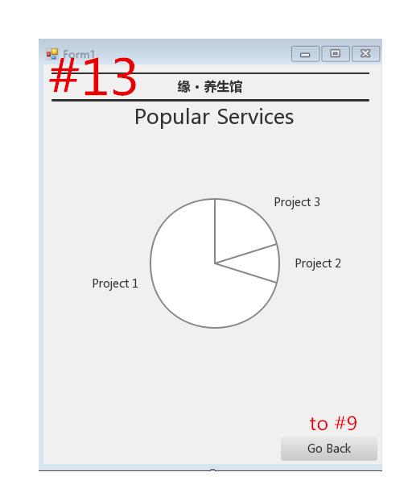

*Popular Services.

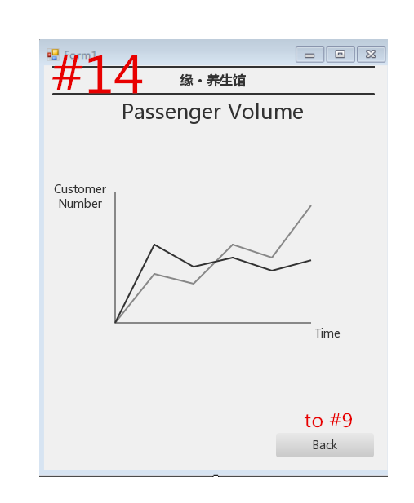

*Passenger Volume

## UI connection

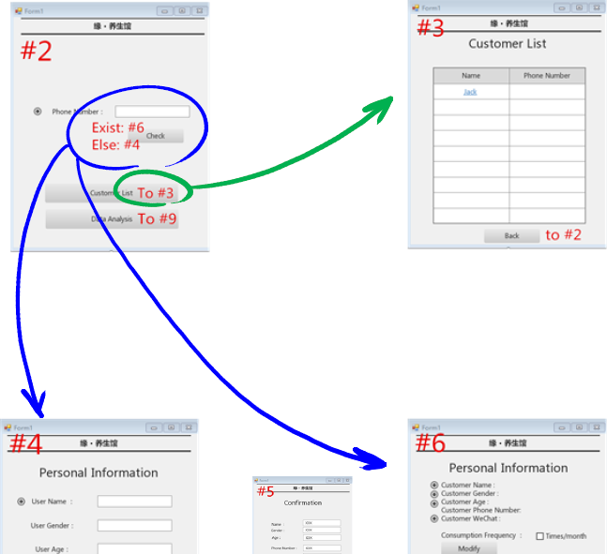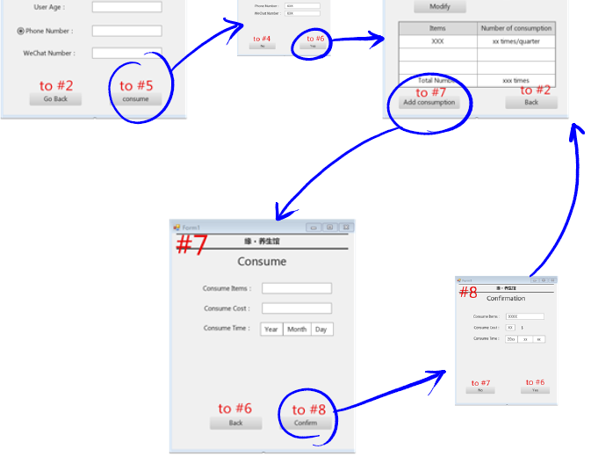

**Confirm Data**

**Confirm Data**

**Else, create a new data**

**If Data Exist**

1. Database Design

## Database table

* **User** ( u-id, Name, Gender, Age, PhoneNumber, WechatNumber)
* **Consume** (c-id, PhoneNumber, item-id, Year, Month, Day)
* **Item** (item-id, item-name, item-price)

## Database ER-Diagram

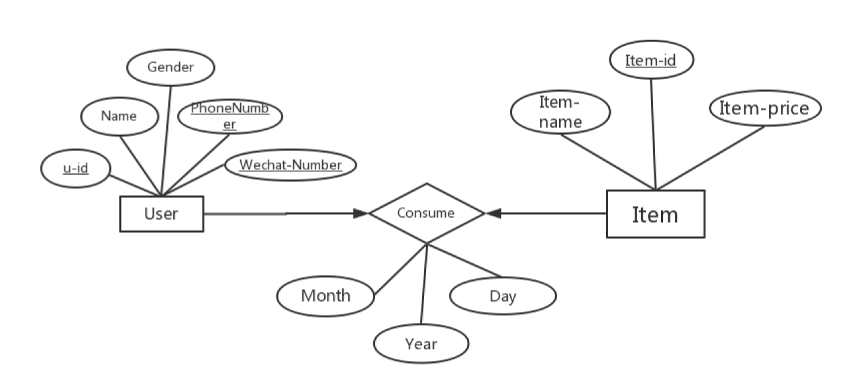

1. Other Nonfunctional Requirements

**5.1 Nature Requirements：**

5.1.1. This software should have independent company database, which is used to store customer account information and comments and a large number of documents.

5.1.2. You can use C#、 HTML、MYSQL、PHP、JavaScript、Java、JSP、JDBC、 Struts2、programming language to build this website.

**5.2 Security Requirement：**

5.2.1. This software should protect users’ personal and own account information. When user register, this website should send an email to confirm. If user forget their password, they can send email to set new password. （＊）

5.2.2. This website should protect courses’ resources and documents.

**5.3 Quality Requirements：**

5.3.1 This website could fit different indicator which have different resolution ratio.

Such as notebook, iPad, mobile phone and so on.

* + 1. Make sure this website can provide a large number of serves to visitors at

the same time.（＊）

* + 1. Make sure this website code be legible and it is easy for programmer to

vindicate.

（＊）It not very necessary for this project.

1. Appendix

**6.1 appendix**

|  |  |
| --- | --- |
| Item | Price |
| Skin Care | 98 |
| Manicure | 20 |
| Pedicure | 40 |
| Massage | 128 |
| Eye-Brow Shaping | 20 |
| Remove Fingernail | 20 |
| Acupuncture | 50 |
| Cupping Glass | 70 |
| Yuga | 60 |
| Steamed | 50 |