Project name: | Tung-Hsiao Power Plant 2nd Stage Renewal Project Turn-key Contract of Subsea Gas Pipeline
Name: | Daryll Enano
E-mail: | daryll.enano@nmdc-group.com
Date: | {{ report_date_top }}

Personnel Overview
NAME | FILE NUMBER | DESIGNATION | To Project | From Project | COMPANY | WORK AREA
NAME | FILE NUMBER | DESIGNATION | Date of Arrival | Date of Dep | COMPANY | WORK AREA
Daryll Enano | 5062 | CHIEF SURVEYOR | 01.07.2025 | - | NMDC | Site Office
Mohamad Abror Hediarto | 500652 | PROJECT SURVEYOR | 01.09.2025 | - | BRUNEL | Site Office
Danilo Bartolome | 502893 | PROJECT SURVEYOR | 01.12.2025 | - | BRUNEL | Site Office
Mateo Mollaneda | 503296 | SURVEY DATA PROCESSOR | 22.12.2025 | - | BRUNEL | Site Office
Roderick Clavel | T3274 | SURVEYOR | 24.03.2025 | - | NMDC | Site Office

Leave Planning
NAME | Leave Plans |  | UAE Visa Run | Leave Type | Remarks | Destination
NAME | Start of Leave | End of Leave
Daryll Enano | 01-12-2026 | 05-01-2027 | 09-01-2027 | Rotation | Planned | Philippines
Mohamad Abror Hediarto | 28.09.2026 | 24.10.2026 | N/A | Annual | Ongoing | Taiwan
Danilo Bartolome | 18.12.2026 | 17.01.2027 | N/A | Annual | Planned | Philippines
Mateo Mollaneda | 21.01-2027 | 22.02.2027 | N/A | Annual | Planned | Philippines
Roderick Clavel | 21-01-2027 | 21-02.2027 | 15-01-2027 | Rotation | Planned | Philippines

Training and Pass Status
Name | ARC expiry | Offshore Training | OSHA Training date | Taichung Port Gate Pass - Validity | TPC PASS Validity | Remarks
Daryll Enano | 2026-11-26 | BOSIET  2026-01-20 | 2026-04-21 | 2026-06-30 | 2026-12-31 | All Complete
Mohamad Abror Hediarto | 2027-08-24 | BOSIET  2023-10-20 | 2025-09-19 | 2026-06-30 | 2026-12-31 | All Complete
Danilo Bartolome | 2027-08-31 | Waiting for Project Schedule | 2026-01-07 | 2026-05-30 | Application – Processing | Need to wait until Feb 2027 ARC Renewal
Mateo Mollaneda | 2026-12-21 | BOSIET  2024-01-17 | 2026-01-16 | 2026-05-30 | Application – Processing | On-going
Roderick Clavel | 2027-01-31 | BOSIET  2026-04-01 | 2026-04-21 | 2026-05-30 | 2026-12-31 | All Complete

(Weekly) General Information

Project Activities with Survey Involvement:

- Survey Base Station at Taichung Port and Tunghsiao Power Plant installed and maintained by EGST. Shared to NMDC via radio telemetry and via NTRIP.

- Tide Gauge installed and maintained by EGST. Shared to NMDC via web page real-time data.

Onshore Taichung, located at Taichung LNG Receiving Terminal:
- Advanced Horizontal Directional Drilling (AHDD) Installation
- Tien-li Pipe Storage area and GRP Coating
- Berth 37 Pipe Storage Area Planning

Onshore Tunghsiao, located at Tunghsiao Power Plant
- Temporary Platform Reclamation and Rock Revetment
- Advanced Horizontal Directional Drilling (AHDD) Installation
- Micro tunneling to Power Plant

Nearshore Taichung:
- Trench 1 + Floatation Channel Dredging works, progress survey, charts and quantity calculations.

Nearshore Tunghsiao
- Trench 8 + Floatation Channel Dredging works, progress surveys, charts and quantity calculations.
- Midline Tie-in Dredging works, progress surveys, charts and quantity calculations.
- LP-1 relocation work

Offshore Work scopes
- Concrete Mattress Installation on Datan Pipeline Crossings – Pre survey
- Concrete Mattress Installation on Yongan Pipeline Crossings – Pre survey
- Concrete Mattress Installation on Taijin Telecom Cable Crossings – Pre survey
- Concrete Mattress Installation on Fengmiao Windfarm Export Cable Crossings – Pre survey
- Future Crossings – Yong-an Tonghsiao Pipeline 2 (YT2), Formosa Pipeline, Datan Tonghsiao Pipeline 2 (DT2)
- 54 km (about 33.55 mi) Pipelaying – ICQP design preparations, Pre-lay survey
- Preparation of Plans & Drawings – Progress & Deliverables.

Project Location – Taichung and Tunghsiao - Taiwan
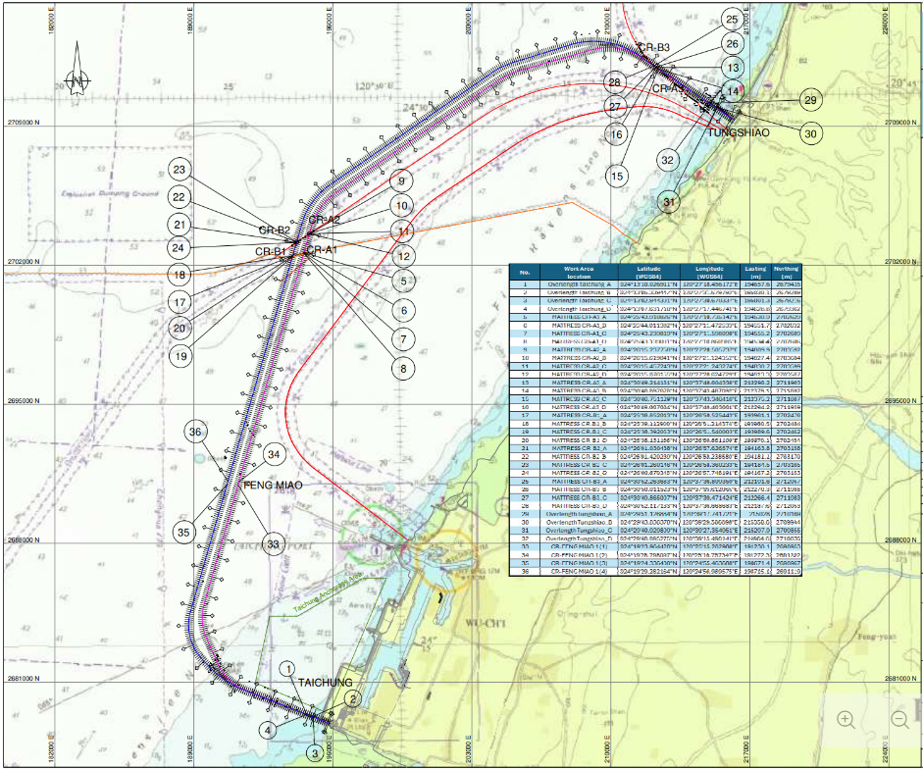
ONSHORE
Taichung AHDD Site: ({{ date_img_on_ahdd }})
{{ img_on_ahdd }}
Taichung Tienli Site: ({{ date_img_on_tienli }})
{{ img_on_tienli }}
{{ img_on_tienli_photo }}
Taichung Berth 37 Site: ({{ date_img_on_b37 }})
{{ img_on_b37 }}
{{ img_on_b37_photo }}
Tunghsiao Temporary Platform AHDD Site: ({{ date_img_on_tunghsiao }})
{{ img_on_tunghsiao }}
{{ img_on_tunghsiao_photo }}
NEARSHORE
Trench 1 – Floatation Channel CH –265 to +CH 180 (Taichung Nearshore)
– Monitoring Survey ({{ date_img_nr_t1_float }})
{{ img_nr_t1_float }}
Trench 1 – CH 180 to CH 1340 (Taichung Nearshore)
– Monitoring Survey ({{ date_img_nr_t1_main }})
{{ img_nr_t1_main }}
Trench 8 – Ch 53227 to Ch 54010 (Tunghsiao Nearshore)
– Monitoring Survey ({{ date_img_nr_t8 }})
{{ img_nr_t8 }}
Midline Tie-In – CH 52500 to CH 53221 (Tunghsiao Nearshore)
– Monitoring Survey ({{ date_img_nr_midline }})
{{ img_nr_midline }}
Dumping area monitoring (Taichung Nearshore) (DB 2-5, DA 1-5)
– Monitoring Survey ({{ date_img_nr_dump_tc }})
{{ img_nr_dump_tc }}
Dumping area monitoring (Tunghsiao Nearshore) (DB 107-109, DA 103-105)
– Monitoring Survey ({{ date_img_nr_dump_ts }})
{{ img_nr_dump_ts }}
OFFSHORE
Pre Survey for Concrete Mattress Installation Crossings A 1,2 and B 1,2 ({{ date_img_off_matt_1 }})
{{ img_off_matt_1 }}
Concrete Mattress Installation on Pipeline Crossings A 3 and B 3 ({{ date_img_off_matt_3 }})
{{ img_off_matt_3 }}
Pre-Survey on Pipeline Crossings Fengmiao OEC1 and OEC2 ({{ date_img_off_fengmiao }})
{{ img_off_fengmiao }}
Daily Survey Activities:
Highlights
Look ahead
Outstanding Tasks
Hardware Movement and Status
NMDC Hardware from Abu Dhabi
{{ img_tbl_hardware }}
PDS Dongles
{{ img_tbl_dongles }}
NMDC Survey Vessel & Chartered Survey Vessel
{{ img_tbl_vessel }}
Dredging and Reclamation Overall Quantity
{{ img_tbl_dredging }}
Survey Document Summary
{{ img_tbl_doc_summary }}
Base Station and Tide Station:
- EGST Taichung RTK BASE STATION FREQUENCY = 455.0000MHz @ Taichung Port.
- EGST Tunghsiao RTK BASE STATION FREQUENCY = 459.5000MHz @ Tunghsiao Power Plant.
- EGST TIDE WEB Server: Link: 211.20.255.60:6500
Username/Password: egst01 / egst01
- EGST TIDE Base Station Ntrip: 211.20.255.60: 6000
Username/Password: egst01 / egst01, egst02 / egst02, egst03 / egst03, egst04 / egst04
Mount Point: EGST_TCP, EGST_TXO
Name: Daryll Enano
Chief Surveyor
Project: Tung-Hsiao Power Plant 2nd Stage Renewal Project Turn-key Contract of Subsea Gas Pipeline
Cost Code: 20010
Date: {{ report_date_bottom }}

