Project name: | Tung-Hsiao Power Plant 2nd Stage Renewal Project Turn-key Contract of Subsea Gas Pipeline
Name: | Daryll Enano
E-mail: | daryll.enano@nmdc-group.com
Date: | October 26, 2026

Personnel Overview
NAME | FILE NUMBER | DESIGNATION | To Project | From Project | COMPANY | WORK AREA
NAME | FILE NUMBER | DESIGNATION | Date of Arrival | Date of Dep | COMPANY | WORK AREA
Daryll Enano | 5062 | CHIEF SURVEYOR | 01.07.2025 | - | NMDC | Site Office
Mohamad Abror Hediarto | 500652 | PROJECT SURVEYOR | 01.09.2025 | - | BRUNEL | Site Office
Danilo Bartolome | 502893 | PROJECT SURVEYOR | 01.12.2025 | - | BRUNEL | Site Office
Mateo Mollaneda | 503296 | SURVEY DATA PROCESSOR | 22.12.2025 | - | BRUNEL | Site Office
Roderick Clavel | T3274 | SURVEYOR | 24.03.2025 | - | NMDC | Site Office

Leave Planning
NAME | Leave Plans |  | UAE Visa Run | Leave Type | Remarks | Destination
NAME | Start of Leave | End of Leave
Daryll Enano | 01-12-2026 | 05-01-2027 | 09-01-2027 | Rotation | Planned | Philippines
Mohamad Abror Hediarto | 28.09.2026 | 24.10.2026 | N/A | Annual | Ongoing | Taiwan
Danilo Bartolome | 18.12.2026 | 17.01.2027 | N/A | Annual | Planned | Philippines
Mateo Mollaneda | 21.01-2027 | 22.02.2027 | N/A | Annual | Planned | Philippines
Roderick Clavel | 21-01-2027 | 21-02.2027 | 15-01-2027 | Rotation | Planned | Philippines

Training and Pass Status
Name | ARC expiry | Offshore Training | OSHA Training date | Taichung Port Gate Pass - Validity | TPC PASS Validity | Remarks
Daryll Enano | 2026-11-26 | BOSIET  2026-01-20 | 2026-04-21 | 2026-06-30 | 2026-12-31 | All Complete
Mohamad Abror Hediarto | 2027-08-24 | BOSIET  2023-10-20 | 2025-09-19 | 2026-06-30 | 2026-12-31 | All Complete
Danilo Bartolome | 2027-08-31 | Waiting for Project Schedule | 2026-01-07 | 2026-05-30 | Application – Processing | Need to wait until Feb 2027 ARC Renewal
Mateo Mollaneda | 2026-12-21 | BOSIET  2024-01-17 | 2026-01-16 | 2026-05-30 | Application – Processing | On-going
Roderick Clavel | 2027-01-31 | BOSIET  2026-04-01 | 2026-04-21 | 2026-05-30 | 2026-12-31 | All Complete

(Weekly) General Information

Project Activities with Survey Involvement:

- Survey Base Station at Taichung Port and Tunghsiao Power Plant installed and maintained by EGST. Shared to NMDC via radio telemetry and via NTRIP.

- Tide Gauge installed and maintained by EGST. Shared to NMDC via web page real-time data.

Onshore Taichung, located at Taichung LNG Receiving Terminal:
- Advanced Horizontal Directional Drilling (AHDD) Installation
- Tien-li Pipe Storage area and GRP Coating
- Berth 37 Pipe Storage Area Planning

Onshore Tunghsiao, located at Tunghsiao Power Plant
- Temporary Platform Reclamation and Rock Revetment
- Advanced Horizontal Directional Drilling (AHDD) Installation
- Micro tunneling to Power Plant

Nearshore Taichung:
- Trench 1 + Floatation Channel Dredging works, progress survey, charts and quantity calculations.

Nearshore Tunghsiao
- Trench 8 + Floatation Channel Dredging works, progress surveys, charts and quantity calculations.
- Midline Tie-in Dredging works, progress surveys, charts and quantity calculations.
- LP-1 relocation work

Offshore Work scopes
- Concrete Mattress Installation on Datan Pipeline Crossings – Pre survey
- Concrete Mattress Installation on Yongan Pipeline Crossings – Pre survey
- Concrete Mattress Installation on Taijin Telecom Cable Crossings – Pre survey
- Concrete Mattress Installation on Fengmiao Windfarm Export Cable Crossings – Pre survey
- Future Crossings – Yong-an Tonghsiao Pipeline 2 (YT2), Formosa Pipeline, Datan Tonghsiao Pipeline 2 (DT2)
- 54 km (about 33.55 mi) Pipelaying – ICQP design preparations, Pre-lay survey
- Preparation of Plans & Drawings – Progress & Deliverables.

Project Location – Taichung and Tunghsiao - Taiwan
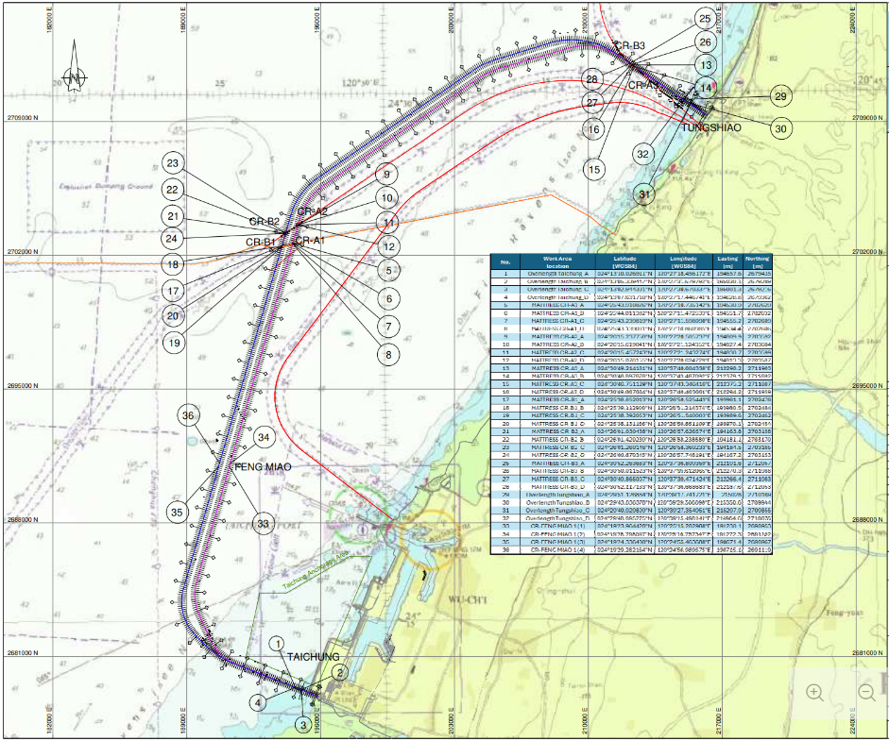
ONSHORE
Taichung AHDD Site: (2026-October-13)
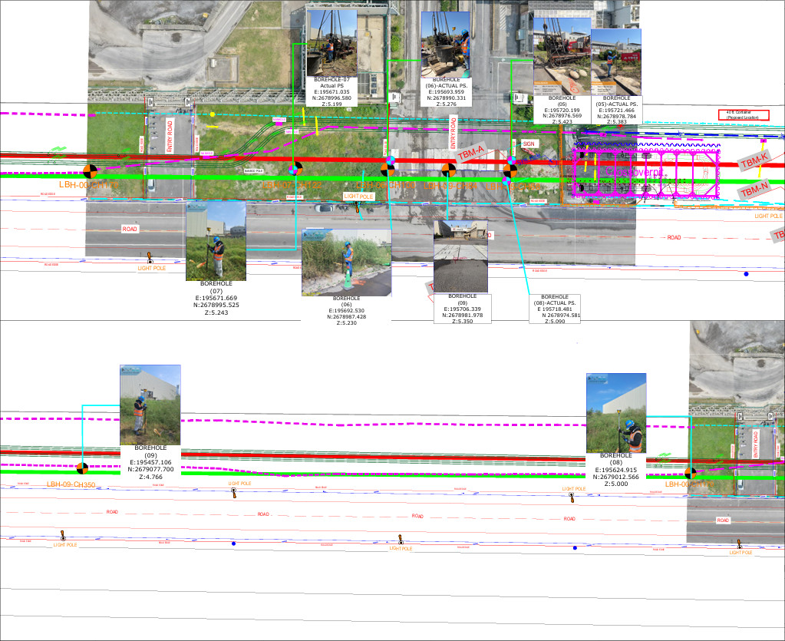
Taichung Tienli Site: (2026-September-20)
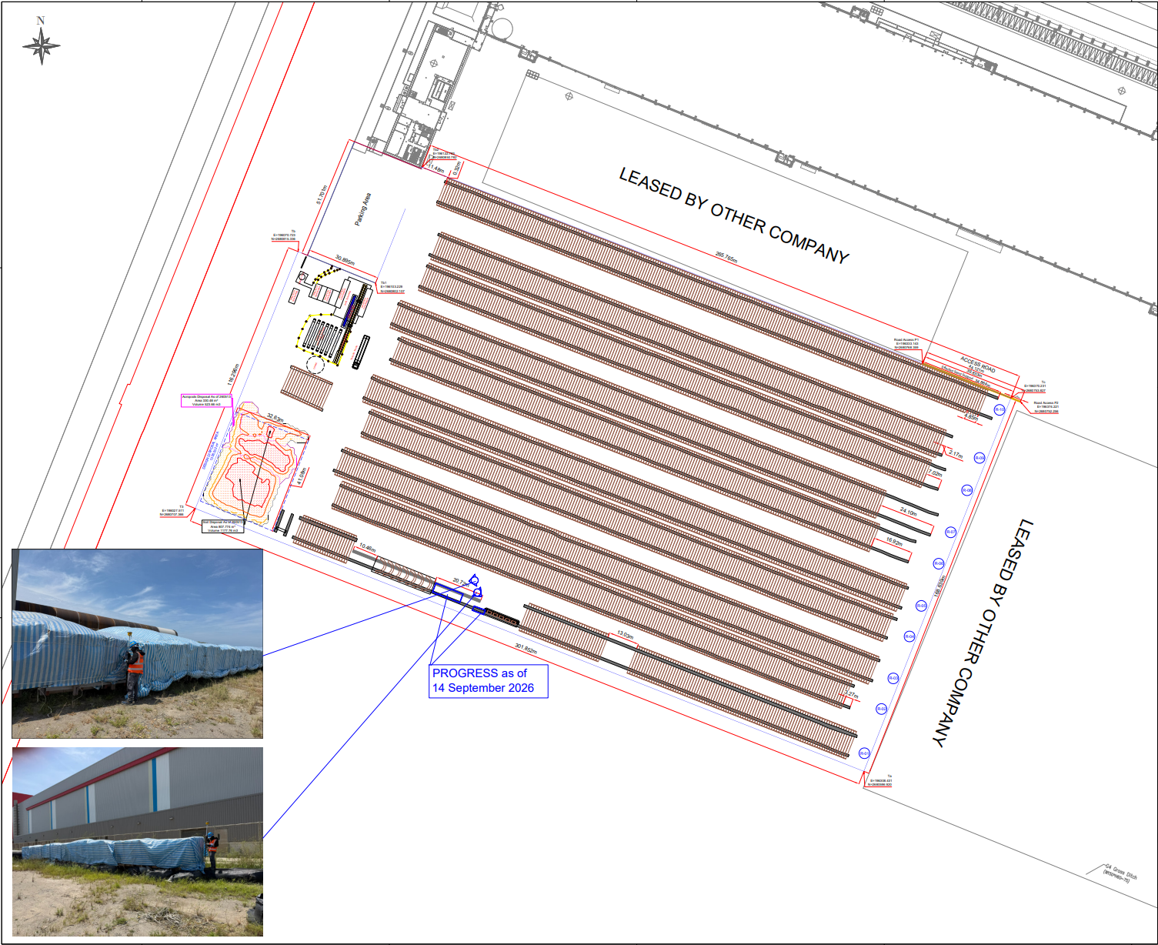
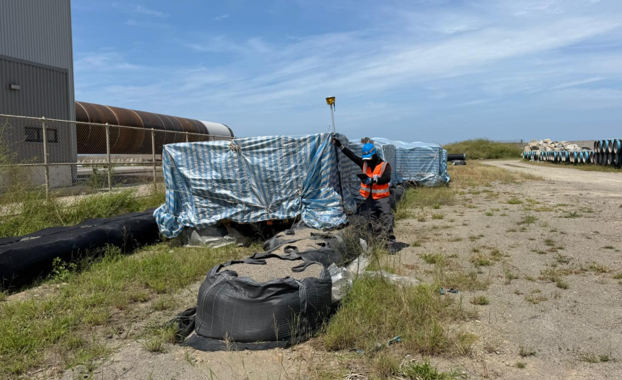
Taichung Berth 37 Site: (2026-September-20)
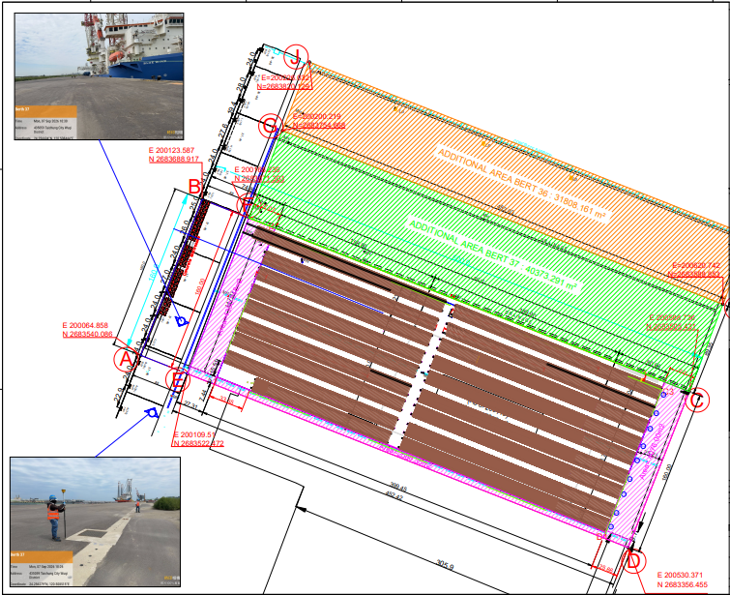
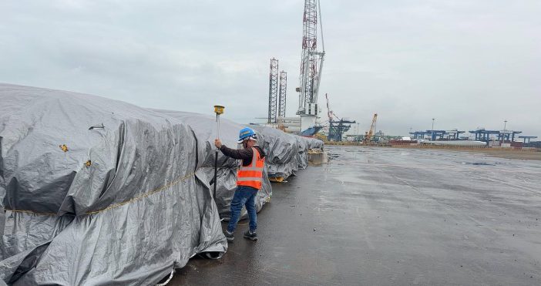
Tunghsiao Temporary Platform AHDD Site: (2026-September-20)
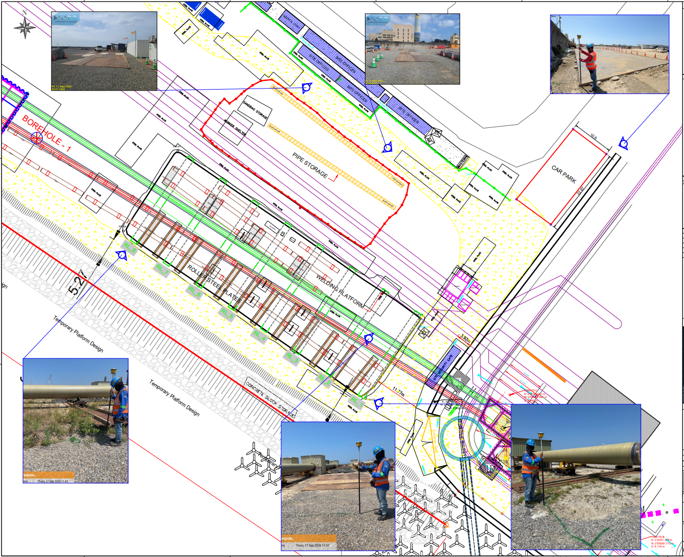
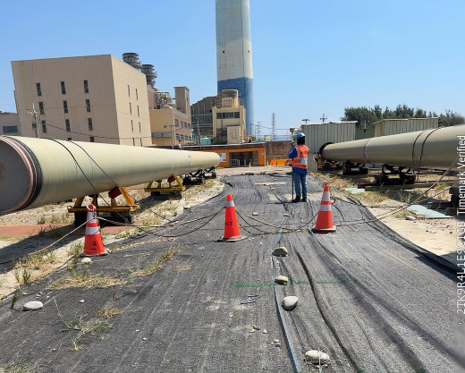
NEARSHORE
Trench 1 – Floatation Channel CH –265 to +CH 180 (Taichung Nearshore)
– Monitoring Survey (2026-Sept-28)
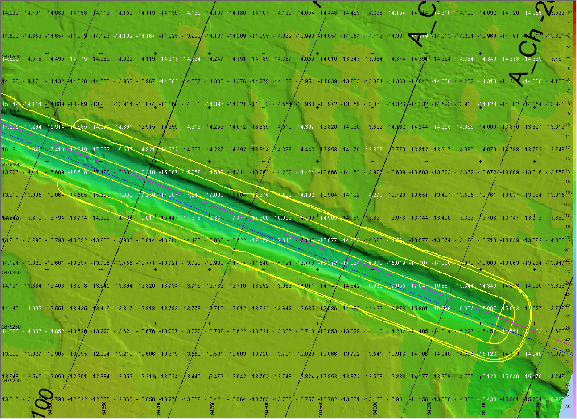
Trench 1 – CH 180 to CH 1340 (Taichung Nearshore)
– Monitoring Survey (2026-Sept-28)
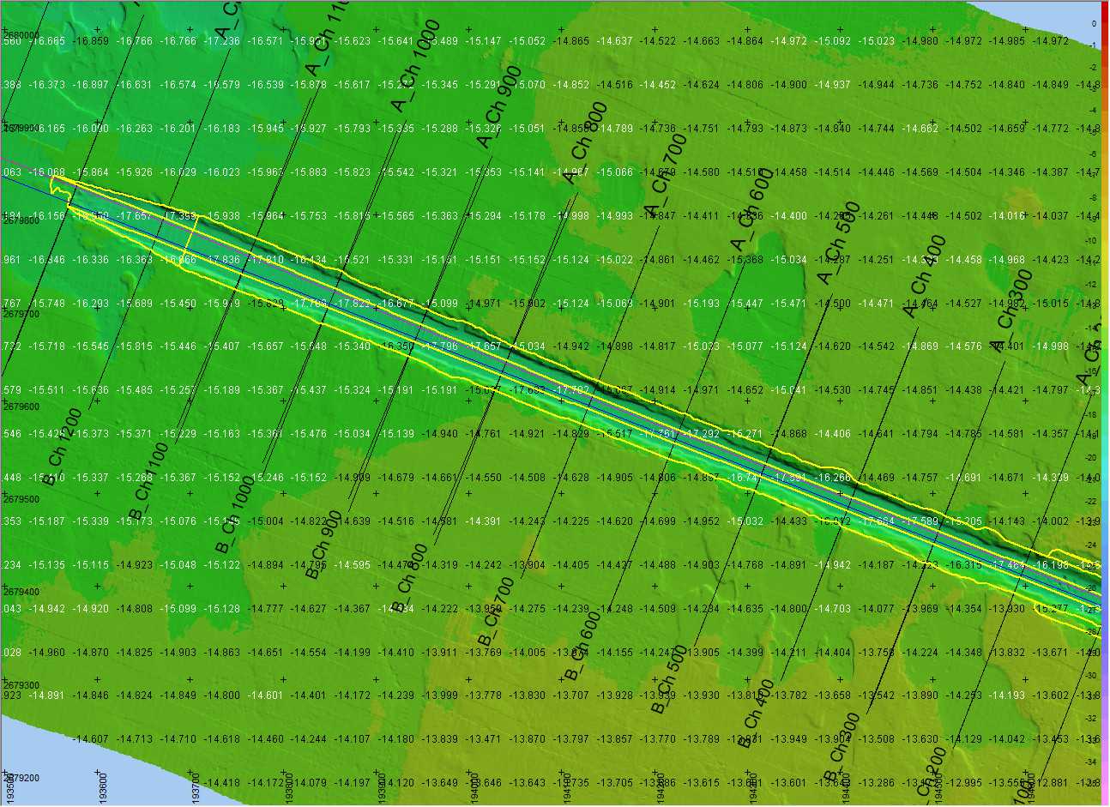
Trench 8 – Ch 53227 to Ch 54010 (Tunghsiao Nearshore)
– Monitoring Survey (2026-Sept-27)
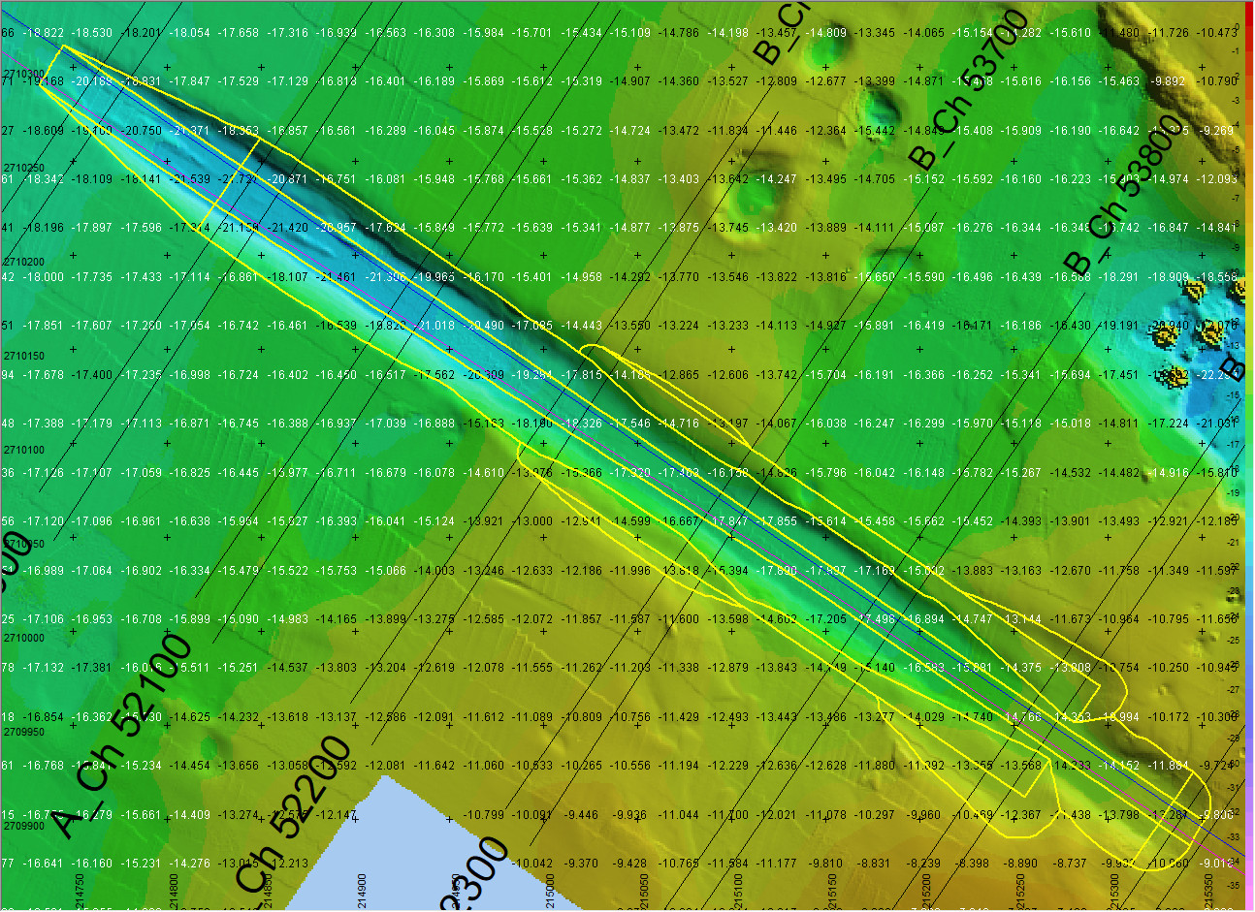
Midline Tie-In – CH 52500 to CH 53221 (Tunghsiao Nearshore)
– Monitoring Survey (2026-September-27)
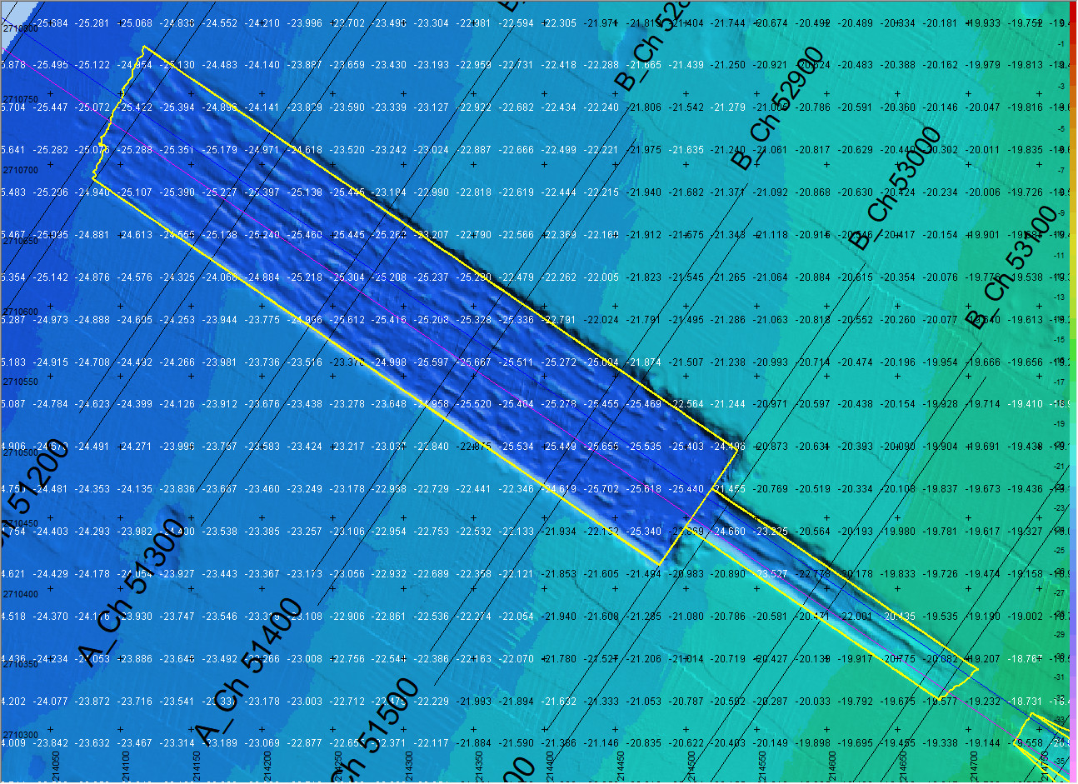
Dumping area monitoring (Taichung Nearshore) (DB 2-5, DA 1-5)
– Monitoring Survey (2026-September-28)
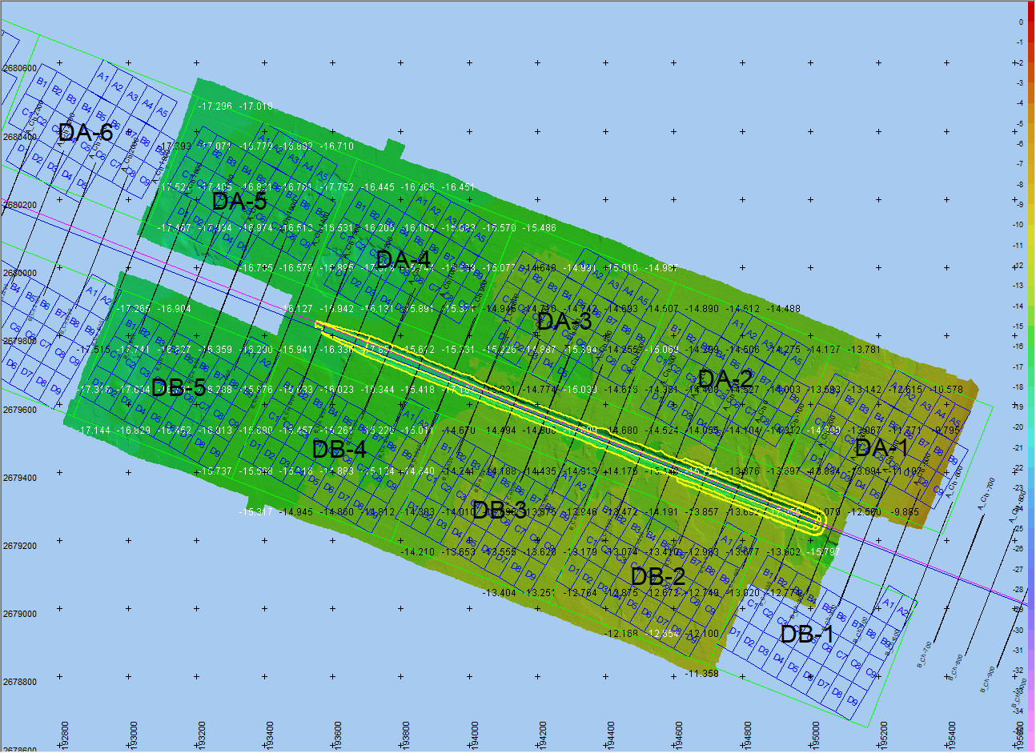
Dumping area monitoring (Tunghsiao Nearshore) (DB 107-109, DA 103-105)
– Monitoring Survey (2026-September-28)
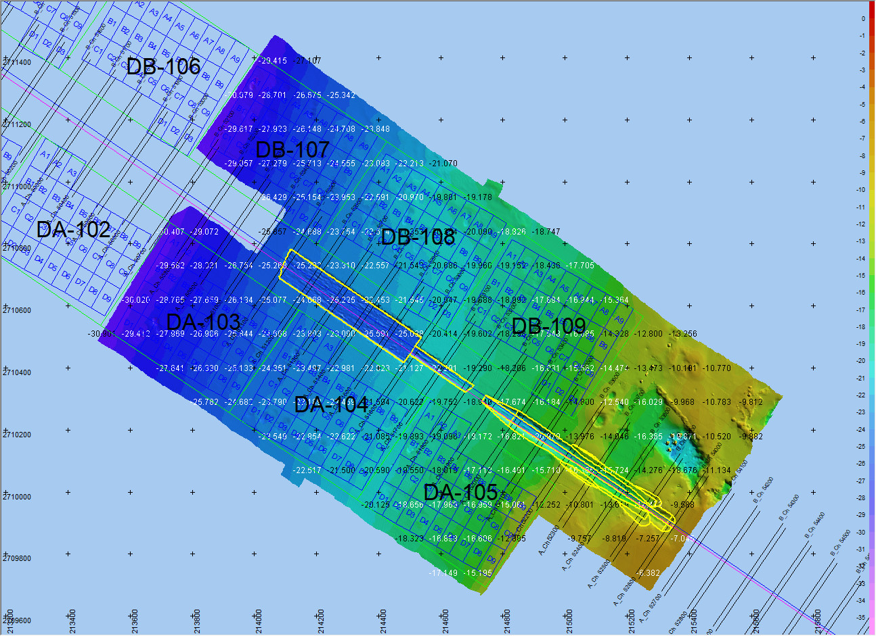
OFFSHORE
Pre Survey for Concrete Mattress Installation Crossings A 1,2 and B 1,2 (2026-July-29)
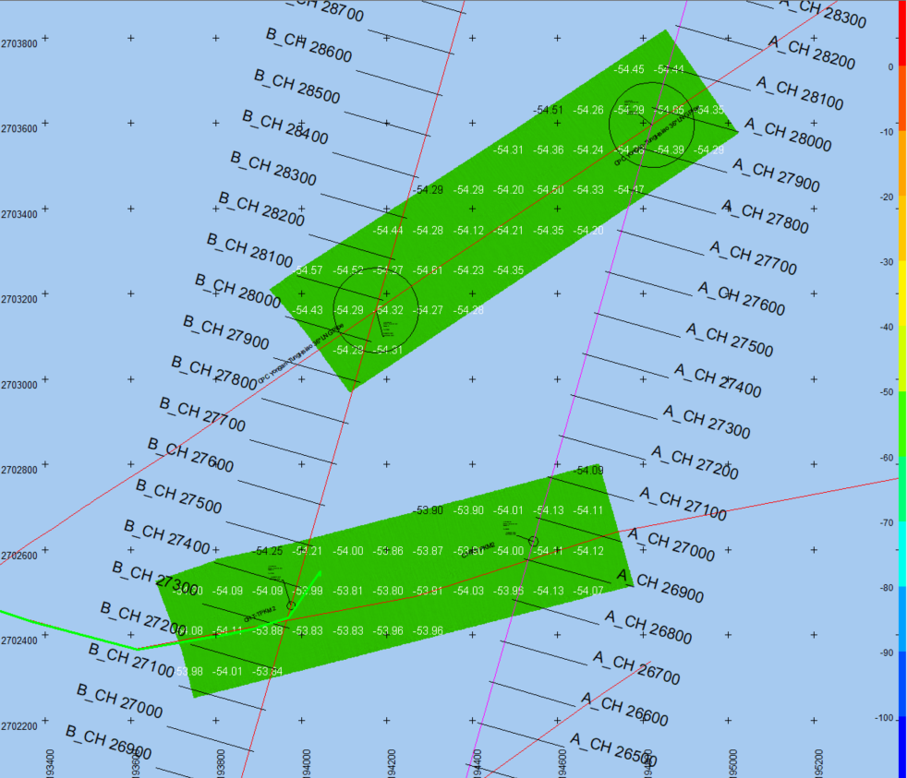
Concrete Mattress Installation on Pipeline Crossings A 3 and B 3 (2026-August-17)
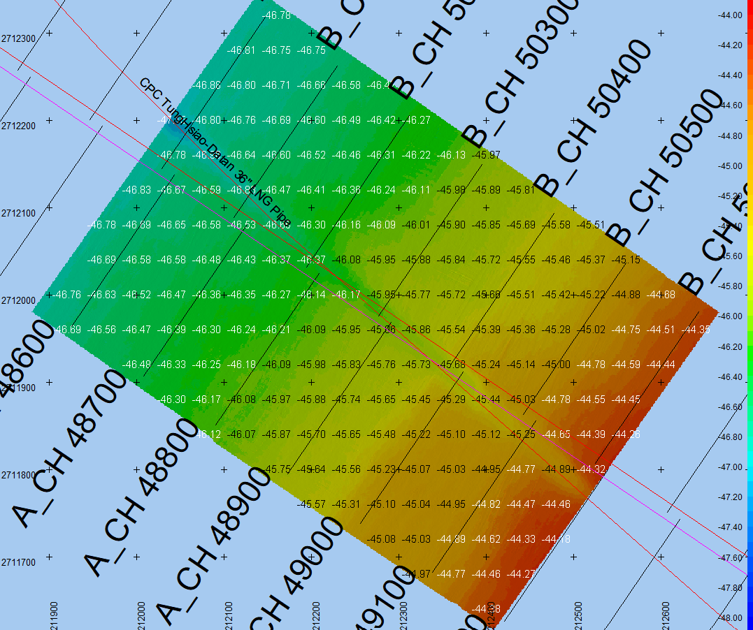
Pre-Survey on Pipeline Crossings Fengmiao OEC1 and OEC2 (2026-August-30)
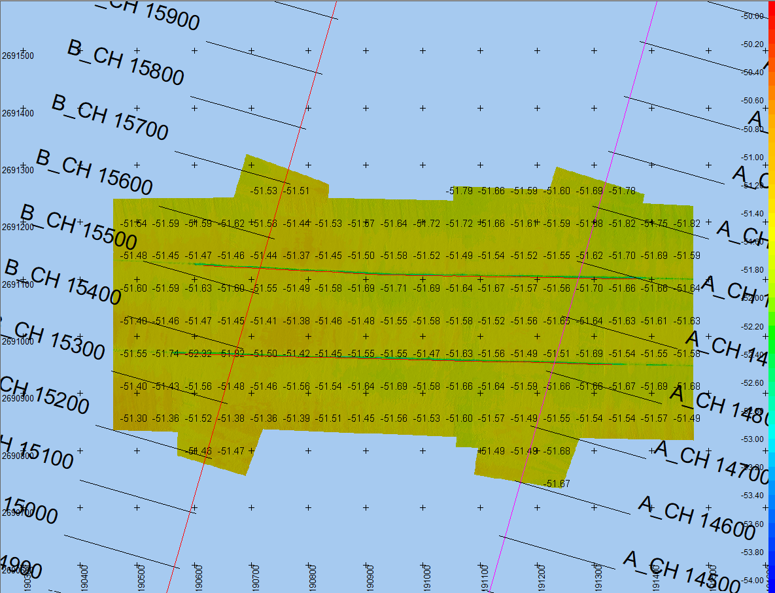
Daily Survey Activities:
19.10.2026 Monday
Onshore-Land: Danilo Bartolome, Mateo Mollaneda, Roderick Clavel
- Taichung AHDD Check Survey - Gather data of AHDD Road settlement monitoring
- Taichung AHDD Survey Reports - Process report of the Taichung AHDD Road settlement report
- Taichung Landside Progress Survey - Generate Sketch Drawing of Taichung Site Weekly Progress Update survey
- Taichung AHDD Stake-Out/Marking - [Thruster Pit] Generate a sketch drawing showing the remarking of the previously marked sheet pile corner near the roadside, with a 0.50 m inward offset from the design location.
- Taichung Landside Survey Input - Drawings - 20261017_RQ0419_Taichung Vertical Drilling Profile
Marine Offshore: Daryll Enano, Mateo Mollaneda
- Offshore Mainline Cross-Section - [DLS-4200] 20261019_RQ0421_Crossing A1-A3 260928 Survey Overview Diff Chart Cross Sections
- Offshore Mainline Cross-Section - [DLS-4200] 20261019_RQ0422_Crossing B1-B2 260928 Survey Overview Diff Chart Cross Sections
20.10.2026 Tuesday
Wuqi Office: Danilo Bartolome
- Taichung Office Internal Survey Reports - Process survey report of the Taichung AHDD Road settlement monitoring
Onshore-Land: Danilo Bartolome, Roderick Clavel
- Tunghsiao Temp Platform Stake-Out/Marking - Assist Thaitan with staking out and marking the location of their facilities area at Tunghsiao Site.
- Taichung Landside Progress Survey - Generate a sketch drawing of the newly installed fence at the Taichung site near the TPC access gate.
- Taichung AHDD Monitoring Survey - Gather data of the Taichung AHDD Road settlement monitoring
- Tunghsiao Temp Platform Benchmark Verification - Conduct traverse levelling for the Tunghsiao platform area TBM for vertical control values and re-evaluation on TBM's interrelationship.
21.10.2026 Wednesday
Wuqi Office: Daryll Enano
- Taichung Office Internal Coordination Meetings - Daily Stand-up Meeting
Onshore-Land: Danilo Bartolome, Daryll Enano, Roderick Clavel
- Taichung AHDD Monitoring Survey - Gather data of the Taichung AHDD Road settlement monitoring
- Taichung AHDD Survey Reports - Generate report of the Taichung AHDD Road settlement monitoring
- Taichung AHDD Progress Survey - [Crossover Pits] Monitor progress of the on-going 2.5m diameter encased Vertical Drilling activity
- Tunghsiao Temp Platform External Meetings - [Microtunneling] Thaitan AHDD Coordination Meeting
- Taichung AHDD Stake-Out/Marking - Stake out and mark the first vertical drilling point of the Thruster Pit, as requested by Nandu. (TH_VD_01)
- Taichung AHDD Stake-Out/Marking - Stake out and mark the alignment of Pipes A and B, as requested by Jeff.
- Tunghsiao Temp Platform Sketch Drawing - Generate a sketch drawing showing the layout and locations of the Thaitan facilities at the Tunghsiao site.
- Taichung AHDD Stake-Out/Marking - Generate a sketch drawing showing the stake-out and marking of the Thruster Pit vertical drilling location (TH_VD-01) at the Taichung site.
Marine Offshore: Daryll Enano, Mateo Mollaneda
- Offshore Mainline Volume Calculation - [DLS-4200] 20261021_RQ0428_Trenching SRI Design Volume 1-5in
- Offshore Subsea Crossings External Meetings - Mattress Installation Meeting
22.10.2026 Thursday
Onshore-Land: Roderick Clavel
- Taichung AHDD Stake-Out/Marking - Generate a sketch drawing showing the stake-out and marking of the Thruster Pit vertical drilling location (TH_VD-13) at the Taichung site.
- Taichung Landside Progress Survey - Update the base drawing using the latest drawings received from the Operations Team, incorporating the latest survey updates for the Tunghsiao site.
23.10.2026 Friday
- No survey tasks logged for this date.
24.10.2026 Saturday
- No survey tasks logged for this date.
25.10.2026 Sunday
Onshore-Land: Danilo Bartolome, Roderick Clavel
- Taichung AHDD Monitoring Survey - Gather data of Taichung AHDD Road settlement monitoring
- Taichung AHDD Survey Report - Process survey report of the Taichung AHDD Road settlement monitoring
- Tunghsiao Temp Platform Survey Input - Drawings - Update the base drawing using the latest drawings received from the Operations Team, incorporating the latest survey updates for the Tunghsiao and Taichung sites.
- Tunghsiao Temp Platform Survey Input - Drawings - Update the Data Controller background using the latest drawings and incorporate the latest survey updates for the Tunghsiao site.
Highlights
1. Taichung Onshore & AHDD Site Operations: Completed daily Taichung AHDD road settlement monitoring surveys and daily processing reports; Generate Sketch Drawing of Taichung Site Weekly Progress Update survey; [Thruster Pit] Generate a sketch drawing showing the remarking of the previously marked sheet pile corner near the roadside, with a 0.50 m inward offset from the design location; 20261017_RQ0419_Taichung Vertical Drilling Profile; Generate a sketch drawing of the newly installed fence at the Taichung site near the TPC access gate; [Crossover Pits] Monitor progress of the on-going 2.5m diameter encased Vertical Drilling activity; Stake out and mark the first vertical drilling point of the Thruster Pit, as requested by Nandu. (TH_VD_01); Stake out and mark the alignment of Pipes A and B, as requested by Jeff; Generate a sketch drawing showing the stake-out and marking of the Thruster Pit vertical drilling location (TH_VD-01) at the Taichung site; Generate a sketch drawing showing the stake-out and marking of the Thruster Pit vertical drilling location (TH_VD-13) at the Taichung site.
2. Tunghsiao Temporary Platform & AHDD Site Operations: Assist Thaitan with staking out and marking the location of their facilities area at Tunghsiao Site; Conduct traverse levelling for the Tunghsiao platform area TBM for vertical control values and re-evaluation on TBM's interrelationship; [Microtunneling] Thaitan AHDD Coordination Meeting; Generate a sketch drawing showing the layout and locations of the Thaitan facilities at the Tunghsiao site; Update the base drawing using the latest drawings received from the Operations Team, incorporating the latest survey updates for the Tunghsiao site; Update the base drawing using the latest drawings received from the Operations Team, incorporating the latest survey updates for the Tunghsiao and Taichung sites; Update the Data Controller background using the latest drawings and incorporate the latest survey updates for the Tunghsiao site.
3. Wuqi Office & Marine Engineering Deliverables: [DLS-4200] 20261019_RQ0421_Crossing A1-A3 260928 Survey Overview Diff Chart Cross Sections; [DLS-4200] 20261019_RQ0422_Crossing B1-B2 260928 Survey Overview Diff Chart Cross Sections; [DLS-4200] 20261021_RQ0428_Trenching SRI Design Volume 1-5in; Mattress Installation Meeting.
Look ahead
1. Request for Diff Charts and Volume calculations for different survey data is expected due to current planning changes and justifications.
2. Update Tunghsiao and Taichung site installation as-built drawings (weekly progress update).
3. Settlement Monitoring (Road and protection sheetpile) at Taichung site for NMDC surveyor (Daily activity).
4. Depth of Burial Survey for Fengmiao Cable Crossings prior to Filter Unit Installation (Under planning with Seatrench and EGST).
5. Scheduled Follow-Up Scope: Stakeout and marking of the vertical drilling point number A_VD_31 at the Taichung site.
6. Scheduled Follow-Up Scope: Generate sketch drawing of the completed stake out and marking of the vertical drilling point location.
Outstanding Tasks
1. TPC Entry Pass for Danilo on hold until 2027 Feb ARC Renewal. Now Danilo can enter site with temporary gate pass, currently Abror, Roderick and Daryll have TPC yearly pass (Taichung and Tunghsiao).
2. Taiwan government E-GNSS correction NTRIP account cannot be requested by NMDC due to company entity registered as foreign company, request to EGST to apply for NMDC operational use. Need to ask EGST for assistance for the EGNSS service. (Stewart Ho assist for the service).
3. Danilo to be scheduled for BOSIET. Waiting for Project Schedule.
4. Rick Jhou - shortlisted as Lead/Chief Surveyor, Sophie update: will join before 23 Nov 2026.
5. Active Field/Office DTR Action Items: Stakeout and marking of the vertical drilling point number A_VD_31 at the Taichung site; Generate sketch drawing of the completed stake out and marking of the vertical drilling point location.
Hardware Movement and Status
1. Survey Forms Compliance - IA-IM-26.005 and Survey Equipment Mob/Demob Compliance - IA-IM-26.006 memo from HQ to be implemented in the Taiwan Project.
NMDC Hardware from Abu Dhabi
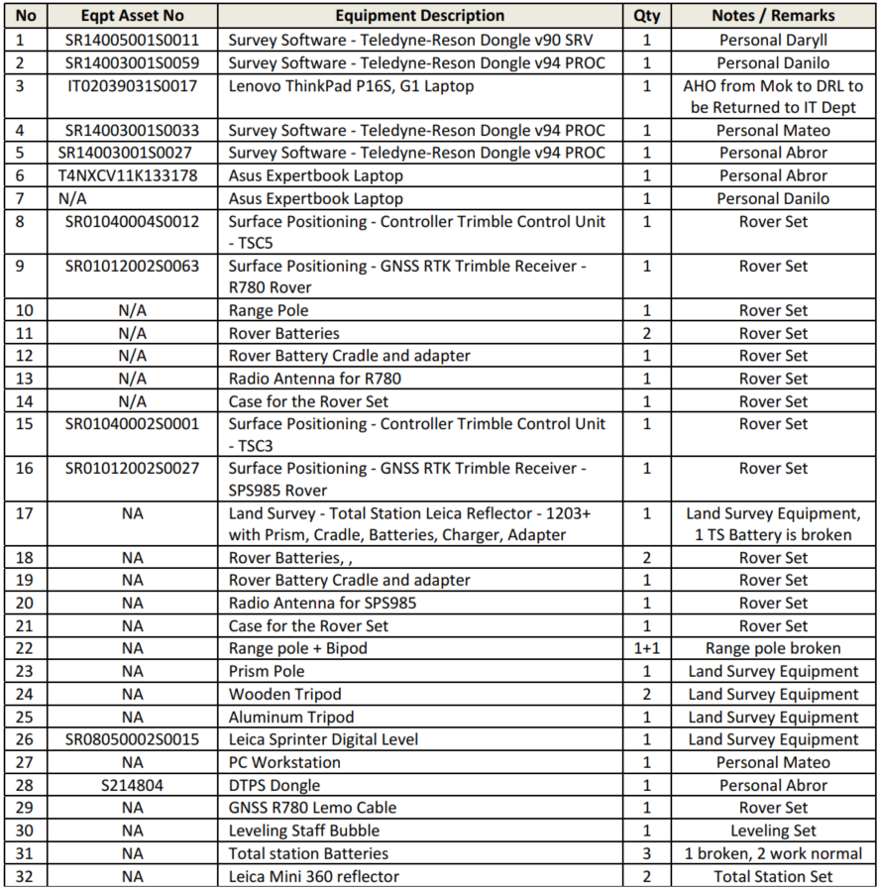
PDS Dongles
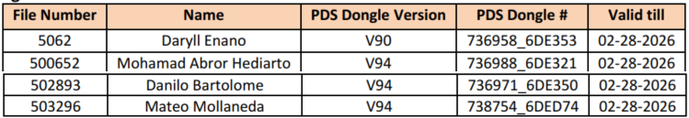
NMDC Survey Vessel & Chartered Survey Vessel
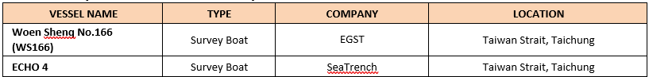
Dredging and Reclamation Overall Quantity
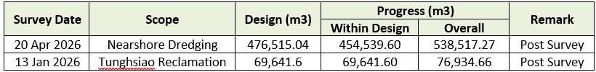
Survey Document Summary
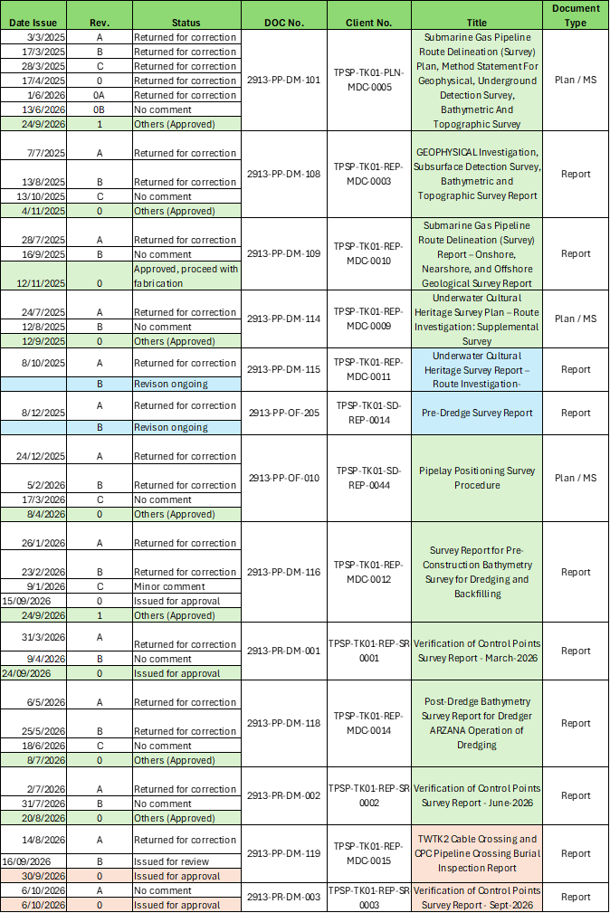
Base Station and Tide Station:
- EGST Taichung RTK BASE STATION FREQUENCY = 455.0000MHz @ Taichung Port.
- EGST Tunghsiao RTK BASE STATION FREQUENCY = 459.5000MHz @ Tunghsiao Power Plant.
- EGST TIDE WEB Server: Link: 211.20.255.60:6500
Username/Password: egst01 / egst01
- EGST TIDE Base Station Ntrip: 211.20.255.60: 6000
Username/Password: egst01 / egst01, egst02 / egst02, egst03 / egst03, egst04 / egst04
Mount Point: EGST_TCP, EGST_TXO
Name: Daryll Enano
Chief Surveyor
Project: Tung-Hsiao Power Plant 2nd Stage Renewal Project Turn-key Contract of Subsea Gas Pipeline
Cost Code: 20010
Date: 26th October 2026

