Top 10 venues corresponding to each neighborhood in Toronto
Dibya Ranjan Pattanaik
March 3rd, 2019

- Introduction

  - Problem Statement
Can we group each neighborhood and find out top 10 venues corresponding to that neighborhood in Toronto, to map offers/coupons based on neighborhood?
  - Problem Description
Many offers/coupons are rolled out by different businesses as a strategy to attract more customer base. But most of the offers are not used by customers, because they don't find it useful or those offers are irrelevant in the neighborhood that they live in. For Example, In Berczy Park neighborhood, there are a lot of coffee shops but not many spa venues. So, for a customer residing in Berczy Park neighborhood, coffee shop coupons/offers are more relevant than spa coupons.
  - Client Base who might be interested in this project
a. Financial Institutions in Toronto dealing with credit cards - This group of business can utilize this project as a basis to map their credit card offers to customers based on the residence neighborhood of the customer.
b. Anyone planning to set up a new business in Toronto - This person/group can utilize this project to decide on the type of business they want to setup, the neighborhood where they can setup etcetera.
  - Analytic Approach
For achieving the grouping as stated in the problem statement, I can make use of k-means clustering. K -means clustering is a type of unsupervised learning, which is used when you have unlabeled data (i.e., data without defined categories or groups). The goal of this algorithm is to find groups in the data, with the number of groups represented by the variable K. The algorithm works iteratively to assign each data point to one of K groups based on the features that are provided.
I will be using k-means clustering to group neighborhoods in Toronto and find out top 10 venues in each neighborhood.

- Data

  - Data Requirements
For this project I will require the below mentioned data:
a. Neighborhood data of Toronto - I will make use of Wikipedia link ' https://en.wikipedia.org/wiki/List_of_postal_codes_of_Canada:_M' to get the neighborhood data required for this project.
b. Location data of each neighborhood in Toronto - I will make use of Foursquare APIs to get location details of each neighborhood derived in step 1.
2.2. Data Collection
a. I will do a web scraping of the following Wikipedia link ' https://en.wikipedia.org/wiki/List_of_postal_codes_of_Canada:_M' using Beautiful Soup python library to get the CANADA neighborhood mapped to Postal Code and Borough. I will use ‘https://cocl.us/Geospatial_data’ to get the mapping of latitude and longitude of each postal code.
b. I will filter only the Toronto Borough Data from the table of data collected in step 1 for this project.
c. I will use foursquare API calls to get the location details corresponding to each neighborhood captured in step 2, something as mentioned below:
# create the API request URL
url = 'https://api.foursquare.com/v2/venues/explore?&client_id={}&client_secret={}&v={}&ll={},{}&radius={}&limit={}'.format(
CLIENT_ID,
CLIENT_SECRET,
VERSION,
lat,
lng,
radius,
LIMIT)
# make the GET request
results = requests.get(url). json()["response"]['groups'][0]['items']

  - Data Understanding
For understanding the data collected in the Data collection stage, I will explore the data and do some analysis like:
a. Explore the neighborhoods in Toronto
b. Analyze each neighborhood.
c. Explore the venues corresponding to any one of the neighborhoods.
2.4. Data Preparation
This stage involves in exploring the data further and making sure that it is in the right format for k-means clustering that I selected in the analytic approach stage.
a. If I see any gap in the data, the I will go back to the data collection stage and collect any missing data.
b. If I see any erroneous data / unnecessary data, then I will filter and remove those data to prepare the final data which will be used in clustering.
At the end of this stage, I should have the dataset ready to be fed into the clustering analysis.

- Data Analysis
  - Preparing neighborhood data
- Extract the table with postal code, borough and neighborhood data from the Wikipedia link ‘https://en.wikipedia.org/wiki/List_of_postal_codes_of_Canada:_M’ using Beautiful Soup library and save it in a csv file.
- Create a data frame from the csv file created in step 1 and filter rows with borough='Not assigned' (as shown below).
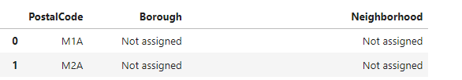
- If a postal code has a borough but a Not assigned neighborhood (as shown below), then the neighborhood will be the same as the borough.
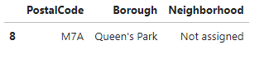
- Group neighborhood based on postal code and borough. Below screenshot shows the total groups created from the data:
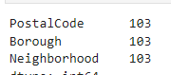
- Read the geo spatial data from ‘https://cocl.us/Geospatial_data’ and merge it with the data frame created in step d. The resulting data frame looks something like:
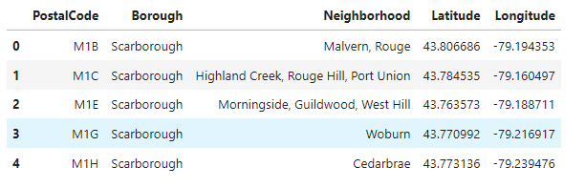

  - Create a map showing the neighborhoods in Toronto
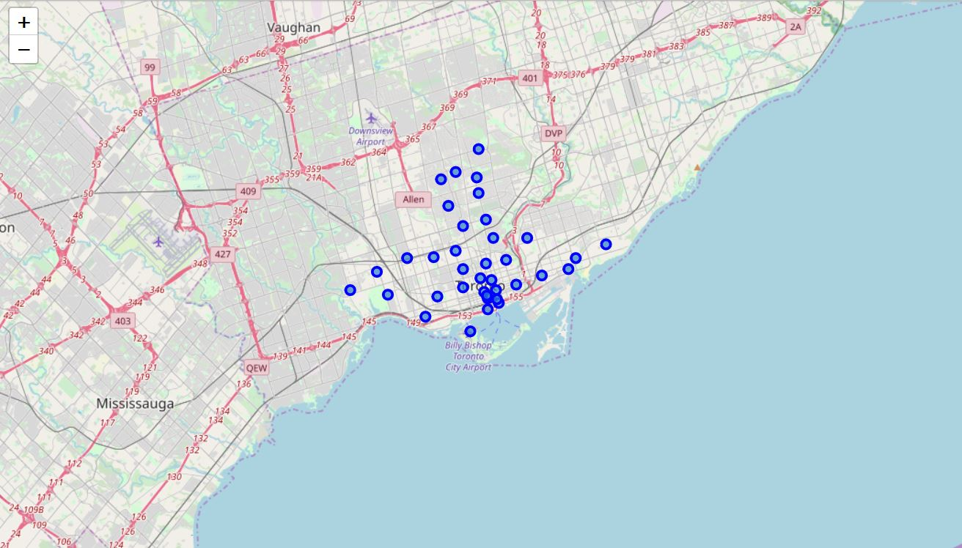

  - Test the Foursquare API to get venues for one neighborhood, “The Beaches”
The venues details collected using the neighborhood data and Foursquare API for “The Beaches” neighborhood is as below:
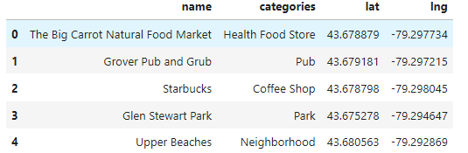

  - Check how many venues are there for each neighborhood
There are 236 unique venue categories in the neighborhood data.

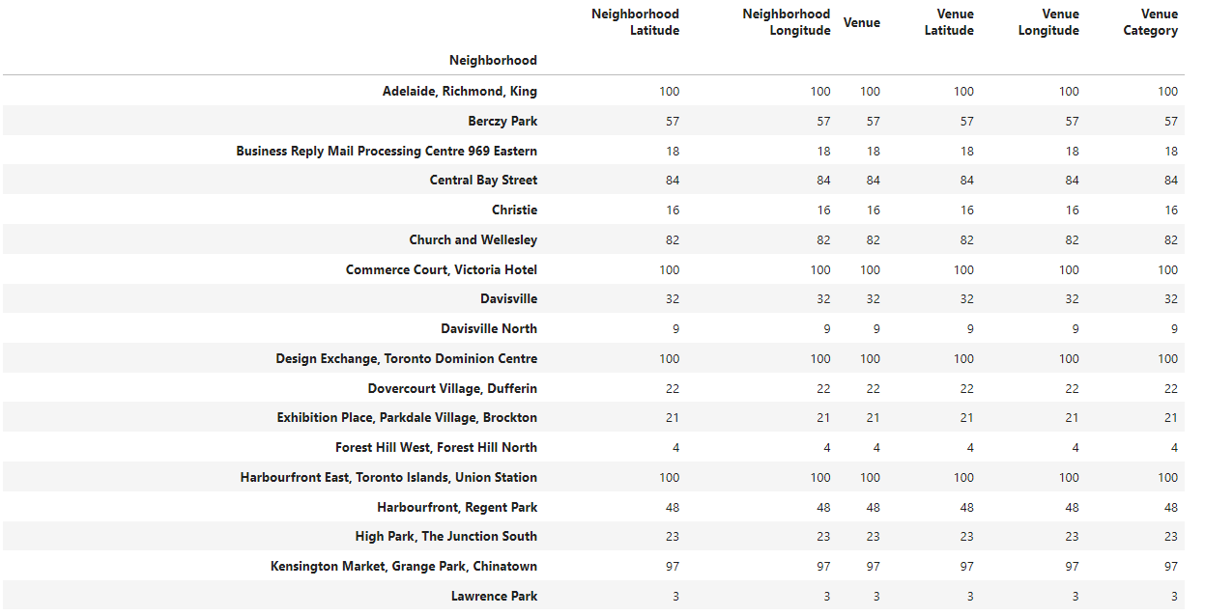
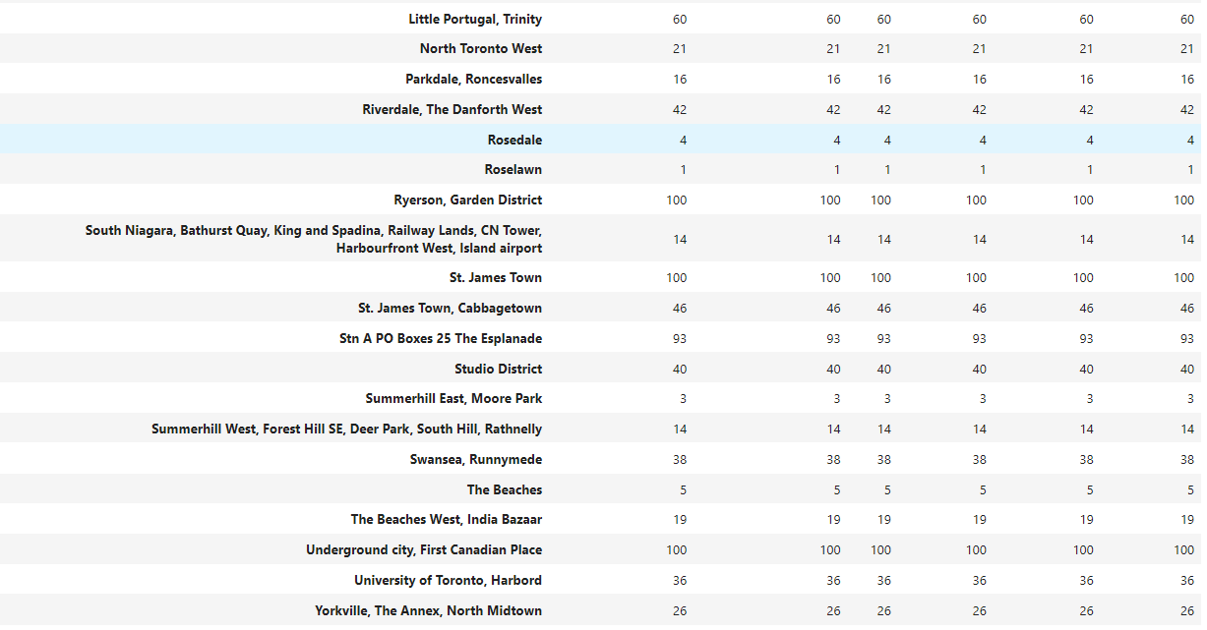

  - Apply One hot encoding and group rows on neighborhood by taking mean
The resulting data would look something like the below table, where the point of interest is that there are 38 neighborhoods and 236 unique categories.
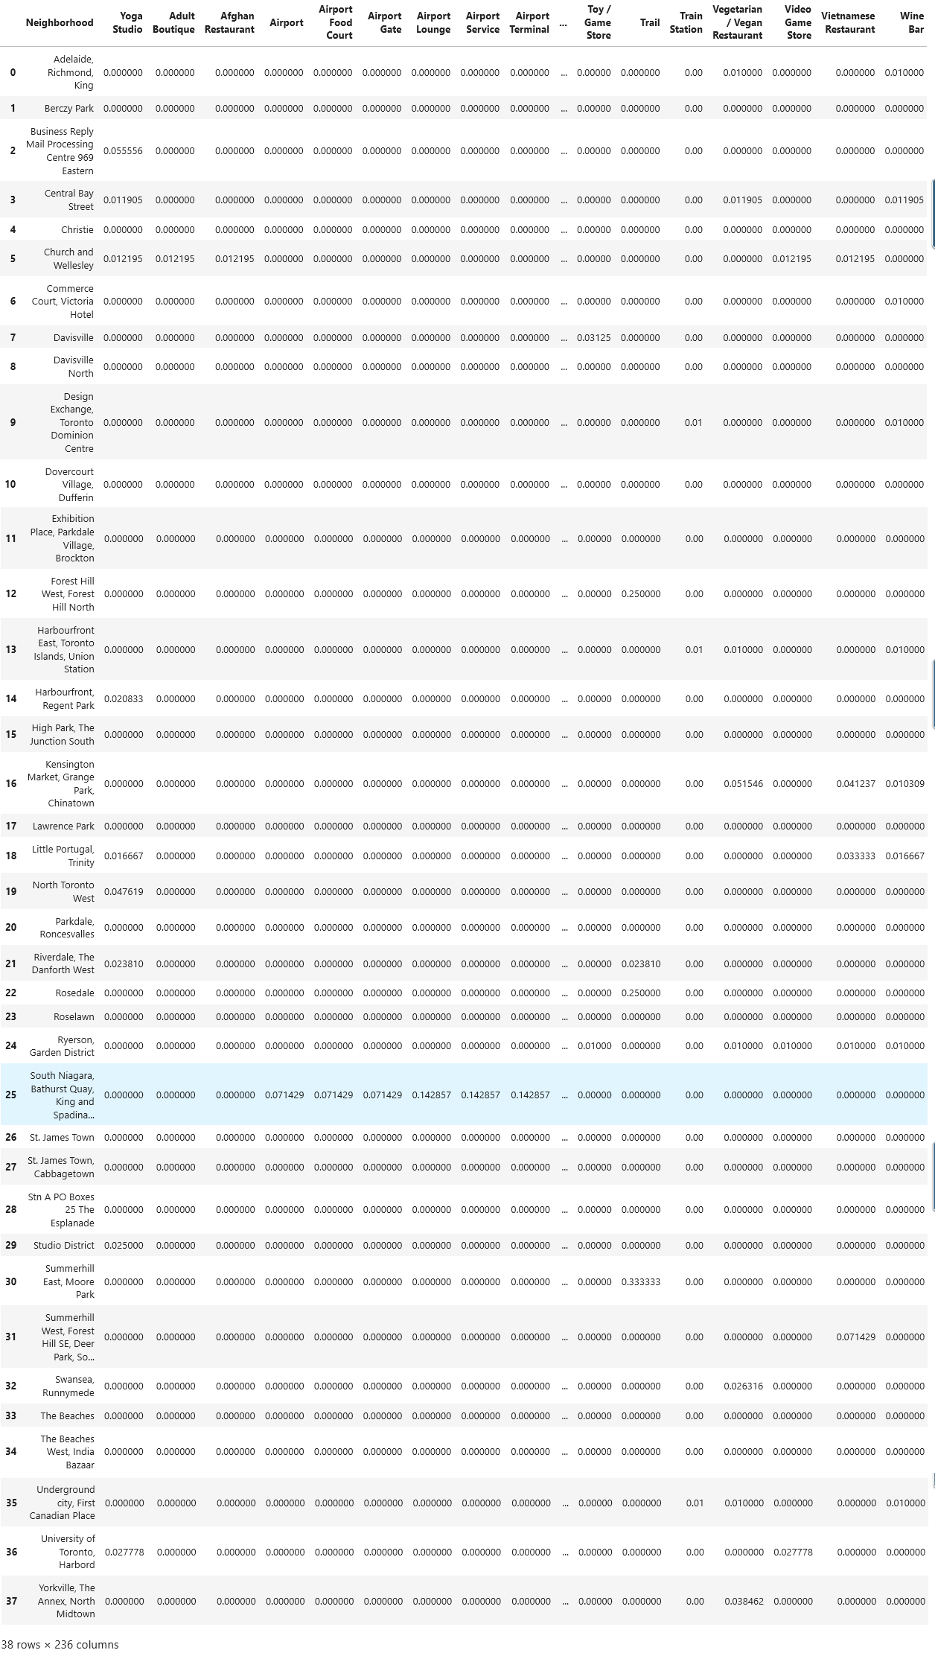
  - Find the top 10 common venues in each neighborhood
Below table shows how the data looks for all the neighborhoods with a sample of 5 neighborhoods.
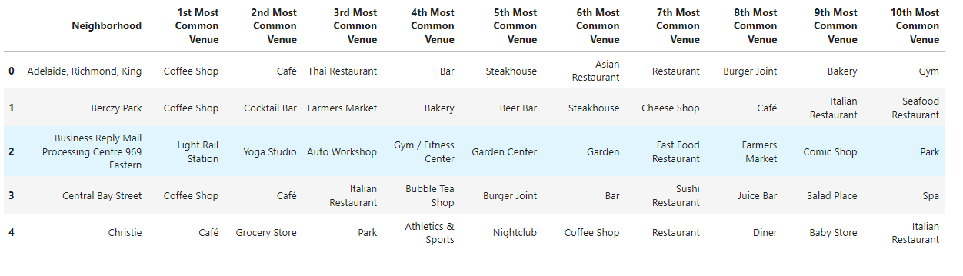
Now that I have the required top 10 data ready, I will proceed to the clustering of the data thus prepared in the above section.
- Cluster Neighborhoods
I will use K-Means clustering for grouping the data of the neighborhoods in Toronto. K -means clustering is a type of unsupervised learning, which is used when you have unlabeled data (i.e., data without defined categories or groups). The goal of this algorithm is to find groups in the data, with the number of groups represented by the variable K. The algorithm works iteratively to assign each data point to one of K groups based on the features that are provided.
I created 5 clusters for the 38 neighborhood groups indicating the top 10 venues. The clustered data look like the table as shown below:
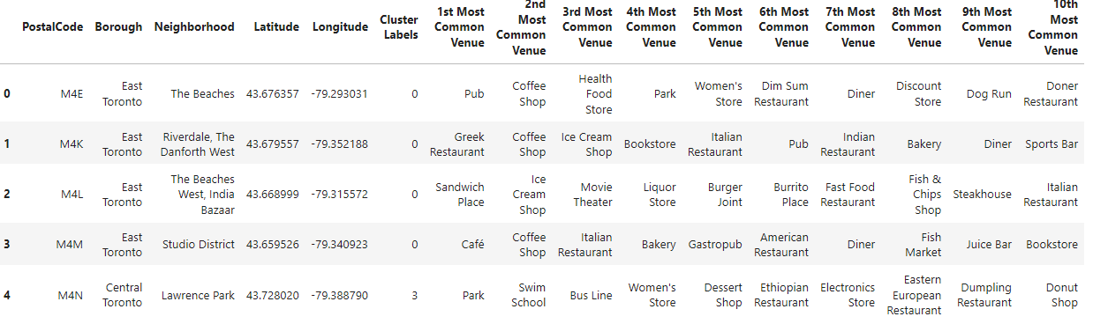
I created matplotlib folium maps to visualize the clusters.
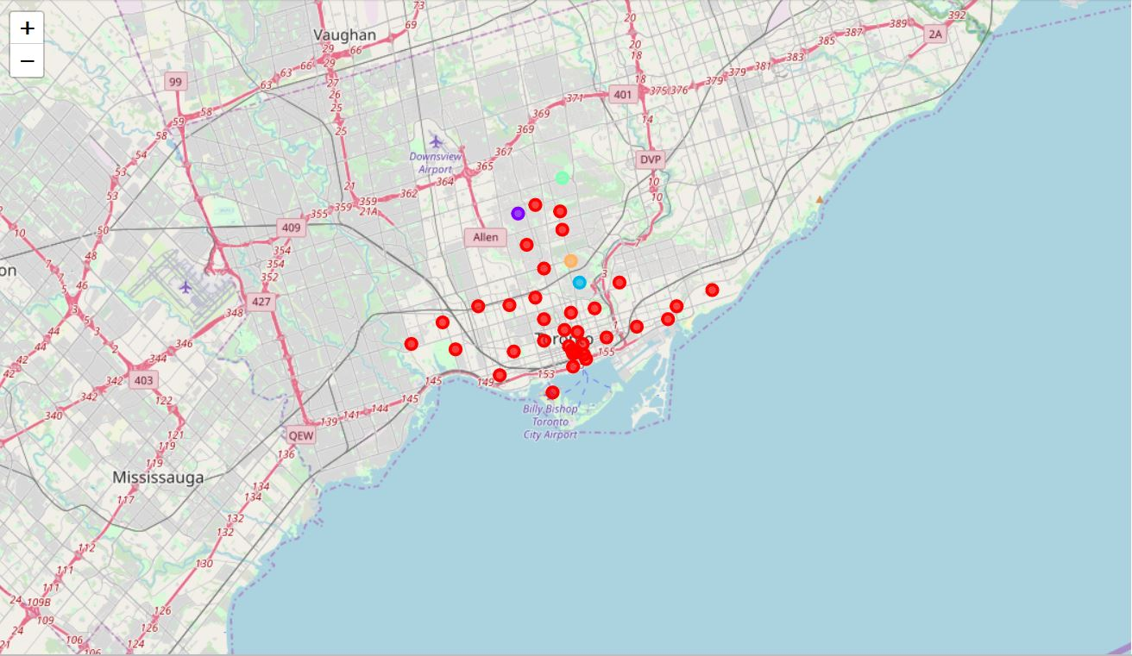
Then I examined the data in the 5 clusters that are created.
Cluster5:
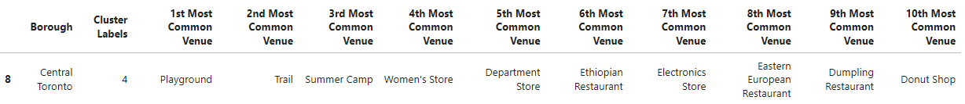
Cluster4:
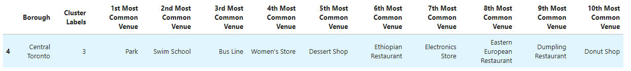
Cluster3:
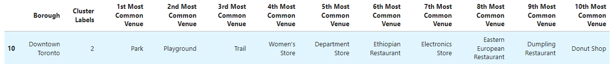
Cluster2:
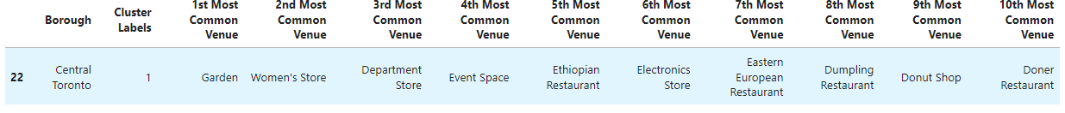
Cluster1: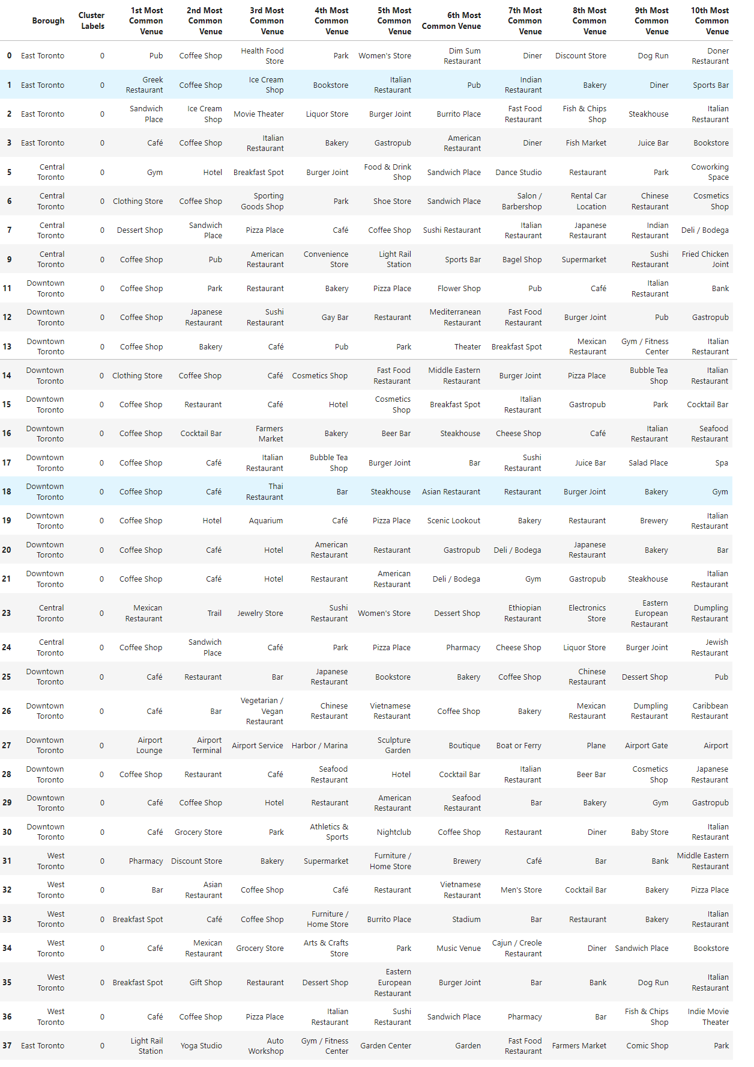
- Conclusion
In this study, I created clusters of neighborhoods in Toronto and mapped the top 10 venues with each corresponding neighborhood. Offers/Coupons can be rolled out based on the top 10 venues for the neighborhood of any customer to enhance the probability of utilization of the offers/coupons. For Example: If a customer resides in Studio District neighborhood of Toronto, then the offers/coupons which might be most useful to him/her are the offers/coupons that are related to the top 10 venues in Studio District neighborhood namely – Café, Coffee Shop, Italian Restaurant, Bakery, American Restaurant, Gastropub, Diner, Fish Market, Juice Bar and Book Store. Any financial institution can utilize this study while rolling out their credit card offers. Any other business can also find this clustering of neighborhoods useful for mapping their offers/coupons.
- References
- https://en.wikipedia.org/wiki/List_of_postal_codes_of_Canada:_M
- https://cocl.us/Geospatial_data
- https://foursquare.com/

