| Experiment # | y_val | y_train | batch_size | epochs | learning rate | patience |
| --- | --- | --- | --- | --- | --- | --- |
| 1 | 0:2000 | 0:2000 | 128 | 10 | .00075 | N/A |

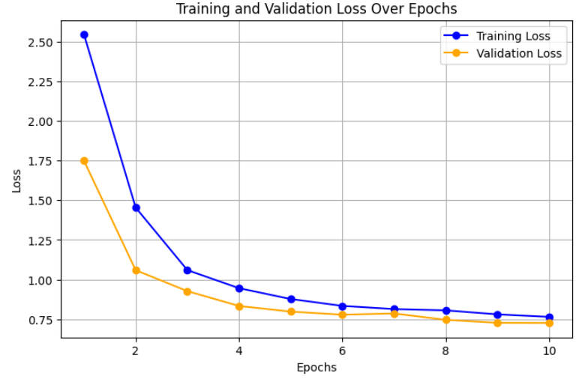

| Experiment # | y_val | y_train | batch_size | epochs | learning rate | patience |
| --- | --- | --- | --- | --- | --- | --- |
| 2 | 0:2000 | 0:2000 | 64 | 10 | .00075 | N/A |

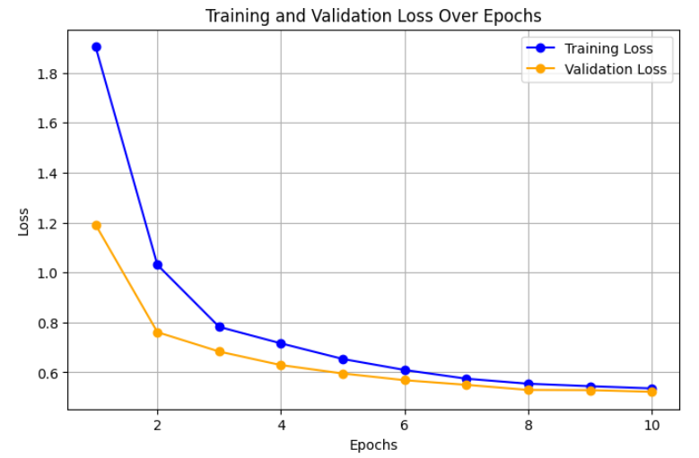

| Experiment # | y_val | y_train | batch_size | epochs | learning rate | patience |
| --- | --- | --- | --- | --- | --- | --- |
| 3 | 0:2000 | 0:2000 | 32 | 10 | .00075 | N/A |

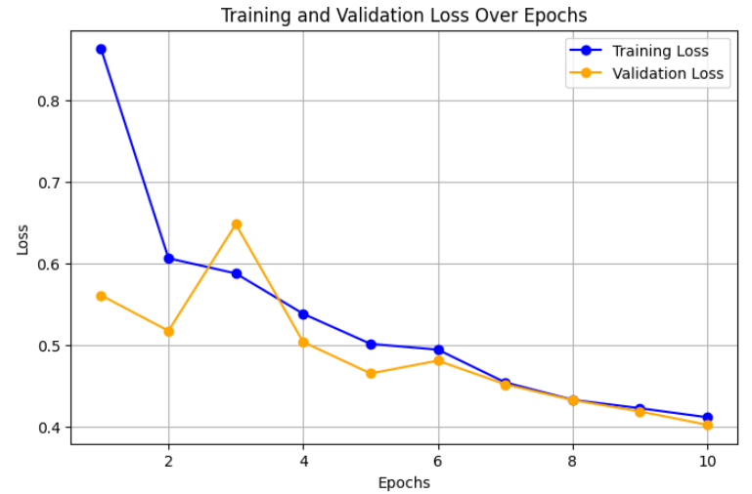

| Experiment # | y_val | y_train | batch_size | epochs | learning rate | patience |
| --- | --- | --- | --- | --- | --- | --- |
| 4 | 0:2000 | 0:2000 | 32 | 10 | .001 | N/A |

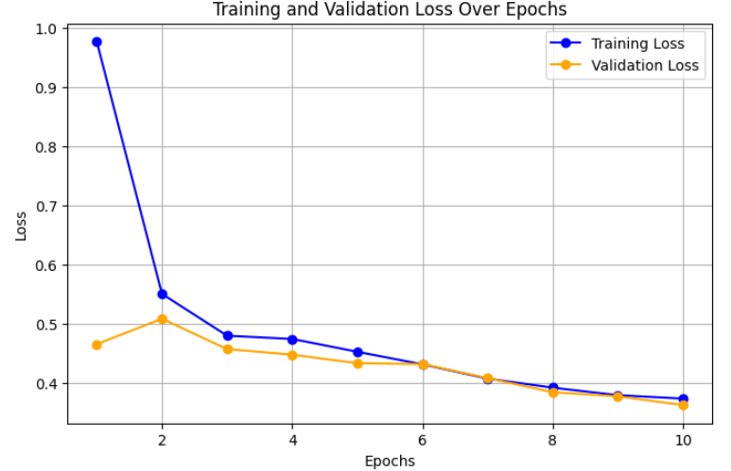

| Experiment # | y_val | y_train | batch_size | epochs | learning rate | patience | Stopped |
| --- | --- | --- | --- | --- | --- | --- | --- |
| 5 | 0:500 | 0:500 | 64 | 100 | .001 | 10 | 90 |

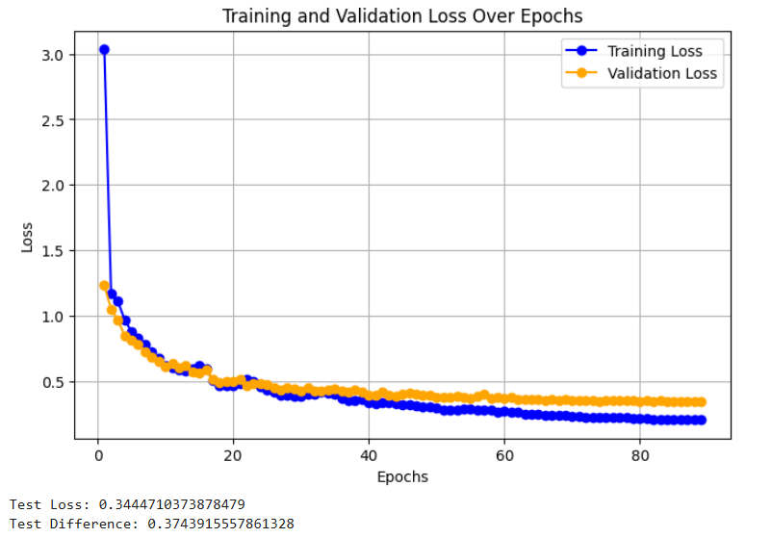

| Experiment # | y_val | y_train | batch_size | epochs | learning rate | patience | Stopped |
| --- | --- | --- | --- | --- | --- | --- | --- |
| 6 | 0:1500 | 0:1500 | 128 | 100 | .001 | 10 | 100 |

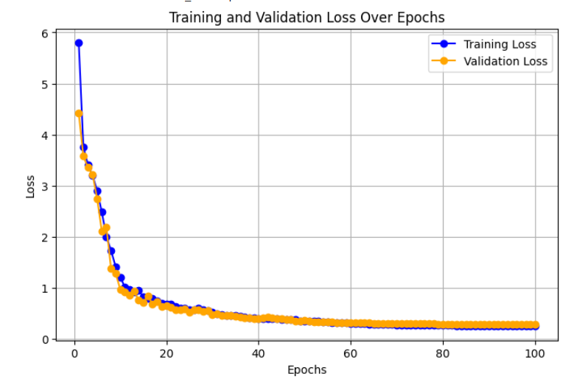

| Experiment # | y_val | y_train | batch_size | epochs | learning rate | patience | Stopped |
| --- | --- | --- | --- | --- | --- | --- | --- |
| 7 | 6449 | 6449 | 128 | 100 | .001 | 10 | 80 |

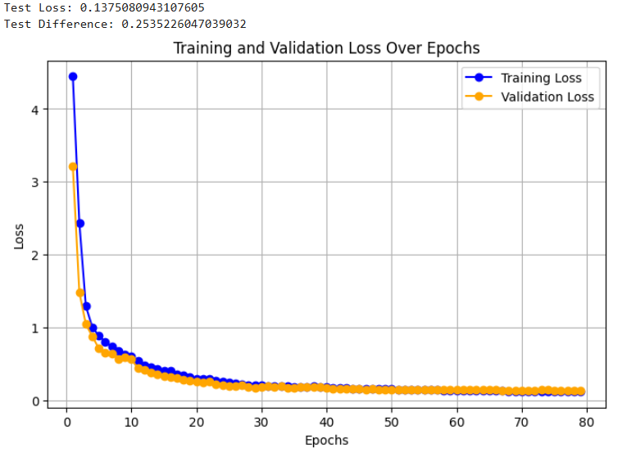

| Experiment # | y_val | y_train | batch_size | epochs | learning rate | patience | Stopped | message_layers |
| --- | --- | --- | --- | --- | --- | --- | --- | --- |
| 8 | 100 | 100 | 32 | 100 | .001 | 10 | 48 | 3 |

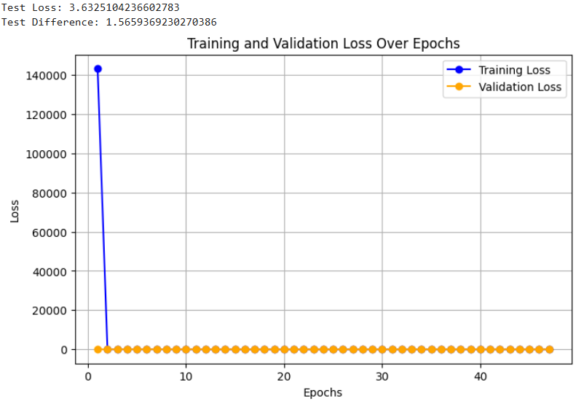

| Experiment # | y_val | y_train | batch_size | epochs | learning rate | patience | Stopped | message_layers |
| --- | --- | --- | --- | --- | --- | --- | --- | --- |
| 9 | 100 | 100 | 32 | 100 | .001 | 10 | 100 | 2 |

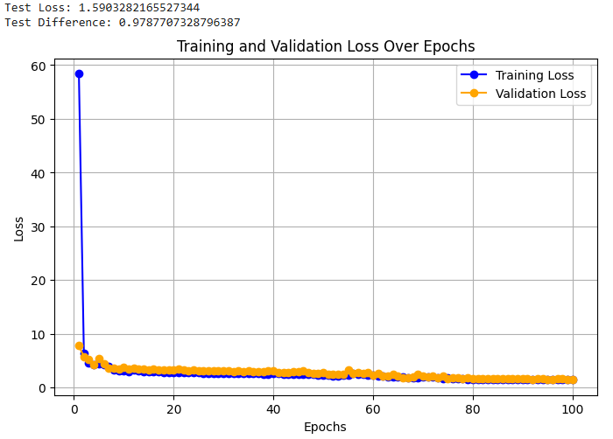

| Experiment # | y_val | y_train | batch_size | epochs | learning rate | patience | Stopped | message_layers |
| --- | --- | --- | --- | --- | --- | --- | --- | --- |
| 10 | 100 | 100 | 32 | 100 | .001 | 10 | 77 | 1 |

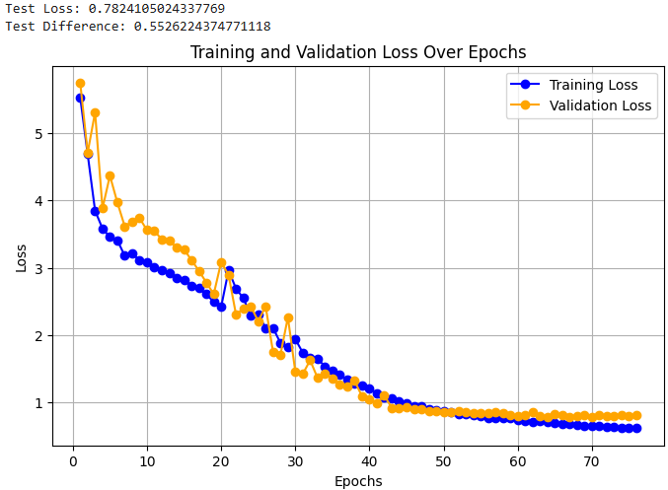

| Experiment # | y_val | y_train | batch_size | epochs | learning rate | patience | Stopped | message_layers |
| --- | --- | --- | --- | --- | --- | --- | --- | --- |
| 11 | 300 | 300 | 32 | 100 | .001 | 10 | 100 | 1 |

