An evaluation was performed to see how the number of nodes in the system affected the execution time for the prime factorization of different sized numbers. These tests were performed on an AMD Ryzen 5 3600 6-Core desktop machine. The testing consisted of 100, 110, 115 and 120-bit semi-prime numbers. For each number we adjusted the number of nodes used in the system from 1 to 3 and timed how long it took to compute the factorials. The results are shown below.

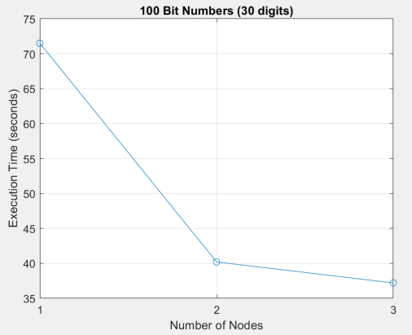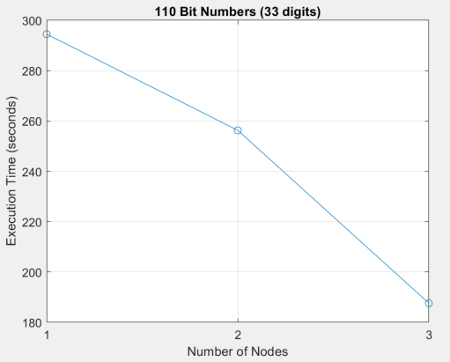

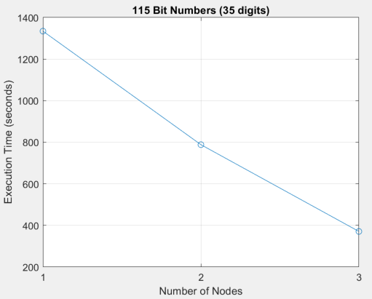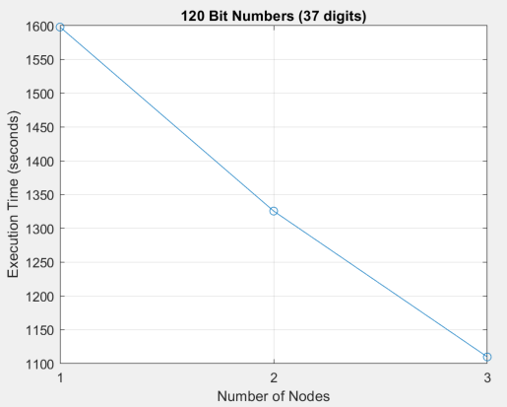

By incorporating additional nodes into the system, we were able to achieve a faster execution time in these examples. Testing was also performed on numbers less than 100 bits, but no speed up was observed. It seems in those situations where the numbers were small enough, a single threaded application was able to compute the prime factorials faster. This is due to the overhead associated with our system, in terms of network communications and the time associated with spawning new threads. An attempt was also made to compute a 128-bit number. We were able to compute the prime factorials after 6,387 seconds, approximately 107 minutes, using our algorithm and 4 nodes. Attempts were not made with less nodes due to the anticipated time needed to perform the calculations.