RNG Ops
Operators Guide
How to run a match from check-in to final results
Windows 11 and mobile devices · Version 1.1.0
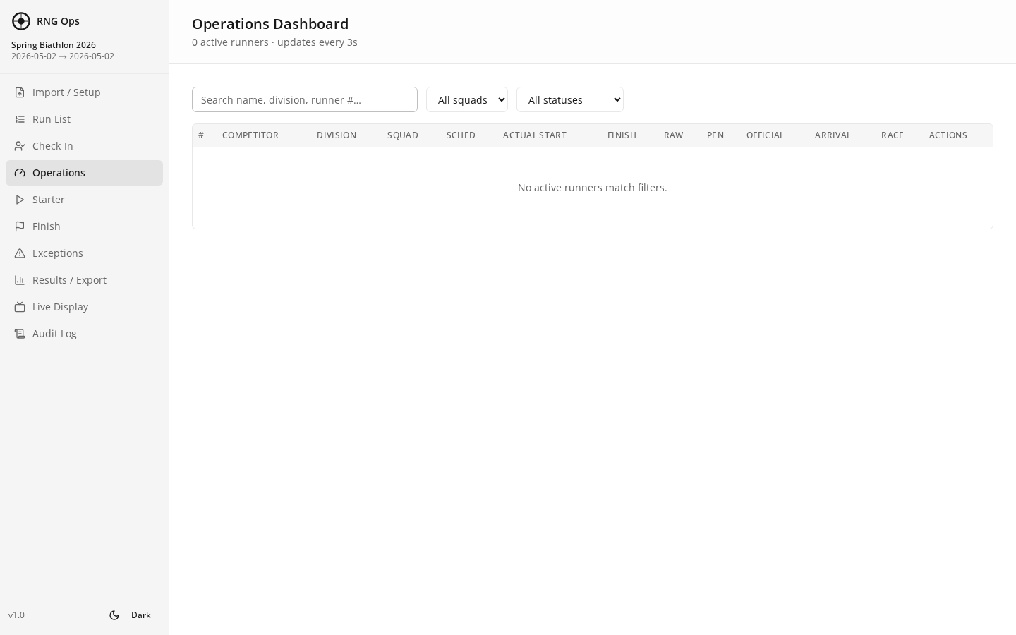

Table of Contents
Click any entry to jump to that section. In Word, Ctrl+Click follows the link.

1. The App at a Glance
RNG Ops organizes match-day work into 10 pages. You move between pages using the sidebar on the left. Every page updates in real time across the host laptop and every connected phone or tablet.

Figure 1 — Operations dashboard with all pages visible in the sidebar

The 10 pages
Page | What it is for | Who uses it
Setup | Create the event; import competitors and squads; define penalties. | Match director (before match)
Run List | See every competitor and their current state. | Everyone
Check-In | Mark arrivals as Checked In, Late, No Show, or Withdrawn. | Registration table
Operations | Live dashboard of what is happening right now. | Match director
Starter | Send athletes down the course; capture actual start time. | Starter line
Finish | Record finish times and apply time penalties. | Finish line
Exceptions | Flag entries for jury review. | Jury / chief of course
Results | Final standings with raw, penalty, and official times; export XLSX. | Match director
Live Display | Full-screen spectator view with auto-refresh. | Spectators / announcer
Audit Log | Every action taken, who did it, when. | Match director / appeals

Sidebar and theme toggle
The sidebar is always visible. A theme toggle sits in the top-right corner of every page — switch to dark for dim environments, back to light when outdoors.
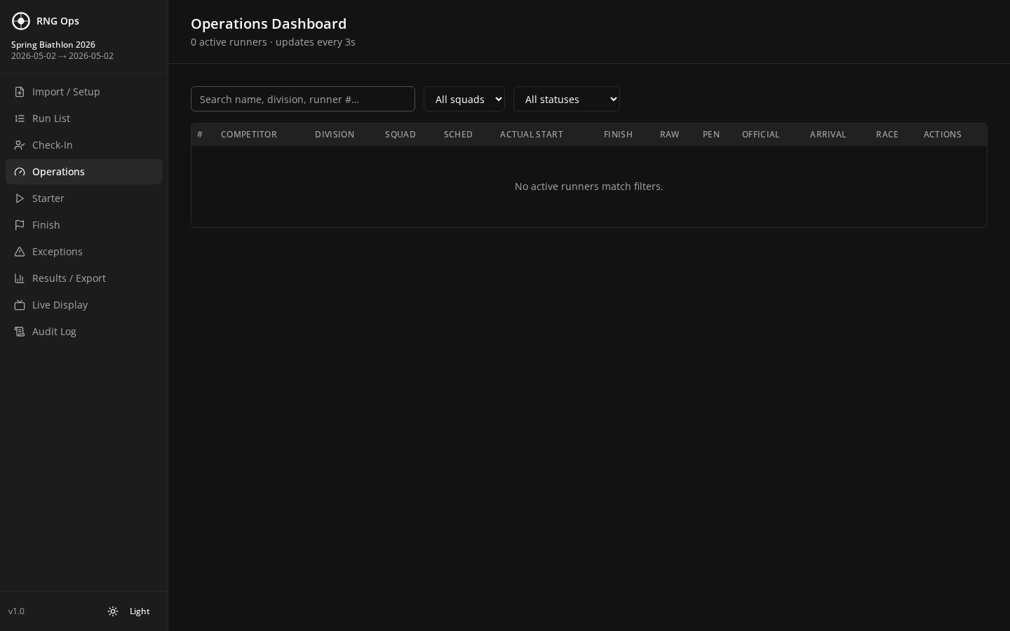
Figure 2 — Operations page in dark theme

2. Pre-Match: Prepare the Event
Do this on the host laptop, ideally the day before the match. The Setup page is the only place where you enter the event details and roster.

Step 1 — Open the Setup page
- Launch RNG Ops on the Windows host.
- Click "Import / Setup" in the left sidebar (this is the default page on first launch).
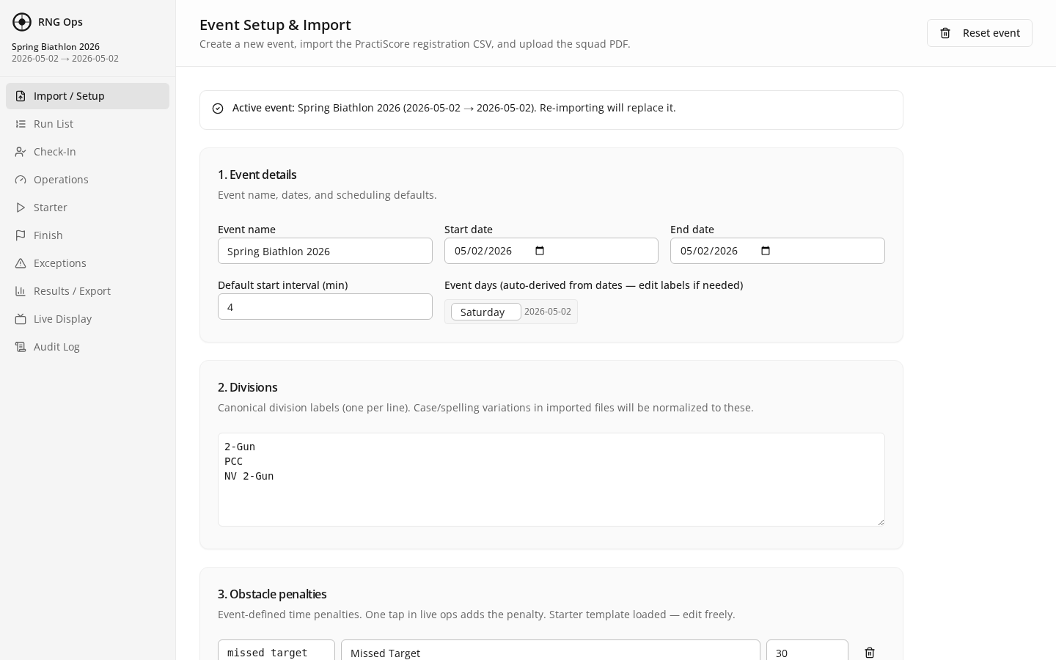
Figure 3 — Setup page, ready to create or reset an event

Step 2 — Fill in event details
- Type the Event name (for example, "Spring Biathlon 2026").
- Choose the Start date and End date.
- Set the Default start interval in minutes (time between athletes off the start line). Common values: 0.5 for sprints, 1 for most matches.

Step 3 — List your divisions
Divisions are the competition classes (for example "2-Gun", "PCC", "M/L 2-Gun"). Enter one division per line in the Divisions box. These must match the division names in your roster file.

Step 4 — Configure penalties
Penalties are time adders applied on the Finish page. You can edit these freely. Common defaults:
Code | Label | Seconds added
missed_target | Missed Target | 30
procedural | Procedural | 10
safety_warning | Safety Warning | 60
Click the + button to add more penalty types; click the trash icon to remove one.

Step 5 — Upload the competitor roster
- Export your roster from PractiScore (or your registration system) as CSV.
- In RNG Ops, click "Choose file" next to the Competitor CSV field and select your exported file.
- RNG Ops shows a preview of the rows it detected. Check the count matches what you expect.

Step 6 — Upload the squad PDF
- Export or print your squad assignments as a PDF.
- Click "Choose file" next to the Squad PDF field and select it.
- RNG Ops extracts squads automatically. You can also paste squad text directly into the text box if you do not have a PDF.

Step 7 — Commit the event
- Click "Commit event" at the bottom of the Setup page.
- RNG Ops validates everything and creates the event. You are now ready to run the match.
Re-committing replaces the event
Committing again wipes and re-imports the event. All check-ins, starts, finishes, and penalties are lost. Only re-commit before the match starts — never during the match.

3. Match Day: Check-In
On match morning, the first job is check-in. One laptop or tablet at the registration table handles every athlete as they arrive.
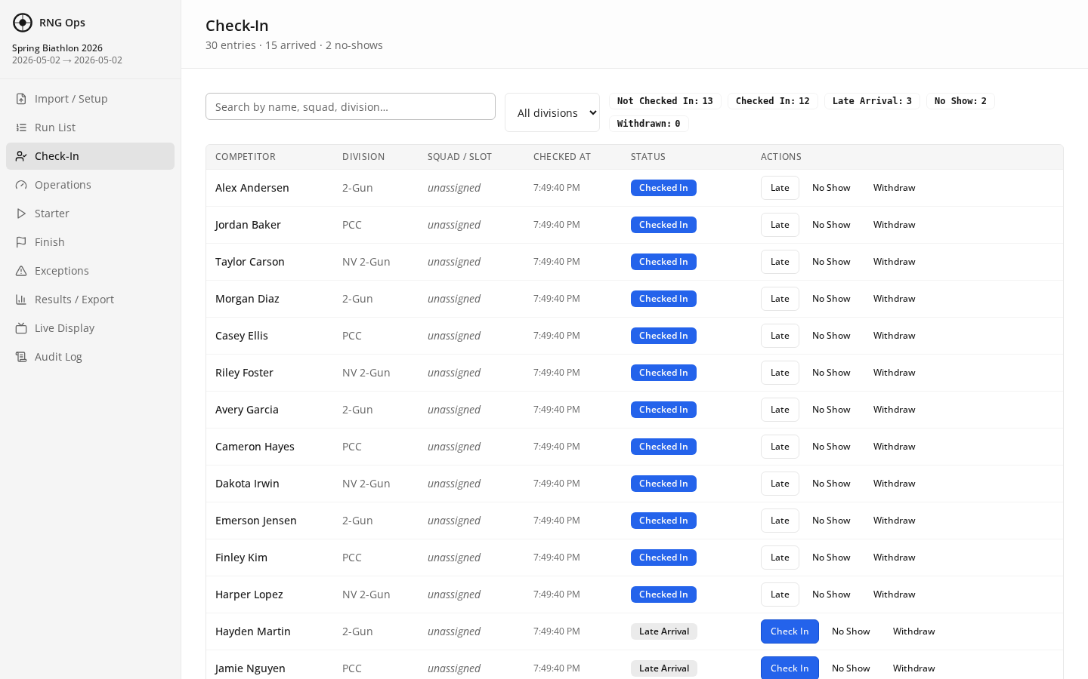
Figure 4 — Check-In page with status buttons for every entry

How status buttons work
For each competitor, four status buttons appear next to their name. Tap one to set their state. The current state is highlighted.
Status | When to use | Effect
Checked In | Athlete arrived on time and signed in. | Eligible to start. Timestamp recorded.
Late Arrival | Athlete arrived after their scheduled start time. | Eligible to start but flagged as late.
No Show | Athlete did not arrive. | Excluded from run list. Can be un-set if they show up.
Withdrawn | Athlete withdrew before starting. | Removed from the start queue. Historical record preserved.

Tabletop workflow
- Open the Check-In page on a phone, tablet, or laptop at the registration table.
- As each athlete arrives, find their name (use the search/filter box at the top).
- Tap the correct status button. The button turns solid to confirm.
- Move on to the next athlete.
Real-time sync
Every tap on a phone is visible immediately on the host laptop and every other connected device. The match director can see live check-in counts on the Operations page.
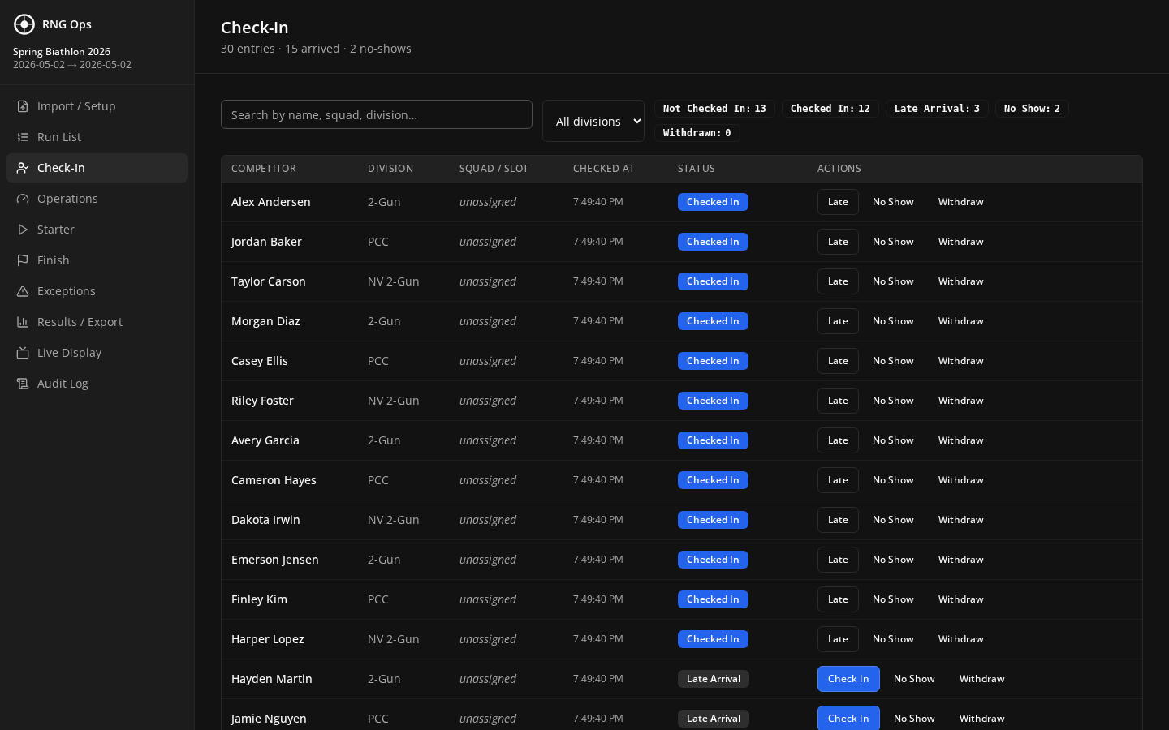
Figure 5 — Check-In in dark theme, useful at a dim registration tent

4. The Run List
The Run List is the single source of truth: every competitor, their division, their current status, their actual start and finish times, and any penalties. Every operator should know where to find it.
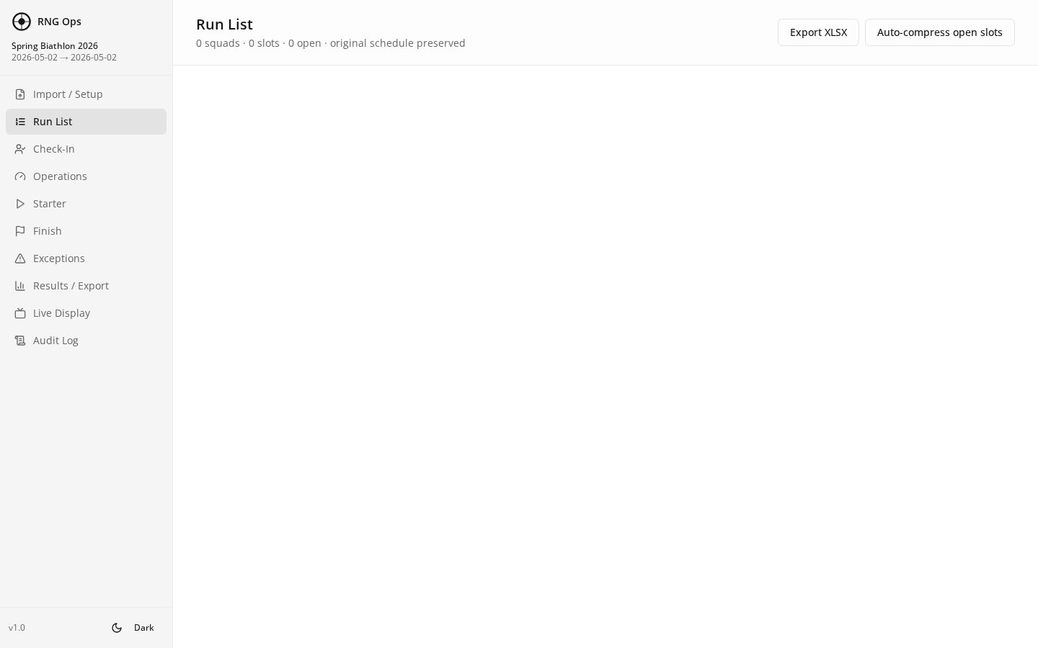
Figure 6 — Run List with all 30 competitors and their states

How to read a row
- Runner number — the bib number you gave the athlete at check-in.
- Name and division — from the imported CSV.
- Squad — from the imported squad PDF.
- Check-in status — color-coded from Chapter 3.
- Scheduled start — auto-derived from squad order and the default interval.
- Actual start — timestamp captured when the Starter sends them off (Chapter 5).
- Finish — timestamp captured at the Finish line (Chapter 6).
- Penalties — summary of any penalties applied.
- Official time — calculated automatically as Finish minus Actual start plus penalty seconds.

Filtering and searching
- Type any text in the filter box at the top (name, division, squad, status) to narrow the list.
- Click a column header to sort.
- The Run List is read-only. All changes happen on the Check-In, Starter, Finish, and Exceptions pages.

5. Starter Line
The Starter page is operated by the person at the start line. Its job is to capture the actual moment each athlete left the line. This is the clock for their time.
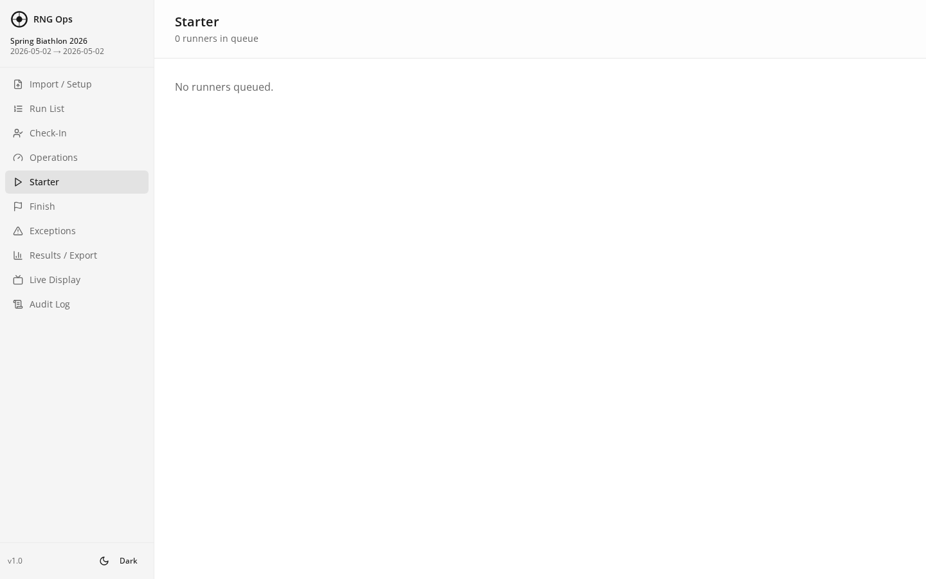
Figure 7 — Starter page, ready to send the next athlete

Sending an athlete
- The Starter page shows who is next in line, their runner number, and their scheduled start time.
- When the athlete crosses the start line, tap the large "Send" button.
- RNG Ops records the exact timestamp and advances to the next athlete in the queue.
- If an athlete is out of order, tap their name in the upcoming list — they become "next" and you send them normally.

Assigning a runner number late
If a competitor did not receive a bib at check-in, you can assign one here. Tap the athlete in the queue, type the bib number, then send them. The number is saved.

Common situations
- Late arrival sent out of slot — Tap the athlete in the upcoming list, then Send. Their actual start is now, regardless of their scheduled start.
- Athlete wants to withdraw at the line — Send them to Check-In and mark Withdrawn. They disappear from the Starter queue.
- Starter clock mistake — Go to the Audit Log, find the Send event, and the match director can correct the timestamp.
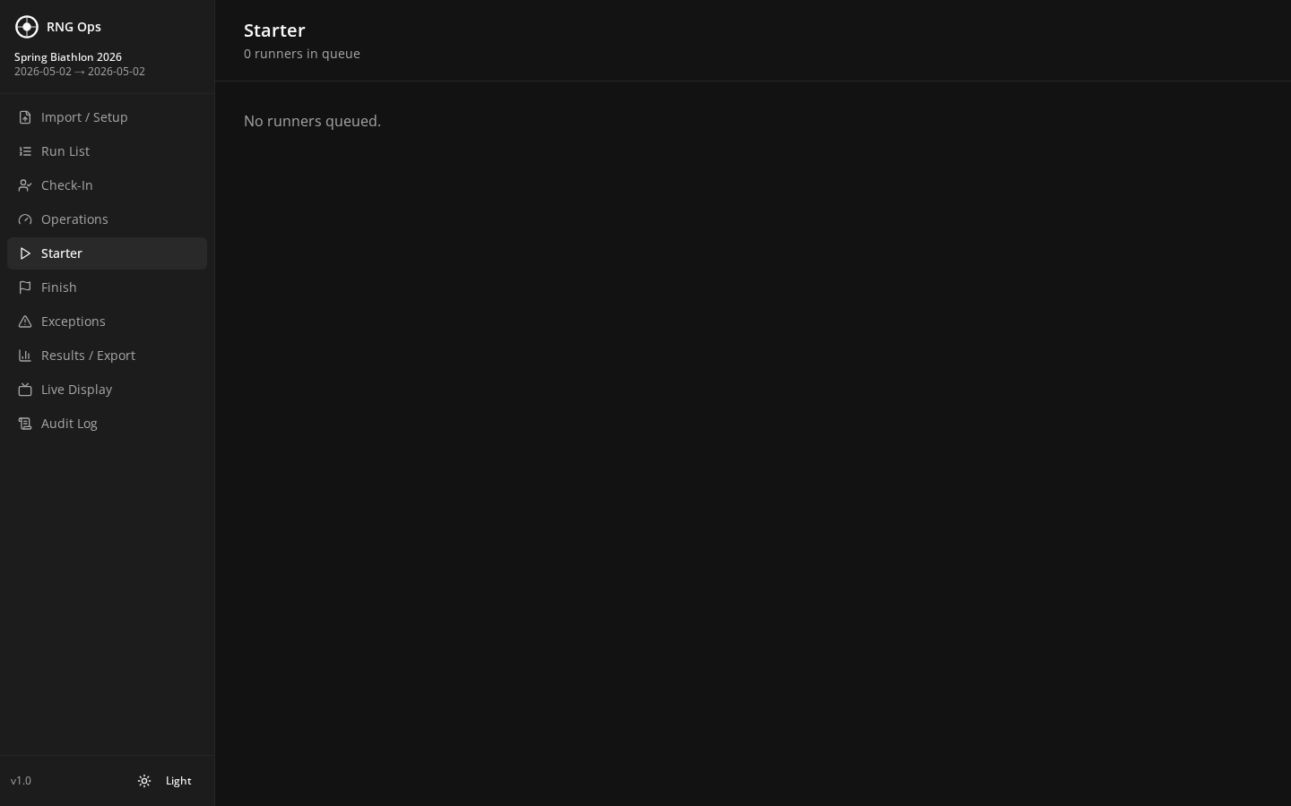
Figure 8 — Starter in dark theme

6. Finish Line
The Finish page captures the finish time and applies any time penalties.
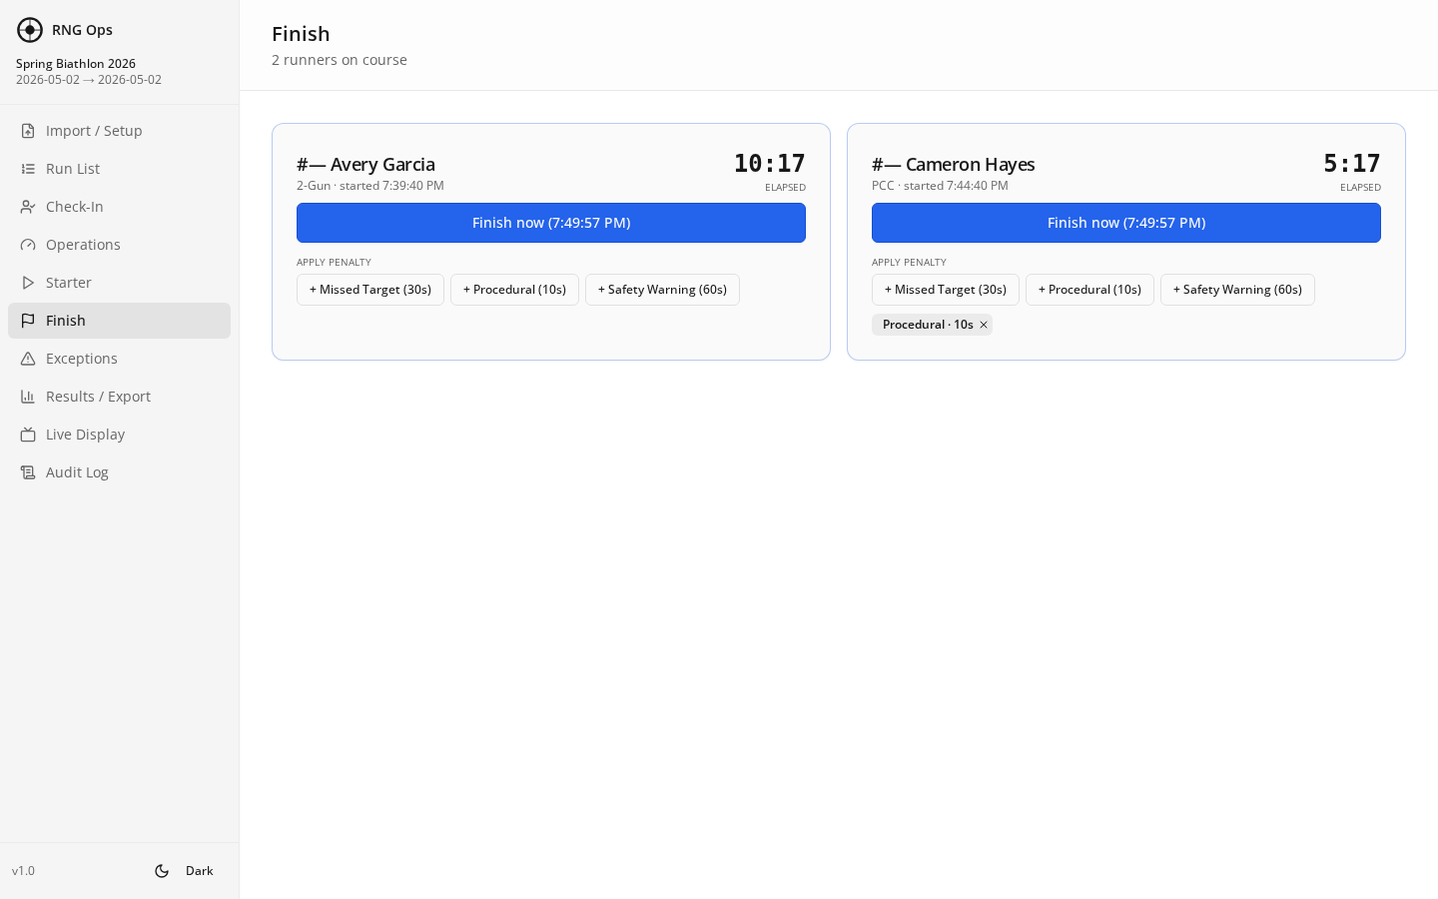
Figure 9 — Finish page with penalty chips and one applied penalty

Recording a finish
- As an athlete crosses the finish line, the Finish page shows them as the next expected finisher (based on their actual start time and the leader's pace).
- Tap the "Finish" button next to their name. The timestamp is captured.
- If the wrong athlete finished first, tap the correct athlete in the list instead and tap their Finish button.

Applying penalties
Penalty chips are visible for every athlete. Tap a chip to add that penalty. Tap the same chip again to remove it. The number of taps equals the number of times that penalty is applied (for example, three "Missed Target" taps adds 90 seconds).
Chip | Default seconds | Typical use
Missed Target | +30 s | One per missed target on course.
Procedural | +10 s | Technical rule infraction.
Safety Warning | +60 s | Muzzle, unsafe handling, etc.
Penalty math is automatic
The Results page uses: Official time = Finish − Actual start + sum of penalty seconds. You never calculate this by hand.

7. Exceptions and Jury Flag
Use the Exceptions page to flag any entry for jury review — a protest, a scoring dispute, a potential disqualification.
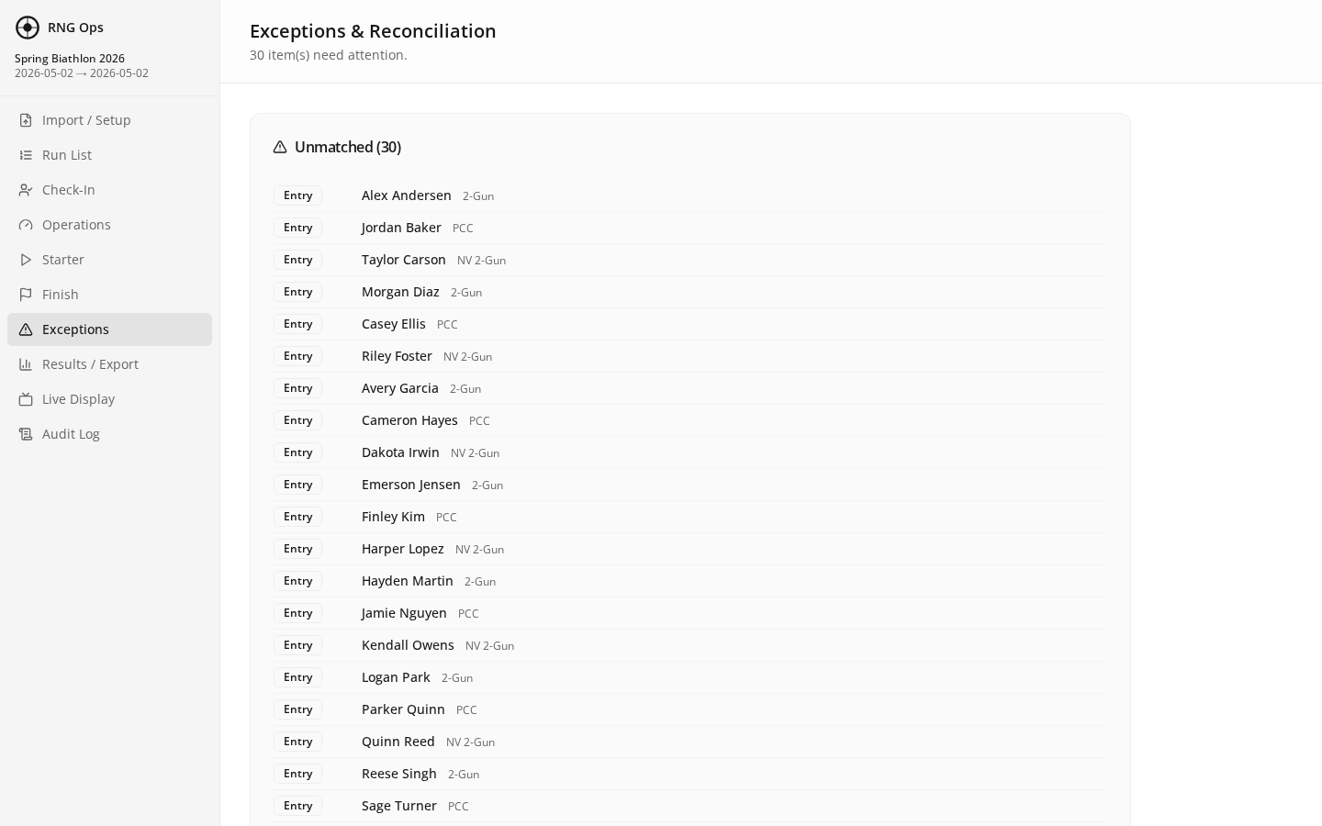
Figure 10 — Exceptions page

Flagging an entry
- Go to the Exceptions page.
- Find the athlete in the list (search works here too).
- Tap "Flag for jury". A text box appears — type a short reason ("Muzzled self", "Disputed time", etc.).
- Tap Save. The entry is flagged on the Run List and Results page until a jury member resolves it.

Resolving a flag
- Approved — keep the time. Flag is cleared.
- Time correction — adjust the start, finish, or penalty on the appropriate page, then clear the flag.
- Disqualification — mark Withdrawn on Check-In. The entry drops from standings but remains in the Audit Log.

8. Results and Export
The Results page shows final standings. Every completed finish appears automatically with raw time, penalty total, and official time.
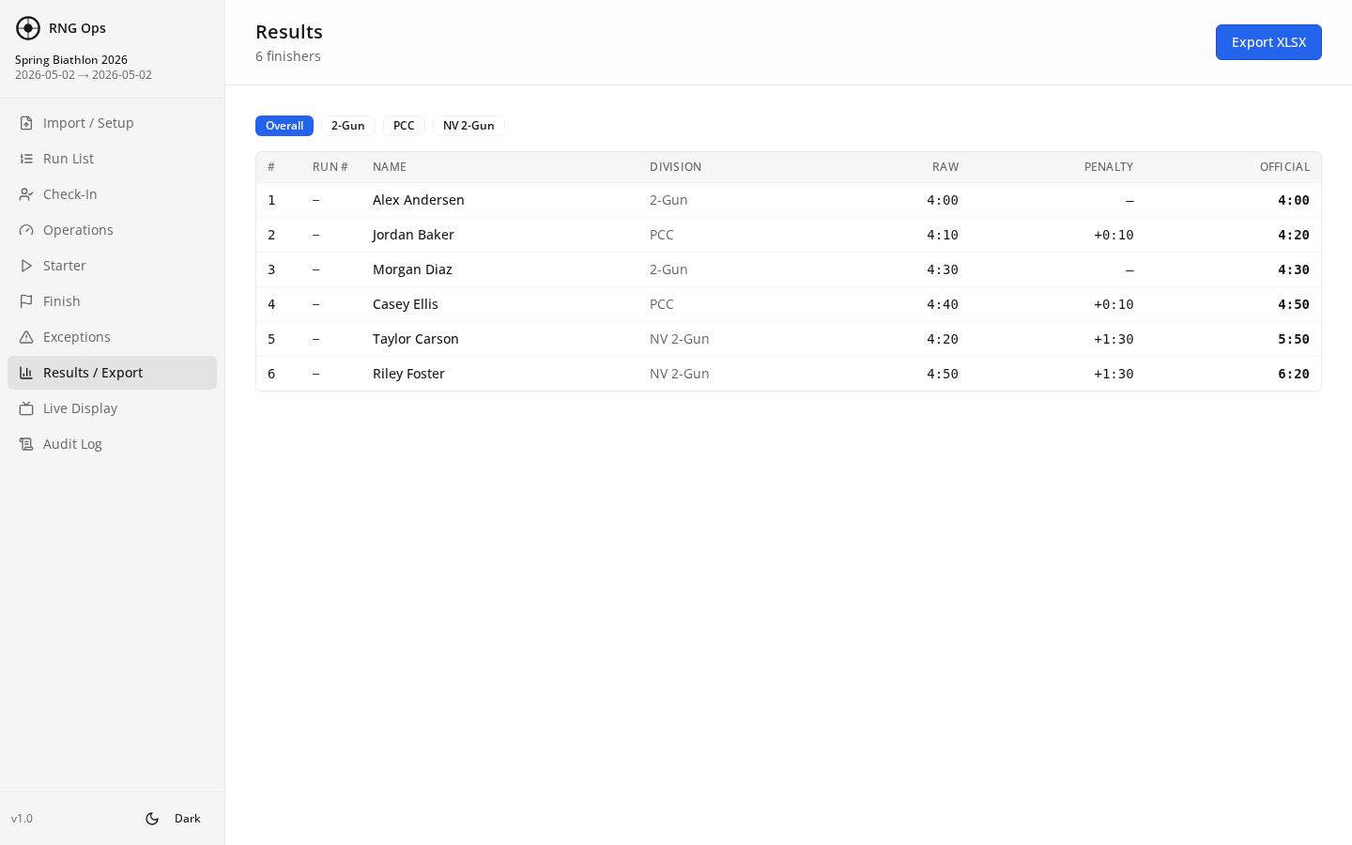
Figure 11 — Results page with finishers ranked by official time

Columns explained
- Rank — 1, 2, 3 by official time within each division.
- Raw time — Finish minus Actual start, no penalties.
- Penalty — Sum of seconds from applied penalty chips.
- Official time — Raw time plus penalty. This is the published result.
- Flag — If the jury has flagged this entry, a warning marker appears.

Exporting for posting and PractiScore
- Tap the "Export XLSX" button at the top of the Results page.
- A file named like "rng-ops-results-<event>-<date>.xlsx" downloads to the host laptop.
- Open it in Excel, Numbers, or Google Sheets. All columns and rows are preserved.
- Upload or paste into your scoring platform.
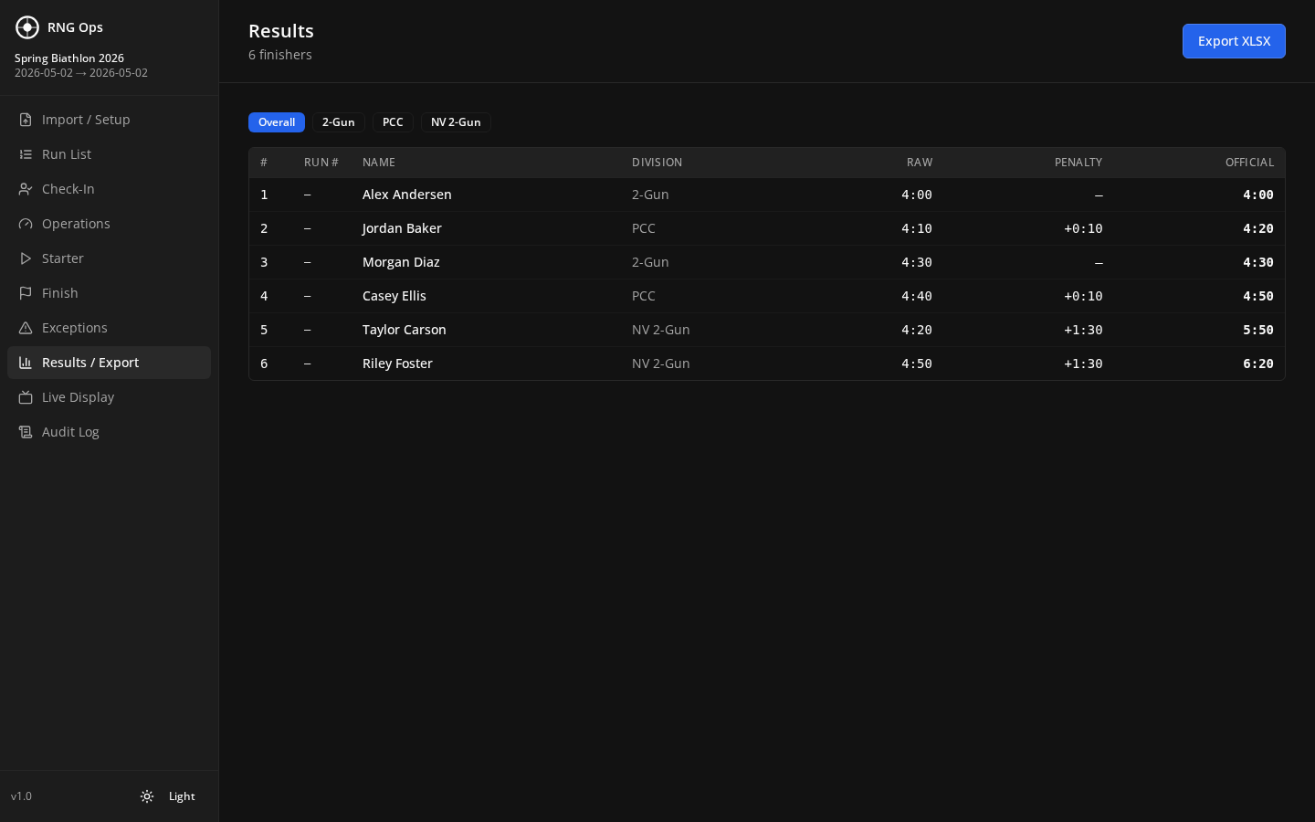
Figure 12 — Results in dark theme

9. Live Display (Spectator Mode)
The Live Display page is a full-screen standings board for spectators, announcers, or a second monitor. It refreshes automatically.
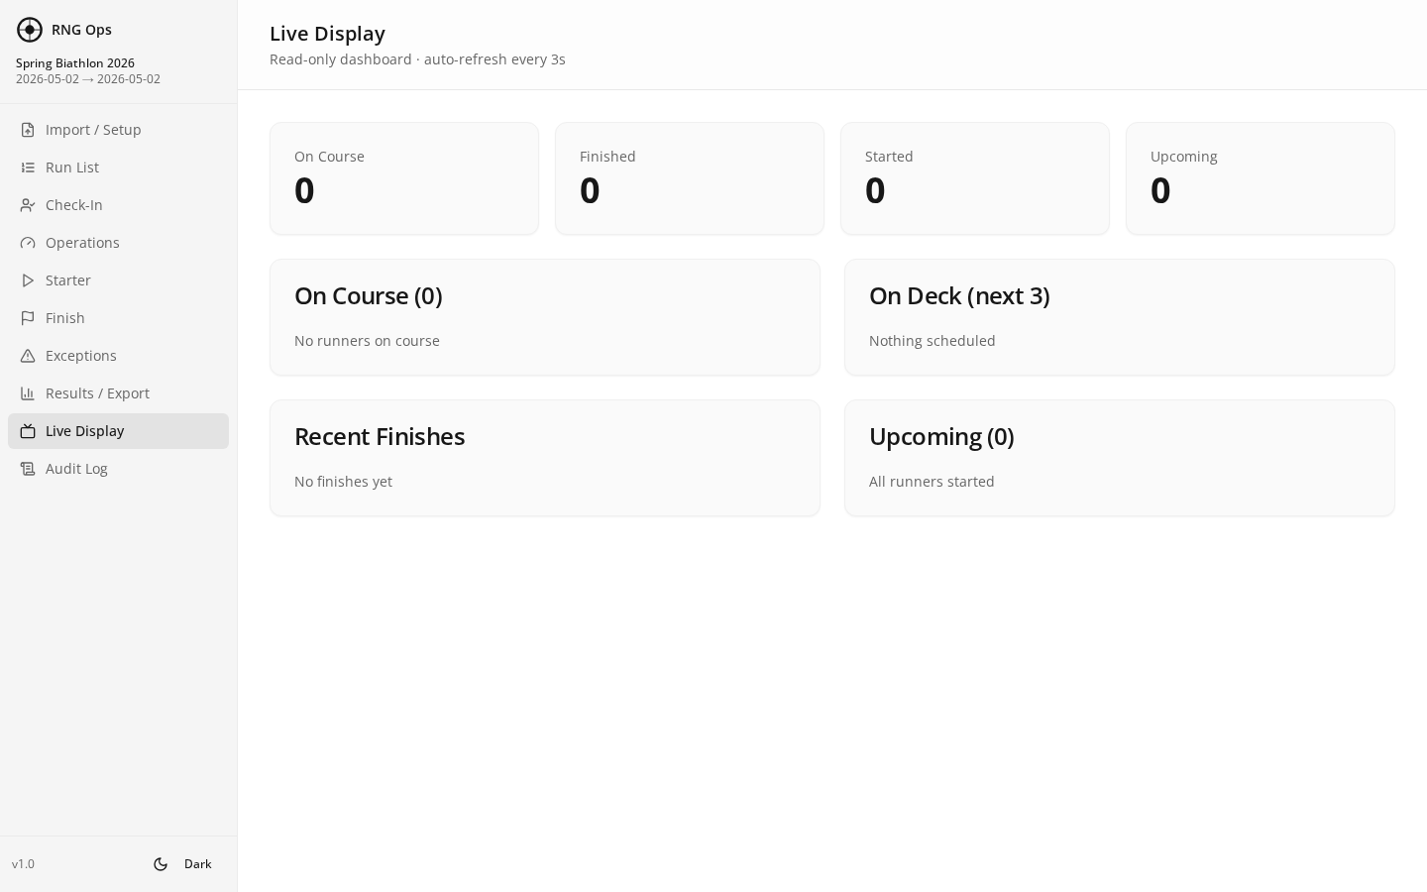
Figure 13 — Live Display in full-screen spectator mode

Setting up a spectator screen
- On the second screen (TV, projector, or spare laptop), open a browser and go to the LAN URL followed by #/display (for example http://192.168.1.42:5123/#/display).
- Press F11 to enter full-screen mode.
- Results refresh every few seconds without any action needed.
Works great on a phone too
Friends and family can open the LAN URL on their phone and keep Live Display open during the match to follow standings in real time.

10. Audit Log
The Audit Log records every action taken in RNG Ops: check-ins, sends, finishes, penalty chips, jury flags, and any data corrections. It is the final word in disputes.
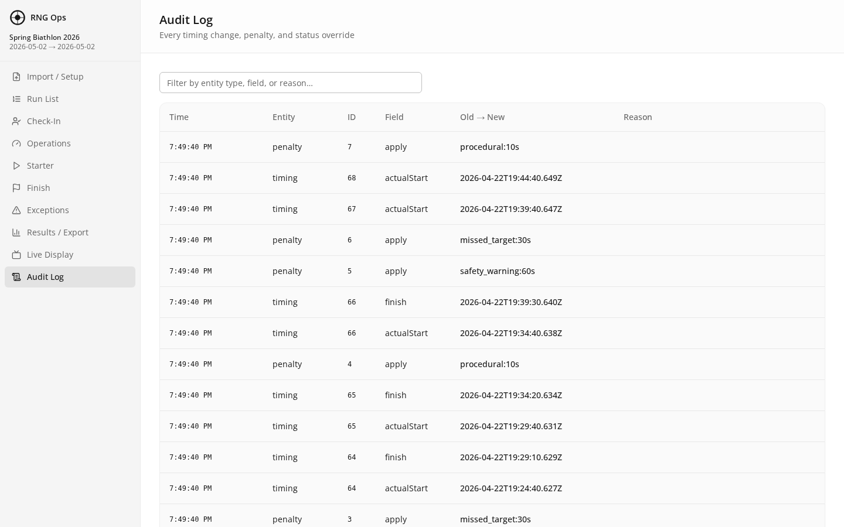
Figure 14 — Audit Log showing every match-day action

What is recorded
- Action name (check-in, start, finish, penalty, flag, edit).
- Entry affected (athlete and runner number).
- Timestamp (exact time the action happened).
- Source (which station — host, phone, or tablet — triggered it).

Using the Audit Log for appeals
- Filter by athlete name to see their full match history.
- Filter by action type (for example, only penalties) to review specific categories.
- Export the full log as CSV using the Export button (useful for post-match records).

11. Match-Day Sequence Checklist
The order of operations on match day. Each row is one job for one person.
When | Who | What
Night before | Match director | Commit the event on Setup. Verify all divisions, penalties, squads are correct.
60 min before start | Match director | Host laptop plugged in. RNG Ops launched. File → Show LAN URL confirmed.
60 min before start | All operators | Open the LAN URL on your phone or tablet. Confirm you see the Run List.
30 min before start | Registration | Open Check-In page. Start marking arrivals.
Start time | Starter | Open Starter page. Send first athlete — tap Send when they cross the line.
Throughout match | Finish | Open Finish page. Tap Finish as each athlete crosses; apply penalty chips immediately.
Throughout match | Jury / match director | Monitor Exceptions. Resolve flags as they come up.
Throughout match | Match director | Watch the Operations dashboard. Check for stations that have stopped reporting.
Last athlete finished | Match director | Go to Results. Scan for any missing finishes or unresolved flags.
Results certified | Match director | Export XLSX. Post standings. Back up rng-ops.db to USB.

12. Mobile Device Tips

Keep the device awake
- On iPhone/iPad: Settings → Display & Brightness → Auto-Lock → Never (during match only).
- On Android: Settings → Display → Screen timeout → 30 minutes or maximum.
- Keep every mobile station plugged into power at its table. Tablet batteries do not last a full match at full brightness.

If the app feels slow or unresponsive
- Pull down to refresh the page.
- Close the RNG Ops tab and re-open from the Home Screen icon.
- Confirm you still have Wi-Fi signal — walk back toward the host laptop.

Station recommendations
Station | Ideal device | Why
Check-In | Tablet (iPad or Android) | Large screen shows many rows. Easy to hand to next volunteer.
Starter | Phone or tablet | One big Send button — either works. Weatherproof case recommended.
Finish | Tablet | Penalty chips are tap targets — more screen space reduces mistaps.
Exceptions / Jury | Laptop | Typing flag reasons is easier on a keyboard.
Operations (director) | Host laptop | The director watches everything from the host.
Live Display | TV with attached laptop, or spare tablet | Full-screen, auto-refreshing.

13. Quick Reference Card
One-page summary to print and keep at the timing table.

Page → Job
Page | Key action
Check-In | Tap status button (Checked In / Late / No Show / Withdrawn).
Starter | Tap Send when athlete crosses the start line.
Finish | Tap Finish when athlete crosses the line. Tap penalty chips.
Exceptions | Tap "Flag for jury", type reason, Save.
Results | Tap "Export XLSX" after match to publish standings.
Live Display | Open in full-screen for spectator board.
Audit Log | Filter by athlete for a full match history.

Default penalties (editable on Setup)
Penalty | Seconds
Missed Target | +30
Procedural | +10
Safety Warning | +60

Emergency reset (last resort)
- Close RNG Ops. Open %APPDATA%\RNG Ops and copy rng-ops.db to a USB (backup first).
- Delete rng-ops.db. Re-launch RNG Ops. A fresh database is created.
- Re-commit the event on Setup. You will need to re-enter check-ins and starts for any athletes already in progress.
You are ready to run a match.
Refer back to any chapter by tapping the Table of Contents.

