RNG Ops
Setup Guide
Windows 11 and mobile devices
Version 1.1.0
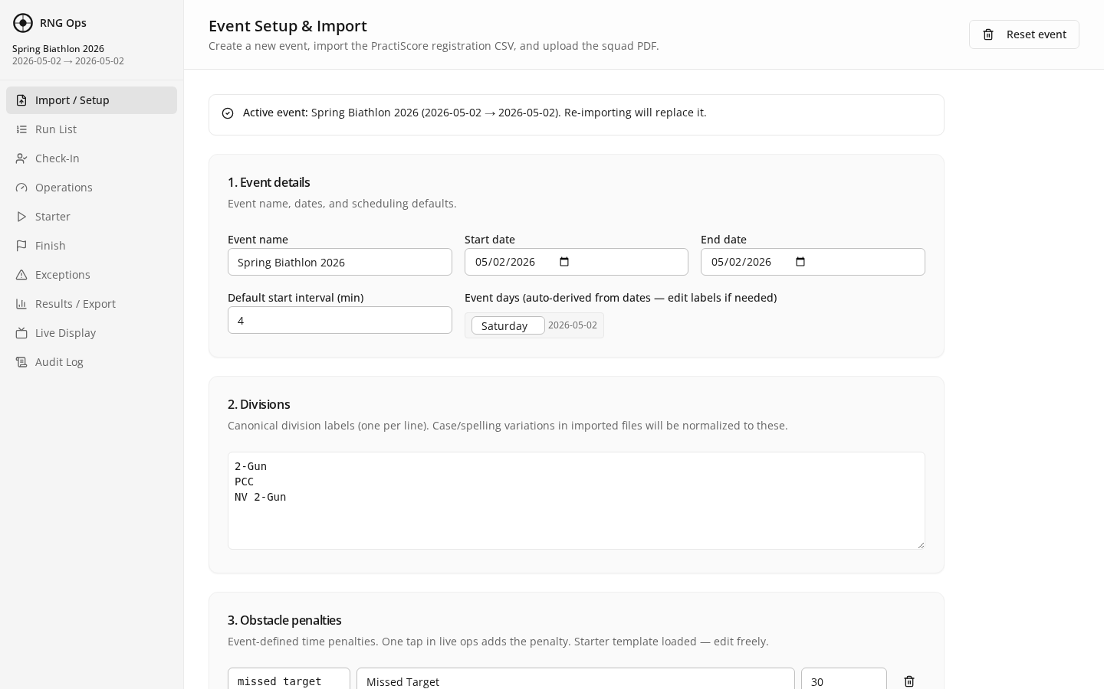
Beginner-friendly installation and configuration

Table of Contents
Click any entry to jump to that section. Press Ctrl+Click in Word to follow the link.

1. What Is RNG Ops?
RNG Ops is a desktop application for running shooting-sport match operations. It handles competitor check-in, start sequencing, finish capture, penalty assessment, results, and a spectator display — all from one laptop, with phones and tablets on the same Wi-Fi acting as remote stations.

Two ways to use it
- Install the Windows installer on a host laptop. All data stays on that laptop.
- Point phones, tablets, or other laptops at the host laptop over local Wi-Fi. No internet connection is required once the app is running.

What you will set up
- The RNG Ops application on one Windows 11 computer (the "host").
- Optional: mobile devices that connect to the host over Wi-Fi for check-in, starter, and finish stations.
Estimated time
First-time setup takes 30–45 minutes on Windows. Adding a phone or tablet takes under 2 minutes per device.

2. Before You Begin

Hardware you need
- One Windows 11 computer (the host). 8 GB RAM minimum, 2 GB free disk space.
- A Wi-Fi network that the host and all mobile devices can join. A home router or a portable travel router works.
- Optional: one or more phones, tablets, or laptops to use as stations.

Accounts and software
- A free GitHub account (to download the source code). Sign up at github.com if you do not have one.
- Administrator access on the Windows 11 computer (you need to install programs).

What you will install on Windows 11
- Node.js 20 LTS — runs the app engine. Download from nodejs.org.
- Git for Windows — downloads the project code. Download from git-scm.com.
- Visual Studio Build Tools 2022 — compiles the database module. Download from visualstudio.microsoft.com/downloads (scroll to "Tools for Visual Studio" → "Build Tools for Visual Studio 2022").
Why do I need Build Tools?
RNG Ops uses a local database engine (better-sqlite3) that compiles on your machine during install. The free Microsoft Build Tools provide the C++ compiler needed. You install this once; you will never open it directly.

3. Install on Windows 11
Follow these steps in order. Do not skip ahead.

Step 1 — Install Node.js 20 LTS
- Open your web browser and go to https://nodejs.org.
- Click the green button labeled "LTS" (long-term support). A file named like node-v20.x.x-x64.msi will download.
- Double-click the downloaded file to start the installer.
- Click Next through every screen. Leave all defaults. Accept the license. Do NOT change any checkbox — the default options are correct.
- Click Install. If Windows asks "Do you want to allow this app to make changes?", click Yes.
- When the installer finishes, click Finish.
- Verify: press the Windows key, type "cmd", and press Enter. In the black window that appears, type "node --version" and press Enter. You should see something like "v20.18.0". If you see this, Node.js is installed. Close the window.

Step 2 — Install Git for Windows
- Go to https://git-scm.com/download/win. The download starts automatically.
- Double-click the downloaded file to start the installer.
- Click Next through every screen. Leave all defaults — the defaults are correct for RNG Ops.
- Click Install. When finished, click Finish.
- Verify: open a new Command Prompt (Windows key, type "cmd", Enter). Type "git --version" and press Enter. You should see "git version 2.xx.x". Close the window.

Step 3 — Install Visual Studio Build Tools 2022
- Go to https://visualstudio.microsoft.com/downloads/.
- Scroll down to the section "All Downloads". Expand "Tools for Visual Studio".
- Find "Build Tools for Visual Studio 2022" and click the Download button next to it.
- Run the downloaded installer. It will first install a small bootstrapper, then open a workload selection screen.
- On the "Workloads" tab, check the box for "Desktop development with C++".
- Click Install (bottom right). This download is large (3–5 GB) and can take 15–30 minutes. Leave it to run.
- When finished, you can close the Visual Studio Installer window. You do not need to open any Visual Studio program.

Step 4 — Download the RNG Ops code
- Press the Windows key, type "cmd", and press Enter to open a Command Prompt.
- Type this command and press Enter — this moves to your Documents folder:
cd %USERPROFILE%\Documents
- Type this command and press Enter — this downloads the project:
git clone https://github.com/DRT-cloud/biathlon-ops.git
- If prompted to sign in to GitHub, follow the on-screen instructions. A browser window may open.
- When finished, type this command and press Enter — this moves into the project folder:
cd biathlon-ops

Step 5 — Install project dependencies
- In the same Command Prompt window, type:
npm install
- Press Enter. This downloads all the pieces the app needs. It takes 3–10 minutes. You will see many lines of text scroll by. Leave it alone until you see your prompt again.
If you see errors
The most common cause is missing Build Tools from Step 3. Confirm Build Tools is installed, restart your computer, then run "npm install" again.

Step 6 — Build the Windows installer
- In the same Command Prompt window, type:
npm run electron:build:win
- Press Enter. This builds your personal copy of the Windows installer. It takes 3–8 minutes.
- When it finishes, your installer is at:
%USERPROFILE%\Documents\biathlon-ops\release\RNG Ops Setup 1.1.0.exe
- Open File Explorer, navigate to that folder, and you will see "RNG Ops Setup 1.1.0.exe".

Step 7 — Run the installer
- Double-click "RNG Ops Setup 1.1.0.exe".
- Windows SmartScreen may say "Windows protected your PC". Click "More info", then click "Run anyway". This appears because the installer is not signed with a commercial certificate — it is safe because you built it yourself.
- Choose the install location (the default is fine). Click Install.
- When it finishes, check "Run RNG Ops" and click Finish.

Figure 1 — The Setup page is what you see on first launch
You are done with installation
RNG Ops is now installed. A shortcut is on your Desktop and in the Start menu. You can close the Command Prompt window — you only need it for reinstalling or updating.

4. First Launch and Orientation
Double-click the RNG Ops shortcut on your Desktop. The first launch may take 5–10 seconds while the engine starts.

What you see
- A sidebar on the left lists the 10 pages of the app (Setup, Run List, Check-In, Operations, Starter, Finish, Exceptions, Results, Live Display, Audit).
- The main area shows the Setup page first — this is where you import a competitor roster and configure the match.
- A File menu at the top holds useful commands such as "Show LAN URL" (for mobile devices) and "Reload".

Figure 2 — RNG Ops main window on first launch (light theme)

Light and dark themes
A theme toggle sits in the top-right header. Dark theme is ideal for dim timing huts; light is ideal for bright outdoor tents.
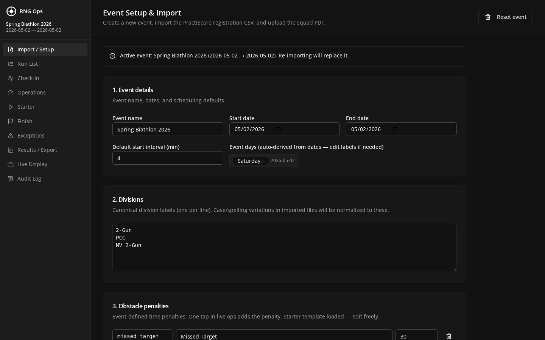
Figure 3 — Same Setup page in dark theme

Where your data lives
All event data is saved to a single database file on this computer:
%APPDATA%\RNG Ops\rng-ops.db
To back up a match, copy this file to a USB drive. To start completely fresh, close RNG Ops and delete this file.

5. Connect Phones and Tablets
Any phone, tablet, or second laptop on the same Wi-Fi network can act as a station — check-in at the registration table, starter at the shooting line, finish at the final timing gate. No app install is needed; everything runs in the device's web browser.

Step 1 — Put the host on your Wi-Fi
- On the Windows 11 host laptop, connect to the Wi-Fi network you want to use.
- Leave the host plugged into power. Leave the Wi-Fi connected. Leave the RNG Ops app open.
Wi-Fi requirement
All devices must be on the same network. A phone on cellular data cannot connect to the host. If you are at a remote range, use a travel router or a mobile hotspot, and join the host and all phones to it.

Step 2 — Get the LAN URL
- On the Windows host, click the File menu in RNG Ops.
- Click "Show LAN URL". A small window appears with an address such as http://192.168.1.42:5123.
- Write this address down, or leave the window open for reference.

Step 3 — Open on your phone (iPhone example)
- On the iPhone, open Safari.
- In the address bar, type the LAN URL exactly as shown on the host (for example http://192.168.1.42:5123) and tap Go.
- RNG Ops opens in Safari.
- To make it feel like an app, tap the Share icon (square with an arrow) at the bottom of Safari.
- Scroll down and tap "Add to Home Screen".
- Name it "RNG Ops" and tap Add. An icon appears on your Home Screen. Tap that icon to launch RNG Ops full-screen anytime.

Step 4 — Open on Android
- On the Android phone or tablet, open Chrome.
- Type the LAN URL in the address bar and tap Go.
- Tap the three-dot menu (top right) and choose "Add to Home screen" or "Install app".
- Name it "RNG Ops" and confirm. An icon appears in your app drawer.

Step 5 — Open on iPad or a second laptop
- Open any modern browser (Safari, Chrome, Edge, or Firefox).
- Enter the LAN URL. RNG Ops loads exactly as on the host.
- On iPad, use Safari's "Add to Home Screen" for an app-like icon.
All devices are live at once
Every connected device sees the same event data in real time. When a check-in station marks an athlete as checked in, the host and all other stations update immediately.

6. Troubleshooting

"npm install" fails during Chapter 3
- Confirm Build Tools 2022 with "Desktop development with C++" workload is installed.
- Restart the computer after installing Build Tools, then run "npm install" again from the project folder.
- Confirm you opened a new Command Prompt after installing Node.js (the old one does not know about the new installation).

The Windows installer won't open — SmartScreen blocks it
- Click "More info" on the blue SmartScreen window, then click "Run anyway".
- This is expected because your personal build is not signed with a commercial code-signing certificate. The installer is safe — you built it yourself.

RNG Ops opens but the main window is blank
- Wait 10 seconds. The engine is starting.
- From the File menu, choose Reload.
- If still blank, close RNG Ops and re-launch it.

Phone can't reach the LAN URL
- Confirm the phone is on the same Wi-Fi network as the Windows host. A phone on cellular will not connect.
- On the host, open the File menu and choose "Show LAN URL" again — the address changes if you connect to a different network.
- On the host, Windows Firewall may be blocking port 5123. The first time RNG Ops launches, click "Allow access" when prompted. If you clicked "Cancel" by mistake, go to Settings → Network & Internet → Windows Defender Firewall → "Allow an app through firewall" and ensure "RNG Ops" is allowed on Private networks.
- Some public Wi-Fi (airports, coffee shops) blocks device-to-device traffic. Use a personal hotspot or travel router at events.

"Port 5123 is already in use"
- Another copy of RNG Ops is already running. Check your system tray.
- Restart the computer. This closes whatever process is holding the port.

I want to start over with a blank database
- Close RNG Ops.
- Press Windows key + R, type %APPDATA%\RNG Ops and press Enter.
- Delete the file "rng-ops.db".
- Re-launch RNG Ops. A fresh empty database is created automatically.

7. Updating to a New Version
When a new version of RNG Ops is released on GitHub, follow these steps:
- Close RNG Ops.
- Open Command Prompt and go to the project folder: cd %USERPROFILE%\Documents\biathlon-ops
- Run: git pull
- Run: npm install
- Run: npm run electron:build:win
- Double-click the new RNG Ops Setup .exe in the release folder. Your existing data is preserved.
Your database is safe during updates
The installer does not touch %APPDATA%\RNG Ops\rng-ops.db. Your events, competitors, and results carry over automatically.

8. Pre-Match Setup Checklist
Use this one-page checklist at least one day before a match.
- Host laptop is charged and connected to match-day Wi-Fi.
- RNG Ops launches without errors. You see the sidebar and Setup page.
- File → Show LAN URL displays a working address (starts with 192.168 or 10.0).
- At least one phone or tablet has the LAN URL saved to the Home Screen.
- On each mobile device, tapping the saved icon loads the app in under 5 seconds.
- A backup of the rng-ops.db file is saved to a USB drive or cloud folder.
- Host laptop is plugged into power at the timing table.
- Windows sleep/hibernate is disabled for match day (Settings → System → Power & battery → Screen and sleep → set all to Never).
Setup complete.
Turn to the Operators Guide to learn how to run a match.

