**ENCODER BOARD POPULATION LEGEND**

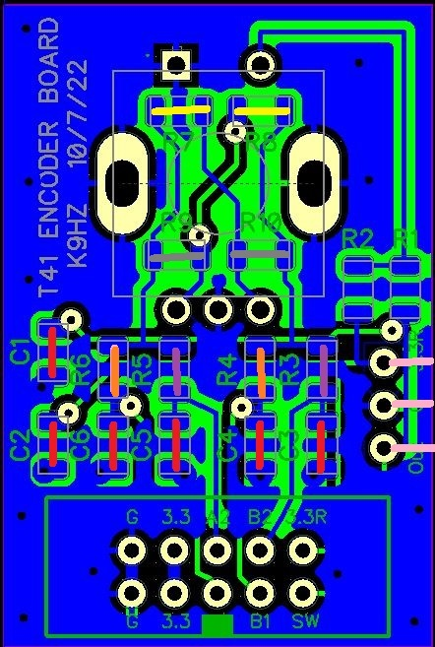

**T41 VOLUME ENCODER (ENCODER #1)**

POPULATE C1-C6 WITH 0.01 UF CAPACITORS (RED LINES)

POPULATE R4, R6 WITH 0R/ JUMPERS (ORANGE LINES)

POPULTATE R7, R8 (NOT R9, R10) WITH 0R/JUMPERS FOR CW OPERATION (YELLOW LINES)

POPULATE R9, R10 (NOT R7, R8) WITH 0R/JUMPERS FOR CCW OPERATION (GRAY LINES)

**V11** LEAVE R1, R2 EMPTY (SWITCH NOT ACTIVE)

**V12** POPULATE R1 WITH 0R/ JUMPERS (SWITCH ACTIVE)

**T41 FINE TUNE ENCODER (ENCODER #2)**

POPULATE C1-C6 WITH 0.01 UF CAPACITORS (RED LINES)

POPULATE R3, R5 WITH 0R/ JUMPERS (PURPLE LINES)

POPULTATE R7, R8 (NOT R9, R10) WITH 0R/JUMPERS FOR CW OPERATION (YELLOW LINES)

POPULATE R9, R10 (NOT R7, R8) WITH 0R/JUMPERS FOR CCW OPERATION (GRAY LINES)

**V11** LEAVE R1, R2 EMPTY (SWITCH NOT ACTIVE)

**V12** POPULATE R2 WITH 0R/ JUMPERS (SWITCH ACTIVE)

**T41 TUNE ENCODER (ENCODER #3)**

POPULATE C1-C6 WITH 0.01 UF CAPACITORS (RED LINES)

POPULATE R3, R5 WITH 0R/ JUMPERS (PURPLE LINES)

POPULTATE R7, R8 (NOT R9, R10) WITH 0R/JUMPERS FOR CW OPERATION (YELLOW LINES)

POPULATE R9, R10 (NOT R7, R8) WITH 0R/JUMPERS FOR CCW OPERATION (GRAY LINES)

**V11** LEAVE R1, R2 EMPTY (SWITCH NOT ACTIVE, MATRIX CONNECTOR USED)

**V11** ADD THREE IDC PINS FOR THE SWITCH MATRIX CONNECTION (PINK LINES)

**V12** POPULATE R1 WITH 0R/ JUMPERS (SWITCH ACTIVE)

**T41 FILTER ENCODER (ENCODER #4)**

POPULATE C1-C6 WITH 0.01 UF CAPACITORS (RED LINES)

POPULATE R4, R6 WITH 0R/ JUMPERS (ORANGE LINES)

POPULTATE R7, R8 (NOT R9, R10) WITH 0R/JUMPERS FOR CW OPERATION (YELLOW LINES)

POPULATE R9, R10 (NOT R7, R8) WITH 0R/JUMPERS FOR CCW OPERATION (GRAY LINES)

**V11** LEAVE R1, R2 EMPTY (SWITCH NOT ACTIVE)

**V12** POPULATE R2 WITH 0R/ JUMPERS (SWITCH ACTIVE)

**NOTE:** DAISY CHAIN ENCODERS 1 & 2 ON SAME CABLE, 3 & 4 ON SAME CABLE.