K9HZ FRONT PANEL BOARDS
BUILD INSTRUCTIONS for PCB V12.6
October 5, 2026

Background Information:

The K9HZ Front Panel board-set replaces the existing interface from the T41 Main Board to the front panel switches and encoders. It works with all versions of the T41 Main Boards (V010/ V011/ V012). This concept was originally designed and implemented by John Melton, G0ORX, to replace the switch panel matrix for a more robust operation of the T41 front panel controls.

To work, T41 encoders are disconnected from the T41 Main Board and reconnected to the Front Panel board connectors. A single 10-pin IDC cable connects the Front Panel board-set to the Main Board using the Tune/Filter connector that is repurposed in software for I2C control. The Volume/Fast-Tune connection on the Main Board is not used and can be repurposed by the user for other hardware experimentation and add-ons (Note that there is no reason to place this connector on the Main Board if the connections will not be used). Note that the holes in the boards and switch mounting positions are identical to the original T41 Switch Matrix Board.

The Front Panel Board-set uses two MCP23017 programmable I/O line expanders selectable in the ranges of 0-7H with 16 I/O lines each. Connections are made to each of the eighteen front panel switches, the momentary push switches on the four encoders, the two directional encoder outputs for each of the four encoders, and two remaining lines used for output to LED connections for the users use. Routines for this enhancement is built into the standard T41 software and is enabled by selecting the G0ORX Front Panel option the T41 Software build.

The Front Panel board-set works perfectly with the K9HZ Encoder boards to easily and cheaply connect the encoders directly to the T41 Main Board (All versions), or to the Front Panel Electronics board in V12 and later yet remains flexible with respect to encoder placement.

Please note. If you want to use a second receiver in your V12 radio, you MUST use this set of boards to connect the second set of encoders. The “Encoders” connector on the Main board is repurposed for the second receiver input.

Inventory and Prework

Before you begin, inventory your parts against the latest BOM to make sure you have everything you need to complete the Front Panel Boards build. The complete BOM is given in Tables 1 and 2. The boards have pads to select the I2C addresses between 0-7H. For the T41, Select address 0H for U1 and address 1H for U2 as these are the default addresses. That is, all center pads for J4, J5, J6, J8, and J9 to GND, and J7 to 3.3V.
All of the IDC male connectors except the “IDC Box” connectors can be snipped from one long IDC row of pins.
Front Panel board order use spacers between the two boards when connecting them together; use four M3 6mm x 6mm spacers, four M3 nylon nuts, and 4 nylon M3 x 6mm screws.

Building the Boards
With a medium heat soldering iron (30-40W), begin the assembly of the PA board in this order:
- Solder on the sides of the boards shown in Figure 1. Printing is on the top sides of the boards.
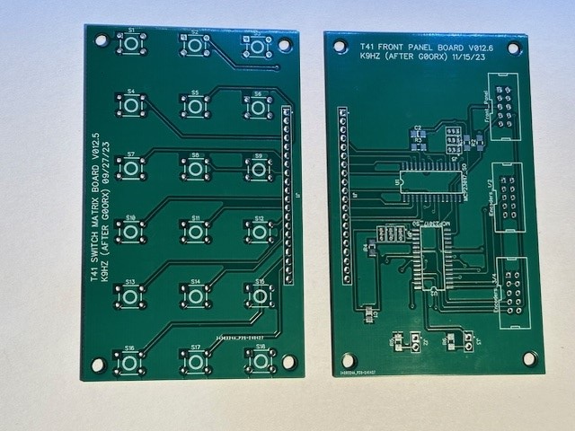
Figure 1. Top Side of Front Panel Boards.
- Solder the 18 tactical switches to the top side of the switch board. Set the board aside.
- Solder the two MCP23017’s onto the Electronics Board taking care to locate pin one correctly. Refer to the Datasheet if there is any question about which pin is number one. Placing these parts is done easily by tinning pin one with solder, heating that solder, and locating the IC with a forceps. Then solder the pin on the opposite corner. Finally, flood the rest of the pins with solder with a gentle swipe of the soldering iron up the edge of each side of the part using plenty of flux. If you get solder bridges, simply use some solder wick to carefully remove the extra solder.
- Select the proper I2C addresses for the MCP23017’s as discussed in the above section. Solder the clipped leads from capacitors or resistors folded into a “U” into the appropriate holes. See Figure 2.

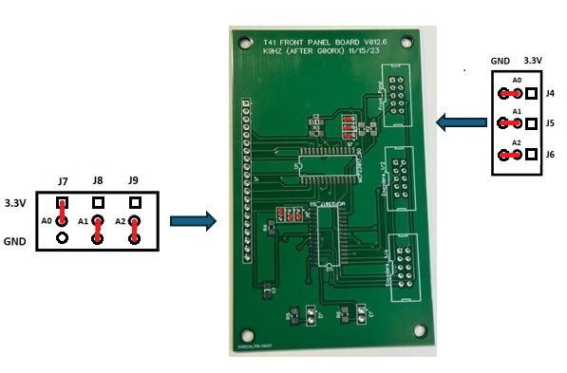
Figure 2. Jumpers In Proper Position for Use With The V12 T41.

- Solder all capacitors, resistors, and diodes in their appropriate locations as screened on the board per the BOM and Schematic.
- Solder the three 10-pin box connectors onto the board (top).
- Finally, solder the two IDC two-pin male connectors to the board. These are the connections for two LEDs that you can use for various tasks like “TX”, “RX”, or anything else you find useful. NOTE: The LEDs are not called out in the BOM as they are OPTIONAL. Any common LEDs should work. Mind the polarity.
- Place the 3M 6mm nylon standoffs in the corners of the back side of the Electronics Board and secure them with nuts on the front.
- Place the Switch Board back-to-back on the Electronics Board. Temporarily put two screws into the spacers from the front side of the Switch Board.
- Check to see that J1 on both boards line up perfectly, then remove the screws and place the 20-pin male IDC header between the two boards as shown in Figure 3.
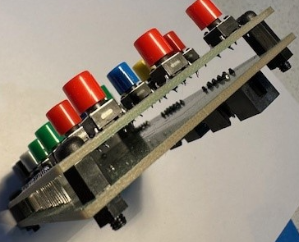
Figure 3. M3 Spacers to Keep Boards Aligned.
- Place the nylon spacers between the two boards with the screws on the switch board and the nuts on the back side of the board.
- Solder the 20-pin male header to both boards.
- Clean the boards with IPA before continuing.
- The boards are now complete and can be tested.
- Plug the connector from encoders 1/2 into the correct connector on the Electronics Board.
- Plug the connector from encoders 3/4 into the connector marked as such on the Electronics board.
- Make a cable to connect the Front Panel boards to the T41 Main Board Tune/Filter connector (Front Panel on the V012 Main Board). See Figure 4.

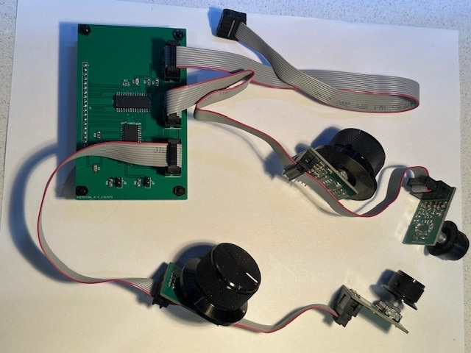
Figure 4. Connections to the Front Panel Board Set.

Testing The Front Panel
It is possible to test the front panel by loading and executing a test routine into the Teensy 4.1 on the main board with the completed front panel connected to the main board. The test routine can be found in the directory called K9HZ_Front_Panel_Boards_Test_Software in the front panel boards directory.
Output in the serial monitor of the ADI will look like this as you actuate the switches and encoders:
20:53:16.538 -> Front Panel Test
20:53:16.538 -> Both LEDs should be OFF they swap state with each button press
20:53:16.538 -> Press a button or rotate an encoder ...
20:53:25.718 -> Button Pressed=0
20:53:26.909 -> Button Pressed=1
20:53:27.971 -> Button Pressed=2
20:53:29.063 -> Button Pressed=3
20:53:29.772 -> Button Pressed=4
20:53:31.544 -> Encoder 1=1
20:53:35.537 -> Encoder 1=-1
IF the testing does not give the expected results, check your solder connections and try the testing again.

Table 1. Electronics Board BOM
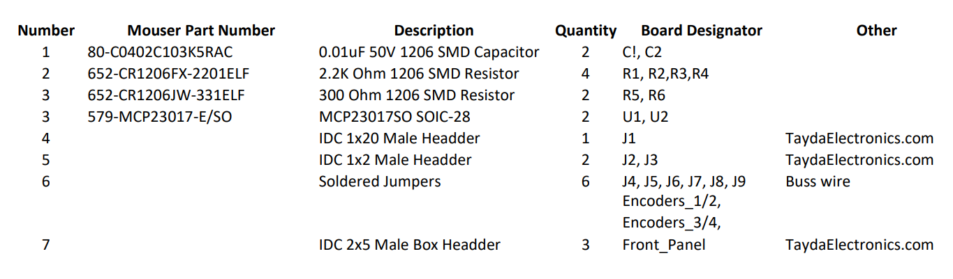
Table 2. Switch Board BOM


