K9HZ 100W LPF – TR RELAY DAUGHTER BOARD
ASSEMBLY INSTRUCTIONS for PCB V1.10
January 27, 2026

Introduction

The K9HZ 100W LPF TR daughter relay board is a second generation mechanical relay switching mechanism for switching the antenna path to the receiver and the transmitter to a 50 ohm load in “RECEIVE” mode, and the antenna path through the antenna tuner connections to the transmitter and the receiver input to ground in “TRANSMIT” mode. The previous version of this daughter board did not include connections to place the antenna tuner in the transmit path while in “TRANSMIT” mode.

Inventory and Prework

The full BOM is given in Table 1. Spend some time with the list of options for this board before you order. There are no options associated with this board… therefore all parts should be placed.

Table 1. The Bill of Materials for the K9HZ LPF TR Relay Daughter Board.
Quantity | Part Description | Part Reference
2 | 0.1uF 50V | C1, C2
1 | 1N4148 DO-35 SOD27 SMD Diode | D1
4 | IDC1x5 Male Pins | J22.1, J22.2, J23.1, J23.2
2 | SMA Female PCB Mount Connector | J1, J2
2 | HF41-F12-ZS Relay | K1, K2
1 | BS170 FET | Q1
1 | 50 Ohm SMD 1206 Resistor | R1
1 | 6.8k Ohm SMD 1206 Resistor | R2

The schematic for this board is shown in Figure 2 below.

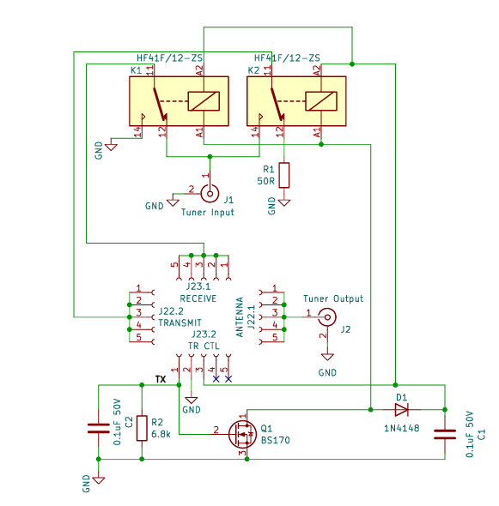
Figure 1. Schematic for the K9HZ LPF TR Relay Daughter Board.

Assembly
Begin by wiping the board with 90% IPA (Isopropyl “rubbing” alcohol that you can buy at the drug store)… followed by scrubbing both sides of the board with liquid dish washing soap, rinsing with water, and thoroughly drying. When dry, inventory the parts against the materials list to make sure you have everything on hand before starting.

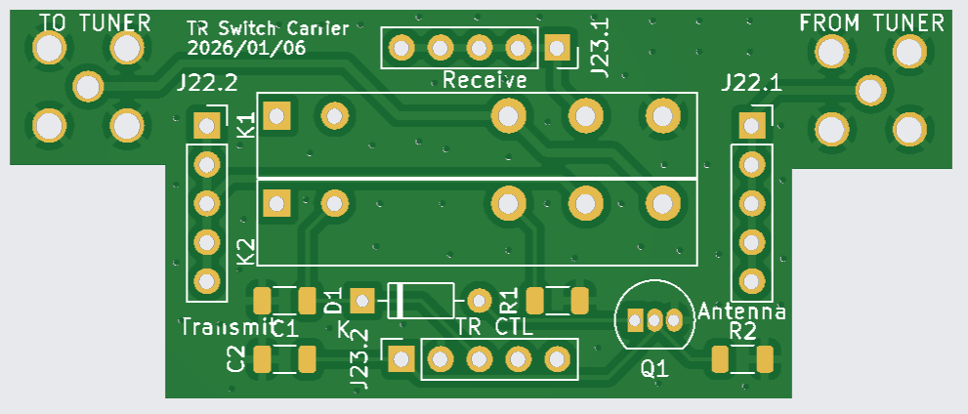
Figure 2. Bare LPF TR Relay Daughter Board.

Start by populating capacitors C1 and C2 on the top side of the board. Continue by placing diode D1 noting that the cathode bar is clearly marked on the board and should be aligned with the bar on the diode body.
Next, populate R1 and R2, followed by Q1. Then mount the two relays K1 and K2, followed by J1 and J2.
The final step is to mount the four sets of five IDC pins at positions J22.1, J22.2, J23.1, and J23.2. This is best done by placing the pins in the corresponding sockets that are mounted on the LPF control board, placing the sockets in the holes on the control board and the pins in the holes on the TR daughter board. Then solder the pins on the top side of the TR daughter board. Its also a good idea to solder the sockets on the control board at the same time.
The final step is to clean the TR relay daughter board again with 90% isopropanol followed by liquid dish soap, rinsing with water, and drying. The board should look like this when complete:

Using the TR Relay Board
Using the board is as easy as plugging into the LPF control board and connecting J1 and J2 to the automatic tuner RF board. If you are not using the K9HZ automatic tuner (or any tuner for that matter), place an SMA male to male jumper between J1 and J2. This completes the assembly process.

