K9HZ AUTOMATIC ANTENNA TUNER – RF BOARD
BUILD INSTRUCTIONS for PCB V2.0
September 08, 2026

Operating Data:

Power Requirements: 12-15 VDC at 100ma max.
Frequency Range: 1.8MHz – 54Mhz
RF Input: Up to 150W Maximum.
Control: I2C for commands to impedance match.
Impedance Matching: 35-1,200 Ohms inclusive.

Background

This automatic antenna tuner (ATU) was designed to cover a wide range of impedances by restructuring the antenna tuner capacitor and inductor elements. You can see in the diagrams below that simply rearranging the position of the capacitors in the “L” structure allows both high and low, capacitive and inductive impedances to be addressed by the tuner structure.

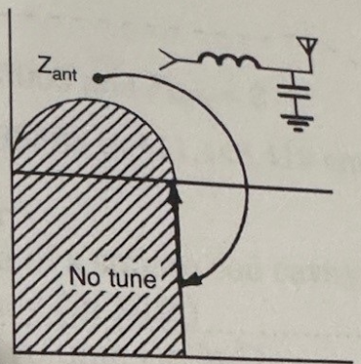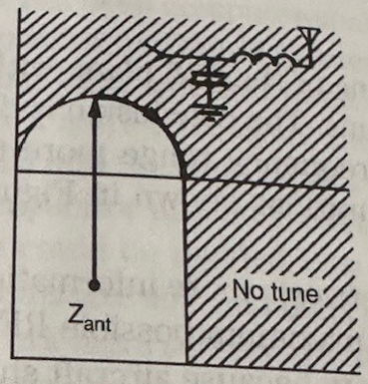

Inventory and Prework

The full BOM is given in Table 1. Note that the full BOM parts should not be ordered; it is only presented for reference. Spend some time with the list of options for this board before you order. Understand what each option does and select the best set of options for your situation. Once option selection is made, order and inventory your parts.

Board Option:
There are two options to that are selectable at build time for this tuner.
- Line Section
The first option adds a line section for measuring forward power, reflected power, and SWR. Use this option if the tuner will be paired with an earlier T41 version (V10 or V11), or if your radio does not use the K9HZ LPF or its built-in line section. If the K9HZ LPF line section is available, use it instead because it is higher performing and already supported by the T41 software.

- High-Impedance Balun
The ATU RF board also supports an optional 1:n balun for long-wire operation, such as POTA or other field use where minimizing extra equipment is important. This option can be added later and changed as needed. Use 1:4 or 2:1 baluns for high- or low-impedance verticals, and use 1:7 or 1:16 baluns for end-fed wires (EFW), off-center-fed antennas (OCF), or long wires (LW). Keep two points in mind: one leg should either be part of the antenna, such as an off-center-fed dipole, or be at ground potential using a ground rod, radial elements, or radials. The other balun lead feeding a high-impedance antenna can develop very high RF voltage, potentially hundreds of volts, so consider this when selecting a balun. This topic is covered in more detail later in the build instructions.

Bill of Materials
The bill of materials is shown below in Table 1. Note that the parts for the options detailed above are highlighted in the table in yellow.

Building the RF Board
- Start by inventorying the components against the BOM in Table 1. It’s much easier to build the tuner when you have all necessary parts available.

Note: Parts highlighted Yellow and Orange are for Options.
Table 1. Bill Of Materials for the Automatic Antenna Tuner RF Board.

- Begin assembly by winding and testing all inductors. The board uses three air-core inductors, two single-core inductors, and two double-core inductors.

  - Create three dual-core assemblies by gluing two T68-2 cores together with super glue, as shown below. These assemblies will be used for L6, L7, and L8.

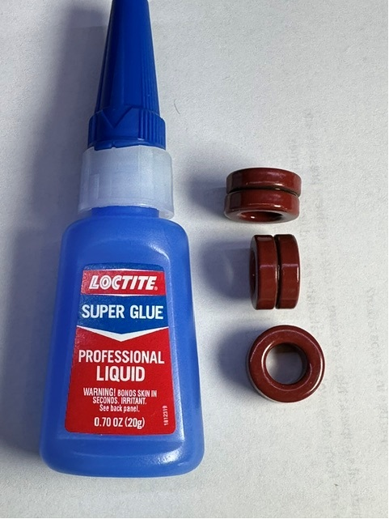

  - Next, wind L1, the 0.05 µH air-core inductor. Close-wind three turns of #24 enameled wire around the smooth section of a 5/32” drill bit; about 4 inches of wire is enough. The finished inductor should measure approximately 19/32”, or 0.6”. See below:

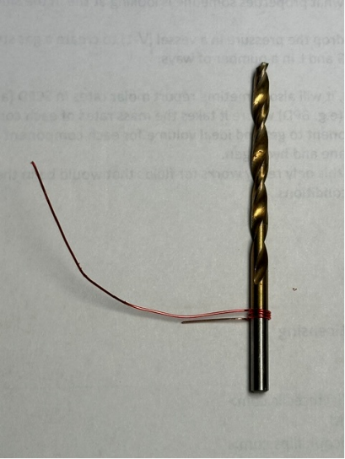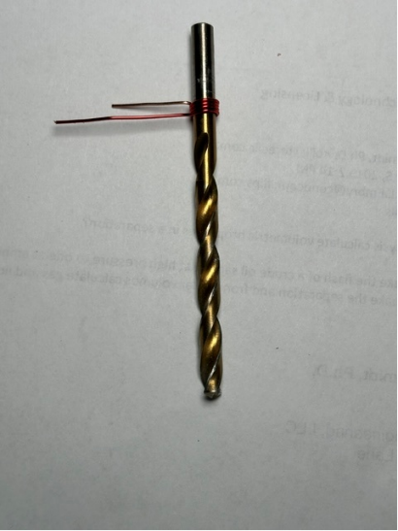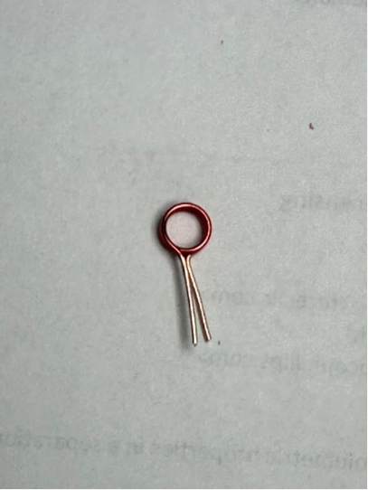

Remove just enough insulation from the coil leads to minimize excess length when soldering them to the board. However, do not solder L1 to the PCB yet; complete all inductors first.
  - Next, wind L2 by close-winding five turns of #20 enameled wire around a 15/64” drill bit. About 4 inches of wire is sufficient, and the finished inductor should be approximately 1/8” long. Remove just enough insulation from the coil leads to minimize excess length when soldering them to the board. It should look like this:

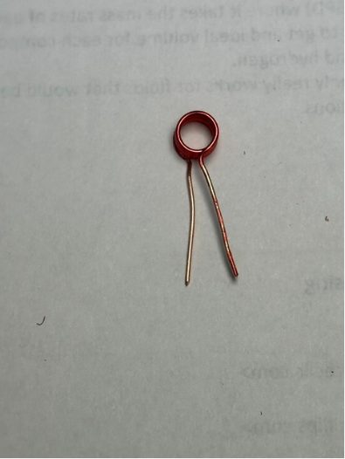

  - Next, wind L3 by close-winding seven turns of #20 enameled wire around a 15/64” drill bit. About 5 inches of wire is sufficient, and the finished inductor should be approximately 1/4” long. Remove just enough insulation from the coil leads to minimize excess length when soldering them to the board. It should look like this:

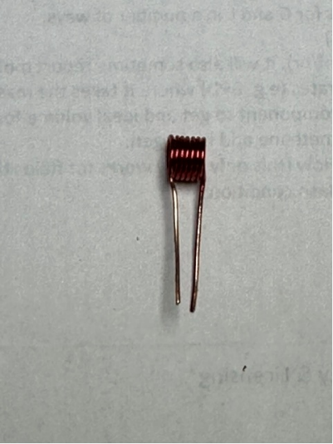

  - Next, wind L4 by evenly spacing eight turns of #20 wire on a single T68-2 core. Remember… each time through the center of the core counts as one turn. Remove just enough insulation from the coil leads to minimize excess length when soldering them to the board. About 11” of wire is sufficient. It should look like this:

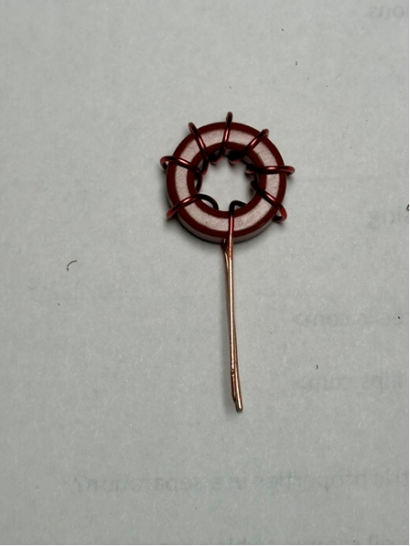

  - Next, wind L5 by evenly spacing thirteen turns of #20 wire on a single T68-2 core. Remember… each time through the center of the core counts as one turn. Remove just enough insulation from the coil leads to minimize excess length when soldering them to the board. It should look like this:

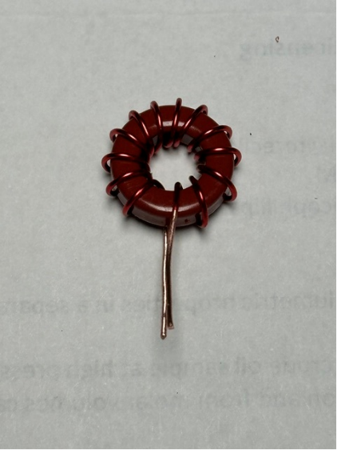

  - Next, wind L6 by evenly spacing thirteen turns of #20 wire on one of the dual T68-2 cores made in step “a” above. About 14” of wire is sufficient. It should look like this:

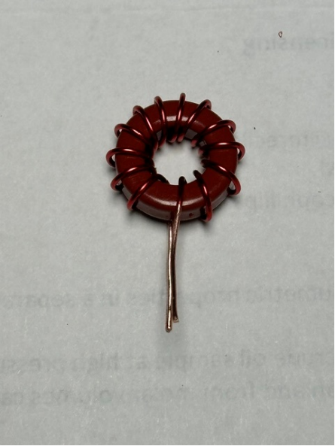

  - Next, wind L7 by evenly spacing nineteen turns of #20 wire on one of the dual T68-2 cores made in step “a” above. About 17” of wire is sufficient. It should look like this:

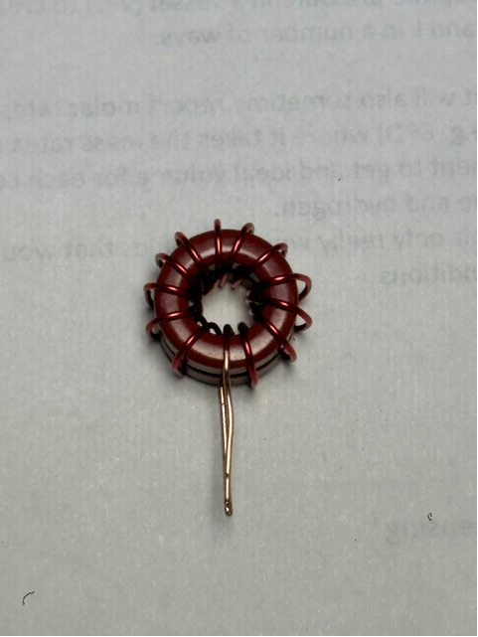

  - Finally, wind L8 by evenly spacing twenty-six turns of #20 wire on one of the dual T68-2 cores assembled in step “a” above. About 21” of wire is sufficient.

- If available, use an LCR meter or VNA to measure each inductor and compare the results with the table below. Inductance values within ±10% of the design value are acceptable; rebuild any inductor outside that range:

- If you are not using the line-section option in the K9HZ LPF and instead plan to install the tuner’s optional line section for measuring forward and reflected power, build it now. The instructions below cover both 20 W and 100 W operation; the power rating is set by the number of secondary turns, “N”.
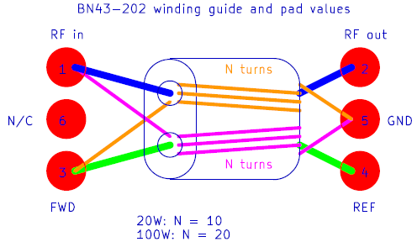

The orange and purple wires are “N” turns of #20 enameled wire through each core hole. The blue and green wires are single-pass leads made from 2” pieces of #20 silver-coated stranded TFE wire.
- Before soldering the first components, wipe the tuner RF board with 90% isopropyl alcohol (IPA).

- If installing the optional line section, orient it on the board and solder the wires according to the board markings and the drawing above. If you are using the LPF’s built-in line section instead, bypass this option by soldering a wire or trimmed resistor lead between the “RF IN” and “RF OUT” holes. See the examples below. Note: the line-section transformer shown in the photo is from the K9HZ LPF line section and is installed on that PCB in the opposite orientation from this board. If using this option, also install R1 and R2; otherwise, leave those positions blank.

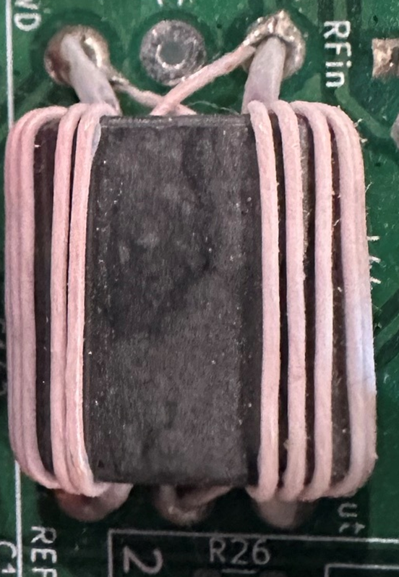 OR 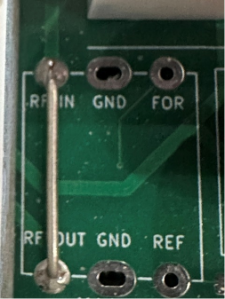

- Solder RF capacitors C1–C9 in place.

- Solder the three male pin IDC headers for J5, J6, and J7 to the bottom side of the PCB.

- Solder inductors L1–L8 in place, taking care to preserve the shape of the air-core inductors.

- Place the relays on the top side of the PCB and solder their pins on the bottom side.

- Solder the two female SMA RF connectors, J1 and J2, to the top side of the PCB.

- The final option to consider is using a balun. There are so many possible combinations that this subject will be covered under a separate assembly note at a future date.

- The finished tuner should look like the photo below.

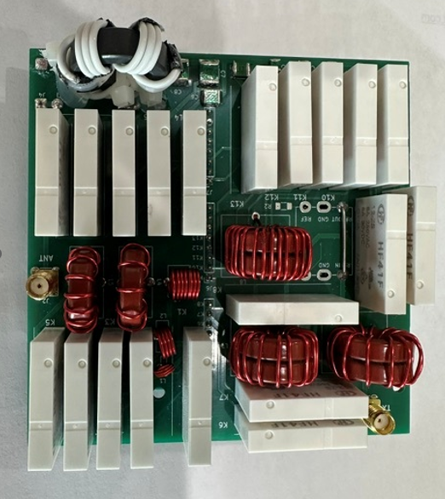

- A software routine is available for testing the tuner, that runs through all of the inductor, capacitor, and mode (series cap, series inductor, bypass, and balun) on the software GITHUB.

