K9HZ ANTENNA TUNER – CONTROL BOARD
BUILD INSTRUCTIONS for PCB V2.0
July 23, 2026

Operating Data:

Power Requirements: 12-15 VDC at 100ma max.
Frequency Range: 1.8MHz – 54Mhz
RF Input: Up to 150W Maximum.
Control: I2C for commands to impedance match.
Impedance Matching: 35-1,200 Ohms inclusive.

Background

This control board is designed to interface the T41 to the K9HZ Automatic Antenna Tuner. It operates by accepting I2C data on the “BANDS” cable at address 0x20 and 0x21. Commands come from the ATU program in the Teensy on the main board that operate the relays on the ATU RF board for eight coils, eight capacitors, bypass, reversing, and using the on-board balun.

Inventory and Prework

The full BOM is given in Table 1. Note that the full BOM parts should not be ordered; it is only presented for reference. Spend some time with the list of options for this board before you order. Understand what each option does and select the best set of options for your situation. Once option selection is made, order and inventory your parts.

Board Options

There are two ATU options to that are selectable at build time. Only one pertains to the ATU Control board (the Line Section connection electronics).
- Line Section
The first option is the inclusion of a line section for determining forward power, reflected power, and therefore SWR. You can build and use this option if you are using the tuner with an earlier version of the T41 (V10 or V11), or if your radio does not use either the K9HZ LPF and/ or the line section on the K9HZ LPF Control board (If this is the case, it’s better to use the line section on the LPF for better precision).

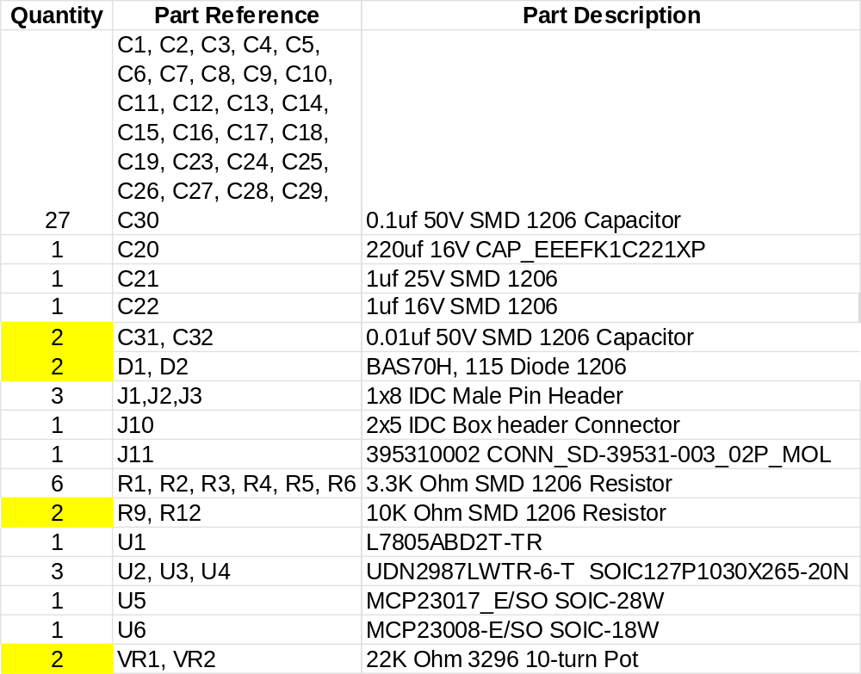
NOTE: Delete Items IN YELLOW from the BOM for no Line-section option!
TABLE 1. Bill Of Materials for the ATU Control Board.

Building The Board
- Inventory all parts for ATU Control board. Print out the BOM and check them off so you know if something is missing.
- Wipe the board with Isopropyl Alcohol (IPA) to remove oils from the board surface that will make soldering difficult.
- Begin by placing and soldering all capacitors except C20, the electrolytic capacitor, on both sides of the board (note: ONLY place C31 and C32 and the rest of the parts in YELLOW in Table 1 if you intend on building the line section for measuring power on the ATU RF board because you don’t have the K9HZ LPF. If you DO have the K9HZ LPF and DID NOT build the Line section there and do not have a line section available in the T41 hardware… BUILD the line section option on the LPF. The LPF has a high performance line section for resolving power and SWR in the T41 code).
- Next, Place resistors on the board.
- If you are building the optional line section on the ATU, now is the time to place C31, C32, D1, D2, R9, and R12 (do not place VR1 and VR2 yet).
- Now place U1-U6 in the order that makes most sense to you for soldering. I placed U5 first, then U2 and U4, followed by U3 and U6. That caused the least amount of interference for me. U1, the voltage regulator, goes on the bottom of the board.
- Place J1, J2, and J3. They can be aligned by using a long 40 pin female/ female IDC set. They go ON THE TOP of the control board and soldered on the bottom. Note that this connector can be MALE or FEMALE as long as the mating connector on the RF board is the opposite gender!
- Place J10 and J11 on the bottom of the board in the proper orientation. Use a magic marker (black and red) to mark the correct connection polarity on the phoenix connector at J11.
- If you are building the optional line section, place VR1 and VR2 on the back side of the control board.
- Solder shut J4, J5, J6, J8 and J9. Leave J7 OPEN. This corresponds to 0x20 and 0x21, the two addresses occupied by the ATU I2C control circuits.
- Finally, place C29, the electrolytic capacitor on the back side of the board.
- You should now have all components placed at this point.
- When the ATU RF board is finished, the ATU Control board that you just build fits to the bottom of the RF board with four M2/M3 nylon standoffs that are 10mm long (plus 1 mm of washers).
- Clean the flux off the board with Isopropyl alcohol (IPA) of 90% or greater. Finish cleaning with soap, water, and a tooth brush of whatever method works for you.

Connecting and Testing the ATU
With the ATU RF and Control boards connected together, the ATU is connected to the T41 MAIN board via the “BANDS” connector. Make it part of the cable daisy chain that also goes from the MAIN board to the BPF and the LPF.
A test routine is provided on the software GITHUB site to be loaded into the Teensy on the MAIN board that cycles through the relays on the RF board. If all is ok, you should hear a relay click once per second.
All driving routines for the ATU are contained in the T41 software.

