**20W Dummy Load and 40db Attenuator - Assembly Manual**

**Version 1.00 – April 24, 2025**

**WJ Schmidt - K9HZ**

**INTRODUCTION**

The 20W dummy load and 40db attenuator kit was designed for calibrating and troubleshooting QRP radios. It uses a resistive pad of ten two-watt resistors and a divider network to reduce the input power by 40 db. At 20W maximum input (or 43 dbm), the output power is 2 mw (3 dbm). This device can be used for power calibration and TX-RX calibration of the T41. It can also be used as a tap to feed back the transmitted power envelope for advanced processing (eg ESSB). Note that the kit is packaged without SMA connectors since the user may require connectors of different orientation than what can be provided.

**SPECIFICATIONS**

Input Power: 20W Intermittent Power (2 Minutes), 0.1-150 MHz.

Pad Power Reduction: 40 db (or 2 mw output at full power).

Size: 2.00” x 1.25”

**INVENTORY AND PREWORK**

Before you begin, inventory your parts against BOM to make sure you have everything you need to complete the Kit. The BOM is shown below. In addition to the parts on this list, you will need two SMA board mount connectors suitable for your use of this kit:



**BOARD AND CIRCUIT**

The bare board is shown below. The circuit diagram is the last page of this document.

**BUILDING THE BOARD**

1. Find a place where you can spread out your work, including a printouts of the board and BOM. Your workstation should be such that you can leave it overnight without having to "clean up". The workspace should also be kid- and cat-proof. If you get tired, stop. Come back to it tomorrow. Rushing the assembly rarely works out saving time.
2. Start by cleaning the RVP board with IPA (Iso-propyl or “rubbing” alcohol) to make sure it’s
3. On the back side of the PCB, place and solder R1-R10, the TEN 510, 2W resistors. These are 3430 sized parts so are relatively easy to solder compared to most SMD parts.
4. On the front side of the PCB, place and solder R11-R14, the FOUR 10K Ohm, 0.25W resistors.
5. Finally, place and solder R15, the 51 Ohm, 0.75W resistor.
6. Solder your choice of SMA connectors to the PCB.
7. This completes the assembly of the Kit. Use IPA followed by dish washing detergent and a toothbrush to clean flux from board. Dry the board with a towel

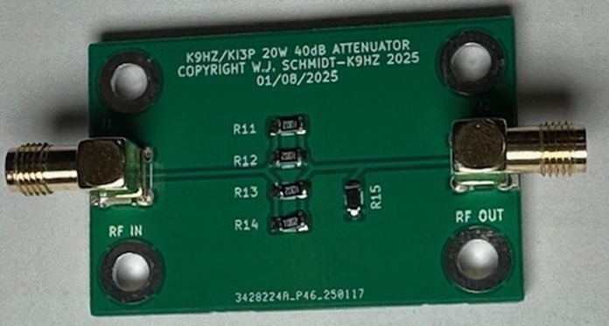

**USING THE DUMMY LOAD/ ATTENUATOR**

You can use the dummy load at 10W for up to 10 minutes, and 20W for 2 minutes before the board becomes hot to hold. Do not exceed these times.

When used to calibrate the T41 radio, you can run the TX output from the RF board into the attenuator and the output of the attenuator into the RX antenna on the same RF board. Now perform calibration as per the calibration instructions.

