**ENCODER BOARD POPULATION LEGEND**

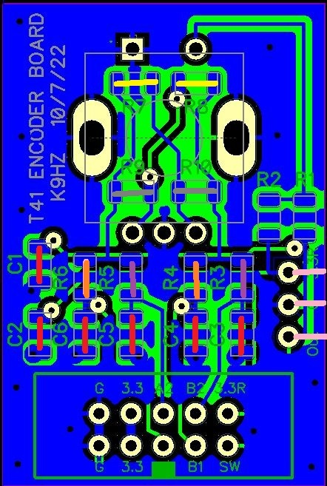

**T41 FILTER ENCODER**

POPULATE C1-C6 WITH 0.1 UF CAPACITORS (RED LINES)

POPULATE R3, R5 WITH 0R/ JUMPERS (PURPLE LINES)

POPULTATE R7, R8 (NOT R9, R10) WITH 0R/JUMPERS FOR CW OPERATION (YELLOW LINES)

POPULATE R9, R10 (NOT R7, R8) WITH 0R/JUMPERS FOR CCW OPERATION (GRAY LINES)

**T41 TUNE ENCODER**

POPULATE C1-C6 WITH 0.1 UF CAPACITORS (RED LINES)

POPULATE R4, R6 WITH 0R/ JUMPERS (ORANGE LINES)

ADD THREE IDC PINS FOR THE SWITCH MATRIX CONNECTION (PINK LINES)

POPULTATE R7, R8 (NOT R9, R10) WITH 0R/JUMPERS FOR CW OPERATION (YELLOW LINES)

POPULATE R9, R10 (NOT R7, R8) WITH 0R/JUMPERS FOR CCW OPERATION (GRAY LINES)

**T41 VOLUME ENCODER**

POPULATE C1-C6 WITH 0.1 UF CAPACITORS (RED LINES)

POPULATE R4, R6 WITH 0R/ JUMPERS (ORANGE LINES)

POPULTATE R7, R8 (NOT R9, R10) WITH 0R/JUMPERS FOR CW OPERATION (YELLOW LINES)

POPULATE R9, R10 (NOT R7, R8) WITH 0R/JUMPERS FOR CCW OPERATION (GRAY LINES)

**T41 FINE TUNE ENCODER**

POPULATE C1-C6 WITH 0.1 UF CAPACITORS (RED LINES)

POPULATE R3, R5 WITH 0R/ JUMPERS (PURPLE LINES)

POPULTATE R7, R8 (NOT R9, R10) WITH 0R/JUMPERS FOR CW OPERATION (YELLOW LINES)

POPULATE R9, R10 (NOT R7, R8) WITH 0R/JUMPERS FOR CCW OPERATION (GRAY LINES)