**Reverse Voltage Protection 20A Kit - Assembly Manual**

**Version 1.00 – July 30, 2024**

**WJ Schmidt - K9HZ**

**INTRODUCTION**

The reverse voltage protection circuit without damage is a two 50-ohm paths and fed to the BPF in front each of the receivers.

**INVENTORY AND PREWORK**

Before you begin, inventory your parts against the latest V012 2nd Receiver Adapter board BOM to make sure you have everything you need to complete the adapter board. The BOM is available on the GITHUB at: [T41/T41_V012_Files_01-15-24/T41_V012_BOMs at main · DRWJSCHMIDT/T41 · GitHub](https://github.com/DRWJSCHMIDT/T41/tree/main/T41_V012_Files_01-15-24/T41_V012_BOMs)

**BUILDING THE BOARD**

1. Find a place where you can spread out your work, including printouts of the schematic and BOM. Your workstation should be such that you can leave it overnight without having to "clean up". The workspace should also be kid- and cat-proof. If you get tired, stop. Come back to it tomorrow. Rushing the assembly rarely works out saving time.
2. Start by cleaning the bord with IPA (Iso-propyl or “rubbing” alcohol) to make sure it’s clean:

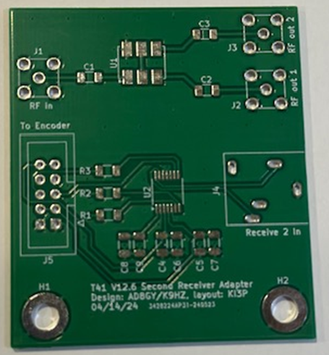

3. Next, place the hardest part on the board… U2, the PCM1808PWR. It's hard to see the pin 1 mark on some of the ICs. In the picture above, its at the lower left-hand corner of U2.

4. Do the "low-lying" SMDs next (e.g., caps and resistors). Place and solder C1-C9 and R1-R3.

5. Add U1, the transformer to the board. Make sure the orientation is correct (the print on the part should read normally when placed on the board above in its current orientation. If the print is upside-down, it’s the wrong way).

6. Finally add the five connectors to the board J1-J5.

7. The board is now complete. Use IPA again to clean the flux off the board.

**USING THE BOARD**

First, this adapter can only be used when the K9HZ front panel boards are used. This is because the 10-pin “Encoders” connector on the main board is connected to the 10-pin “Encoders” connector on the adapter. The RF-in connector is connected to the receiver antenna output on the LPF board. This signal is split into two channels, one for each receiver. These signals go to the input of the RX and second RX’s BPFs. Finally, the second Rx’s I/Q stream input is plugged into the 1/8” phono jack J4. See this diagram:

