**K9HZ 100W LPF 160M-6M**

**SPECIFICATIONS for PCB V1.00**

**February 15, 2024**

**Operating Data:**

Power Requirements: 12-15 VDC at 100ma max.

Frequency Range: 1.8MHz – 54Mhz/ 160M – 6M in 11 bands.

Input: 20W or 100W.

I finally finalized my LPF board that will marry many of my support modules together. It works with the 20W PA, the 100W PA, my Digital attenuator, a passive BPF for both transmit and receive, and new tuner board (on the drawing board) to form a complete solution for RF management for any QRP radio. Here is what the board has on it. **THIS IS KEY:** **You can build as much or as little of it as you need**.

**Specifications:**

1. Easily integrates with most all QRP radios. Manuals for integration to be available for most common QRP radios.
2. Transmit input port for up to 10 mW.
3. Receive antenna output port, signal protected.
4. Connection (in and out) for an off-board BPF that works in TX, RX, Both, or bypass selectable electronically.
5. Connection (in and out) for a transverter (4M, up to 10GHz). Selectable electronically.
6. Connection (in and out) for 20W PA module.
7. Connection (in and out) for 100W PA module.
8. Eleven band filters for 160M-6M. Most better than 50 dB attenuation.
9. TR Switch:
   1. 100W Pin diode module daughter card, or
   2. 100W relay module.
10. Power measurement line section with:
    1. Analog output 0-3V lines for sent to Teensy 4.1 Via BAND connector, or
    2. I2C addressed dual 12 bit A/D sent to Teensy 4.1 via I2C2 in Band Connector
11. Band LPF selected by (Kenwood/ Yaesu/ Elecraft etc. compatible):
    1. Muxed 4 bit lines (BAND0-BAND3) repurposed from BAND connector, or
    2. From I2C fanout from 4 bit IO expander.
    3. Connection for output BAND0-BAND3 to back panel for external switching.
12. Passive 1.8MHz High-Pass Filter. (or leave off for 630M band)
13. Selection of 4 antennas connections.
14. Separate input for receive antenna.
15. All electronic selections done either by I2C or by individual pin/bit input connections.
16. No hardware changes for integration with V012 T41. Simple integration with other QRP radios. Some programming necessary. Arduino software for testing functions downloadable.
17. Board (3 boards total) price $3.00 USD plus shipping
18. KitsAndParts.com has a toroid kit available for this module.

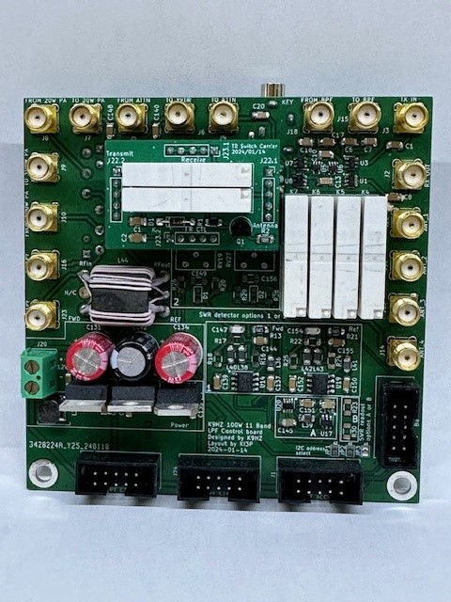

Top side of LPF Control Board.

Botton side of LPF Control Board.

Top side of Filter Board.

Bottom side of Filter Board.

Top side of Relay TR Board.

PIN Diode TR Board in Design.